Dear Candidate,

Here is the exercise.

Please build a currency convertor app like below using NodeJS (you can use ExpressJS Framework)

Need a feature where an admin of this app can configure the API of his choice and the end user should be able to use the application like shown below.

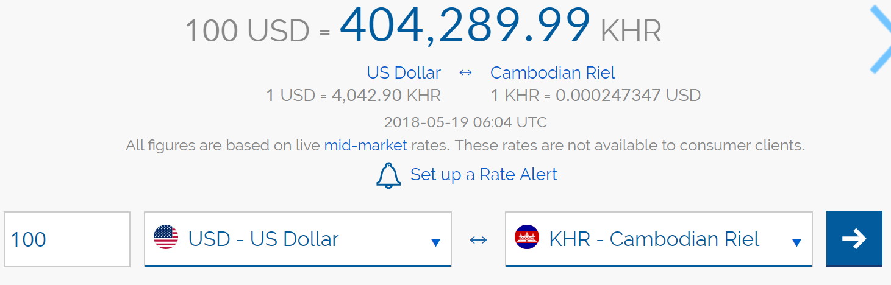

Please use NodeJS 9.x and ExpressJS version 5.6 for this exercise.

Please do not use any currency libraries available on the internet, please build by yourself and send the code in zip format. If you can host it anywhere it would be great.

Please share a date and time after 30th for a phone interview to review the code you have written.

Thanks,

Nel