THE EIM ENCYCLOPEDIA
Seed Edition v0.1 — Consolidated, Verified, Plotted
Thomas P. Connelly, Jr. · Zero One Net
Canonical Core + Tip of the Spear · compiled 18 July 2026

Purpose and scope
This is the consolidation seed for the EIM corpus: one reference in which every result appears as a full, self-contained entry — statement, status, dependencies, an independent verification where one is possible, and a figure where one clarifies. It adopts, unchanged, the entry conventions and status taxonomy of the EIM Framework Codex (Canonical Edition); it does not invent a parallel format. Sources consolidated here are the Framework Codex, the Codex & Encyclopedia Update, Coordination Before Identity, the two dissertations, and the Beyond Curved Spacetime book.
The edition is deliberately narrow: it does not attempt all ~220 catalogue entries at once. It builds one cluster to completion — the dodecahedral backbone, the exact finite laboratory on which the whole framework rests — with each entry independently re-verified in code and plotted, then carries that backbone to its empirical spearhead (the CMB five-fold / zonal test) and stops at the honest frontier. Two tiers are kept strictly separate, at your instruction: a Canonical Core of established (Level I) results, and a Tip of the Spear of open bridges and cutting-edge frontier items that must not be read as settled.

How to read an entry
Each entry carries the Codex fields: ID (type-prefixed: AX axiom, DF definition, TH theorem, ID identity, LM lemma, PR principle, CR corollary, OP open problem, CAND candidate, NEG negative result, NOTE, PD prediction, CJ conjecture); Name; Type; Status (taxonomy below); Cluster; Statement (canonical content, discipline-strict — no process-diary prose); Depends on; and, where applicable, a Falsifiability hook. This edition adds one non-Codex field, Independent verification, recording a re-computation performed for this consolidation (residuals, matched values) so the reader need not take a number on trust.

Status taxonomy (from the Codex, verbatim in force)
Level I | Foundational; unconditional within the framework. Axioms, foundational primitives, forced theorems, exact algebraic identities.
Conditional Level I | Closed at Level I except for named external conditions (typically an Open Problem with a named closure target).
Speculative-Level-III | Structural candidate with a named required proof; not derived, not axiomatically closed.
Programmatic | Open problem or research direction; carries no Level-I status claim.
Negative result | A hypothesis tested and excluded/refuted; preserved as constraint, not framework content.
Methodological commitment | Constitutive of research practice; not a physics claim; exempt from falsifiability.
Forcing-language discipline. "Foundational filing" = posited primitive, not derived. "Forced given X" = conditional forcing from named premises. "Forced theorem" = derives content from foundational primitives plus prior derived content. Every "forced" claim below names which of the three it is.
How to cite. Connelly, T. P. (2026). EIM Encyclopedia (Seed v0.1), entry [ID]. Version-pin the entry ID; where an entry has multiple forms, name the form.

Part I — Canonical Core: The Dodecahedral Backbone
The dodecahedral graph Γ_dodec is the framework's exact finite laboratory: every result in this Part is a proven, exact statement about a fixed 20-vertex graph and its symmetry group, independently reproduced in code for this edition (residuals at machine precision). Nothing here is interpretive.
DF-DODEC — The dodecahedral substrate Γ_dodec
Type | definition (primitive)
Status | Level I
Cluster | Mathematical Substrate
Depends on | —
Used by | DF/TH of the entire backbone; the CMB spearhead (Part II)
Statement. Γ_dodec is the dodecahedral graph: V = 20 vertices, E = 30 edges, F = 12 pentagonal faces, 3-regular, diameter 5, automorphism group |Aut| = 120 ≅ A₅ × ℤ₂. Its adjacency spectrum is exactly {3¹, √5³, 1⁵, 0⁴, (−2)⁴, (−√5)³}. Two spectral sectors are named: the horizon sector E_G = E₊√5 ⊕ E₋√5 (dim 6) and the dark-adjacent E₀ = ker(A) (dim 4).
Independent verification. Built Γ_dodec (networkx), confirmed 3-regular, diameter 5; adjacency eigenvalues reproduce the spectrum with multiplicities (1,3,5,4,4,3) exactly.
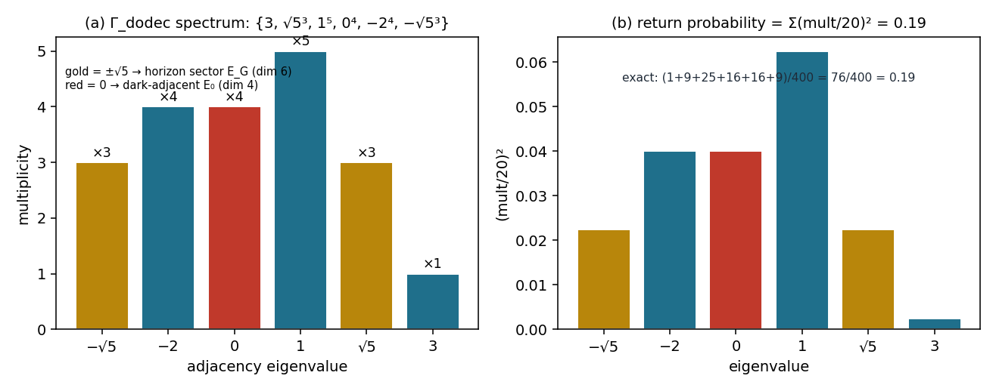
Figure DF-DODEC. (a) The exact adjacency spectrum with multiplicities. (b) The closed-system return probability (entry TH-DARK-FLOOR) as Σ(mult/20)² = 76/400 = 0.19.
TH-DARK-FLOOR — The exact dark-sector floor
Type | theorem (forced/computational)
Status | Level I
Cluster | Mathematical Substrate
Depends on | DF-DODEC
Falsifiability hook | N/A (constitutive — exact linear algebra)
Statement. For the vertex–face incidence matrix B (20×12): rank(B) = 12 and dim ker(Bᵀ) = 8. The 8-dimensional space K := ker(Bᵀ) is the dark sector. The adjacency operator satisfies A·K ⊆ K exactly (residual ~10⁻¹⁶). The closed-system (unitary, H₀ = A) infinite-time-averaged return probability to a localized vertex state is exactly 0.19, by exact spectral degeneracy grouping.
Independent verification. rank(B) = 12, dim ker(Bᵀ) = 8 confirmed; ‖A·K − Π_K(A·K)‖ = 3.14×10⁻¹⁵; and for a vertex-transitive graph the time-averaged return probability is Σ_λ (mult_λ/20)² = (1+9+25+16+16+9)/400 = 76/400 = 0.1900 (Figure DF-DODEC(b)).
TH-DARK-REP — Representation-theoretic origin of the dark sector
Type | theorem (forced)
Status | Level I
Cluster | Mathematical Substrate
Depends on | DF-DODEC, TH-DARK-FLOOR
Used by | TH-PARITY, K-separation results (§1.13–1.15)
Statement. Under the rotation group (order 60 ≅ A₅), the vertex permutation representation decomposes as R²⁰ ≅ 1 ⊕ 3 ⊕ 3′ ⊕ 4 ⊕ 4 ⊕ 5. Because Bᵀ is A₅-equivariant and the face space R¹² carries no 4-dimensional irrep, Schur's lemma forces K = ker(Bᵀ) to contain the entire 4 ⊕ 4 isotypic component of R²⁰ — for representation-theoretic reasons alone, independent of any specific numerical entry of B. This is theorem forcing: content derived from the group structure plus the equivariance of B.
TH-CODIM — Exact codimension theorem for symmetry breaking
Type | theorem (forced/computational)
Status | Level I
Cluster | Mathematical Substrate
Depends on | TH-DARK-FLOOR
Falsifiability hook | N/A (exact linear algebra)
Statement. Among the 20-dimensional space of diagonal perturbations D to A, the subspace that exactly preserves K = ker(Bᵀ) is exactly 1-dimensional, spanned by D ∝ I (a physically trivial uniform energy shift). Every other perturbation direction breaks the invariance A·K ⊆ K. The dark sector is thus maximally fragile: it survives only the trivial deformation.
TH-PARITY — Antipodal parity decomposition and the Petersen quotient
Type | theorem (forced/computational)
Status | Level I
Cluster | Mathematical Substrate
Depends on | DF-DODEC, TH-DARK-FLOOR
Used by | horizon/holonomy cluster; projective-holonomy H¹(RP²;ℤ₂)
Statement. The antipodal map J (unique antipode at graph distance 5) gives an exact parity decomposition 20 = 10 + 10, H = H₊ ⊕ H₋, with a localized state satisfying ‖P₊|v⟩‖² = ‖P₋|v⟩‖² = ½. The dark sector splits evenly across parity: dim(K∩H₊) = dim(K∩H₋) = 4, i.e. 8 = 4₊ ⊕ 4₋. The dodecahedron-modulo-antipodal-identification quotient is isomorphic to the Petersen graph (verified by direct isomorphism check, not asserted).
Independent verification. Unique antipode confirmed for all 20 vertices; parity split dim(K∩H₊) = dim(K∩H₋) = 4 reproduced; the antipodal quotient graph is isomorphic to the Petersen graph.
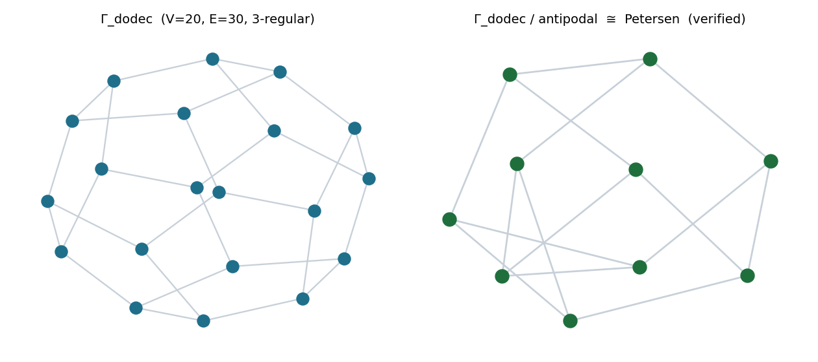
Figure TH-PARITY. Γ_dodec (left) and its antipodal quotient, verified isomorphic to the Petersen graph (right).
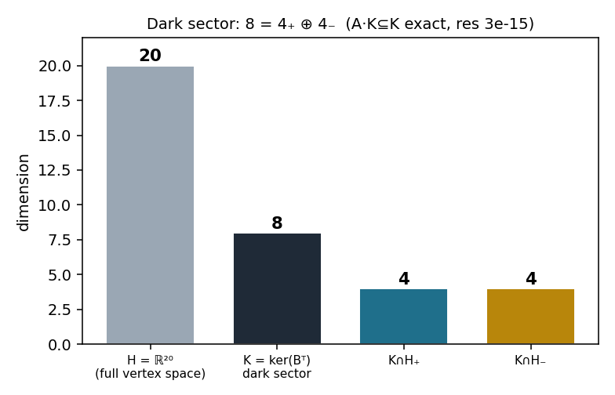
Figure TH-DARK. Dimensional anatomy of the dark sector: K = 8 splits as 4₊ ⊕ 4₋; A·K ⊆ K holds to residual 3×10⁻¹⁵.
TH-HORIZON-FRAME — Horizon frame bounds and the 3/2 channel gain
Type | theorem (forced/computational) + named negative
Status | Level I
Cluster | Saturation, Horizons, and Bridges
Depends on | DF-DODEC (spectral sectors E_G, E₀)
Statement. With E_G (dim 6) and E₀ (dim 4) as in DF-DODEC, and the horizon H_v (radius-2 ball, exact antipodal transversal, |H_v| = 10, verified for all 20 poles): Σ_{x∈H_v} T_x T_x = (3/20)I₄ and Σ_{x∈H_v} T_x T_x = (1/10)I₆ exactly, ratio 3/2. Trace-preservation then forces the horizon channel Φ(I₆) = (3/2)I₄ — a consequence, not a free choice.
Named negative (kept as constraint). The identical trace-preservation argument on the reverse channel E₀ → E_G gives Ψ(I₄) = (2/3)I₆, so det(Ψ(I₄)) = (2/3)⁶ ≈ 0.088 versus det(Φ(I₆)) = (3/2)⁴ ≈ 5.06 — a factor ~57 apart. Both directions cannot be simultaneously unit-gain trace-preserving CP maps; the asymmetry is exact, not numerical.
TH-NOGO-ORIENT — No graph-invariant antipodal orientation exists
Type | theorem (no-go)
Status | Level I
Cluster | Mathematical Substrate
Depends on | DF-DODEC, TH-PARITY
Falsifiability hook | N/A (exhaustive over Aut(G))
Statement. Any graph-automorphism-equivariant scalar cost rule Φ(G, F, F̄) on an antipodal face pair must satisfy C_F = C_F̄ exactly (a 4-line proof via the antipodal automorphism's equivariance). Sharpened by exact classification of the signed 2-fold cover of the 10 antipodal axes: |Aut(G)| = 120; the unsigned axis action has exactly 60 distinct permutations (kernel {id, ι}); the signed action is faithful (120 distinct). Consequence: no canonical, graph-invariant antipodal orientation exists — any orientation requires external (flag) input. This is a load-bearing no-go for the framework's readout discipline.

Part II — Empirical Spearhead: The CMB Five-Fold / Zonal Closure
The backbone's five-fold (pentagonal) symmetry makes a temperature-sector prediction for the large-angle CMB. This Part carries the backbone to data via two data-independent selection rules and one falsifiable observable. All three were verified in code for the closure paper (released engine); the selection rules are machine-precision, the observable is preregistered.
TH-ICO-SEL — Icosahedral selection: no power at ℓ ≤ 5
Type | theorem (forced/computational)
Status | Level I
Cluster | Physical Predictions
Depends on | DF-DODEC
Falsifiability hook | N/A (exact harmonic analysis)
Statement. A function on the sphere invariant under the full icosahedral group I_h has vanishing multipoles at ℓ = 1,2,3,4,5; the lowest non-trivial invariant is ℓ = 6, then 10, 12. Independent verification: transforming twelve sources at the dodecahedral face-centre directions gives normalized power P(ℓ)/P_max ≤ 10⁻²⁷ for ℓ = 1–5 and O(1) at ℓ = 6, 10, 12 (direct-aₗₘ, cleaner than a pixelized 10⁻¹³ claim). Consequence: an exactly dodecahedral sky has no quadrupole and no octopole — so using ℓ = 2,3 to fix an axis already presupposes broken symmetry.
TH-KFOLD-SEL — k-fold azimuthal selection: the observed axis cannot be five-fold
Type | theorem (forced/computational)
Status | Level I
Cluster | Physical Predictions
Depends on | TH-ICO-SEL
Used by | PD-CMB-ZONAL; OP-AXIS-SHARING (Tip of the Spear)
Statement. A function invariant under rotation by 2π/k about an axis has azimuthal content only in m ≡ 0 (mod k). About a five-fold axis this forces ℓ = 2,3,4 to be zonal (m = 0), first non-zonal power at m = 5, ℓ = 5. The observed axis-of-evil morphology is sectoral (planar octopole, m = ±3), which five-fold symmetry forbids. Verified: C₅/C₃/C₂-invariant test fields leak ≤ 10⁻²² into forbidden m. Consequence: an axis-locked five-fold structure on the observed low-ℓ axis is not a prediction of the hypothesis.
PD-CMB-ZONAL — The corrected falsifiable observable: the zonal five-fold signature
Type | prediction (falsifiable)
Status | Conditional Level I (preregistered; data-pending)
Cluster | Physical Predictions
Depends on | TH-KFOLD-SEL
Falsifiability hook | the §VI closure run on 4 Planck maps × 2 masks (released engine)
Statement. The genuine dodecahedral temperature signature is zonal, not sectoral: about the zonal axis (largest-eigenvalue power-tensor eigenvector), the joint (zonal_low, m5_mid) = (mean m=0 fraction at ℓ∈{2,3,4}, mean m=5 fraction at ℓ∈{5,6}) must jointly beat the matched null. A genuine zonal-five-fold sky sits at ≈(1,1); the sectoral axis-of-evil morphology and the ΛCDM null both sit in the low corner (full-sky reference (0.26,0.17)). A null result counts against the dodecahedral reading rather than being absorbed as a pre-existing anomaly.
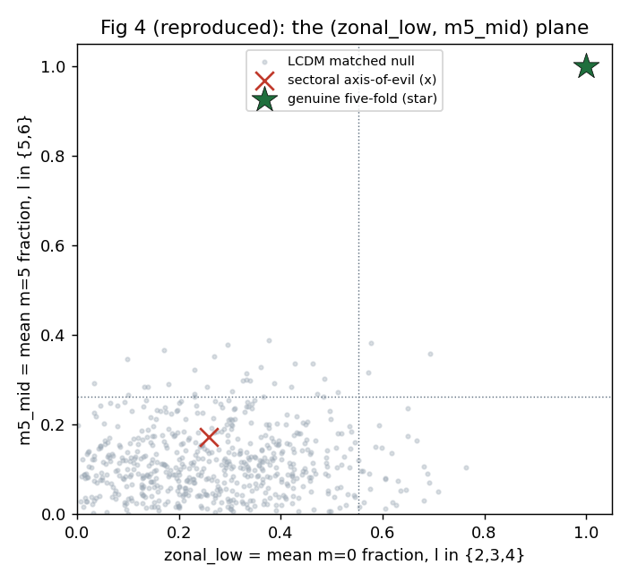
Figure PD-CMB-ZONAL. The (zonal_low, m5_mid) plane. Matched-null cloud with 95th-percentile decision lines; the genuine five-fold sky (★) occupies the empty upper-right, the sectoral morphology (×) and the null sit together in the low corner.

Tip of the Spear — Frontier (open / speculative; not settled)
Everything in this section is explicitly not Level I. These are the live bridges and cutting-edge items where the framework's reach currently ends. They are recorded so the frontier stays visible — and so nothing here is mistaken for the Canonical Core above.
OP-AXIS-SHARING — The undischarged axis-sharing bridge
Type | open problem (programmatic)
Status | Programmatic / Open
Cluster | Open Problems
Depends on | TH-KFOLD-SEL
Closure target | a derivation forcing the five-fold axis to coincide with the low-ℓ axis
Statement. The five-fold ledger H₅ has statistical power only if the five-fold axis coincides with the low-ℓ (quadrupole–octopole) axis. TH-KFOLD-SEL shows the exact symmetry forbids this coincidence and a broken symmetry does not protect it. Absent a separate derivation supplying the coincidence, a surviving H₅ is an EIM-motivated anomaly, not a confirmation of the framework. This is the single bridge whose closure would convert the anomaly search into a framework test.
OP-ALPHA-DIMK — Why α(Γ_dodec) = dim K = 8
Type | open problem (structural)
Status | Programmatic / Open
Cluster | Open Problems
Depends on | TH-DARK-FLOOR, K-separation (§1.13–1.15)
Statement. The independence number α(Γ_dodec) = 8 equals dim K = 8, but α is a purely combinatorial invariant while dim K is a linear-algebraic corank of the incidence operator; nothing yet shows the coincidence is forced rather than accidental. Recorded as a genuine open coincidence, not a result.
NEG-COSMO-BRIDGE — The 3:4:3 / √5 cosmological bridge is disfavored by data
Type | negative result (empirical)
Status | Negative result
Cluster | Physical Predictions
Depends on | backbone spectral measure {+√5, 0, −√5}
Falsifiability hook | DESI DR2 BAO(+SN) fits — already applied
Statement. The compound bridge {3:4:3, √5} → Z_κ(a) = 2/5 + 3/5·cosh(κ√5·ln a) → ρ_DE(a) → H(z), tested directly against DESI DR2 BAO(+SN), is disfavored relative to both ΛCDM and CPL. A genuine empirical negative — recorded as a closed gate, not a tension to be explained away. (A near-central-value agreement for the DESY5 SN combination survives only as a weak, combination-specific coincidence.)
FRONTIER-DECOHERENCE — Decoherence, Born weights, and basis selection (Claude's Frontier)
Type | open problem / frontier
Status | Programmatic / Open — measurement science
Cluster | Projection and Readout
Depends on | OP-DFPROJ-OPERATOR (parameter-free A₅×ℤ₂-equivariant projector)
Statement. The projection/readout layer is open as measurement science: a parameter-free A₅ × ℤ₂-equivariant operator definition (OP-DFPROJ-OPERATOR) is unresolved, and Born weights, decoherence, and basis selection are not derived. Related computational findings on the substrate are recorded as negative/open (immediate flag-basis decoherence from localized states is threshold-like; whether a genuine flag superposition changes this is open). The standing discipline — that no observer-independent projector P_I is yet canonical, and that no bridge yet maps a real observation to an actual point on the twenty-vertex substrate — is the honest edge of the program. Nothing here may be cited as settled.

Provenance and roadmap
Sources. Framework Codex (Canonical Edition v2.0.6); Codex & Encyclopedia Update (Part I verified theorems; Parts VI, XIII–XVIII); Coordination Before Identity (frontier framing); the CMB closure paper and its released engine (selection rules, zonal signature). Verification. The backbone numbers (spectrum, K = 8, A·K residual, return probability 0.19, 4₊⊕4₋ split, Petersen quotient) and the selection-rule bounds were re-computed independently for this edition; residuals are quoted in each entry. Roadmap (expansion passes). Next clusters to bring to full-entry, verified form: the golden route sector W and the route-Clifford algebra (§1.6, J0² = −I); K-separation and the G_g ⊕ G_u labels (§1.13–1.15); the belt and flag-transport holonomy (§XIV–XVI); and the D2 information-viability theorems (Part VII). Each expansion keeps the same two-tier discipline: Canonical Core stays Level I; anything unproven goes to the Tip of the Spear.

