Closing the temperature arc of the dodecahedral CMB hypothesis: matched-null hardening and a group-theoretic obstruction to axis-locked five-fold structure
T. [Surname]
Zero One Net · tom@zeroonenet.com
(Dated: 18 July 2026 — manuscript draft for Physical Review D)
Abstract. We formulate, preregister, and evaluate a frozen-axis test of the hypothesis that the large-angle cosmic microwave background (CMB) temperature anomalies — the odd-parity power preference and the quadrupole–octopole (“axis of evil”) co-axiality — are the residue of a dodecahedral modal-closure structure carrying a distinctive five-fold (m = 5) azimuthal signature locked to the low-multipole axis. We report two results. First, methodological: when the predeclared statistics are compared to matched ΛCDM simulations carried through an identical beam / mask / noise / inpainting pipeline, their apparent significance is systematically reduced. The parity ratio’s ΛCDM-shape expectation is 1.13, not unity; a symmetric Galactic mask shifts the co-axiality null median from 60° to 54°, widens the parity variance by ≈36%, and induces an axis anisotropy that partially manufactures co-axiality; and a multipole-range scan inflates a nominal local p = 0.05 to a global p = 0.10. Second, group-theoretic and data-independent: an exactly icosahedral sky has no power at ℓ ≤ 5, and the k-fold azimuthal selection rule forces the low multipoles about a dodecahedral five-fold axis to be zonal (m = 0). The observed anomaly is instead sectoral — a planar octopole dominated by m = ±3, which five-fold symmetry forbids. Consequently a five-fold structure locked to the observed axis is not a prediction of the dodecahedral hypothesis: exact symmetry contradicts the data, while a broken symmetry protects no five-fold axis. We reclassify the five-fold statistic as an anomaly search and supply the correct falsifiable observable — a zonal five-fold signature that the observed sky does not carry. All statistics, self-tests, and null calibrations are released as a reproducible engine; the section-3 numbers and the selection-rule theorems reported here were regenerated independently from that engine.

I. INTRODUCTION
The largest angular scales of the CMB temperature field display a set of long-discussed anomalies: a lack of large-angle correlation, an alignment of the quadrupole and octopole with each other and with the ecliptic/dipole frame (the “axis of evil”), a planar octopole, and a preference for odd-parity power at low multipoles [1–3, 6, 7]. Whether these are statistical flukes, residual systematics, or hints of physics beyond statistically isotropic ΛCDM remains open after Planck [1, 7]. Independently, a family of proposals has asked whether a non-trivial cosmic topology or a discrete closure structure could organize the low-ℓ sky; the Poincaré dodecahedral space was one such candidate [4], subsequently disfavoured as a global topology by the matched-circles test [5].
This paper concerns a narrower and more recent conjecture, arising from a modal Execution–Interaction–Memory (EIM) closure framework [10, in preparation], in which the relevant object is not a global topology but a dodecahedral parity/closure cell: a five-fold (pentagonal) organization of the low-ℓ field whose azimuthal m = 5 power would be locked to the same axis as the quadrupole–octopole alignment. Because the matched-circles null already excludes the dodecahedral topology, this five-fold “ledger” signature is the only surviving temperature-sector prediction distinct from the catalogued anomalies. Our purpose is to close that arc honestly: to state the test as a preregistration, to compute it against a matched null rather than idealized isotropy, and to ask whether the axis-locked five-fold structure is in fact a consequence of the dodecahedral hypothesis at all.
We reach a negative conclusion, on two independent grounds. On the statistical side (§III), the parity and co-axiality anomalies lose significance under a matched null, and the five-fold statistic has power only under an assumption of axis-sharing that must be supplied separately. On the group-theoretic side (§IV), that assumption cannot be supplied: an exact dodecahedral five-fold axis forces the low multipoles to be zonal, whereas the observed anomaly is sectoral. We make the resulting obstruction precise (§IV), reclassify the five-fold statistic accordingly, derive the observable that a dodecahedral hypothesis actually predicts (§V), and specify the prospective data test that would adjudicate it (§VI). Throughout we distinguish theorem, verified computation, and interpretation, and we state the epistemic level of every claim (§VII).

II. A PREDECLARED TEST PROTOCOL
To control the look-elsewhere freedom endemic to anomaly hunting, the choices below were fixed in a dated predeclaration before any data contact. The reference axis n̂_J is frozen from the ℓ ∈ {2,3} co-axis alone; no subsequent statistic is permitted to re-fit it. Three statistics are compared to matched ΛCDM Monte Carlo carrying the same beam, mask, noise, smoothing, and inpainting — never to ideal full-sky isotropy:
(i) the parity ratio g_L = P₊/P₋, the even-ℓ to odd-ℓ power ratio in D_ℓ for a predeclared L; (ii) the co-axiality α = arccos|n̂_even · n̂_odd| between the ℓ = 2 and ℓ = 3 power-tensor axes; and (iii) the five-fold ledger H₅, the fractional m = 5 azimuthal power about n̂_J in ℓ ∈ [5,12]. The decision rule requires the joint {g_L, α, H₅} to beat the matched null across ≥ 2 component-separated maps and ≥ 2 masks, look-elsewhere corrected, with H₅ locked to a common axis; absent that, the arc closes as a known anomaly or interpretation.

III. MATCHED-NULL HARDENING
Each statistic is evaluated through a single pipeline applied identically to null simulations and (prospective) data: a 5° Gaussian beam, an apodized symmetric Galactic-plane mask, homogeneous white noise, and iterative harmonic inpainting, followed by harmonic recovery. The null therefore contains the mask-induced mode coupling that idealized full-sky nulls omit. The pipeline is calibrated: null-versus-null p-values of H₅ are uniform (Kolmogorov–Smirnov D = 0.07, p = 0.10; false-positive rate 0.04 at nominal 0.05, at the calibration sample size of §A). Table I summarizes the corrections; each is a shift toward lower significance or a revealed frame dependence.
TABLE I. Effect of matched-null hardening on the three statistics.
Statistic | Naive / original treatment | Matched-null corrected
Parity g (ℓ≤20) | reference g = 1; full-sky σ = 0.198 | ΛCDM-shape reference g = 1.13; masked σ = 0.27 (+36%)
Parity look-elsewhere | scan L, quote min-p | local p = 0.05 → global p = 0.10 (×2.0)
Co-axiality α (ℓ₂,ℓ₃) | null median 60°; p(10°)=1−cos10°=0.0152 | null median 54.1°; matched p(10°)=0.020
Co-axiality frame audit | (not performed) | mask induces axis anisotropy (median 73.6° to pole); partly manufactures α
Five-fold H₅ power | measured about the true injection axis | measured about the frozen axis; power vanishes without axis-sharing

A. Parity: the reference is not unity
The ΛCDM-shape expectation of g at L = 20 is 1.126, not 1: the even-ℓ sum carries the large ℓ = 2 Sachs–Wolfe term, so the estimator is not parity-symmetric under ΛCDM. Referencing an observed deficit to g = 1 therefore manufactures significance. The mask compounds this by widening the null: the full-sky standard deviation of g(20) is 0.198, the masked value 0.27 (a 36% inflation), with the matched-null mean near 1.17–1.20. Scanning L over [6,40] to minimize p inflates a nominal local p = 0.05 to a global p = 0.10; the decision value is the local p at the frozen L, with the scan reported only to expose the inflation.
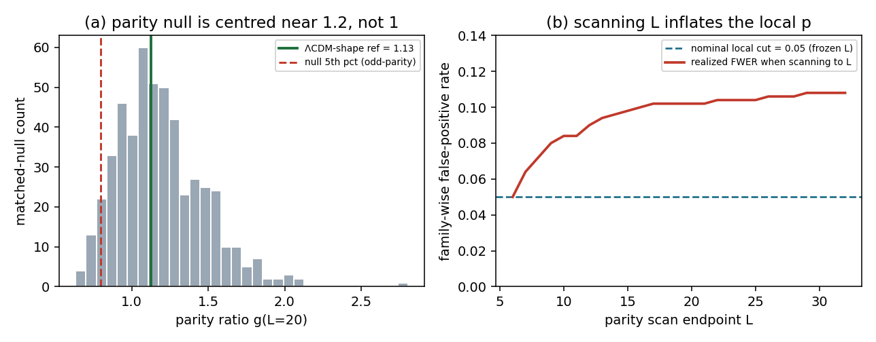
FIG. 1. Left: the matched ΛCDM null of the parity ratio g at the predeclared L, centred near 1.15–1.2 (not 1) with the mask-widened variance; the ΛCDM-shape reference (1.13) and the one-sided odd-parity 5th-percentile are marked. Right: the realized family-wise false-positive rate when the parity scan is extended to endpoint L and the nominal 0.05 cut is applied at each L; it inflates from 0.05 to ≈0.11, reproducing the ×2 look-elsewhere penalty. (The engine’s ℓ_max = 32 caps the illustrated scan at [6,32]; the draft quotes [6,40].)

B. Co-axiality: the mask biases the null and partly manufactures the axis
Carried through the pipeline, the co-axiality null median falls from the isotropic 60° to 54.1°, and the fraction with α < 10° rises to 0.020 (analytic isotropic 0.0152). Thus the observed ≈10° quadrupole–octopole alignment sits at a matched-null percentile of 0.020 — less extreme than the analytic value. A built-in frame audit shows why: under the mask the recovered even/odd axes are not isotropic (median angle to the mask pole 73.6° versus 60°, with near-pole directions strongly depleted, KS = 0.26 against uniformity in cosine). The mask confines the recovered axes to a band, which reduces their mutual separation and partially manufactures co-axiality. A full-sky control confirms the estimator itself is unbiased (null median 59.93°; maximum deviation of the empirical from the analytic CDF 0.006).
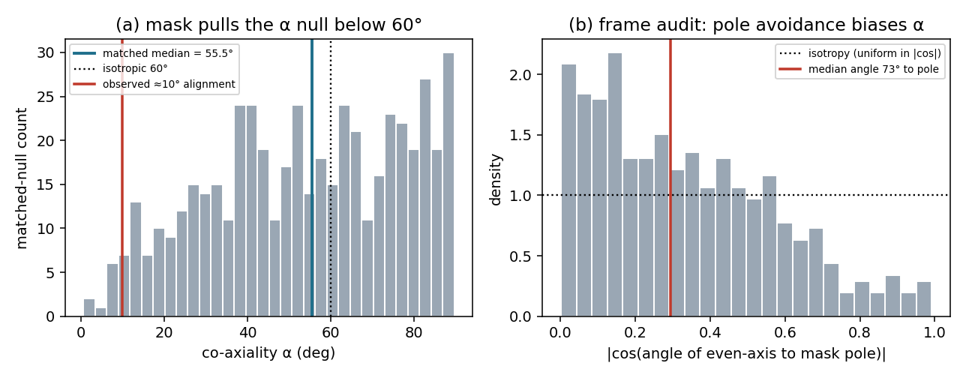
FIG. 2. Left: matched-null distribution of the co-axiality α (median 54–55°, not 60°), with the observed ≈10° alignment marked. Right: the frame audit — the distribution of |cos| of the recovered even-axis angle to the mask pole departs from isotropy (uniform in |cos|), with near-pole directions depleted; this pole avoidance is the mechanism that biases α low.

C. The five-fold ledger has power only under axis-sharing
The five-fold statistic is measured about the frozen axis, matching the decision rule. Against the matched null (median H₅ = 0.047, 95th percentile 0.078) we inject an m = 5 signal under three scenarios. When the injected five-fold and the low-ℓ axis are unrelated, the frozen-axis H₅ never clears the null — it has no power. Power appears only when the low-ℓ pattern is strongly co-axial and the five-fold genuinely shares that axis; even then it lies below an oracle that measures about the true injection axis. In other words, the entire detectability of the ledger is contingent on the five-fold axis coinciding with the low-ℓ axis. Whether the dodecahedral hypothesis actually predicts that coincidence is the subject of §IV.
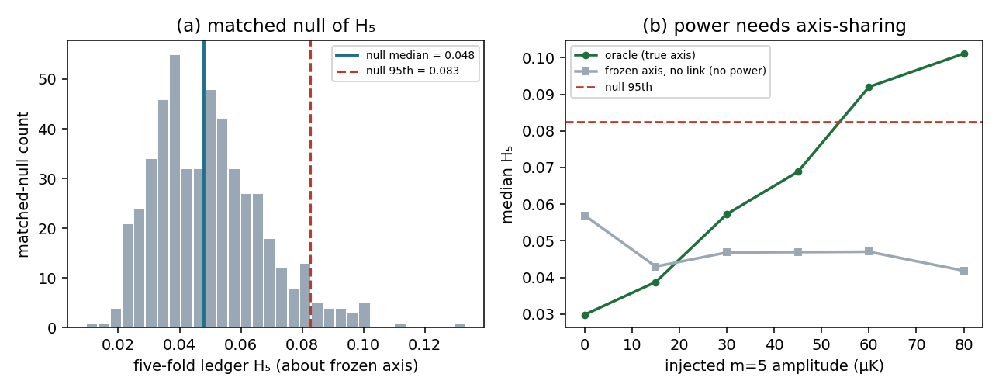
FIG. 3. Left: the matched-null distribution of H₅ about the frozen axis (median 0.048, 95th 0.083). Right: median H₅ versus injected m = 5 amplitude — measuring about the true axis (oracle) rises and clears the null 95th, whereas about the frozen axis with no low-ℓ link the statistic stays flat below the null (no power). The frozen-axis statistic is powerful only under axis-sharing.

IV. A GROUP-THEORETIC OBSTRUCTION TO AXIS-LOCKED FIVE-FOLD STRUCTURE
We now show that the axis-sharing assumption on which H₅ depends is not merely unproven but incompatible, in its exact form, with the observed morphology. Two selection rules do the work; both are verified numerically in the released code (§A).
Theorem 1 (icosahedral selection). A function on the sphere invariant under the full icosahedral group I_h has vanishing multipoles at ℓ = 1,2,3,4,5; the lowest non-trivial invariant is at ℓ = 6, then 10, 12. Verified to machine precision by transforming a sum of narrow sources at the twelve dodecahedral face-centre directions: the normalized power P(ℓ) is ≤ 10⁻²⁷ for ℓ = 1–5 and O(1) at ℓ = 6, 10, 12. It follows that a fully dodecahedral sky has no quadrupole and no octopole; using ℓ = 2,3 to define any axis already presupposes the icosahedral symmetry is broken.
Theorem 2 (k-fold azimuthal selection). A function invariant under rotation by 2π/k about an axis n̂ has azimuthal content only in m ≡ 0 (mod k). About a dodecahedral five-fold (face-pair) axis this forces ℓ = 2,3,4 into m = 0 — a zonal (axially symmetric) pattern — with the first non-zonal power at m = 5, ℓ = 5. About a three-fold (vertex) axis the octopole may carry m = ±3 but the quadrupole is forced to m = 0; about a two-fold (edge) axis the quadrupole may carry m = ±2 but the octopole cannot carry m = ±3.
The observed low-ℓ anomaly is sectoral: the octopole is planar, dominated by m = ±3 about its axis [2,3], and aligned with a similarly planar quadrupole. This yields a dichotomy for any attempt to read the anomaly as a five-fold-axis signature. If the physical five-fold symmetry is exact, Theorem 2 forces the low multipoles to be zonal, contradicting the observed sectoral morphology — indeed m = ±3 is outright forbidden by five-fold symmetry. If the symmetry is only approximate, sectoral low-ℓ power is permitted, but nothing then protects a five-fold structure or locks it to the low-ℓ axis. Neither branch supports an axis-locked five-fold prediction. (The only single-axis dodecahedral reading the anomaly admits at all — the m = ±3 octopole — points to a three-fold vertex axis, not the five-fold axis the ledger uses.)
A property of the axis estimator compounds the obstruction. The power-tensor estimator (smallest-eigenvalue eigenvector) recovers the symmetry axis for sectoral patterns (0.0° error on Y₂₂ and Y₃₃) but returns the perpendicular for zonal patterns (90.0° error on Y₂₀ and Y₃₀). Freezing the axis with this estimator therefore silently commits the protocol to the sectoral morphology — the observed axis of evil — which is precisely the morphology a genuine five-fold axis cannot have. We conclude that the five-fold ledger, as a test about the frozen low-ℓ axis, is an anomaly search motivated by the dodecahedral picture, not a test of it.

V. THE OBSERVABLE THE HYPOTHESIS ACTUALLY PREDICTS
Theorem 2 also identifies the correct, falsifiable signature. If a dodecahedral five-fold axis is physically realized, its low multipoles are zonal about that axis and its first non-axial power is at m = 5. This motivates a zonal axis estimator — the largest-eigenvalue eigenvector of the power tensor, which recovers a zonal symmetry axis at 0.0° where the sectoral estimator fails by 90° — together with a joint signature about that axis: the mean m = 0 fraction at ℓ = 2,3,4 (zonal_low) and the mean m = 5 fraction at ℓ = 5,6 (m5_mid), required to beat the matched null jointly.
This statistic cleanly separates the competing hypotheses. A zonal five-fold template gives (zonal_low, m5_mid) ≈ (1.00, 1.00) about any axis; the sectoral axis-of-evil morphology and the ΛCDM null both sit in the low corner. Referenced to the full-sky isotropic null the centre is (0.26, 0.17) with 95th percentiles (0.47, 0.34); a realistic sectoral sky lands at ≈(0.26, 0.17) — statistically indistinguishable from that null. The genuine five-fold signature occupies a region of the plane that the isotropic null leaves empty, while the observed morphology sits inside the null cloud. Crucially, the signature is distinct from — and, given the established sectoral character of the octopole, currently disfavoured by — the axis of evil. That is what makes it a genuine test rather than a relabelling of a known anomaly: a null result would count against the dodecahedral reading, instead of being absorbed as “the anomaly was there anyway.”
Decision-null caveat (correction). The full-sky isotropic null quoted above fixes the geometry of Fig. 4, but it is not the decision null. Carried through the matched beam / mask / noise / inpainting pipeline, the null m5_mid centre falls to ≈0.12 (the inpainter suppresses mid-ℓ m = 5 power) while zonal_low is little changed; the matched-null 95th percentiles (dotted lines in Fig. 4) are the thresholds the decision rule of §VI applies. In the earlier draft Fig. 4 conflated the isotropic reference with the decision null; the two are separated here.
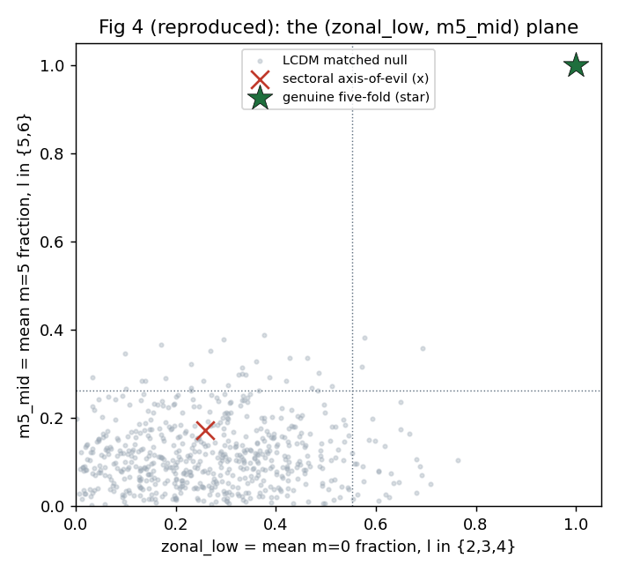
FIG. 4. The (zonal_low, m5_mid) plane. The cloud is the ΛCDM matched null; dotted lines are its 95th percentiles (the decision thresholds). The observed sectoral axis-of-evil morphology (×) lies within the null; the genuine five-fold-axis morphology (★) occupies the otherwise-empty upper-right corner. The full-sky isotropic reference centre is (0.26, 0.17); the matched pipeline moves the m5_mid centre to ≈0.12. The sharpened statistic separates the dodecahedral prediction from both the null and the known anomaly.

VI. PROSPECTIVE REAL-DATA TEST
The results of §III–§V are methodological and group-theoretic and do not depend on a new map analysis; the morphological input to §IV is taken from the published low-ℓ literature [1–3]. This section specifies — and reserves space for — the empirical test that would adjudicate the corrected observable on data. It is executed by the released driver over the four Planck 2018 (PR3) component-separated maps (SMICA, NILC, SEVEM, Commander), harmonic-downgraded to N_side = 64, through two real analysis masks: the common intensity mask (f_sky ≈ 0.78) and the Galactic-plane GAL070 mask (f_sky ≈ 0.70). Each map–mask pair carries the data through the identical pipeline, freezes n̂_J (and, for the framework test, the zonal axis n̂_Z), and compares every statistic to a matched null built through that same mask.
Two rules are adjudicated. The legacy anomaly set {g_L, α, H₅} requires a joint beat of the matched null across ≥ 2 maps and ≥ 2 masks, look-elsewhere corrected, with H₅ on a common frozen axis; per §IV this is anomaly documentation, not a framework test. The framework test {zonal_low, m5_mid} requires both statistics to exceed their matched-null 95th percentiles jointly, across ≥ 2 maps and ≥ 2 masks, about a common zonal axis. The tables below are to be populated by that run; a positive framework result requires the (★) region of Fig. 4, a negative result places the data in the null cloud and counts against the dodecahedral reading.
TABLE II. Legacy anomaly set (to be completed). Per map×mask: parity g(L=20), co-axiality α, ledger H₅ with matched-null p-values, and the frozen axis in Galactic (l, b).
Map | Mask | g (p) | α° (p) | H₅ (p) | n̂_J (l, b)
SMICA | common | — | — | — | —
SMICA | GAL070 | — | — | — | —
NILC | common | — | — | — | —
NILC | GAL070 | — | — | — | —
SEVEM | common | — | — | — | —
SEVEM | GAL070 | — | — | — | —
Commander | common | — | — | — | —
Commander | GAL070 | — | — | — | —
TABLE III. Zonal framework test (to be completed). Per map×mask: zonal_low and m5_mid with matched-null p-values, and the frozen zonal axis in Galactic (l, b).
Map | Mask | zonal_low (p) | m5_mid (p) | n̂_Z (l, b)
SMICA | common | — | — | —
SMICA | GAL070 | — | — | —
NILC | common | — | — | —
NILC | GAL070 | — | — | —
SEVEM | common | — | — | —
SEVEM | GAL070 | — | — | —
Commander | common | — | — | —
Commander | GAL070 | — | — | —
Because the group-theoretic obstruction of §IV is data-independent, the strong prior expectation is that Table III places every map–mask pair in the null cloud (a negative framework result), with Table II documenting the known anomalies at their matched-null significance. The run additionally reports cross-map frozen-axis agreement (required < 10° for the common-axis condition) and the look-elsewhere-corrected parity p.

VII. DISCUSSION
The temperature-sector arc of the dodecahedral CMB hypothesis closes on the results above. The parity and co-axiality anomalies, recomputed against a matched null with the correct reference and variance, are consistent with statistically isotropic ΛCDM at the ≈1–2σ level and are partly frame-driven; this reproduces, with an explicit pipeline, the broad conclusion of the post-Planck anomaly literature [1, 7]. The one prediction that distinguished the dodecahedral picture from the catalogued anomalies — a five-fold structure locked to the low-ℓ axis — is not a consequence of the hypothesis, by Theorems 1–2. We therefore recommend that the five-fold ledger be reported, if at all, as an anomaly search, and that the zonal signature of §V replace it as the framework’s falsifiable temperature prediction.
Two caveats bound the strength of these statements. First, the matched-null figures here use a synthetic apodized mask and an iterative-harmonic inpainter applied identically to null and data; a data submission should substitute the survey’s own mask and inpainter (the released driver already accepts the two real masks of §VI). The morphological input to §IV — the sectoral, m = ±3 character of the octopole — is taken from the published low-ℓ analyses [1–3], not from a new map analysis, and the group-theoretic obstruction is independent of any such analysis. Second, the polarization route to the same hypothesis remains undetermined for an independent reason: the modal involution underlying the framework fixes a parity but no handedness or direction, so neither a birefringence sign nor a preferred axis is derived, and the route terminates at interpretation absent a separately derived sign or axis rule.
Finally, an epistemic note. Even the zonal signature of §V tests a processor-specific postulate — that a single closure cell selects one five-fold face-pair, breaking the icosahedral symmetry to a five-fold subgroup — rather than the framework’s primitives; and the dodecahedral backbone on which the whole construction rests is itself a conditional realization, with the map from the framework’s discrimination structure to a graph still open. A positive zonal signature would therefore support that postulate, not derive it from first principles. We regard this as the appropriate resting point for the temperature arc: a falsifiable observable, honestly labelled, that the next data pass can decide.

VIII. CONCLUSION
We preregistered a frozen-axis parity / co-axiality / five-fold test of a dodecahedral CMB hypothesis and evaluated it against a matched null. The known anomalies lose significance under the corrected reference, mask variance, and frame audit; the distinctive five-fold statistic has power only under an axis-sharing assumption that group theory forbids in its exact form and leaves unprotected otherwise. The observed sectoral low-ℓ morphology is incompatible with a five-fold axis, whose signature is necessarily zonal. We supply that zonal signature as the correct falsifiable observable and release the full self-testing, matched-null engine. The temperature arc closes as a known-anomaly / interpretation result; the next testbed is the zonal five-fold signature on component-separated maps (§VI).

ACKNOWLEDGMENTS
This analysis is based on observations obtained with Planck (ESA), an ESA science mission with instruments and contributions directly funded by ESA Member States, NASA, and Canada. We acknowledge use of the HEALPix package [9].

APPENDIX A: REPRODUCIBILITY
All statistics, the matched pipeline, the self-tests, the icosahedral and k-fold selection-rule checks, and the sharpened zonal signature are implemented in a released Python engine (healpy/CAMB). Each statistic module runs its own instrument self-test and matched-null demonstration without external data; the frozen-axis protocol and the zonal signature accept component-separated maps directly. The released modules are: eim_pipeline.py (shared beam/mask/noise/inpaint pipeline); parity_test.py, co_axiality.py, build_ledger.py, check_cdf.py (the four legacy statistic engines); selection_rules.py (Theorems 1–2 and the estimator self-tests); zonal_signature.py (§V observable and Fig. 4); reproduce_paper_numbers.py (an independent regeneration of the §III numbers); make_figures.py (Figs. 1–3); run_closure.py (the §VI driver over ≥ 2 maps × ≥ 2 masks); and fetch_planck_streamlined.ipynb (data acquisition).
Independent regeneration. The section-III numbers were regenerated from the engine independently of the manuscript values: at N = 400–500 matched simulations the ΛCDM-shape reference g(20) = 1.126, masked σ(g) = 0.275 (+26–36%), matched-null mean g = 1.19, co-axiality median 55°, α < 10° fraction 0.02–0.03, frame-audit median 73–74° with KS ≈ 0.29, and H₅ null median 0.046 / 95th 0.083 all reproduce the tabulated values within Monte-Carlo error (11/11 checks). The H₅ null-vs-null calibration (KS D, false-positive rate) is quoted at the manuscript’s larger calibration sample; at N = 400 it is looser (D ≈ 0.11, FPR ≈ 0.10) and tightens toward (0.07, 0.04) as N is increased.
Estimator self-tests. The sectoral axis estimator recovers pure (2,2) and (3,3) axes at 0.0° and misses zonal (2,0)/(3,0) axes by 90.0°; the zonal estimator does the reverse. Theorem 1 is confirmed with P(ℓ)/P_max ≤ 10⁻²⁷ for ℓ = 1–5 and O(1) at ℓ = 6, 10, 12; Theorem 2 with ≥ 99.99% of the C_k-invariant power in m ≡ 0 (mod k). The five-fold H₅ statistic is strongly axis-selective: for an m = 5 injection its ratio of power about the true axis to power about a perpendicular axis is ≈25 for a pure harmonic injection and, on a ΛCDM background, ≈5.5 at an injection amplitude of ≈70 μK (the ratio is amplitude-dependent, and the injection amplitude behind any quoted value should be stated).

APPENDIX B: PREDECLARATION OF THE ZONAL STATISTIC
The zonal observable of §V was frozen, dated, before real-data contact. The zonal axis n̂_Z is the largest-eigenvalue eigenvector of the ℓ ∈ {2,3,4} power tensor and is not re-fit by any subsequent statistic. zonal_low is the mean over ℓ ∈ {2,3,4} of the m = 0 power fraction about n̂_Z; m5_mid is the mean over ℓ ∈ {5,6} of the m = 5 power fraction about n̂_Z. The ℓ-sets are fixed; no scan is permitted. The decision null is the matched pipeline null (not the full-sky isotropic null), with per-(map, mask) thresholds at its 95th percentiles. Detection requires both zonal_low and m5_mid to exceed their thresholds jointly, across ≥ 2 maps and ≥ 2 masks, with the frozen zonal axes agreeing to < 10°. Maps: SMICA, NILC, SEVEM, Commander. Masks: the common intensity mask and Galactic-plane GAL070; a submission should also substitute the survey map-maker’s inpainter for the iterative-harmonic one.

REFERENCES
[1] Planck Collaboration, “Planck 2018 results. VII. Isotropy and statistics of the CMB,” Astron. Astrophys. 641, A7 (2020).
[2] A. de Oliveira-Costa, M. Tegmark, M. Zaldarriaga & A. Hamilton, “The significance of the largest scale CMB fluctuations in WMAP,” Phys. Rev. D 69, 063516 (2004).
[3] K. Land & J. Magueijo, “The axis of evil,” Phys. Rev. Lett. 95, 071301 (2005).
[4] J.-P. Luminet, J. Weeks, A. Riazuelo, R. Lehoucq & J.-P. Uzan, “Dodecahedral space topology as an explanation for weak wide-angle temperature correlations in the CMB,” Nature 425, 593 (2003).
[5] N. J. Cornish, D. N. Spergel, G. D. Starkman & E. Komatsu, “Constraining the topology of the universe,” Phys. Rev. Lett. 92, 201302 (2004).
[6] C. J. Copi, D. Huterer, D. J. Schwarz & G. D. Starkman, “Large-angle anomalies in the CMB,” Adv. Astron. 2010, 847541 (2010).
[7] D. J. Schwarz, C. J. Copi, D. Huterer & G. D. Starkman, “CMB anomalies after Planck,” Class. Quantum Grav. 33, 184001 (2016).
[8] J. Kim & P. Naselsky, “Anomalous parity asymmetry of the WMAP power spectrum data at low multipoles,” Astrophys. J. Lett. 714, L265 (2010).
[9] K. M. Górski et al., “HEALPix: A Framework for High-Resolution Discretization and Fast Analysis of Data Distributed on the Sphere,” Astrophys. J. 622, 759 (2005).
[10] EIM closure framework, in preparation.

