PLACEMENT PORTAL

GROUP #17

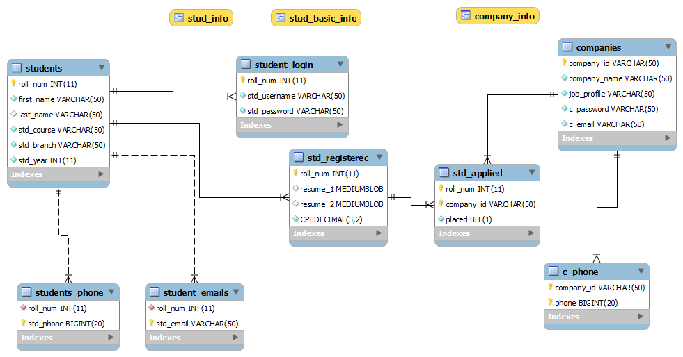

This Doc includes

1. Database creation queries

2. Queries used in PHP files

3. ER Diagram

4. Some Screenshots

DROP DATABASE placement_portal;

CREATE DATABASE placement_portal;

USE placement_portal;

CREATE TABLE students(

roll_num INT NOT NULL PRIMARY KEY,

first_name VARCHAR(50) NOT NULL,

last_name VARCHAR(50),

std_course VARCHAR(50) NOT NULL,

std_branch VARCHAR(50) NOT NULL,

std_year INT NOT NULL );

INSERT INTO students VALUES (11012322,'Naveen','Chaudhary','Btech','Mathematics',2015);

INSERT INTO students VALUES (11012327,'Prashant','Sankhla','Btech','Civil',2015);

INSERT INTO students VALUES (11012342,'Ravindra','Gahlot','Btech','Biotechnology',2015);

INSERT INTO students VALUES (11012319,'Lokesh','Meena','Btech','CSE',2015);

INSERT INTO students VALUES (11012312,'Parik','Gupta','Btech','Design',2015);

CREATE TABLE std_registered (

roll_num INT NOT NULL PRIMARY KEY ,

FOREIGN KEY (roll_num) REFERENCES students(roll_num) ON DELETE CASCADE ON UPDATE CASCADE,

resume_1 MEDIUMBLOB,

resume_2 MEDIUMBLOB,

CPI decimal(3,2) NOT NULL,

CHECK (CPI >= 5.00));

INSERT INTO std_registered(roll_num,CPI) VALUES (11012322,6.52);

INSERT INTO std_registered(roll_num,CPI) VALUES (11012327,9.72);

INSERT INTO std_registered(roll_num,CPI) VALUES (11012319,5.99);

INSERT INTO std_registered(roll_num,CPI) VALUES (11012312,8.26);

CREATE TABLE student_login (

roll_num INT NOT NULL PRIMARY KEY ,

FOREIGN KEY (roll_num) REFERENCES students (roll_num) ON DELETE CASCADE ON UPDATE CASCADE,

std_username VARCHAR(50) NOT NULL ,

std_password VARCHAR(50) NOT NULL);

INSERT INTO student_login VALUES (11012322,'n.chaudhary','123');

INSERT INTO student_login VALUES (11012327,'p.sankhla','123');

INSERT INTO student_login VALUES (11012342,'r.gahlot','123');

INSERT INTO student_login VALUES (11012319,'l.meena','123');

INSERT INTO student_login VALUES (11012312,'g.parik','123');

CREATE TABLE student_emails (

roll_num INT NOT NULL ,

std_email VARCHAR(50) NOT NULL ,

PRIMARY KEY (std_email),

FOREIGN KEY (roll_num ) REFERENCES students(roll_num) ON DELETE CASCADE ON UPDATE CASCADE);

INSERT INTO student_emails VALUES (11012322,'n.chaudhary@iitg.ernet.in');

INSERT INTO student_emails VALUES (11012327,'p.sankhla@iitg.ernet.in');

INSERT INTO student_emails VALUES (11012342,'r.gahlot@iitg.ernet.in');

INSERT INTO student_emails VALUES (11012319,'l.meena@iitg.ernet.in ' );

INSERT INTO student_emails VALUES (11012312,'g.parik@iitg.ernet.in');

CREATE TABLE students_phone(

roll_num INT NOT NULL,

std_phone BIGINT NOT NULL,

PRIMARY KEY (std_phone),

FOREIGN KEY (roll_num ) REFERENCES students(roll_num) ON DELETE CASCADE ON UPDATE CASCADE);

INSERT INTO students_phone VALUES (11012322,97067227);

INSERT INTO students_phone VALUES (11012322,97067364);

INSERT INTO students_phone VALUES (11012327,98014562);

INSERT INTO students_phone VALUES (11012342,97064521);

INSERT INTO students_phone VALUES (11012319,80114961);

INSERT INTO students_phone VALUES (11012312,80116982);

CREATE TABLE companies (

company_id VARCHAR(50) NOT NULL PRIMARY KEY,

company_name VARCHAR(50) NOT NULL,

job_profile VARCHAR(50) NOT NULL,

c_password VARCHAR(50) NOT NULL,

c_email VARCHAR(50) NOT NULL );

INSERT INTO companies VALUES ('goo_dev','google','developer','234','goo@hotmail.com');

INSERT INTO companies VALUES ('goo_mar','google','marketing','234','goo@hotmail.com');

INSERT INTO companies VALUES ('fb_dev','facebook','developer','234','fb@hotmail.com');

INSERT INTO companies VALUES ('ms_dev','microsoft','developer','234','ms@hotmail.com');

CREATE TABLE std_applied(

roll_num INT,

company_id VARCHAR(50),

placed BIT NOT NULL,

PRIMARY KEY (company_id,roll_num),

FOREIGN KEY (company_id ) REFERENCES companies(company_id ) ON DELETE CASCADE ON UPDATE CASCADE,

FOREIGN KEY (roll_num) REFERENCES std_registered(roll_num) ON DELETE CASCADE ON UPDATE CASCADE);

INSERT INTO std_applied VALUES (11012312,'goo_dev',0);

INSERT INTO std_applied VALUES (11012312,'goo_mar',0);

INSERT INTO std_applied VALUES (11012319,'goo_mar',0);

INSERT INTO std_applied VALUES (11012319,'ms_dev',1);

INSERT INTO std_applied VALUES (11012322,'fb_dev',0);

INSERT INTO std_applied VALUES (11012327,'goo_dev',0);

INSERT INTO std_applied VALUES (11012327,'ms_dev',0);

CREATE TABLE c_phone(

company_id VARCHAR(50),

phone BIGINT NOT NULL,

PRIMARY KEY (company_id,phone),

FOREIGN KEY (company_id ) REFERENCES companies(company_id ) ON DELETE CASCADE ON UPDATE CASCADE);

INSERT INTO c_phone VALUES ('goo_dev',99576869);

INSERT INTO c_phone VALUES ('goo_mar',99576869);

INSERT INTO c_phone VALUES ('goo_mar',99574536);

INSERT INTO c_phone VALUES ('fb_dev',90856869);

INSERT INTO c_phone VALUES ('ms_dev',96549436);

INSERT INTO c_phone VALUES ('ms_dev',98653265);

CREATE VIEW stud_info AS SELECT students.roll_num, students.first_name, students.last_name, students.std_course, students.std_branch, students.std_year, student_login.std_username, student_login.std_password,std_registered.resume_1,std_registered.resume_2

FROM students INNER JOIN student_login ON students.roll_num=student_login.roll_num INNER JOIN std_registered ON students.roll_num=std_registered.roll_num;

CREATE VIEW company_info AS SELECT companies.company_id, companies.company_name, companies.job_profile, companies.c_password, companies.c_email

FROM companies ;

CREATE VIEW stud_basic_info AS SELECT std_registered.roll_num, students.first_name, students.last_name ,student_login.std_username

FROM std_registered INNER JOIN students ON std_registered.roll_num=students.roll_num INNER JOIN student_login ON std_registered.roll_num=student_login.roll_num;

DROP USER 'student_manager'@'localhost';

CREATE USER 'student_manager'@'localhost' IDENTIFIED BY 'pass1';

GRANT SELECT, INSERT,DELETE,UPDATE ON placement_portal.stud_info TO student_manager@localhost IDENTIFIED BY 'pass1';

DROP USER 'company_manager'@'localhost';

CREATE USER 'company_manager'@'localhost' IDENTIFIED BY 'pass2';

GRANT SELECT, INSERT,DELETE,UPDATE ON placement_portal.company_info TO company_manager@localhost IDENTIFIED BY 'pass2';

***Functional Dependencies and Normal Forms:***

roll_num : RN company_id : CID

first_name : FN company_name : CN

last_name : LN c_password : CP

std_username : SU c_email : CE

std_password : SP phone : CPH

std_phone : SPH job_profile : JP std_course : SC

std_branch : SB placed : PD

std_email : SE

std_year : SY

resume_1 : R1

resume_2 : R2

CPI : C

1. Students Table :

RN ---> RN FN LN SC SY SB

Since there is a PRIMARY KEY, no partial or transitive dependencies and no overlapping candidate keys

Therefore it is in BCNF

2. Registered Students Table :

RN ---> RN R1 R2 C

Since there is a PRIMARY KEY, no partial or transitive dependencies and no overlapping candidate keys

Therefore it is in BCNF

3. Students Application Table :

RN CID ---> RN CID PD

Since there is a PRIMARY KEY, no partial or transitive dependencies and no overlapping candidate keys

Therefore it is in BCNF

4. Companies Table :

CID ---> CID CN CP CE JP

Since there is a PRIMARY KEY, no partial or transitive dependencies and no overlapping candidate keys

Therefore it is in BCNF

5. Company Phone Table :

CPH CID--->CPH CID

Since there is a PRIMARY KEY, no partial or transitive dependencies and no overlapping candidate keys

Therefore it is in BCNF

6. Student Login Table

RN ---> RN SU SP

SU ---> RN SU SP

Since there is a primary key, therefore It is in 1NF

Since there are no partial dependencies, therefore it is in 2NF

But since there is a transitive dependency (RN--->SU , SU--->SP) , therefore it is not in 3NF

7. Student Phone Table

SPH ---> SPH RN

Since there is a PRIMARY KEY, no partial or transitive dependencies and no overlapping candidate keys

Therefore it is in BCNF

7. Student Email Table

SE ---> SE RN

Since there is a PRIMARY KEY, no partial or transitive dependencies and no overlapping candidate keys

Therefore it is in BCNF

Queries that we used for fetching and updating the database :

We first created views using inner join then we used these views in the queries.

§ CREATE VIEW **stud_info** AS SELECT students.roll_num, students.first_name, students.last_name, students.std_course, students.std_branch, students.std_year, student_login.std_username, student_login.std_password,std_registered.resume_1,std_registered.resume_2

FROM students INNER JOIN student_login ON students.roll_num=student_login.roll_num INNER JOIN std_registered ON students.roll_num=std_registered.roll_num;

§ CREATE VIEW **company_info** AS SELECT companies.company_id, companies.company_name, companies.job_profile, companies.c_password, companies.c_email FROM companies ;

§ CREATE VIEW **stud_basic_info** AS SELECT std_registered.roll_num, students.first_name, students.last_name ,student_login.std_username

FROM std_registered INNER JOIN students ON std_registered.roll_num=students.roll_num INNER JOIN student_login ON std_registered.roll_num=student_login.roll_num;

1. Companies.php

$sql = "select * from companies ";

To print the list companies with their profiles

2. Company_insert.php

$sql = "insert into companies(company_id,company_name,job_profile,c_password,c_email) values('".$CompanyID."','".$CompanyName."','".$JobProfile."','".$Password."','".$Email."')";

$sql2 = "insert into c_phone(company_id,phone) values('".$CompanyID."','".$Mobile."')";

To insert the data of the new registering company into companies and c_phone respectively

3. Login.php

$sql = "select * from company_info where company_id='".$UserName."' and c_password='".$Password."'";

$sql = "select * from stud_info where std_username='".$UserName."' and std_password='".$Password."'";

For login of companies and students respectively

4. New_reg_stud_Insert.php

$sql = "SELECT * from student_login where std_username='$UserName'";

$sql = "insert into std_registered(roll_num,resume_1,resume_2,CPI) values('".$RollNum."','".$path1."','".$path2."','".$Cpi."')";

To insert the data of the new registering student

5. Company -> Profile.php

$sql = "select * from company_info where company_id ='".$ID."' ";

$sql = "select * from c_phone where company_id ='".$ID."' ";

To display company profile

6. Company -> EditProfile.php

$sql = "select * from company_info where company_id ='".$ID."' ";

$sql = "select * from c_phone where company_id ='".$ID."' ";

$sql = "select * from company_info where company_id ='".$ID."' ";

For editing company info

7. Company ->UpdateProfile.php

$sql = "Update companies set c_email='".$txtEmail."',job_profile='".$txtArea."',c_password='".$txtPassword."'

Where company_id='".$txtId."'";

To update the company profile

8. Student -> Profile.php

$sql = "select * from stud_info where roll_num='".$ID."' ";

$sql = "select * from students_phone where roll_num ='".$ID."' ";

$sql = "select * from student_emails where roll_num ='".$ID."' ";

To display the student profile

9. Student ->EditProfile.php

$sql = "select * from students where roll_num ='".$ID."' ";

$sql = "select * from students_phone where roll_num ='".$ID."' ";

$sql = "select * from student_emails where roll_num ='".$ID."' ";

$sql = "select * from std_registered where roll_num ='".$ID."' ";

$sql = "select * from student_login where roll_num ='".$ID."' ";

To edit student info

10. Student -> register_ajax.php

$sql="select roll_num from stud_basic_info where std_username='$add[1]'";

$sql="insert into std_applied (roll_num,company_id) values('$roll','$add[0]') ";

To register a student for a company

11. Student -> Show_detail.php

$sql="select roll_num from stud_basic_info where std_username='$add[1]'";

$sql=" select company_id from std_applied where roll_num=$roll and company_id='$add[0]'";

12. Student -> Unregister_ajax.php

$sql=" select roll_num from stud_basic_info where std_username='$add[1]'";

$sql="delete from std_applied where roll_num=$roll and company_id='$add[0]' " ;

To unregister a student from a company

***Some Screen Shots :***

