1. Install Node.js on your system. Recommended version 8.11.3.
2. Install Node Package Manager npm. Recommended version 5.6.0.
3. Install Ganache client by following the command **npm install -g ganache-cli** on command prompt.
4. Start you ganache by running the command **ganache-cli** on command prompt. This will initiate your ganache and will generate public and private keys and runs the blockchain.

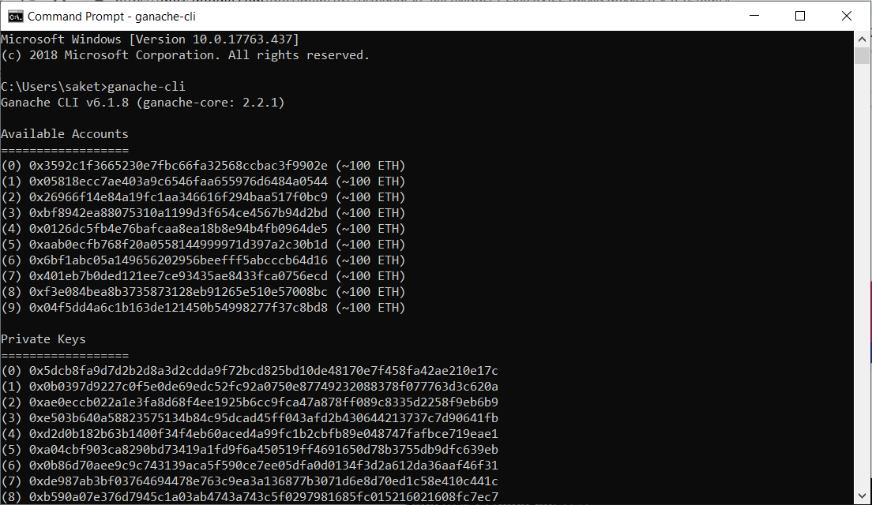

1. Create a directory for the project.
   1. Cd Project
   2. Mkdir CS764Project
   3. Cd CS764Project

The following steps take you to the project folder.

1. Initiate the node package manager in the project directory path by running the following command in command prompt. Follow the prompts and give the command “yes” once all the information is correct.

***“npm init”***

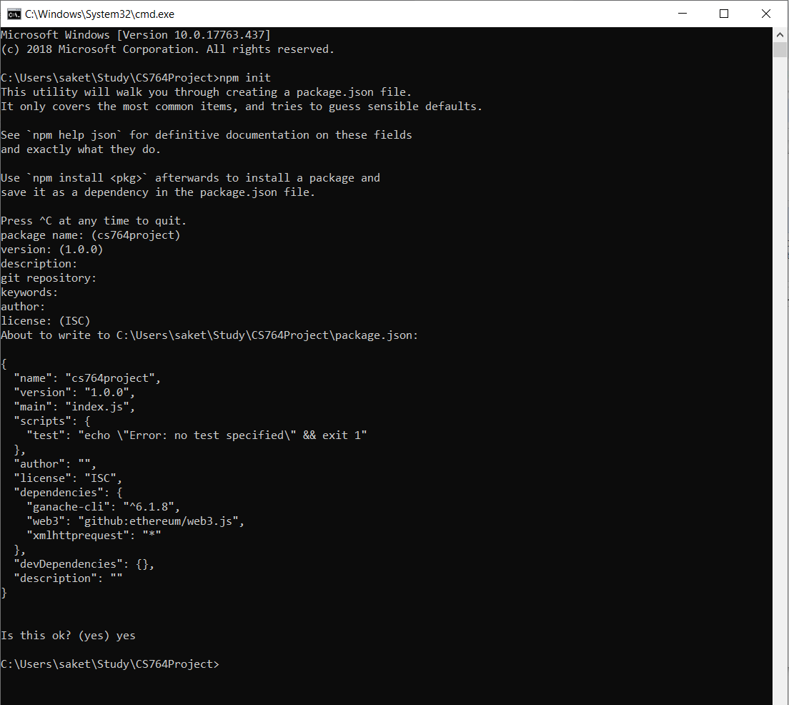

1. Open [https://remix.ethereum.org](https://remix.ethereum.org/) to write your smart contract based on the requirement. Set the compiler to 0.4.24 version and then compile. Once there are no errors you can deploy your contract under the run tab on the right top corner of the browser.

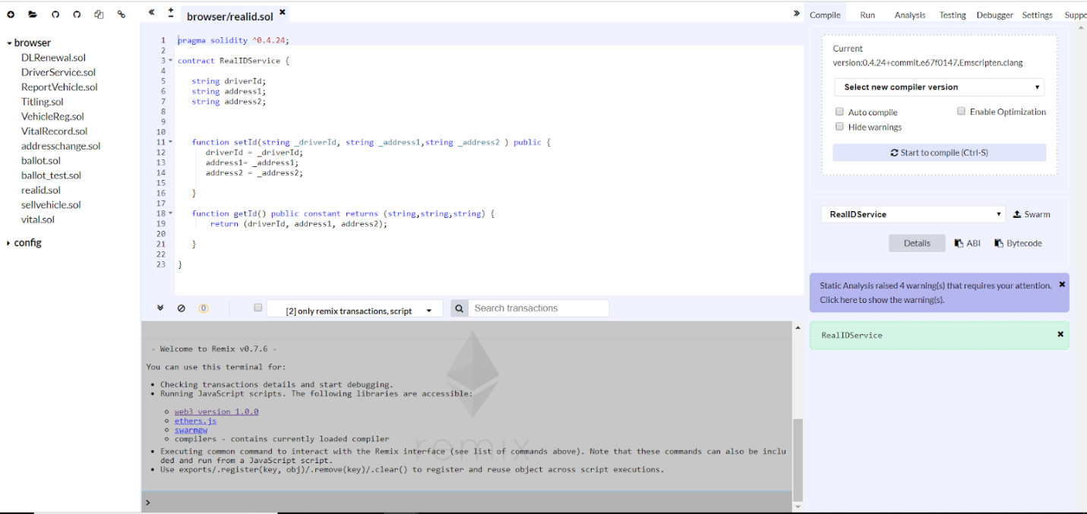

Select Web3 Provider and click OK to set the Web3 connection.

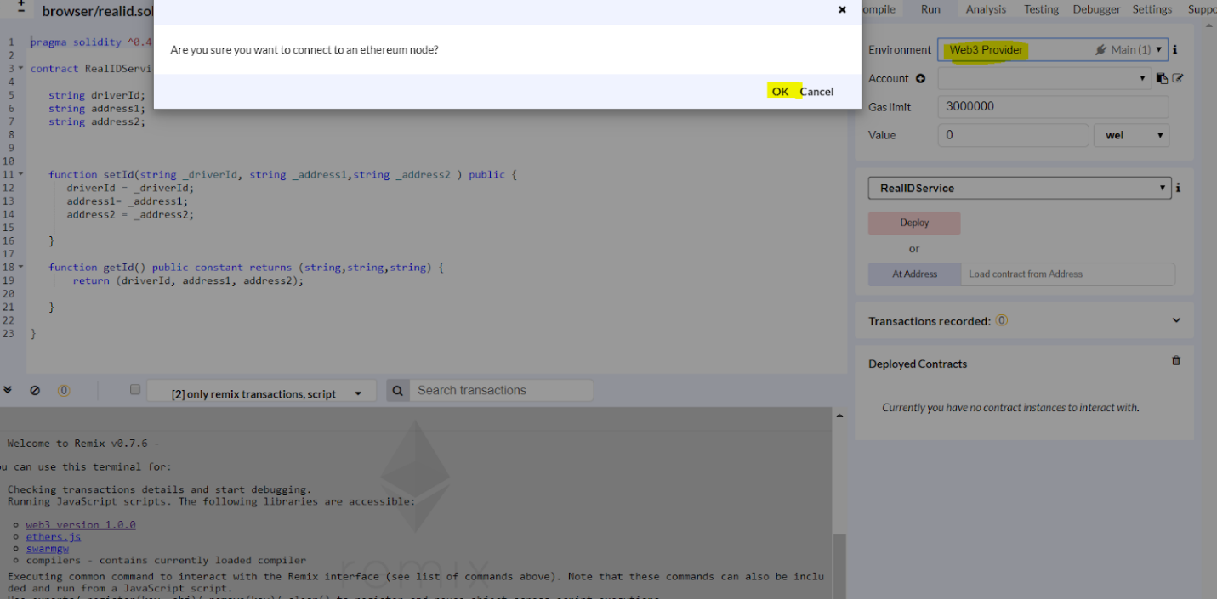

Provide the same localhost name where the ethereum’s ganache client is running so it listens on the same endpoint to establish the Web3 connection.

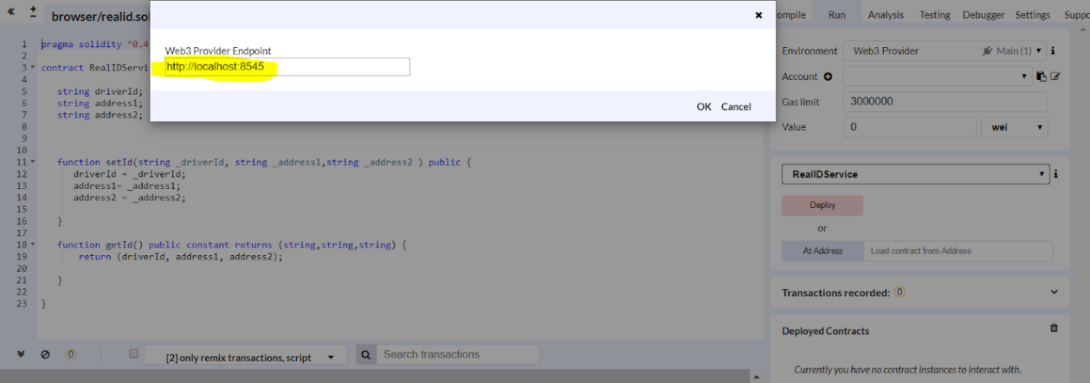

1. Create Home.html and main.css files in Visual studio with the user interface you need. Make sure to save these files in your project directory.
2. Write the Web3 connection inside the index.html file to connect it to the blockchain.

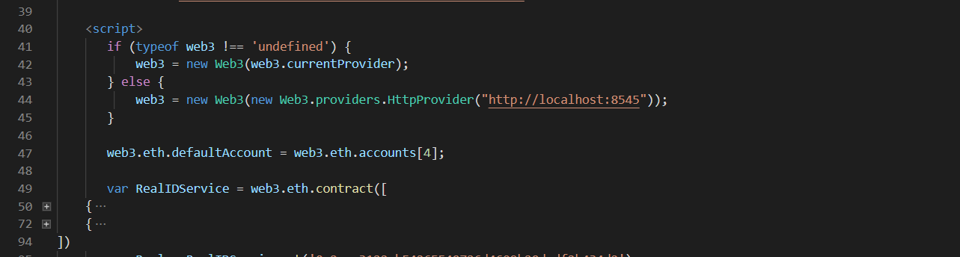

1. Once the contract is compiled on Remix browser, copy the ABI code from the compiled contract. This must be pasted inside the .html file under the Web3 connection to specify the same application binary interface. Below are the screenshots of the ABI code pasted inside the Web3 provider.

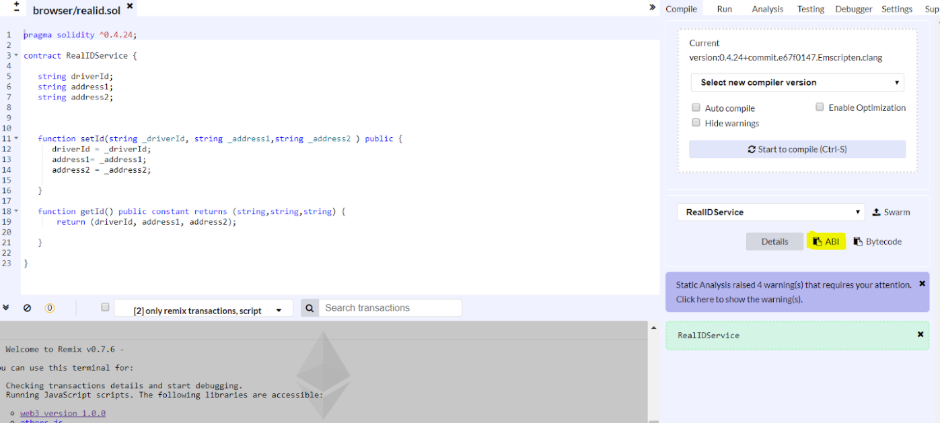

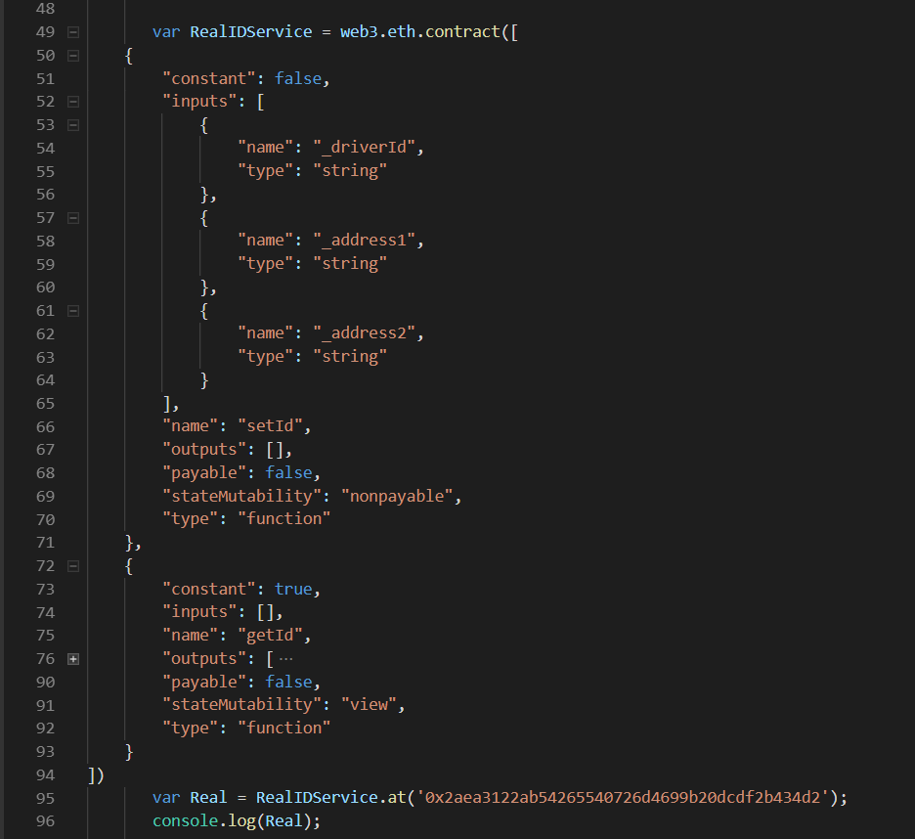

**11.** Once the contract is deployed, copy the address of the deployed contract and paste in .html file to connect it to the blockchain so the data changes are saved inside the blocks and to retrieve the information from blocks.

