Business Requirements Document(BRD) Template
Project/Initiative
Month 20YY
Version X.XX

Company Information

Document Revisions
Date | Version Number | Document Changes
05/02/20xx | 0.1 | Initial Draft

Approvals
Role | Name | Title | Signature | Date

Introduction

Project Summary

Objectives
Reduce the load on Customer Service from requests about booking cancellations and date changes on the TravelMate platform by 40–50% within 6 months after feature release, by introducing self-service tools in the Personal Account (one-click cancellation with automatic fee calculation, date changes with a “before/after” price comparison, and automatic notifications to the hotel).

Background
Currently, TravelMate allows users to book hotel rooms. However, users cannot cancel a booking or change its dates on their own. To do this, they have to contact Customer Service.
Without self-service tools, users don’t know whether they will pay a cancellation fee or an extra amount for new dates. Customer Service handles a large number of routine requests, and hotels may not get updated room availability in time.
The new Personal Account feature will allow users to view their trip history, cancel bookings in one click, and change dates with a clear “before / after” price comparison. The system will automatically calculate fees based on the hotel’s policy and notify the hotel about every change.
This will reduce the load on Customer Service by 40–50%, make booking management clearer for users, and help hotels keep their room availability up to date.

Business Drivers
- Reduce the load on Customer Service by 40–50%
- Give users full control over their bookings without contacting support
- Reduce losses from late cancellations through automatic fee calculation
- Prevent double bookings by keeping hotel room availability up to date
- Increase customer trust through clear pricing for cancellations and date changes

Project Scope

In Scope Functionality
- User can view trip history split into “Active”, “Completed”, and “Cancelled”
- User can cancel an active booking in one click
- System automatically calculates the cancellation fee based on the hotel’s policy
- User can change booking dates if a room of the same type is free for the new dates
- System shows the “before / after” price and the amount to pay or refund before the user confirms a date change
- System blocks cancellation and date changes for non-refundable rates
- System sends a notification to the hotel about every cancellation or date change
- System sends a confirmation to the user and lets them download an updated invoice
- System records the updated booking status in the database
- User can leave a review for a completed trip

Out of Scope Functionality
- Payment processing (charging the extra amount or sending the refund)
- Changing the room type or the number of guests
- Changes to hotel cancellation policies
- Hotel room inventory management
- Communication between the user and support or the hotel via chat
- Review moderation and the hotel’s reply to reviews

System Perspective
[Provide a complete description of the factors that could prevent successful implementation or accelerate the projects, particularly factors related to legal and regulatory compliance, existing technical or operational limitations in the environment, and budget/resource constraints.]

Assumptions

Constraints

Risks

- .

Issues

Business Process Overview
[Describe how the current process(es) work, including the interactions between systems and various business units. Include visual process flow diagrams to further illustrate the processes the new product will replace or enhance.
Use case documentation and accompanying activity or process flow diagrams can be used to create the description(s) of the proposed or “To-Be” processes.]

Current Business Process (As-Is)
At any point during or after deployment of web apps or web sites (internal or external) to support business activities, development/support teams may create and deploy widgets.
- CMS / database administrators for the employee portal use the CMS tool to create widgets. They can test widgets in the designated staging environment, then register them and deploy to production.
- Development teams may deploy widgets to development and testing environments set up for their development projects. They must check widget code into and out of the source code repository according to their projects’ development schedule.
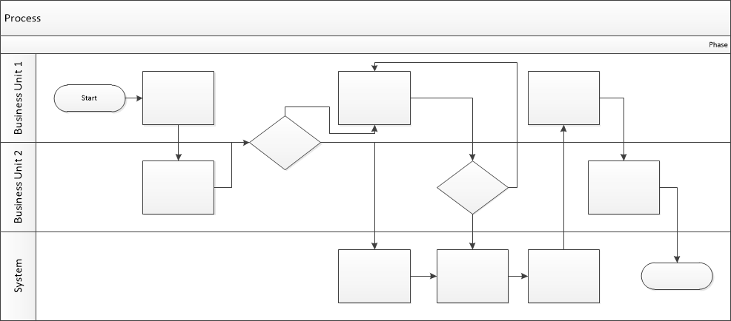

Proposed Business Process (To-Be)
- Technical Lead searches repository
- If widget is not found, user creates a new widget name record.
- WINS validates that all fields have been completed.
- WINS confirms that no similar widgets exist
- User confirms record to be created.
- User searches repository to locate existing widget description.
- WINS displays record
- User selects Edit to open and modify record
- WINS validates all fields completed correctly
- User confirms changes.
- WINS confirms changes and updates Audit table.

Stakeholder Requirements
SR-001: The user wants to cancel a booking on their own, without contacting support.
SR-002: The user wants to know the cancellation fee before cancelling a booking.
SR-003: The user wants to change booking dates on their own.
SR-004: The user wants to see whether they will pay extra or get a refund before confirming a date change.
SR-005: The user wants to download a payment receipt (invoice) for their booking.
SR-006: The user wants to see their trips split into active, completed, and cancelled.
SR-007: The user wants to leave a review after a completed trip.
SR-008: The business owner wants cancellation fees to be charged according to the hotel’s cancellation policy.
SR-009: The business owner wants date changes to be allowed only when the same room type is available.
SR-010: The business owner wants the price difference after a date change to be charged or refunded according to the hotel’s policy.
SR-011: The business owner wants to reduce the load on Customer Service by 40–50%.
SR-012: The hotel administrator wants to be notified about every cancellation or date change.
SR-013: The hotel administrator wants bookings on non-refundable rates to stay unchanged.
The requirements in this document are prioritized as follows:
Value | Rating | Description
1 | Critical | This requirement is critical to the success of the project. The project will not be possible without this requirement.
2 | High | This requirement is high priority, but the project can be implemented at a bare minimum without this requirement.
3 | Medium | This requirement is somewhat important, as it provides some value but the project can proceed without it.
4 | Low | This is a low priority requirement, or a “nice to have” feature, if time and cost allow it.
5 | Future | This requirement is out of scope for this project, and has been included here for a possible future release.

Functional Requirements
Req# | Priority | Description | Rationale | Use Case Reference | Impacted Stakeholders
General / Base Functionality
FR-G-001 | 1 | The system shall display a “Cancel booking” button for each active booking. |  |  | User
FR-G-002 | 1 | The system shall ask the user to confirm the cancellation before applying it. |  |  | User
FR-G-003 | 1 | The system shall change the booking status to “Cancelled” and send the user a confirmation email. |  |  | User
FR-G-004 | 2 | The system shall show the cancellation fee amount in the confirmation window. |  |  | User
FR-G-005 | 2 | The system shall show “Free cancellation until [date, time]” if no fee applies yet. |  |  | User
FR-G-006 | 1 | The system shall display a “Change dates” button for each active booking. |  |  | User
FR-G-007 | 1 | The system shall show a calendar to select new check-in and check-out dates. |  |  | User
FR-G-008 | 1 | The system shall not allow selecting dates in the past. |  |  | User
FR-G-009 | 1 | The system shall update the booking dates and send the user a confirmation email. |  |  | User, Hotel administrator
FR-G-010 | 3 | The system shall show the old price and the new price side by side. |  |  | User
FR-G-011 | 3 | The system shall show the difference labeled “To pay” or “To refund”. |  |  | User
FR-G-012 | 1 | The system shall display a “Download invoice” button for each booking. |  |  | User
FR-G-013 | 2 | The system shall generate the invoice as a PDF file. |  |  | User
FR-G-014 | 2 | The system shall generate an updated invoice after a cancellation or date change. |  |  | User
FR-G-015 | 1 | The system shall display trips in three tabs: “Active”, “Completed”, and “Cancelled”. |  |  | User
FR-G-016 | 1 | The system shall move a booking to “Completed” automatically after the check-out date. |  |  | User
FR-G-017 | 1 | The system shall move a booking to “Cancelled” right after cancellation. |  |  | User
FR-G-018 | 1 | The system shall display a “Leave a review” button for each completed trip. |  |  | User
FR-G-019 | 1 | The system shall hide the “Leave a review” button after the review is submitted. |  |  | User
FR-G-020 | 1 | The system shall not allow reviews for cancelled trips. |  |  | User, Business owner
FR-G-021 | 2 | The system shall save the hotel’s cancellation policy with each booking at the moment of booking. |  |  | Business owner, User
FR-G-022 | 1 | The system shall calculate the fee based on the saved policy and the time of cancellation. |  |  | Business owner, User
FR-G-023 | 1 | The system shall charge the fee automatically after the cancellation is confirmed. |  |  | Business owner, User
FR-G-024 | 1 | The system shall check if the same room type is available for the new dates. |  |  | Business owner, Hotel administrator
FR-G-025 | 1 | The system shall block confirmation and show “No rooms available for these dates” if the room type is not available. |  |  | User
FR-G-026 | 1 | The system shall not offer other room types during a date change. |  |  | Business owner, User
FR-G-027 | 1 | The system shall request payment of the difference if the new price is higher. |  |  | Business owner, User
FR-G-028 | 1 | The system shall create a refund of the difference, minus the commission set by the hotel’s policy, if the new price is lower. |  |  | Business owner, User
FR-G-029 | 1 | The system shall apply the date change only after the extra payment is successful. |  |  | Business owner
FR-G-030 | 1 | The system shall send a notification to the hotel when a booking is cancelled. |  |  | Hotel administrator
FR-G-031 | 1 | The system shall send a notification to the hotel when booking dates change, with the old and new dates. |  |  | Hotel administrator
FR-G-032 | 1 | The notification shall include the booking number, room type, and guest name. |  |  | Hotel administrator
FR-G-033 | 1 | The system shall disable the “Cancel booking” and “Change dates” buttons for non-refundable bookings. |  |  | Hotel administrator, User
Security Requirements
FR-S-001 | 1 | The system shall reject cancellation or date change requests for non-refundable bookings on the server side. |  |  | User
Reporting Requirements
FR-R-001 | 2 | The system shall generate a monthly report on the number of cancellations and date changes made through self-service. |  |  | Business Owner, Customer Service
Usability Requirements
FR-U-001 | 1 | Cancellation and date change must take no more than 3 steps from opening the booking to confirmation. |  |  | User
FR-U-002 | 2 | The system shall show the label “Non-refundable rate” with an explanation. |  |  | User
Audit Requirements
FR-A-001 | 1 | The system shall record the date, time, user, and fee amount for each cancellation. |  |  | Business Owner, Customer Service

Non-Functional Requirements
[Include technical and operational requirements that are not specific to a function. This typically includes requirements such as processing time, concurrent users, availability, etc.]
ID | Requirement
NFR-001 | The cancellation must be processed in less than 3 seconds after the user confirms.
NFR-002 | The cancellation fee must be shown in less than 1 second after the user clicks “Cancel booking”.
NFR-003 | The new price and the difference must be calculated in less than 2 seconds.
NFR-004 | The invoice must be generated in less than 5 seconds.
NFR-005 | The trip list must load in less than 2 seconds.
NFR-006 | The availability check must take less than 2 seconds.
NFR-007 | Payment and refund data must be stored encrypted in the database.
NFR-008 | The Personal Account must work on mobile devices and desktop browsers.
NFR-009 | System availability must be at least 99.5% of time.
NFR-010 | The notification must be sent within 30 seconds after the change.

Appendices

List of Acronyms
[If needed, create a list of acronyms used throughout the BRD document to aid in comprehension.]

Glossary of Terms
[If needed, identify and define any terms that may be unfamiliar to readers, including terms that are unique to the organization, the technology to be employed, or the standards in use.]

Related Documents
[Provide a list of documents or web pages, including links, which are referenced in the BRD.]

