Functional Design

Software Requirements Specification
Version 2.01

Created: | Al Smith 03/08/2008
Last Updated: | Administrator 10/08/2008
Filename: | LoanAppFunctionalDesign.doc

Revision History

Date  (mm/dd/yy) | Author | Version | Description
11/08/2008 1:22 PM | Greg Smith | 2.01
12/09/2008 3:15 PM | Greg Smith | 2.02 | Update based on requirement change

Distribution List

Distribution List
Development | Greg Richards, Catherine Edwards

Table of Contents

1 Introduction 5
1.1 Goal and Objectives 5
1.2 Scope 5
1.3 References 5
1.4 Terminology 5
1.5 Page Design 5
1.5.1 Login Page 5
1.5.1.1 Page Description 5
1.5.1.2 Page Mock Up 5
1.5.1.3 Page Data fields 6
1.5.1.4 Page Hyperlinks 6
1.5.1.5 Page Functions 6
1.5.1.6 Page Validations 7
1.5.2 Home Page 7
1.5.2.1 Page Description 7
1.5.2.2 Page Mock Up 7
1.5.2.3 Page Data fields 8
1.5.2.4 Page Hyperlinks 8
1.5.2.5 Page Functions 8
1.5.2.6 Page Validations 8
1.5.3 Main Menu (Navigational Bar) 8
1.5.3.1 Main Menu Description 8
1.5.3.2 Main Menu Mock Up 9
1.5.3.3 Main Menu Functions 9
1.5.4 List of Branch Users Page 9
1.5.4.1 Page Mock Up 9
1.5.4.2 Page Data fields 10
1.5.4.3 Page Hyperlinks 10
1.5.4.4 Page Functions 10
1.5.4.5 Page Validations 10
1.5.5 Add User Page 10
1.5.5.1 Page Mock Up 10
1.5.5.2 Page Data fields 11
1.5.5.3 Page Hyperlinks 11
1.5.5.4 Page Functions 11
1.5.5.5 Page Validations 12
1.5.6 List of Branch Customers Page 12
1.5.6.1 Page Mock Up 12
1.5.6.2 Page Data fields 12
1.5.6.3 Page Hyperlinks 12
1.5.6.4 Page Functions 13
1.5.6.5 Page Validations 13
1.5.7 Add Customers Page 13
1.5.7.1 Page Mock Up 13
1.5.7.2 Page Data fields 13
1.5.7.1 Page Hyperlinks 14
1.5.7.2 Page Functions 14
1.5.7.3 Page Validations 14
1.5.1 ‘Loan Prequalifier’ window 16
1.5.1.1 Menu Title ‘File’ 17
1.5.1.2 Menu Tile ‘Edit’ 17
1.5.1.3 Menu Title ‘Options’ 17
1.5.1.4 Menu Title ‘Help’ 18
1.5.1.5 ‘Customer Personal Data’ area 18
1.5.1.6 ‘Customer Financial Data’ area 19
1.5.1.7 Loan Terms 19
1.5.1.8 20
1.5.1.9 Preview Letter Invocation 20

Introduction
Loan Prequalifier consolidates many different functions of loan management processes into a single integrated solution.

Goal and Objectives
Improve processing efficiencies and maximize productivity, while deliver functionality that automates every key process in the administration of a loan portfolio and will be configurable to a wide range of tasks.

Scope
This document will address only user aspects of the requirements

References
N/A

Terminology
LMS – Loan Management System

Page Design

Login Page

Page Description
Lifecycle management of LMS must be supported by multiple users that share the same data pool of customers. This means that for security reasons users need to be able to have their own user names and passwords.

Page Mock Up

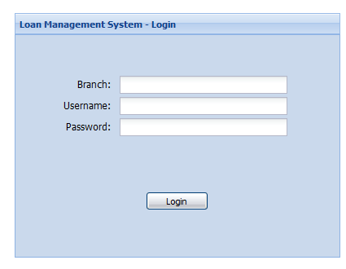

Page Data fields

Page Caption | Description | Data Type | M / O | Comments
Branch | Branch name | Text | M
Username | Branch user username | Text | M
Password | Branch user password | Text | M

Page Hyperlinks
Name | Action
N/A

Page Functions

Name | Action
 | Login to the application

Page Validations

Validation | Message
Branch name must be entered | Please enter branch name
Username must be entered. | Please enter username
Password must be entered. | Please enter password
Branch name is invalid | Invalid branch name
Username is invalid | Username or password is invalid
Password is invalid | Username or password is invalid

Home Page

Page Description
Home page provides ability to search for the existing users and customers and navigate to other functional areas

Page Mock Up

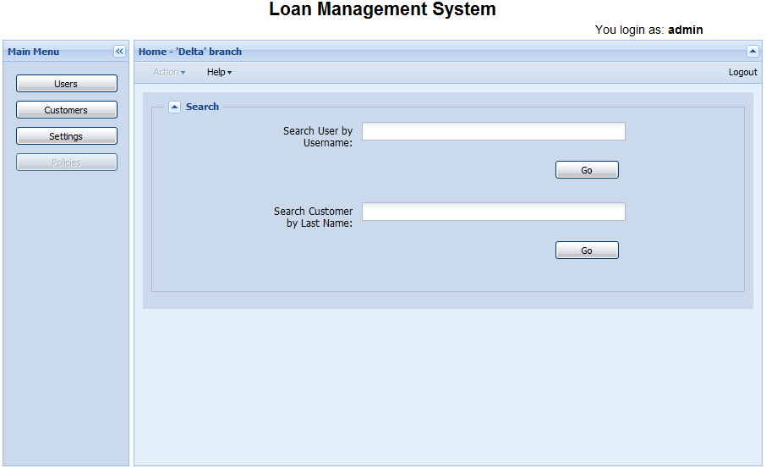

Page Data fields
Page Caption | Description | Data Type | M / O | Comments
Search User for Username | Edit field to enter username to search | Text
Search Customer by Last Name | Edit field to enter customer last name to search | Text

Page Hyperlinks
Name | Action
Logout | Logout of the application

Page Functions
Name | Action
 | Perform users search
 | Perform customers search

Page Validations
Validation | Message
N/A

Main Menu (Navigational Bar)

Main Menu Description
Main Menu provide means to navigate to all major functional areas:
- Users
- Customers
- Settings
- Policies (not implemented in current release)

Main menu is present and consistent on all pages of the application

Main Menu Mock Up
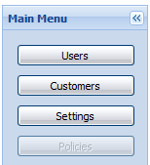

Main Menu Functions

Name | Action
 | Navigate to branch Users page (enabled when login as branch admin, disabled when login as branch user)
 | Navigate to branch Customers page
 | Navigate to branch users personal settings page
 | Navigate to bank policies page (disabled for current release)

List of Branch Users Page

Page Description
Display all branch users info in a table form

Page Mock Up
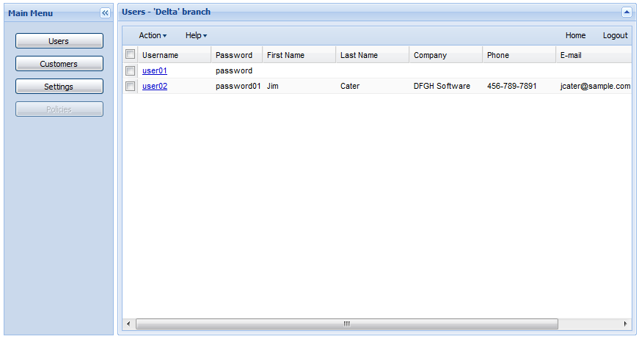

Page Data fields
Page Caption | Description | Data Type | M / O | Comments
N/A

Page Hyperlinks
Name | Action
Home | Navigate to Home page
Logout | Logout of the application
Username | Navigate to Edit User page

Page Functions
Name | Action
Action | Add User, Edit User, Delete User
Help | Help Topics, Online Support, About

Page Validations
Validation | Message
N/A

Add User Page

Page Description
Form to enter New User information

Page Mock Up

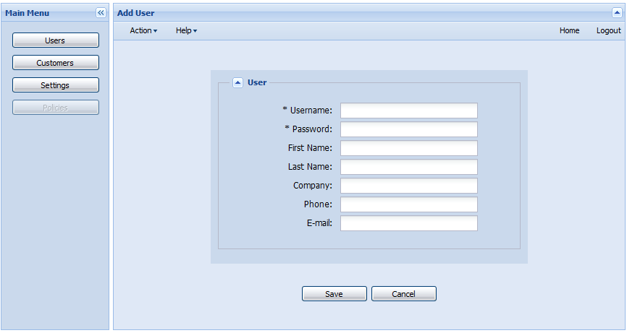

Page Data fields
Page Caption | Description | Data Type | M / O | Comments
Username | Unique username | text | M
Password | Password | text | M
First Name | User's first name | text | O
Last Name | User's last name | text | O
Company | User's company | text | O
Phone | User's phone number | text | O
E-mail | User's email address | text | O

Page Hyperlinks
Name | Action
Home | Navigate to Home page
Logout | Logout of the application

Page Functions
Name | Action
Action | View User History
Help | Help Topics, Online Support, About
 | Save user's data
 | Cancel saving the user's data

Page Validations
Validation | Message
Username is mandatory | Mandatory field 'Username' is empty
Password is mandatory | Mandatory field Password is empty
Username is not unique | Username already exists
Password is less than 5 characters | Password must be at least 5 characters
Password is more than 16 characters | Password must be no more that 16 characters

List of Branch Customers Page

Page Description
Display all branch customers information in a table form

Page Mock Up

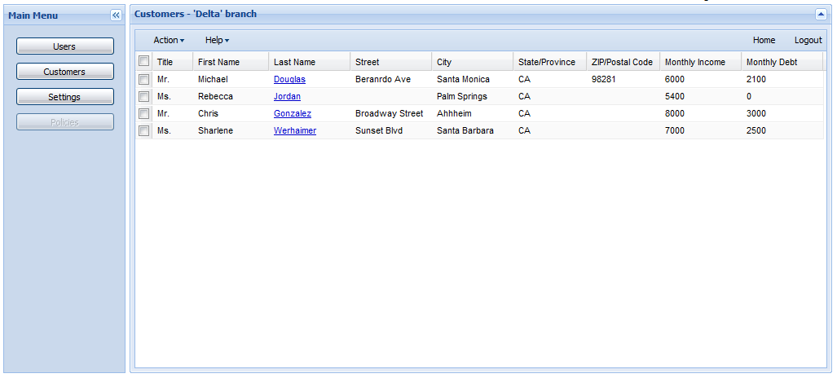

Page Data fields
Page Caption | Description | Data Type | M / O | Comments
N/A

Page Hyperlinks
Name | Action
Home | Navigate to Home page
Logout | Logout of the application
Last Name | Navigate to Edit Customer page

Page Functions
Name | Action
Action | Add Customer, Edit Customer, Delete Customer
Help | Help Topics, Online Support, About

Page Validations
Validation | Message
N/A

Add Customer Page

Page Description
Form to enter New Customer information

Page Mock Up

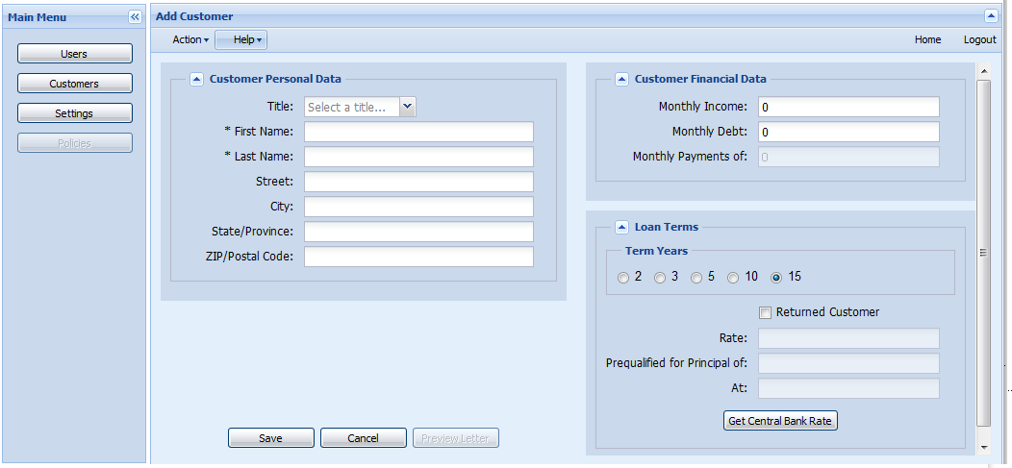

Page Data fields
Page Caption | Description | Data Type | M / O | Comments
Title | Customer's title (Drop Down List Box) | Text | O | Mr., Ms., Mrs., Miss, Dr.
First Name | Customer's First Name | Text | M
Last Name | Customer's Last Name | Text | M
Street | Customer's Street | Text | O
City | Customer's City | Text | O
State/Province | Customer's State/Province | Text | O
ZIP/Postal Code | Customer ZIP/Postal Code | Text | O
Monthly Income | Customer's monthly income | Text | O
Monthly Debt | Customer's monthly debt | Text | O
Monthly Payment of | Customer's monthly payment | Text | O | Calculated field (not editable)
Terms Years | Loan Terms Years | Radio List | O | 2,3,5,10,15
Returned Customer | Indicates if customer already had loan in a past | Checkbox | O | When checked reduce customer's rate by 0.5%
Rate | Central Bank rate | Text | O | Populated when Central Bank Rate is obtained.  Not editable
Prequalified for Principal of | Principal amount of Loan | Text | O | Calculated field. Not editable
At | Customer's rate | Text | O | Calculated field. Not editable

Page Hyperlinks
Name | Action
Home | Navigate to Home page
Logout | Logout of the application
Last Name | Navigate to Edit Customer page

Page Functions
Name | Action
Action | View Account History, Print
Help | Help Topics, Online Support, About
 | Save Customer's information
 | Cancel and return user to the List of Customers page
 | Open Pre-qualification letter for preview. Disabled if central bank rate is not obtained
 | Obtain Current Central Bank Rate

Page Validations
Validation | Message
First Name is mandatory | Mandatory field "First Name" is empty
Last Name is mandatory | Mandatory field "Last Name" is empty
Customer already exist | Customer with {First Name, Last Name pair} already exist
Province is less than 2 or more than 3 characters | "State/Province" must be a least 2 and no more than 3 characters
ZIP/Postal Code is less than 5 or more than 7 characters | "ZIP/Postal Code" must be a least 5 and no more than 7 characters and contain letters and numbers only

Edit Customer Page

Page Description
Form to modify existing customer information

Page Mock Up

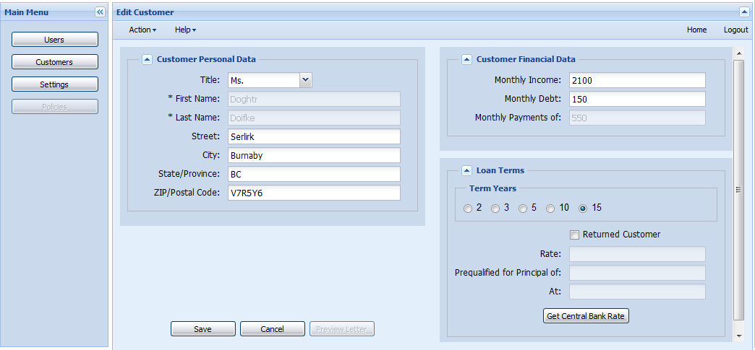

Page Data fields
Page Caption | Description | Data Type | M / O | Comments
Title | Customer's title (Drop Down List Box) | Text | O | Mr., Ms., Mrs., Miss, Dr.
First Name | Customer's First Name | Text | M | Not editable. If legal name was changed, new loan need to be issued
Last Name | Customer's Last Name | Text | M | Not editable. If legal name was changed, new loan need to be issued
Street | Customer's Street | Text | O
City | Customer's City | Text | O
State/Province | Customer's State/Province | Text | O
ZIP/Postal Code | Customer ZIP/Postal Code | Text | O
Monthly Income | Customer's monthly income | Text | O
Monthly Debt | Customer's monthly debt | Text | O
Monthly Payment of | Customer's monthly payment | Text | O | Calculated field (not editable)
Terms Years | Loan Terms Years | Radio List | O | 2,3,5,10,15
Returned Customer | Indicates if customer already had loan in a past | Checkbox | O | When checked reduce customer's rate by 0.5%
Rate | Central Bank rate | Text | O | Populated when Central Bank Rate is obtained.  Not editable
Prequalified for Principal of | Principal amount of Loan | Text | O | Calculated field. Not editable
At | Customer's rate | Text | O | Calculated field. Not editable

Page Hyperlinks
Name | Action
Home | Navigate to Home page
Logout | Logout of the application
Last Name | Navigate to Edit Customer page

Page Functions
Name | Action
Action | View Account History, Print
Help | Help Topics, Online Support, About
 | Save Customer's information
 | Cancel and return user to the List of Customers page
 | Open Pre-qualification letter for preview. Disabled if central bank rate is not obtained
 | Obtain Current Central Bank Rate

Page Validations
Validation | Message
First Name is mandatory | Mandatory field "First Name" is empty
Last Name is mandatory | Mandatory field "Last Name" is empty
Customer already exist | Customer with {First Name, Last Name pair} already exist
Province is less than 2 or more than 3 characters | "State/Province" must be a least 2 and no more than 3 characters
ZIP/Postal Code is less than 5 or more than 7 characters | "ZIP/Postal Code" must be a least 5 and no more than 7 characters and contain letters and numbers only

Prequalification Letter Page

Page Description
Letter to the customer with loan application resolution

Approval Letter Mock Up

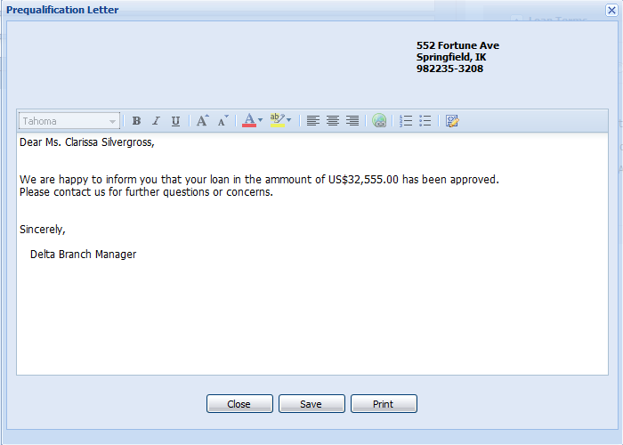

Rejection Letter Mock Up

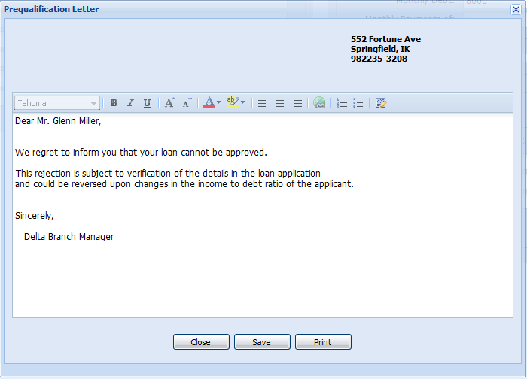

Page Data fields
Page Caption | Description | Data Type | M / O | Comments
Prequalification Letter | Edit field | Text | O | Pre-populated.  Editable

Page Hyperlinks
Name | Action
N/A

Page Functions
Name | Action
Close | Close Prequalification Letter pop up
Save | Save letter in PDF format
Print | Print letter

Page Validations
Validation | Message
N/A

