Project Pandaan – Malang Toll Road East Java

**Project Description**

Gempol-Pandaan is a toll road that stretches 37.62 kilometers connect the Gempol with Pandaan, Pasuruan, East Java. The toll road is a continuation of toll roads and the Surabaya-Porong Porong-Gempol that will connect with Highway Pandaan-Malang. Gempol-Pandaan is part of the toll road that will connect the two largest cities in East Java, Surabaya and Malang.

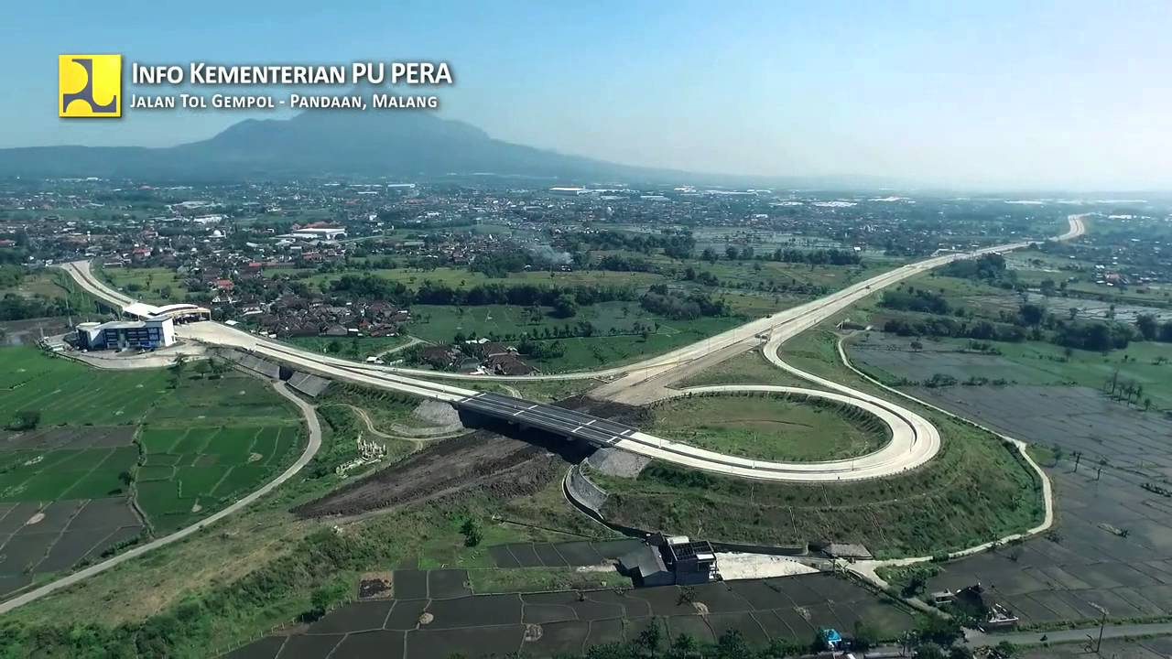

***Scope of Works***  
Length : 38.55 km  
Design Speed : 80 - 120 km/h  
Number of Lane : 2x3 lanes  
Lane of Width : 3.60 m  
Outer Shoulder Width : 3.00 m  
Inner Shoulder Width : 1.50 m  
Median Width : 12.70 m  
Right of Way : 60.00 m (minimum)

**Estimated project cost**  
Estimated Project Value : US$ 420.00 million  
Land acquisition : US$ 325.66 million  
Economic Feasibility  
EIRR : 25.93 %  
Financial Feasibility  
FIRR : 15.87 %

**PPP Modality**  
BOT (Build – Operate – Transfer).  
The concession period will be granted for 35 years.

**Project Implementation Schedule**  
Project preparation : 2011-2013  
Tender : 2013  
Contract Signing : 2014  
Construction : 2014-2015  
Operation : 2015

Why?

* So the demand will be predicted that 22.220 vehicles that will use this toll.
* With the project value US$ 252.76 million, it get the IRR 16.09%.
* This project start from 2011 and end in 2015. So this project only need about 5 years.
* The government support is available for this project