Capital Market Weekly Report

Week 8 and 9

Hanindita Guritna 29114713

Hussein 29114737

Eska Anisa N.F.A. 29114777

Rini Amelia 29114857

Hidratul Fidic Dirgantara 29114859

Karin de Vries 19150044

JSX Index Overview

In the last two weeks between date 7 October and 20 October 2015, JSX Index has strengthened by 111 pont or 2.5% from 4458 to 4569. On 7 October the transaction volume 7.056 billion shares with value of transaction Rp. 6.183 trillion close the index on 4487.13. Based on index data from Monday until Wednesday the overall price has been risen to 244 point or 5.7%.

In the following day the index was closed with weaken price. The index was opened at 4502 and closed at 4491.43. This is the first decline on index since the previous seven days. This decline was caused MSCI Asia Pacific has been decreased by 0.4%. The majority of the benchmark index in the depressed region. Such as the Hong Kong Hang Seng index dropped 0.7%, Japan's Topix index fell 0.8%, Taiwan Taeix index fell 0.6%, Singapore's Straits Times Index fell 0.4%, and the S & P / NZX 50 down 0, 4%. However, there are also a number of regional index climbing. Such as the S & P / ASX 200 rose 0.2%, South Korea's Kospi index rose 0.7%, and China's Shanghai Composite Index soared 3%.

The declining on index price did not last long. The next Monday the index was opened at 4538.5 or 1% higher than previous day. The index kept increasing for two days. Overall the index was increased by 92 point or 2% for two days. The cause of this rebound were the foreign investor that take action to buy. The cash flow of foreign investor continue to rush into the Indonesian stock market, since the US released data worsening labor. Many analysts expect the Fed will delay interest rate hikes this year. It made a profit taking in global markets, include Indonesia.

On the 13 October, the second day of second week of this month, the index was fall deeply. With opening price 4621.885 and closed 4483.076, the decrease was 147.631 point or -3.2%. Ten sectors issued a red signal. The three sectors with the largest decrease among others the industrial sector fell 6.5%, basic industrial sector fell 3.6%, and the financial sector fell 2.8%. Not only Indonesia, most of Asia Pacific stock market also decreasing. Japan's Topix index fell 0.9%, Hong Kong's Hang Seng index fell 0.5%, the Shanghai Composite Index fell 0.3%. The decline also occurred in the S & P / ASX 200 by 0.5% and South Korea's Kospi index by 0.4%. The sentiment that cause the falling was the import rate of China was lower than estimation.

On the 15 October after holiday of Islam New Year, the index was opened at 4513.272 with increase 30 point from previous day. This happened because the optimism from the market player try to hold the decreasing of index. After the closing the index moving with stable price although the change was decrease by 0.5%, but market was expected to kept strengthened since China was expected to give the stimulus for weaker external demand and decrease domestic consumption.

The strengthened price in index kept increasing until the next four days. On the 20 October the index was closed on 4585.82. Since the decline on 13 October the index increase to 102 point or 2.2%. Based on analysis the strengthened JCI sustained by the flow of foreign funds into the domestic stock market that began slowly get in. The cash flow from foreign funds, indicating investor confidence in the domestic economy, plus the Asian economies are likely to begin to improve. Technically, JCI further towards the target level of 4,640 points, is expected to be achieved so as to strengthen the pattern of strengthening trend.

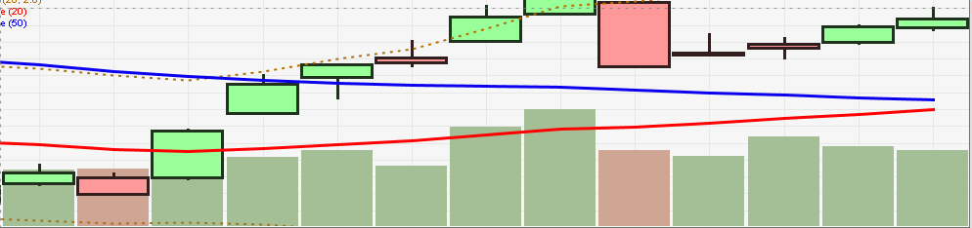

The index movement from October 1st

**Transaction Activity**

Here are our previous portfolios before 6 October.

|  |  |  |  |  |
| --- | --- | --- | --- | --- |
| Stock |  | | | Total |
| Date buy | Price | Qty (Shares) |
| BBRI | 9/29/15 | 8350 | 100 | Rp836,503 |
| ADHI | 10/1/15 | 2000 | 200 | Rp400,720 |
| PGAS | 10/1/15 | 2600 | 100 | Rp260,468 |
| PGAS | 10/1/15 | 2595 | 100 | Rp259,967 |
|  |  |  |  | Rp1,757,658 |

For two weeks, we already done some transaction activity buy and sell stocks. Given that the unstable market condition we must take quick decision when to buy and when to sell.

Here are our transaction activity in the market between 6 October until 20 October.

PGAS (Sell)

|  |  |  |  |  |  |  |  |  |  |
| --- | --- | --- | --- | --- | --- | --- | --- | --- | --- |
| Stock | Buy | | | Total | Sell | | | Total | Gain |
| Date | Price | Qty (Shares) | Date | Price | Qty (Shares) |
| PGAS | 10/1/2015 | 2600 | 100 | Rp260,468 | **10/12/2015** | 3055 | 200 | Rp609,289 | 17% |
| 10/1/2015 | 2595 | 100 | Rp259,967 |  |  |  |  |
|  |  |  |  |  |  |  |  |
|  |  |  |  |  |  |  |  |
|  | Rp2,602.18 | 200 | Rp520,435 |  |  |  | Rp609,289 | Rp88,854 |

Since we buy PGAS shares for 2 lot on 1 October. The price have been significantly increasing. On 12 October the shares was opened at 3010. When the price have reach more than 3000 we decided to start sell. The transaction was successful and sell at 3055. From this selling we gain 17% profit. This decision is right call, because the next day the price began to drop until its lowest 2955.

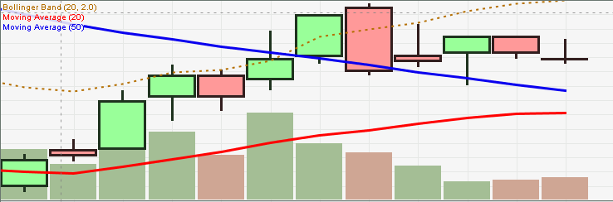

PGAS shares from 1 October to 20 October

ADHI (Sell)

|  |  |  |  |  |  |  |  |  |  |
| --- | --- | --- | --- | --- | --- | --- | --- | --- | --- |
| Stock | Buy | | | Total | Sell | | | Total | Gain |
| Date | Price | Qty (Shares) | Date | Price | Qty (Shares) |
| ADHI | 10/1/2015 | 2000 | 400 | Rp801,440 | **10/12/2015** | 2140 | 400 | Rp853,603 | 7% |
|  |  |  |  |  |  |  |  |
|  |  |  |  |  |  |  |  |
|  |  |  |  |  |  |  |  |
|  | Rp2,003.60 | 400 | Rp801,440 |  |  |  | Rp853,603 | Rp52,163 |

Same with PGAS we have ADHI since 1 October. The market price also kept rise. Until 12 October based on the chart the price of ADHI already surpass the resistance level. That means that this price might be the highest level and there is a possibility that it will decrease. So we decided to sell on 12 October with price 2140. From this transaction we gain profit 7%.

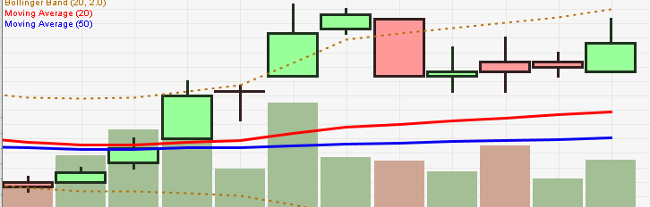

ADHI shares from 1 October to 20 October

BUMI (Buy and Sell)

|  |  |  |  |  |  |  |  |  |  |
| --- | --- | --- | --- | --- | --- | --- | --- | --- | --- |
| Stock | Buy | | | Total | Sell | | | Total | Gain |
| Date | Price | Qty (Shares) | Date | Price | Qty (Shares) |
| BUMI | **10/12/2015** | 81 | 5000 | Rp405,729 | **10/12/2015** | 81 | 5000 | Rp403,866 | 0% |
|  |  |  |  |  |  |  |  |
|  |  |  |  |  |  |  |  |
|  |  |  |  |  |  |  |  |
|  | Rp81.15 | 5000 | Rp405,729 |  |  |  | Rp403,866 | (Rp1,863) |

BUMI is a mining company. The market price for this company is not performing well. Since the second quartal in 2015 the price always kept decreasing until August the price touch the lowest level which is 50. But on 9 October the BUMI price start to rise. This was triggered by the company tried to restructure its debt. For 2 days the price touch its highest level 88. We decided to buy this shares. But based on market history, this shares good performance will not long-lasting. On 12 October try to buy this shares on 81 for 50 lots. After second session after we buy, it seems that the price will start to drop. Then we decided to sell again at the same price. From that transaction we gain nothing but lose because of transaction fees.

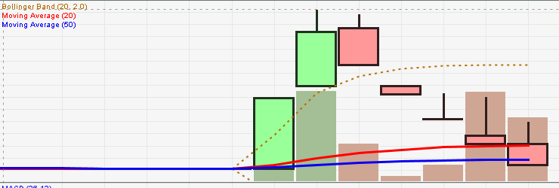

BUMI shares from 1 October to 20 October

KLBF (Buy)

|  |  |  |  |  |
| --- | --- | --- | --- | --- |
| Stock | Buy | | | Total |
| Date | Price | Qty (Shares) |
| KLBF | **10/12/2015** | 1530 | 200 | Rp306,551 |
| **10/13/2015** | 1455 | 300 | Rp437,286 |
|  |  |  |  |
|  |  |  |  |
|  | Rp1,487.67 | 500 | Rp743,837 |

After the shares start declining on 8 October, KLBF seems attractive. We start to buy 3 lots at 1530. The next day the price keep to drop about 3%, we decided to average our shares. With buy additional 300 lots at 1455. The averaging price now become 1487. Until today the KLBF start to rise again with closing price 1455.

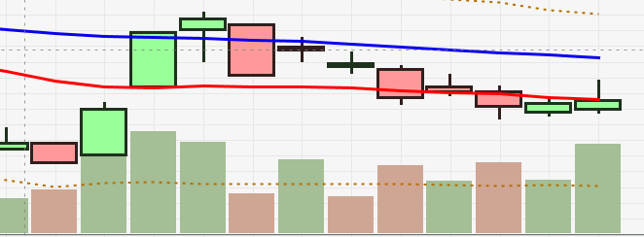

KLBF shares from 1 October to 20 October

BBRI

|  |  |  |  |  |  |  |  |  |  |
| --- | --- | --- | --- | --- | --- | --- | --- | --- | --- |
| Stock | Buy | | | Total | Sell | | | Total | Gain |
| Date | Price | Qty (Shares) | Date | Price | Qty (Shares) |
| BBRI | 9/29/2015 | 8350 | 100 | Rp836,503 | **10/15/2015** | 10500 | 100 | Rp1,047,060 | 25% |
|  |  |  |  |  |  |  |  |
|  |  |  |  |  |  |  |  |
|  |  |  |  |  |  |  |  |
|  | Rp8,365.03 | 100 | Rp836,503 |  |  |  | Rp1,047,060 | Rp210,557 |

Since the BBRI price stop drop until 28 September. BBRI start to rise. The rise of BBRI was proven with the shares price has increased significantly. From 8000, BBRI has touch highest level to 10800. When the BBRI reach its highest we not sell it. For the next two days the price began to fall. The falling price held only two days. For the next day the price signal that it will increase. We decided to sell it. The transaction was successful, we sell BBRI 100 lot at 10500. From that transaction we gain 25%.

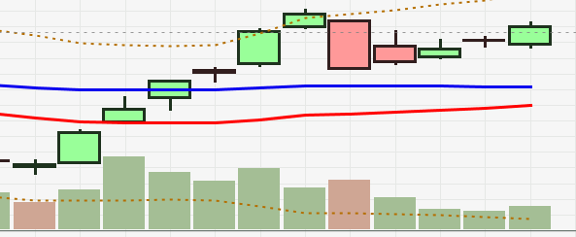

BBRI shares from 1 October to 20 October

UNVR (buy)

|  |  |  |  |  |
| --- | --- | --- | --- | --- |
| Stock | Buy | | | Total |
| Date | Price | Qty (Shares) |
| UNVR | 10/16/2015 | 37500 | 100 | Rp3,756,750 |
|  |  |  |  |
|  |  |  |  |
|  |  |  |  |
|  | Rp37,567.50 | 100 | Rp3,756,750 |

UNVR is one of the expensive shares. With its range price from 36000 to 40000 will make a high spending for us to buy. So decision to buy it must be considered carefully. After we sell PGAS and ADHI we have enough cash in hand to buy UNVR, but in that time still at range 39000. On 16 October UNVR price touch 37200. We consider to buy UNVR. The transaction was succesfull, we buy 1 lot at 37500.

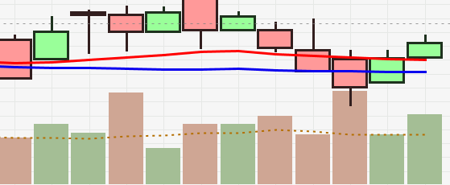

UNVR shares from 1 October to 20 October

After the transaction that we have described above, here are our current portfolios.

|  |  |  |  |  |
| --- | --- | --- | --- | --- |
| Stock |  | | | Total |
| Date buy | Price | Qty (Shares) |
| KLBF | **10/12/2015** | 1530 | 200 | Rp306,551 |
| KLBF | **10/13/2015** | 1455 | 300 | Rp437,286 |
| UNVR | 10/16/2015 | 37500 | 100 | Rp3,756,750 |
|  |  |  |  | Rp4,500,587 |