Coffee Shop Sales
Exploratory Data Analysis
Problem Statement:
The objective of this project is to analyze coffee shop sales data to identify sales trends, product performance, and factors influencing revenue. The ultimate goal is to provide actionable insights to increase profitability, optimize inventory management, and improve overall customer satisfaction.
Business Impact:
Conducting an in-depth exploratory data analysis (EDA) will allow stakeholders to:
- Identify top-performing products and underperforming categories to improve product offerings.
- Optimize pricing strategies and inventory management based on demand patterns.
- Understand seasonality and peak sales times to enhance marketing campaigns and resource allocation.
- Improve store-level performance by analyzing location-specific sales data.
General Dataset Information:
File Name: CoffeeShopSales.xlsx
Dataset Details: 149116 Rows & 11 Columns
Size: 8.97 MB
Source: Kaggle - Dataset Link
Target Features:
This analysis will support data-driven decision-making to maximize profitability, improve customer satisfaction, and drive sustainable growth.

The key features in question that can be found within the dataset are:
- transaction_id: Unique sequential ID for each transaction
- transaction_date: Date of transaction
- transaction_time: Time of transaction
- transaction_qty: Quantity of items sold
- store_id: Unique ID of the coffee shop
- store_location: Location of the store
- product_id: Unique product identifier
- unit_price: Price per unit
- product_category: Broad classification of product
- product_type: Sub-classification of product
- product_detail: Specific description of product

Columns of Interest :

- transaction_qty: Quantity of items sold
- store_location: Location of the store
- unit_price: Price per unit
- product_category: Broad classification of product
- year
- month
- day
- total revenue: unit_price * transaction_qty

Note: I split the transaction_date into 3 column ( year, month, day)

Data Types Summary

- Date/Time Columns: transaction_date, transaction_time
- Categorical Columns: store_location, product_category, product_type, product_detail
- Numerical Columns: transaction_qty, unit_price

- List of Analysis
- Analysis #1 - Total Records
To provide context, the total number of records in the coffee shop dataset was utilized to demonstrate the breadth of the data used in the analysis. The dataset contains 149,116 transactions spanning multiple stores and product categories, representing comprehensive sales activity across all locations.

- Analysis #2 - Sales by Store Location
Grouping by store_location allows an analysis of sales performance across different coffee shop branches.
- A summary of total sales revenue and transaction count was computed per location.
- The visualization below displays each location’s total revenue:
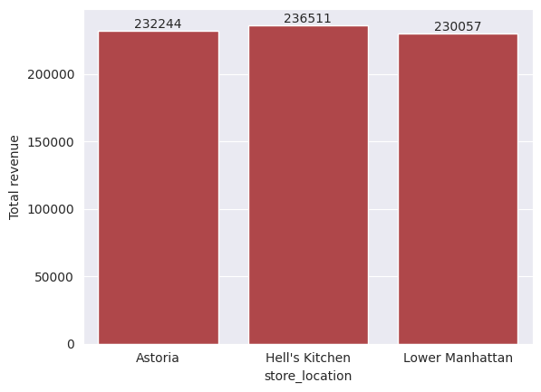
- Key Insights:
  - Hell’s Kitchen store has the highest total sales, indicating strong customer traffic and demand.
  - Store Lower Manhattan has the lowest performance, highlighting potential areas for marketing improvement or product optimization.

Analysis #3 - Sales Trends by Date
Using the transaction_date column, sales trends were analyzed over time.
- Grouping sales data by month and plotting the trend line revealed seasonal patterns in consumer behavior.
- Insights from the visualization:
  - Sales peak in Aprile and June, likely due to Summer Season and holiday season
  - A consistent dip in sales occurs during the winter months, suggesting opportunities for targeted promotions.
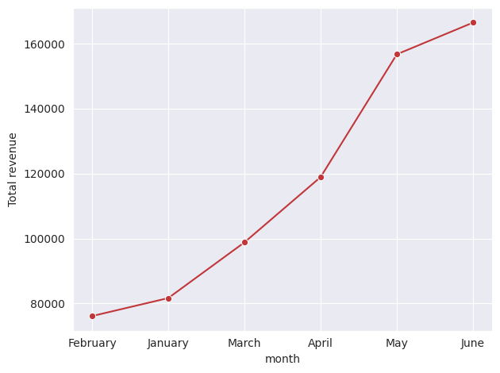

Analysis #4 - Product Category and Type Distribution
Analyzing product categories and types gives insights into customer preferences.
- Grouping by product_category and product_type produced a frequency table and bar chart.
- Key Findings:
  - The "Coffee" category contributes the most to overall sales, followed by "Hot Chocolate".
  - Within "Coffee", "Gourmet brewed coffee" and "Barista Espresso" are the most frequently sold items.
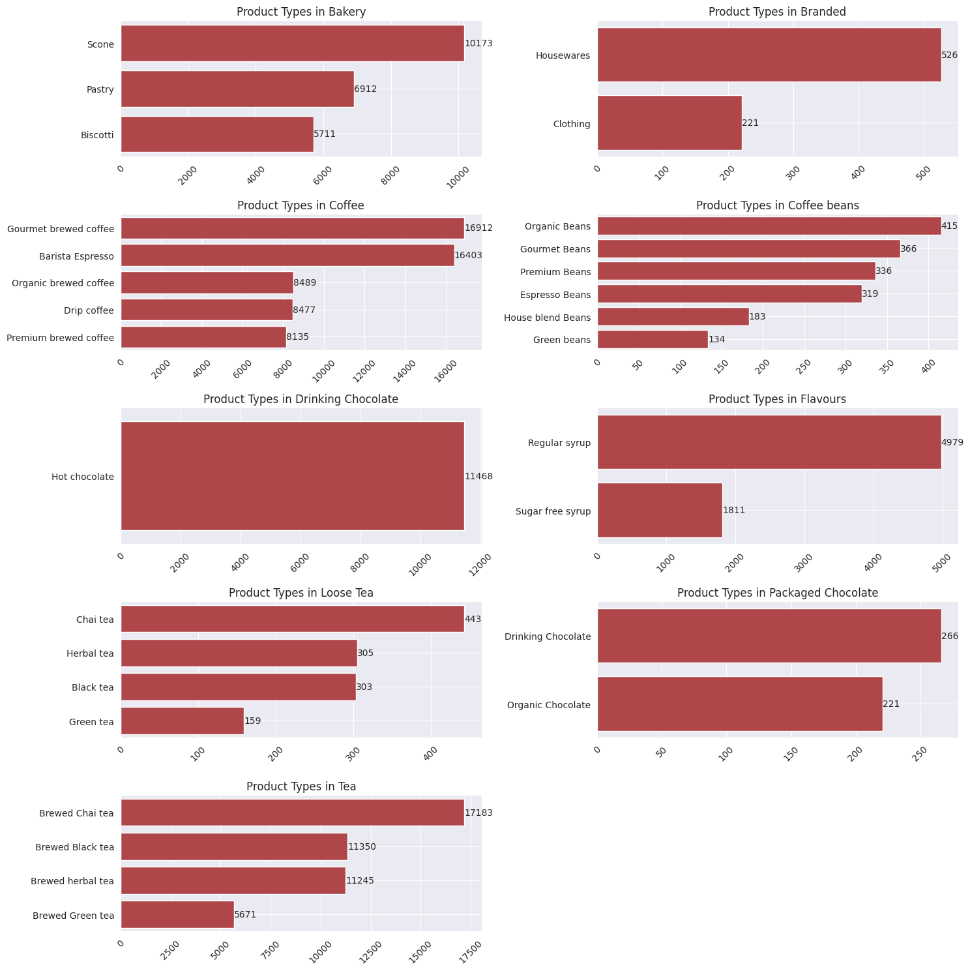

Analysis #5 - Unit Price Distribution
Exploring unit_price shows the range and distribution of product pricing.
- A histogram of unit_price highlights the pricing strategy across all items.
- Takeaways:
  - Most products are priced between $2 and $5, with a few premium items exceeding $10.
  - This aligns with typical pricing strategies for coffee shops targeting affordability and occasional premium offerings.
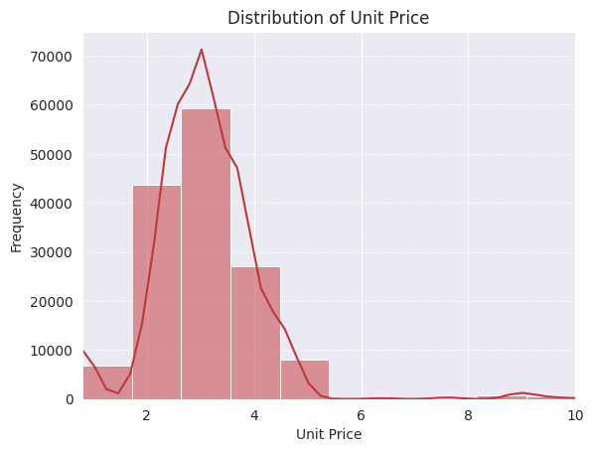

Analysis #6 - Correlation Between Quantity Sold and Unit Price
The relationship between transaction_qty and unit_price was examined using a scatter plot.
Observations:
There is a slight negative correlation, suggesting that lower-priced items are sold in higher quantities, while premium items are sold less frequently.

This insight can inform bundling or discount strategies to encourage higher sales volumes for premium products.
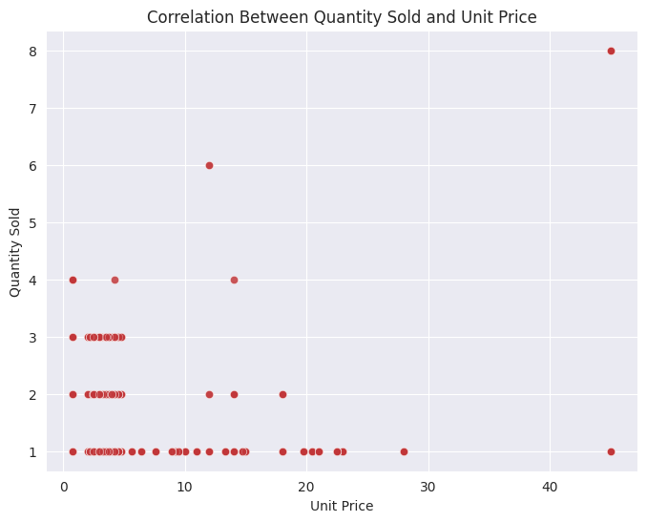

Analysis #7 - Correlation Between product category and Unit Price
The relationship between product_category and unit_price was examined using a scatter plot.
This is the average unit price for each product:
product_category:

Bakery | 3.551682
Branded | 17.720214
Coffee | 3.023646
Coffee beans | 21.018397
Drinking Chocolate | 4.148827
Flavors | 0.800000
Loose Tea | 9.267438
Packaged Chocolate | 9.050595
Tea | 2.817121

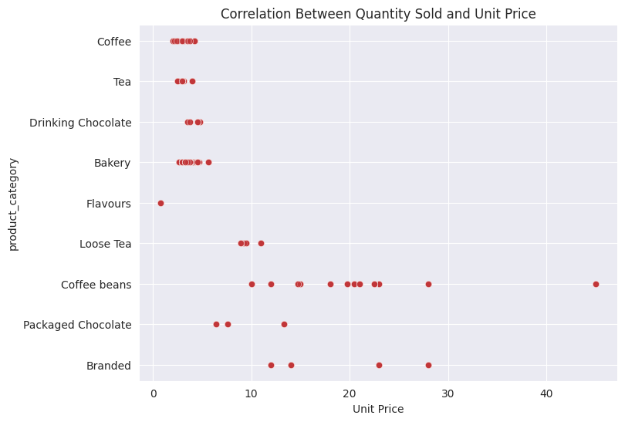

- Conclusion
The analysis of the coffee shop sales dataset from January to June highlights several important trends. June recorded the highest sales, indicating a potential seasonal or promotional effect. Beverages led in sales, followed by pastries and snacks.
A correlation analysis between quantity sold and unit price revealed a slight negative relationship—lower-priced items sell in higher quantities, while premium products are sold less frequently. This suggests opportunities for strategic pricing or bundling to drive premium product sales.
These insights can inform better pricing strategies, promotional timing, and product mix optimization to enhance revenue and profitability.

