Project Scoping Document

Name: Coffee Shop Sales Analysis

Business Problem
The coffee shop industry is highly competitive, and understanding key business drivers like sales trends, product performance, and customer preferences is crucial. Analyzing transaction data can uncover actionable insights to help optimize inventory management, improve marketing strategies, and enhance store operations.

Business Impact
- Increase revenue by identifying best-selling products and underperforming items.
- Optimize inventory and supply chain management by understanding sales patterns and peak demand periods.
- Improve customer satisfaction and retention by tailoring product offerings and promotional strategies.

Support decision-making on store locations and operational efficiency.

Dataset(s)
Strengths:
- Comprehensive transaction-level data for sales analysis.
- Includes geographic performance information for store comparisons.
- Detailed product-level breakdown enables product performance tracking.
Weaknesses:
- No customer demographic data to analyze buying behavior across different segments.
- Lacks external variables such as promotions or seasonal trends that influence sales.

Methods
Variables and comparisons

Time-based analysis:

Use transaction_date and transaction_time to analyze sales trends over time.
Identify peak sales hours and seasonal patterns to optimize staffing and inventory.

Product performance:

Analyze product_category, product_type, and product_detail to determine the best- and worst-performing products.
Compute metrics such as total revenue per product, average unit price, and sales volume.
Store performance:

Compare revenue, transaction counts, and average sales per transaction across store_id and store_location.

Price and quantity relationships:

Assess the correlation between unit_price and transaction_qty to analyze pricing strategies' impact on sales.

Statistical Techniques

Use descriptive statistics to calculate:

Average sales per transaction

Sales variance

Revenue growth rate over time

Apply trend analysis to detect upward or downward patterns in sales.

Use correlation analysis to explore relationships between product pricing and sales volume.

Software and Tools
- Data Cleaning and Analysis: Python (pandas, NumPy), SQL
- Visualization and Dashboard: Tableau for creating interactive dashboards and Excel for preliminary charts and insights

Dashboard
- Overall Sales Performance: Display total revenue, average transaction size, and number of transactions.
- Sales Trend Over Time: Line chart showing sales by date and time to identify peak periods.
- Top-Selling Products: Bar chart highlighting the best and worst-performing products.
- Store Performance: Location-based visualization comparing revenue and transaction counts across stores.
[You can also include a picture of a hand-drawn sketch of the dashboard to show us that you have thought about what your final product will look like]

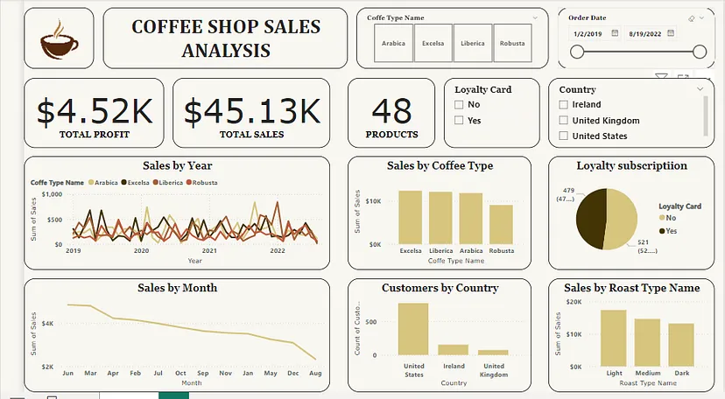

Milestones
- Week 1: Define project scope and explore dataset structure
- Week 2: Perform data cleaning and preprocessing
- Week 3: Conduct exploratory data analysis and identify trends
- Week 4: Develop visualizations and build an interactive dashboard
- Week 5: Finalize the project report and prepare the presentation

Timeline

Week | Tasks
Week 1
  Define the business problem, and scope project, and explore the dataset
Week 2
  Clean and preprocess data
Week 3
  Perform exploratory data analysis
Week 4 | Build and refine the dashboard
Week 5
  Create final report and presentation

