Lab Activity 0A: Flutter Installation

Materials Needed:
- A computer with Flutter installed.
- A code editor (like VS Code or Android Studio).
- The provider package installed in your Flutter project.

Instructions:
Follow the installation process.

Steps:
Install Flutter SDK
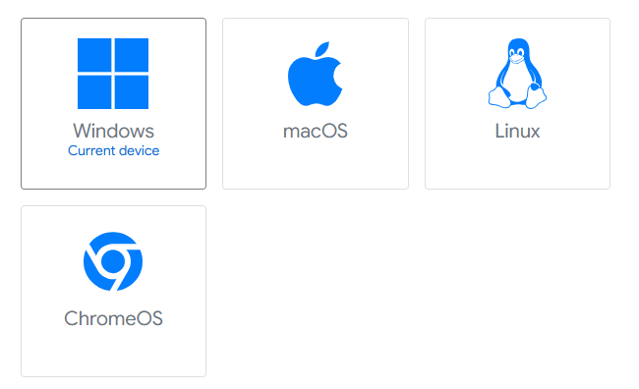
Install | Flutter

Extract to C:
Add to PATH
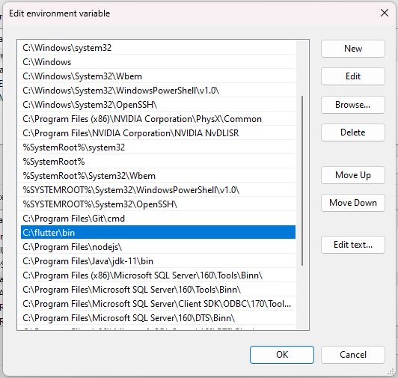
Run “flutter doctor -v”
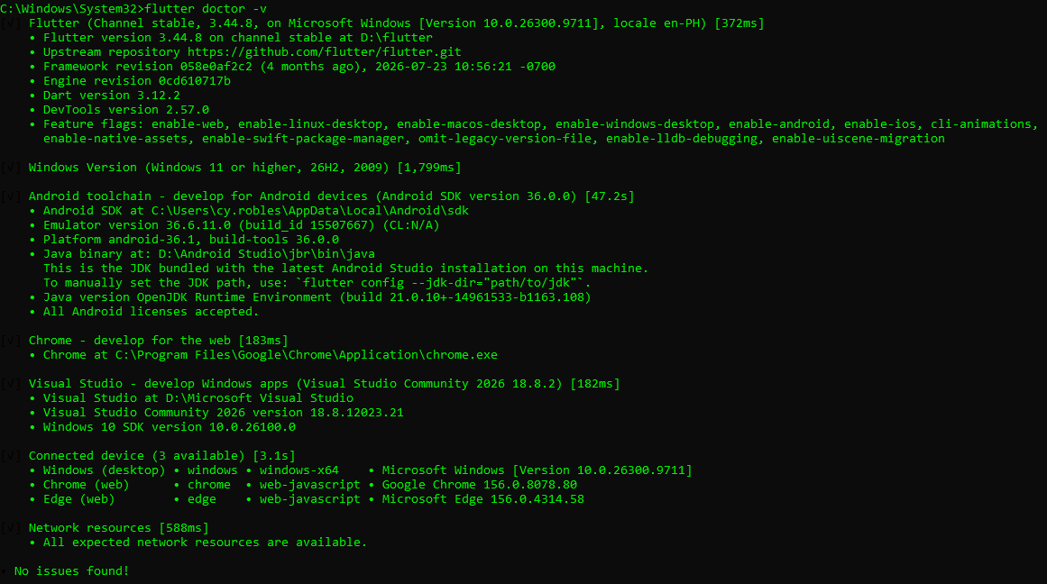

Laboratory A: Instruction
Complete each step of the provided procedure in order. Document your progress by taking a screenshot of each accomplished step, then paste the screenshots in chronological order into the initial output section of the Laboratory Activity Submission Form.

