1. 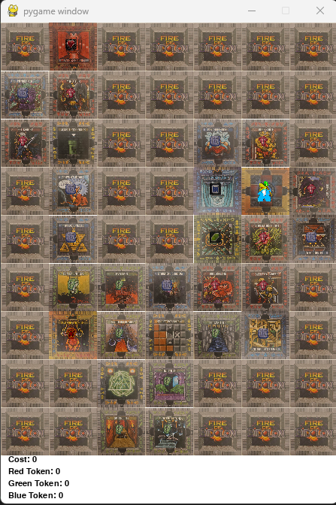
2. A screenshot of a game

   Description automatically generated with medium confidence

15 April 2023: Problem: Not shortest Route: Manhattan Heuristic

X_heuristic 5

Y_heuristic 5

tile_order = [[ 0, 3, 0, 0, 0, 0, 0], [20, 10, 0, 0, 0, 0, 0], [16, 7, 0, 0, 13, 25, 0], [0, 24, 0, 0, 5, 1, 27], [ 0, 15, 0, 0, 4, 9, 29], [ 0, 18, 26, 12, 14, 21, 0], [ 0, 2, 22, 8, 19, 28, 0], [ 0, 0, 6, 23, 0, 0, 0], [ 0, 0, 17, 11, 0, 0, 0]]

rotations = [[0, 0, 0, 0, 0, 0, 0], [0, 0, 0, 0, 0, 0, 0], [0, 0, 0, 0, 0, 0, 0], [0, 0, 0, 0, 2, 0, 1], [0, 0, 0, 0, 3, 0, 2], [0, 0, 0, 0, 0, 0, 0], [0, 2, 0, 0, 0, 2, 0], [0, 0, 0, 0, 0, 0, 0], [0, 0, 0, 0, 0, 0, 0]]

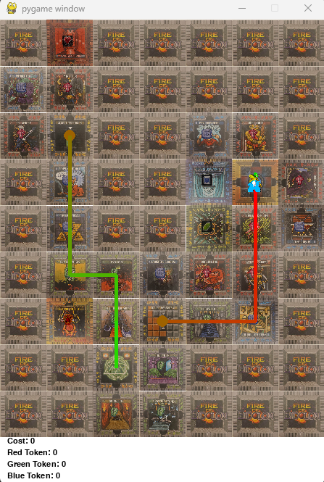

Problem: Not shortest Route: Euclidian Heuristic

X_heuristic 4.123105625617661

Y_heuristic 3.605551275463989

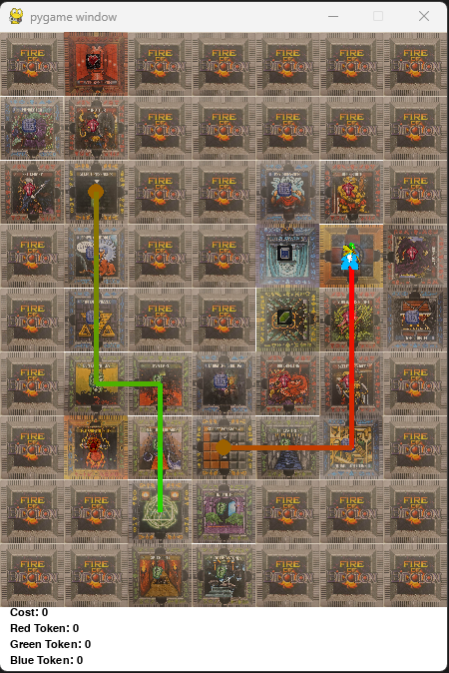

No secret heuristic

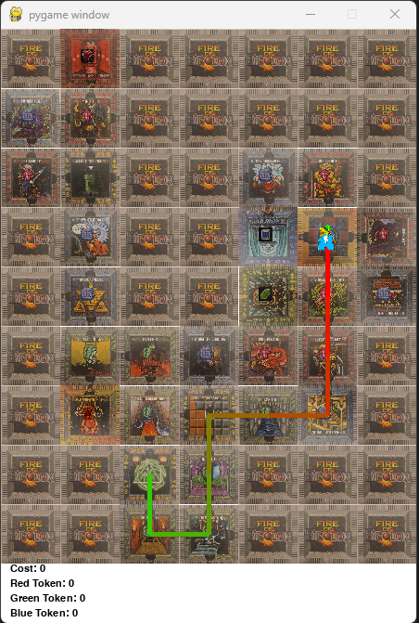

Manhattan with goal and front heuristic. Problem fixed.

