Logical View of the components involved:



SoapUI test cases (with assertions):

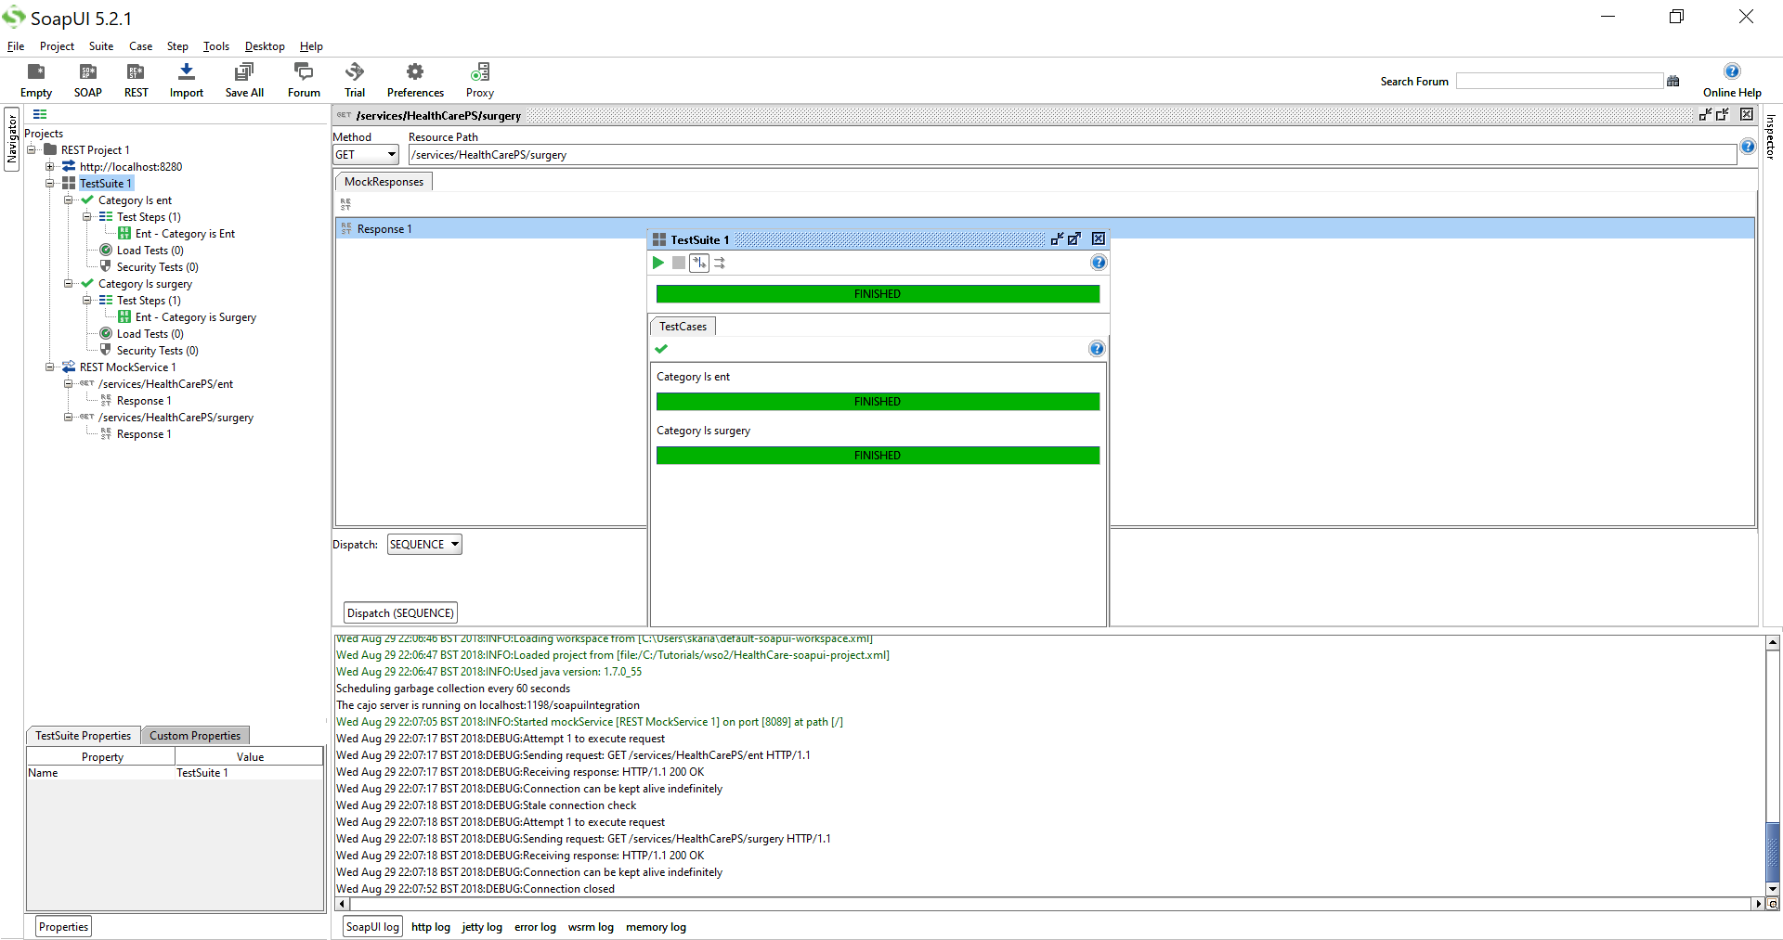

Mock SoapUI services for Healthcare Mock Proxy Service:

Healthcare Mock Proxy Service calls SoapUI Mock Services

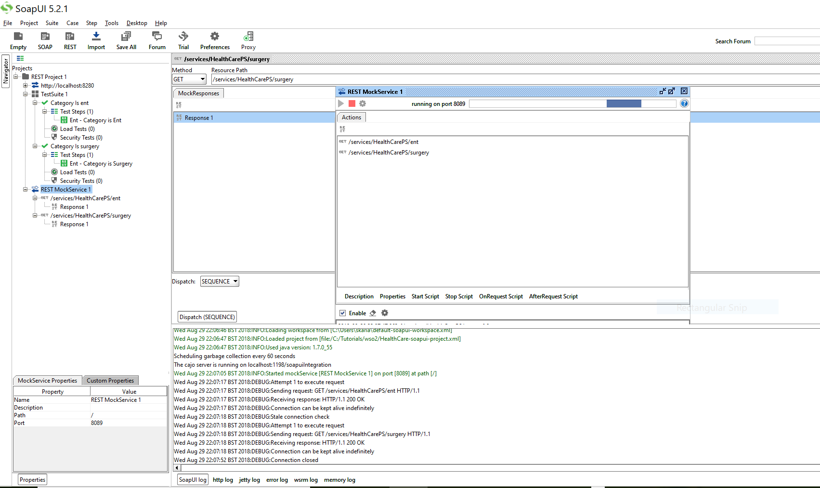

1. Issues faced:
   1. By default Proxy uses SOAP protocol, it seems like that
   2. EI Endpoint design view became form view and did not appear again in design view?
   3. choosing type of endpoint is important if it is REST
   4. have to add new PS via editor, otherwise if you copy, then it does not get reflected in the Composite App?
   5. Port clashed between EI and API Manager, so had to set port offset in carbon.xml file(-ve offset of 1000)
   6. http://localhost:7280/healthcare/1.0.0   
      [http:// localhost:7280/healthcare/](http://10.47.49.232:7280/healthcare/)