ER Model for FLIP

2014

Contents

Relationships 2

Students - Sessions 2

Students - Activity 2

Students - Exercises 2

Exercises – Attempts 2

Exercises – Tasks 2

Concepts – Tasks 3

Exercises – Misconceptions_Identified 3

Rules – Misconceptions_Identified 3

Misconception_Categories - Rules 3

Rules - Conditions 4

Conditions – Condition_Templates 4

Rules - Actions 4

Actions – Action_Templates 4

ER Diagram 5

Data Dictionary 6

# Relationships

Identification and authentication of users (students) will be done using the Facebook security infrastructure.

The students entity comprises only two properties. The (id) which is taken from Facebook and the time of registration. The rest of the information can be provided on demand from Facebook dynamically and therefore doesn’t have to be recorded in the system.

## Students - Sessions

One student can be associated with one or more sessions.

One session can be associated with only one student.

## Students - Activity

One student can be associated with one or more activity states. In other words the student can be active or inactive many times during the usage of the system.

One state can be associated with only one student.

Activity represents the state of the student (active vs inactive) at any given time throughout the session.

## Students - Exercises

One student can be associated with zero or more exercises.

One exercise can be associated with only one student.

## Exercises – Attempts

One exercise can be associated with one or more attempts.

One attempt can be associated with only one exercise.

Exercises represent tasks that students decide to accomplish. These tasks can be student-defined or tutor-defined. The latter are predefined and stored in the system. The idea is that as the student is experimenting with some code, she can give it a name and description and store it in the database. After that any attempt to accomplish the requirements of the exercise can be recorded in the database as an ‘attempt’ associated with it. Attempts represent all the historical data associated with an exercise.

## Exercises – Tasks

One exercise can be associated with zero or more tasks.

One task can be associated with zero or more exercises.

A student may want to accomplish a task given by a tutor. In this case the task is used as a template exercise. If the student wants to use it as it is then the generated exercise is linked to the task. If the user wants to modify it then there is the option to maintain in as an independent user-defined exercise.

The relationship between the two entities is many-to-many. Implementation-wise that presupposes an intermediary entity that will be used to brake this relationship in two one-to-many parts. The entity exercises_tasks serves this purpose.

## Concepts – Tasks

One task can be associated with zero or more concepts.

One concept can be associated with zero or more tasks.

This is again a many-to-many relationship. The entity ‘concepts_tasks’ is used to decompose it in two one-to-many relationships.

## Exercises – Misconceptions_Identified

One exercise can be associated with zero or more misconceptions.

One misconception can be associated with only one exercise.

## Rules – Misconceptions_Identified

One rule (misconception) can be associated with zero or more identified misconceptions.

One identified misconception can be associated with only one rule.

## Misconception_Categories - Rules

One misconception category can be associated with one or more rules (misconceptions).

One rule (misconception) can be associated with only one misconception category.

Rules represent abstract known student misconceptions.

Misconceptions_identified represent materialised student misconceptions associated with a particular code fragment and the corresponding exercise it belongs to.

Rules comprise two parts: the conditional (conditions) and the subsequent (actions).

A condition represents a situation that is supported (satisfied) by a number of facts.

An action represents the action that needs to be taken as a consequence of a condition that is satisfied.

## Rules - Conditions

One rule can be associated with one or more conditions.

One condition can be associated with only one rule.

## Conditions – Condition_Templates

One condition template can be associated with zero or more conditions.

One condition can be associated with only one condition template.

## Rules - Actions

One rule can be associated with one or more actions.

One action can be associated with only one rule.

## Actions – Action_Templates

One action template can be associated with zero or more actions.

One action can be associated with only one action template.

Condition and action templates are used by experts to provide facts and actions for the formation of a rule.

# ER Diagram

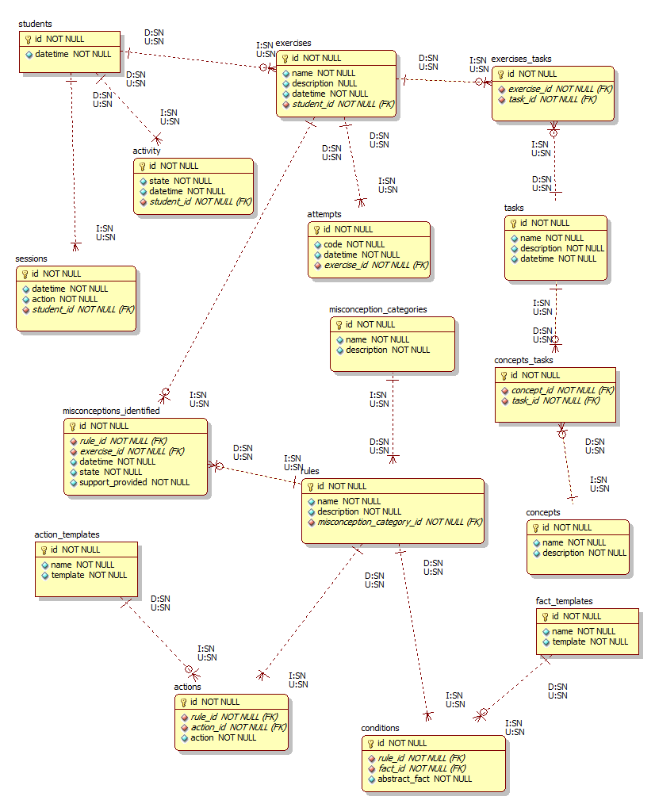

# Data Dictionary

