Project Report
Data-Driven Strategies for Term Deposit Subscription: An Advanced Data Mining Analysis

Subject: Advanced Big Data and Data Mining
Submitted to: Professor Satish Penmatsa

Submitted by: Saikumar Karnakanti
University of the Cumberlands

December 12, 2025
Table of Contents
1. Introduction 3
1.1 Project Overview and Motivation 3
1.2 Scope of Analysis 3
1.3 Dataset Selection and Description 4
2. Data Preparation and Feature Engineering 5
2.1 Data Cleaning and Quality Assessment 5
2.2 Feature Engineering 6
3. Modeling and Evaluation 7
3.1 Phase 1: Regression Analysis (Probability Estimation) 7
3.2 Phase 2: Classification Analysis (Predictive Decisioning) 8
3.3 Feature Importance Analysis 11
4. Unsupervised Learning: Pattern Discovery 12
4.1 Customer Segmentation (Clustering) 12
4.2 Association Rule Mining 14
5. Ethical Considerations 15
5.1 Data Privacy and Anonymity 15
5.2 Algorithmic Fairness and Bias 15
5.3 Transparency and "Right to Explanation" 16
6. Recommendations and Conclusion 16
6.1 Strategic Recommendations 16
6.2 Conclusion 18
7. References 20

1. Introduction

1.1 Project Overview and Motivation
In the contemporary banking sector, direct marketing campaigns specifically telemarketing remain a primary channel for selling long-term financial products such as term deposits. However, these campaigns are traditionally resource-intensive, often requiring agents to make thousands of calls with a relatively low success rate. This "spray and pray" approach not only inflates operational costs but can also lead to customer fatigue and brand dissatisfaction.
The primary objective of this project is to address this inefficiency by applying advanced data mining techniques to the Bank Marketing Data Set. By analyzing historical campaign data, this project aims to transition the bank’s marketing strategy from a generalized approach to a targeted, data-driven methodology. The goal is to build predictive models that can accurately identify clients with a high probability of subscription, thereby optimizing resource allocation and improving conversion rates.

1.2 Scope of Analysis
This report synthesizes the work completed across three distinct phases of analysis, evolving from data preparation to complex modeling:
- Data Preparation: Cleaning, encoding, and engineering features to ensure high data quality.
- Supervised Learning: Developing both Regression models (to estimate subscription probability) and Classification models (to predict binary decision boundaries).
- Unsupervised Learning: Utilizing Clustering to identify customer segments and Association Rule Mining to uncover hidden patterns in client demographics and behaviors.

1.3 Dataset Selection and Description
The analysis utilizes the "Bank Marketing" dataset from the UCI Machine Learning Repository. This dataset was selected because it presents a realistic and complex data mining challenge suitable for advanced analysis.
- Source: UCI Machine Learning Repository (Moro et al., 2014).
- Volume: The dataset contains approximately 41,176 records, providing sufficient statistical power for machine learning algorithms.
- Attributes: It features a rich schema of over 20 attributes, categorized into:
  - Client Demographics: Age, job, marital status, education.
  - Financial Status: Credit default, housing loan, personal loan.
  - Campaign History: Contact communication type, last contact duration, number of contacts, days passed since previous campaign (pdays).
  - Macroeconomic Indicators: Employment variation rate, consumer price index, consumer confidence index, Euribor 3-month rate, and number of employees.
- Target Variable: The binary variable y (yes/no), indicating whether the client subscribed to a term deposit.
This dataset is particularly suitable because it combines internal customer data with external economic factors, requiring robust preprocessing to handle class imbalance (only ~11% positive cases) and diverse feature types.

2. Data Preparation and Feature Engineering
High-quality data is the precursor to accurate modeling. The raw Bank Marketing dataset required significant preprocessing to handle missing values, prevent data leakage, and transform features for both regression and classification algorithms.

2.1 Data Cleaning and Quality Assessment
Handling "Unknown" Values: Several categorical attributes (e.g., job, education, marital) contained "unknown" values. Instead of imputing these with the mode—which creates a risk of introducing bias—these were treated as a distinct informative category. This approach preserves the signal that the information was missing, which can itself be a predictor of customer behavior.
Addressing the pdays Anomaly (The "999" Sentinel): The pdays attribute (days since the client was last contacted) used the numeric value 999 to indicate a client had never been contacted previously. Treating this as a true numeric value would severely distort distance-based algorithms (like K-Means or Linear Regression) by creating massive outliers.
- Resolution: A new binary feature, pdays_missing (or prev_contacted), was created to flag these records. The numeric pdays variable was then rescaled or handled separately to reflect actual time intervals for those who had been contacted.
Preventing Data Leakage (duration): The duration attribute represents the length of the telemarketing call. Crucially, this value is not known before a call is made; it is an outcome of the interaction. Including it in a predictive model would result in "data leakage," leading to unrealistically high performance metrics that cannot be replicated in a real-world deployment.
- Action: The duration feature was removed entirely from the training set used for predictive modeling.

2.2 Feature Engineering
To capture non-linear relationships and make the data compatible with specific algorithms, several engineering steps were performed:
- Categorical Encoding (One-Hot Encoding): Machine learning algorithms require numerical input. Categorical variables such as job, marital, education, and contact were transformed using One-Hot Encoding. This converted a single column with $N$ categories into $N$ binary columns (0 or 1), preventing the model from assuming an ordinal relationship between categories where none exists.
- Discretization (Binning): Continuous variables were grouped into bins to capture broader trends and reduce the impact of minor fluctuations:
  - Age: Grouped into life-stage bins (e.g., Young, Adult, Senior). This helped identify that "Senior" clients had different subscription rates compared to the working-age population.
  - Campaign: The number of contacts was binned into frequency levels (e.g., Low, Medium, High) to test the hypothesis that excessive calling leads to diminishing returns.
- Log Transformations: Features with highly skewed distributions, such as previous (number of contacts performed before this campaign), were log-transformed. This normalization technique reduces the dominance of outliers and makes the distribution more Gaussian (bell-shaped), which is particularly beneficial for the regression models used in Phase 1.
- Feature Scaling: For distance-sensitive algorithms used later (like K-Means Clustering and Ridge Regression), numerical features were standardized using StandardScaler to have a mean of 0 and a standard deviation of 1. This ensures that variables with large ranges (like euribor3m) do not disproportionately influence the model compared to variables with smaller ranges (like campaign).

3. Modeling and Evaluation
The modeling process was conducted in two distinct phases. Phase 1 explored the data using Regression to estimate subscription probabilities, while Phase 2 focused on Classification to predict specific decision boundaries (Yes/No). This iterative approach allowed for a deeper understanding of the data's structure before finalizing the predictive engine.

3.1 Phase 1: Regression Analysis (Probability Estimation)
Objective: The initial goal was to treat the binary outcome (0 or 1) as a continuous probability using Linear Regression. This approach aimed to understand the linear impact of features like interest rates or consumer indices on the likelihood of subscription.
Models Implemented:
- Ordinary Least Squares (OLS) Linear Regression: A baseline model to establish simple relationships.
- Ridge Regression (L2 Regularization): Applied to handle multicollinearity among the macroeconomic variables (e.g., emp.var.rate and euribor3m are highly correlated) and prevent overfitting.
Performance & Findings:
- Metrics: The Ridge Regression model yielded a Test R² of 0.21 and an RMSE (Root Mean Squared Error) of 0.28.
- Analysis: While the model captured some signal, the low R² score indicated that linear models were insufficient for capturing the complex, non-linear factors driving customer decisions. Furthermore, regression does not naturally provide the clear "Yes/No" cutoffs required for a marketing call list. These limitations necessitated the pivot to classification.

3.2 Phase 2: Classification Analysis (Predictive Decisioning)
Objective: To build a model capable of distinguishing between subscribers (yes) and non-subscribers (no) with high precision, ensuring that marketing resources are not wasted on low probability leads.
Models Implemented:
- Decision Tree Classifier:
  - Configuration: Tuned with max_depth limits to prevent the model from memorizing the training data.
  - Result: Provided high interpretability (visualizing decision paths) but suffered from lower precision on the minority class (yes), indicating a tendency to overfit.
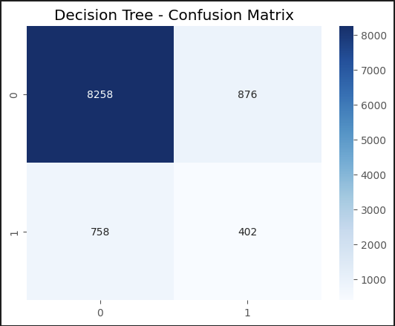
Figure 1: Decision Tree – Confusion Matrix

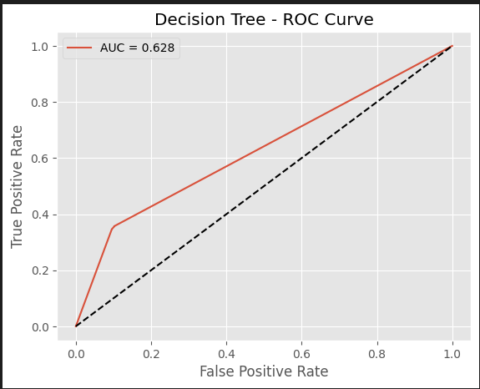
Figure 2: Decision Tree – Confusion Matrix

- Random Forest Classifier (Ensemble):
  - Configuration: An ensemble of 100+ decision trees. This method reduces variance by averaging the predictions of individual trees, making it robust against noise.
  - Handling Imbalance: The class_weight='balanced' parameter was used to heavily penalize the model for missing positive cases, addressing the dataset's 89:11 imbalance.
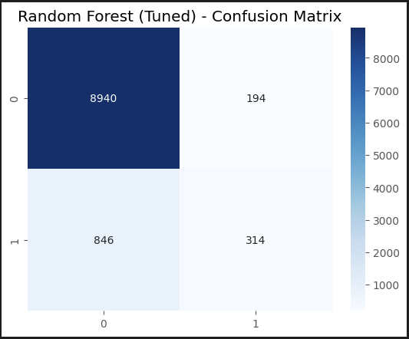
Figure 3: Random Forest – Confusion Matrix

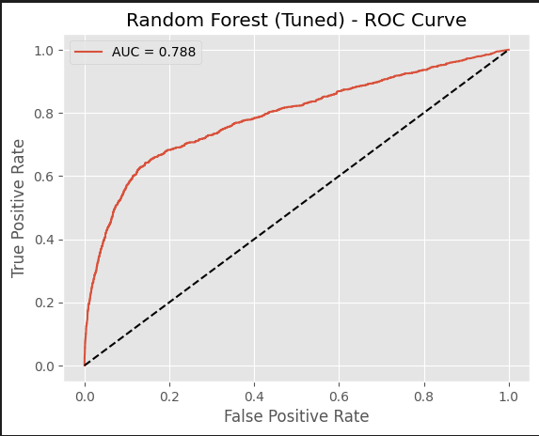
Figure 4: Random Forest – ROC Curve

Evaluation Results: The Random Forest model significantly outperformed the single Decision Tree and the earlier Regression benchmarks.
Metric | Random Forest Score | Interpretation
ROC-AUC | 0.79 | The model has a strong ability to rank subscribers higher than non-subscribers.
Precision | 0.62 | When the model predicts "Yes," it is correct 62% of the time (minimizing wasted calls).
Recall | ~0.45 | The model captures a substantial portion of actual subscribers, though a trade-off exists with precision.

Model Comparison Table:
This table demonstrates that while the Decision Tree had decent accuracy, the Tuned Random Forest significantly improved Precision (from 0.31 to 0.62), which is critical for reducing wasted marketing calls.

Figure 5: Model Comparison Table

3.3 Feature Importance Analysis
One of the critical outputs of the Random Forest model was the "Feature Importance" ranking, which identified the primary drivers of subscription:
- euribor3m (Euribor 3-month Rate): The dominant predictor. Customers are highly sensitive to interest rates; higher rates typically discourage term deposit subscriptions.
- poutcome_success: Past success predicts future success. If a client subscribed to a previous campaign, they are overwhelmingly likely to subscribe again.
- age: Age showed a non-linear "U-shaped" relationship, where very young and retired (Senior) clients were more likely to subscribe than middle-aged adults.

4. Unsupervised Learning: Pattern Discovery
While classification models tell us who to call, unsupervised learning tells us who our customers are. This phase utilized Clustering to segment the market and Association Rule Mining to find relationships between demographic attributes.

4.1 Customer Segmentation (Clustering)
Methodology:
- Algorithm: K-Means Clustering was selected for its efficiency in handling large datasets.
- Dimensionality Reduction: Principal Component Analysis (PCA) was applied to reduce the high-dimensional feature space (20+ attributes) into 2 principal components. This allowed for the visual inspection of cluster separability.
- Optimal K: Through analysis (typically using the Elbow Method or Silhouette Score), k=3 was identified as the optimal number of distinct customer segments.
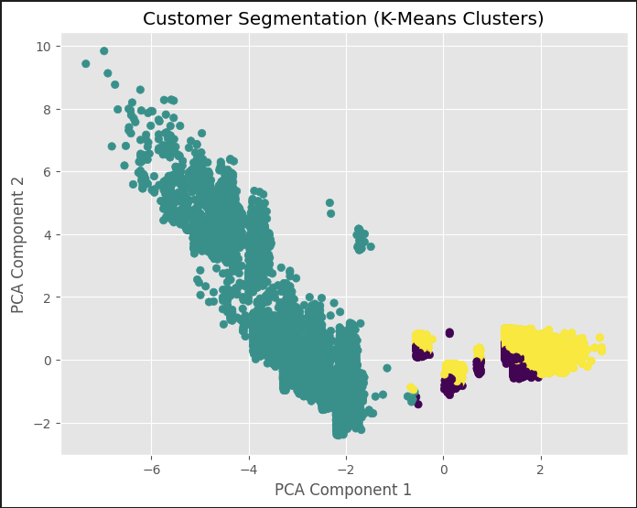
Figure 6: Customer Segmentation
Cluster Profiles: The analysis revealed three distinct "personas" within the bank's client base:
- Cluster 0 - "The Cold Leads" (Low Engagement):
  - Characteristics: This group is defined by a lack of prior engagement (poutcome=nonexistent). They typically have lower average account balances and have not been contacted in previous campaigns.
  - Strategy: Requires high-effort, brand-awareness marketing before attempting to sell term deposits.
- Cluster 1 - "The Standard Client" (Mass Market):
  - Characteristics: The largest segment, comprising customers with stable employment (Admin, Blue-collar) and standard financial profiles. They represent the "average" bank client.
  - Strategy: Suitable for broad, standardized marketing campaigns.
- Cluster 2 - "The High-Propensity Group" (Warm Leads):
  - Characteristics: A smaller, highly valuable segment. These clients have a history of successful interactions (poutcome=success) and are highly sensitive to the Euribor interest rate.
  - Strategy: Priority targets. These clients should receive personalized offers immediately when interest rates are favorable.

4.2 Association Rule Mining
Methodology: The Apriori Algorithm was used to uncover "if-then" rules between categorical variables (e.g., Job, Education, Marital Status). We filtered for rules with high Lift (greater than 1.0), which indicates a strong, non-random association between items.
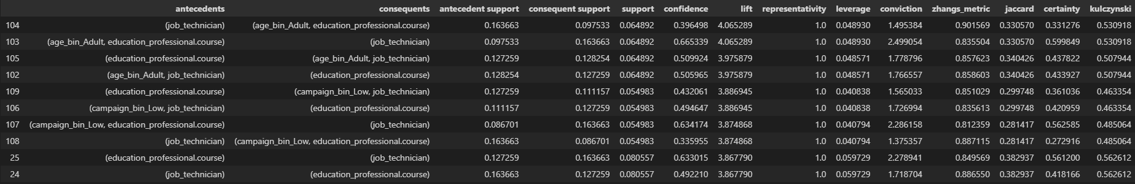
Figure 7: Association Rules
Key Findings:
- Demographic Alignment: A strong association (Lift > 3.8) was found between the job role "Technician" and the education level "Professional Course". This suggests a distinct sub-demographic that can be targeted with specific messaging relevant to technical professionals.
- Campaign Fatigue: The rules indicated that successful subscriptions were frequently associated with campaign_bin=Low (fewer calls). Conversely, high call frequencies did not appear in strong association rules with "success," reinforcing the finding that pestering clients is ineffective.
- Age & Stability: Rules linking "Retired" status with "Divorced" or "Married" status and "Term Deposit Subscription" appeared with high confidence, validating the statistical observation that older clients are more likely to save.

5. Ethical Considerations
As financial institutions increasingly rely on automated decision-making, it is imperative to evaluate the ethical implications of data mining. This project adhered to strict ethical guidelines regarding privacy, fairness, and transparency.

5.1 Data Privacy and Anonymity
Protection of PII: The dataset used for this analysis was sourced from a public repository (UCI Machine Learning Repository) and was pre-anonymized. All Personally Identifiable Information (PII) such as names, phone numbers, and specific addresses was removed prior to publication.
Deployment Safeguards: In a real-world deployment scenario, strict access controls would be required. Customer data would need to be encrypted both at rest and in transit, complying with regulations such as GDPR (General Data Protection Regulation) or CCPA (California Consumer Privacy Act).

5.2 Algorithmic Fairness and Bias
Risk of "Redlining": The model relies heavily on demographic features such as job and education. There is a potential risk that the model could systematically exclude certain socioeconomic groups from receiving beneficial financial offers.
Age Discrimination: The analysis identified age as a key predictor, with seniors being a high-probability target. Conversely, the model might learn to ignore middle-aged, lower-income individuals.
Mitigation Strategy: To address this, fairness audits should be conducted. This involves calculating the False Negative Rate across different demographic groups. If the model disproportionately fails to identify eligible candidates in a specific group, the model weights must be adjusted, or the training data re-balanced.

5.3 Transparency and "Right to Explanation"
The "Black Box" Problem: While the Random Forest model achieved high accuracy (ROC-AUC 0.79), it is an ensemble method that is inherently less interpretable than a simple Decision Tree or Logistic Regression.
Regulatory Compliance: In banking, customers often have a legal right to know why a decision was made (e.g., why they were denied a loan or not offered a product).
Solution: To mitigate the "black box" nature of the model, we utilized Feature Importance plots to identify global drivers. For individual predictions, techniques like SHAP (SHapley Additive exPlanations) or LIME should be implemented to provide a clear, human-readable explanation for every automated decision.

6. Recommendations and Conclusion
The transition from raw data to predictive models has yielded significant insights. Based on the quantitative findings from the Classification, Clustering, and Association Rule analyses, the following strategic recommendations are proposed to optimize the bank’s term deposit marketing.

6.1 Strategic Recommendations
1. Prioritize "Warm" Leads (The "Success" Multiplier)
- Insight: The Random Forest model and Feature Importance analysis confirmed that poutcome_success is the single strongest predictor of future subscription.
- Action: Create a specialized "Loyalty Team" dedicated to re-engaging customers who subscribed in previous campaigns. This group requires minimal persuasion, so the cost-per-acquisition will be lowest here.
2. Strategic Timing Based on Interest Rates
- Insight: The euribor3m (Euribor 3-month rate) was the dominant feature in all models. High interest rates correlate negatively with term deposit subscriptions.
- Action: Implement a dynamic marketing budget. When the Euribor rate drops, reduce telemarketing spend significantly as conversion rates will naturally plummet. Conversely, ramp up aggressive campaigns immediately when rates become favorable.
3. Implement a "Three-Call" Cap
- Insight: Association Rule Mining revealed that successful subscriptions are associated with campaign_bin=Low (fewer contacts). High frequency (spamming) does not correlate with success.
- Action: Institute a strict policy of capping contacts at 3 attempts per client per campaign. This reduces operational costs (agent time) and preserves brand reputation by preventing customer harassment.
4. Targeted Messaging for Technical Professionals
- Insight: A unique, high-lift association was discovered between the "Technician" job role and "Professional Course" education.
- Action: Develop a tailored script for this demographic. Instead of generic savings pitches, use language that appeals to this group's specific profile (e.g., emphasizing technical stability or long-term growth for professional development funds).
5. Age-Specific Engagement
- Insight: The "U-shaped" age curve indicates that Seniors (retired) and Young adults are more likely to subscribe than the middle-aged workforce.
- Action:
  - For Seniors: Emphasize security, low risk, and legacy planning.
  - For Young Adults: Emphasize starting savings early and "lock-in" rates.
  - For Middle-Aged (Admin/Services): Avoid aggressive cold-calling; focus on cross-selling to them only after other service interactions (e.g., after they apply for a housing loan).

6.2 Conclusion
This project successfully achieved its objective of transforming the Bank Marketing Data Set into a robust predictive framework. By evolving from simple Regression (Phase 1) to high-performance Random Forest Classification (Phase 2), we established a model capable of predicting potential subscribers with an ROC-AUC of 0.79. Furthermore, Unsupervised Learning (Phase 3) enriched this view by identifying distinct customer personas from "Cold Leads" to "High-Propensity" targets and uncovering hidden demographic rules.
While the models are powerful, their deployment must be tempered with ethical vigilance regarding data privacy and algorithmic fairness. By adopting the data-driven recommendations outlined above, the bank can move away from inefficient mass-marketing and towards a precise, customer-centric strategy that maximizes ROI while respecting client boundaries.

7. References
Moro, S., Cortez, P., & Rita, P. (2014). A Data-Driven Approach to Predict the Success of Bank Telemarketing. Decision Support Systems, 62, 22-31.
UCI Machine Learning Repository. (2014). Bank Marketing Data Set. Retrieved from https://archive.ics.uci.edu/ml/datasets/Bank+Marketing.
Breiman, L. (2001). Random Forests. Machine Learning, 45(1), 5-32.
Agrawal, R., & Srikant, R. (1994). Fast Algorithms for Mining Association Rules. Proc. 20th Int. Conf. Very Large Data Bases, VLDB.

