MSDS 458: Assignment 1
Computer Vision with MNIST

Soraya Butler
MSDS 458: AI & Deep Learning
January 25, 2026

1.0 Abstract
The MNIST handwritten digit dataset is foundational to both the history of neural networks, and to the education of students new to computer vision. This paper seeks to explore how adding increasing complexity to a simple single hidden-layer neural network affects neural network model performance over the MNIST dataset. While similar experiments have been conducted by experts in the field to understand the efficacy of single layer neural networks for classification, this report is focused on experimenting with single layer model composition for educational purposes only. Five experiments encompassing eleven models were developed to analyze how greater node count and various preprocessing steps affect model scoring. Ultimately, a higher node count corresponded to better performance at little sacrifice to computational efficiency, with a node count of 100 yielding the best testing accuracy, without the need for preprocessing. With PCA preprocessing to reduce dimensionality to 154, test accuracy and loss had similar results but suffered poorer comparisons of validation/training loss and accuracy. Further experiments are necessary to understand model generalizability, and enhancements to model complexity with additional layers, nodes, or model compile steps are worth considering.
2.0 Introduction
The MNIST dataset is foundational in the field of computer vision, and since its development in 1998 for optical character recognition, it has been used by students and developers as a reliable benchmark for evaluating image classification models (Astrodave and Cukierski 2012). Developed by Yann LeCun (1998), MNIST was originally used to train an iteration of the first practical convolutional neural network, dubbed LeNet-5. Today, the MNIST dataset is a popular learning tool for students beginning their education in computer vision. Towards the effort of knowledge and education, this report describes the methodology and results for a series of experimentations over the MNIST dataset. The goal of experimentation is to understand the architecture of a simple neural network, and evaluate how incremental modifications to single layer node count affect model performance for MNIST digit recognition. The experiments were performed in Python, in a Google Colab notebook using Tensorflow Keras. Relevant figures to the study are in Appendix A, and the source code and model outputs are provided in the separate HTML-file Appendix B.
3.0 Literature Review
Neural Networks have their origins in the perceptron, developed by Rosenblatt in 1957, consisting of a single layer that maps input to output (Foote 2021). Due to the development of backpropagation by Werbos in 1974 that was repopularized by Rumelhart, Hinton & William in the 1980s, the perceptron later evolved to a network with multiple hidden layers, though complex pattern recognition came at the expense of computational expense and model instability (Voulodimos 2018). LeCun’s 1998 paper “Gradient-Based Learning Applied to Document Recognition” marks one of the first successful implementations of neural networks using gradient descent for image classification, using the MNIST dataset to classify handwritten digits. Deep learning was further popularized in the 2010’s, partially in credit to the major advances in graphical processing units (GPUs) which made large-scale neural network training feasible for practical use (Foote 2021).
Similar experiments to those described in this paper have been conducted, to understand how the performance of single-layer neural networks are affected by node count. In 1998, Zhang and Morris used a sequential approach to train a single hidden layer by adding one node at a time and mapping the results orthogonally to previous results. The authors use Gram-Schmidt orthogonalization method to optimize for neuron weight and selection. Zhang and Morris proposed this sequential orthogonal training method to right-size the number of nodes in a hidden layer and reduce model complexity.
Moreover, there is a field of machine learning that seeks to only use a wide, single hidden-layer for classification and regression: Extreme Machine Learning (EML) (McDonnell et al. 2015). While the modifications that need to be performed over a neural network to adapt it to EML are outside of the scope of this report, a 2015 experiment using EML to classify MNIST digits is relevant due to the similarities in methodology (McDonnell et al. 2015). The study found that, after experimenting with incremental node count to classify MNIST using an EML, that 15k hidden nodes returned the best accuracy of 99%.
While the approach to single-layer neural networks for MNIST classification is performed at a much simpler scope in this report than the experiments described in this literature review, the questions being addressed are similar. The goal of this report is to understand how the architecture of a single hidden-layer neural network can best be configured for classification in practical application.
4.0 Methods
Keras Tensorflow in a Google Colab notebook is used to develop and evaluate a total of single layer neural network models. A number of other Python libraries were necessary for experimentation, such as Pandas, Numpy, sci-kit learn, seaborn, and matplotlib. The first eight models used the same base structure: a flattened 784-element input layer followed by a single hidden layer with ReLU activation, and a softmax output layer for multiclass prediction. Validation was employed over 5000 samples of the training set, and separated before fitting to reduce data leakage in later experiments.
The data was loaded into the notebook using Keras, and preprocessing was performed over the loaded data. A total of 55,000 samples are included in the training set, and 10,000 in the testing set. Each sample is an image of a handwritten numeral, from 0 to 9. Images are reshaped from a 28 by 28 2D array to a 1D array of shape 784 to meet input requirements for Keras neural network development. Preliminary exploratory data analysis (EDA) was performed over the test and training data set (Figure A1, Figure A2). Because the loss function chosen for the experiment is sparse cross entropy, one-hot encoding was not required over the data. With sparse categorical cross-entropy, target labels are captured as integers for more efficient multi-class classification (Bomble 2025). Methodology for the eleven models, across five experiments, are as follows.
Experiment 1 served as the baseline, establishing scores when a very simple neural network was employed. A single layer, with a single hidden node, is used. The testing set is used for predictions, and metrics accuracy, loss, validation accuracy, and validation loss are generated. Using Matplotlib, two multiline charts are generated (Figure A3). The first line chart shows model training and validation accuracy across epochs, and the second line chart shows model training and validation loss across epochs. A confusion matrix is also generated, showing the distribution of predictions across true labels (Figure A4). Additional analysis was employed over the activation values of the hidden layer. Activations are gathered from the hidden layer for each class, and visualized with a boxplot (Figure A5). The pattern that maximally activates the hidden node is displayed (Figure A6).
Experiment 2 sought to incrementally improve upon experiment 1 by adding an additional node to the single hidden layer. The same scores are gathered from model training and testing as with experiment 1, in addition to the same visualizations (Figure A7, Figure A8). Digit misclassification is scrutinized in greater detail here (Figure A9). Similar to experiment 1, activation values are obtained from the model. However, this time a scatterplot is used to visualize the differences in activation values by hidden nodes, by prediction (Figure A10).
Experiment 3 ran the data through six different models, with varying node types, to select a “best” model for further feature engineering. All models were trained using the rmsprop optimizer, sparse categorical crossentropy loss, and 30 epochs. Despite having the same foundational design, the variation in architecture influenced both training behavior and final accuracy. Visualizations to evaluate model performance include a multi-line chart to evaluate training and validation accuracy and loss (Figure A11), and confusion matrices (Figure A12).
Two models, featured in experiment 4 and 5, attempted to reduce dimensionality of the input vector using PCA and random forest. These models used the best identified node count from experiment 3. The PCA-preprocessed model used a multi-line chart of training and validation accuracy and loss to evaluate model performance (Figure A13). The performance of the random forest model to select important pixels are visualized (Figure A14, Figure A15), and like the PCA-preprocessed model, training and validation accuracy and loss are evaluated (Figure A16)
5.0 Results
Preliminary results by EDA revealed that the frequency of each label is relatively uniform, with digit 5 having the lowest training frequency of 5421 and digit 1 present at the highest training frequency of 6742 (Figure A1). The images are plotted directly in the notebook to analyze how digits appear. Digits appear handwritten, largely by the same hand, with slight variations in how digits are formed and the weight of the “pen.” Some sevens, for example, are drawn with the dash through the vertical line, while others are not (Figure A2). These variations in digit composition that are apparent through human perception also need to be accurately captured by the neural network.
Experiment 1 tested how the simplest model, with 1 node in the hidden layer, performed, and served as a baseline. It converged quickly but achieved the lowest test accuracy of 0.3945 and highest loss of 1.5629, highlighting the limitations of reduced capacity. However, it’s worth noting that this accuracy is still greater than a “random” guess for the digits, which would be 0.1. Training accuracy for experiment 1 closely followed or improved upon validation accuracy throughout epochs, suggesting that the model performs similarly to unseen data (Figure A3). A confusion matrix for experiment 1 test results shows that classification for some digits performed far worse than others, namely 5, which had 0 correct predictions (Figure A4). This shows that the model for experiment 1 does a poor job at capturing the variations in digit composition that differentiate digits with similar features. Mapping activation values by class for the hidden layer did reveal that activation by class tended to cluster, although many digits had a number of outlying activation values that overlapped the central 50% of other classes, demonstrating ineffective learning ability (Figure A5). The pattern that maximally minimized the node for experiment 1 is not readily identifiable, though there is a discernable concentration of high values near the center, where pixel importance may be heightened for digit recognition (Figure A6).
In experiment 2, the additional node included in the hidden layer nearly doubled the testing accuracy, at 0.6621, and lowered the loss by 29.76% at 1.0978. Similarly to experiment 1, training accuracy and loss closely followed validation accuracy loss, demonstrating consistent performance on unseen data (Figure A7). The digit 5 was much better classified with this model compared to the last, at 358 out of 982 (36.5%) accurately classified from the test dataset (Figure A8). From this experiment, 5’s are sometimes classified as a 3, and a visual analysis of 5’s classified as 3’s and 3’s classified as 5’s shows common details - the bottom curve of a 5 is oftentimes identical to that of the 3 (Figure A9). Activation values by node are plotted on a scatter plot, where the x axis follows activation values of node 1 and the y axis represents activation values of node 2 (Figure A10). Because the activation values are generated using ReLU activation function, a non-zero value corresponds to learning for digit classification (Brownlee 2020). This analysis demonstrates that certain digits that had zero value activation values for using only a single hidden node were non-zero for the second hidden node, such as 6 and 0, meaning the additional node is valuable towards digit classification. However, some digits like 4 and 9 had identical, lower, or 0-value activation values from node 1 to node 2, showing that additional complexity of the model did not serve to always increase performance.
Experiment 3 sought to maintain all elements of previous model composition and analysis, except experiment with the number of nodes fit into the model. Adding nodes did successfully increase model performance. The model with the highest number of nodes, 100, resulted in the best testing accuracy of 0.974. This metric is nearly a 50% increase from the accuracy in model 2, though is only a 0.5% increase from the second-best model in experiment 3, at 85 nodes. Testing loss was also at its lowest value with 100 nodes, at 0.166 (Figure A11). It’s additionally evident that a higher node count is associated with a wider gap between validation and training losses, with validation loss remaining constant while model loss decreases. While validation loss plateaus at around 0.2 at a node count of 30, training loss continues to decrease. Altogether, the similarities of metrics across node count experimentation in experiment 3 may suggest that increasing the node count beyond 30 results in diminishing returns in certain model scoring, with the model's ability to fit generally plateauing at the expense of computational efficiency. Similarly, model and validation accuracy approach 1 even at the lowest node count attempted, 10. This demonstrates that a neural network can effectively solve MNIST classification with a single layer and a small (<100) number of nodes. The confusion matrices show much better classification at even the lowest node count of 10 compared to experiment 2 and 1, with 5’s being classified at an accuracy of 91% (Figure A12). At a node count of 100, this previously frequently-misclassified digit is now being classified at an accuracy of 98%. At 100 nodes, digits 1 and 2 are classified with a 99% testing accuracy, demonstrating that the higher node count key to successfully classifying digits on unseen data and solving the “MNIST problem.”
The best model from experiment 3, the one with 100 nodes, is used for experiment 4. Using PCA, with a variance explainability set to 0.95, input shape was reduced to 154. Test accuracy for this model was very close to the best model from experiment 3, at 96.8%, and test loss was even close, at 0.188. Evidently, PCA is a powerful technique that can reduce the model input complexity to drive similar if not better results than without PCA preprocessing. Validation loss was notably higher than training loss for this experiment, however, which is a clue that points to potential overfitting in the training stage (Figure A13). Similarly, validation accuracy is lower than training accuracy. These metrics give less confidence on the ability of the model to perform over unseen data.
Finally, experiment 5 used random forest to reduce the input shape to 70. Again, a node count of 100 was used. A visualization of how the random forest classifier grouped pixels by importance showed more importance in the middle of the image, with the highest importance in the center (Figure A14). This aligns logically with how the images look to the human eye - the digit is always concentrated near the center of the image, and the very center of image is important for differentiating between digits like 5, 3, and 8. When overlapped over a 3 and an 8, the selected pixels largely overlap in the center of the digits (Figure A15). Notably, pixels present in the white space for 3 are present inside the digit boundary for 8. This shows how pixels were selected to precisely differentiate between digits, where the presence or lack of white space for a digit being maximally important for the selected pixels. While the chosen pixels may have been optimally selected by the random forest model, the test accuracy and loss are much worse compared to the 100 node model without preprocessing. Test accuracy is at 0.9196, and test loss is at 0.2887, a 5.59% decrease and 73.9% increase respectively. Similarly to the PCA preprocessing attempt in experiment 4, training loss was better than validation loss, and validation accuracy was worse than training loss (Figure A16). Again, it’s seen that the feature reduction preprocessing step may yield a lessened ability to perform over unseen data, and may overfit in the training step.
6.0 Conclusions
This project evaluated eleven neural network architectures for digit recognition using the MNIST dataset. From the experiments conducted, it can be interpreted that models with greater node count required longer training times and achieved slightly higher training accuracies. The best model performance overall was from experiment 3, where feature reduction preprocessing was not applied and the model was fit with a node count of 100. This model returned a test accuracy of 0.974 and loss of 0.166. While the model using PCA for feature engineering had very similar results, ultimately the scores were worse from the experiment, and the model showed signs of serious overfitting when comparing the training and validation accuracy and loss. Further investigation into how PCA can be applied at preprocessing while ensuring model generalizability should be conducted. Conversely, using random forest to reduce dimensionality to 70 while maintaining a node count of 100 reduced accuracy and increased loss substantially. Further investigation would be required to determine whether the method of dimension reduction or the number of dimensions had a greater impact on the loss of accuracy.
Ultimately, the experiments illustrated the trade off between number of dimensions, nodes, training time, and accuracy that should be considered in neural network development. Across the board, accuracy gains were incremental with increasing complexity, suggesting that simplicity and efficiency should remain guiding principles when tuning neural networks for similar classification tasks. In application for a real-life scenario, individuals in management positions regarding optical character recognition tasks can reasonably use a single layer neural network to classify handwritten digits, although until a 99% accuracy is achieved across all digits, the presence of false positives and false negatives should consistently be evaluated.
Future enhancements could include the use of additional layers, convolutional layers, dropout regularization, or early stopping to prevent overfitting. Additionally, an ensemble of neural networks may provide further gains in prediction accuracy. These findings emphasize the need to balance complexity with generalization when designing deep learning models.

References
AstroDave and Will Cukierski. Digit Recognizer. https://kaggle.com/competitions/digit-recognizer, 2012. Kaggle.

Bomble, Shivam. 2025. “Understanding Sparse Categorical Cross-Entropy and Binary Cross-Entropy.” Medium, February 3, 2025. https://medium.com/@shivamvbomble/understanding-sparse-categorical-cross-entropy-and-binary-cross-entropy-d37aa33aed8e

Brownlee, Jason. 2020. “A Gentle Introduction to the Rectified Linear Unit (ReLU).” MachineLearningMastery.com, August 20, 2020. https://machinelearningmastery.com/rectified-linear-activation-function-for-deep-learning-neural-networks/

Foote, Keith D. 2021. “A Brief History of Neural Networks.” DATAVERSITY, November 9, 2021. https://www.dataversity.net/articles/a-brief-history-of-neural-networks/

Voulodimos, Athanasios, Nikolaos Doulamis, Anastasios Doulamis, and Eftychios Protopapadakis. 2018. "Deep Learning for Computer Vision: A Brief Review." Computational intelligence and neuroscience. 2018: 1-13. https://doi.org/10.1155/2018/7068349.

Zhang, Jie, and A. J. Morris. 1998. "A Sequential Learning Approach for Single Hidden Layer Neural Networks." Neural networks : the official journal of the International Neural Network Society. 11 (1): 65-80. https://doi.org/10.1016/S0893-6080(97)00111-1.
Appendix A
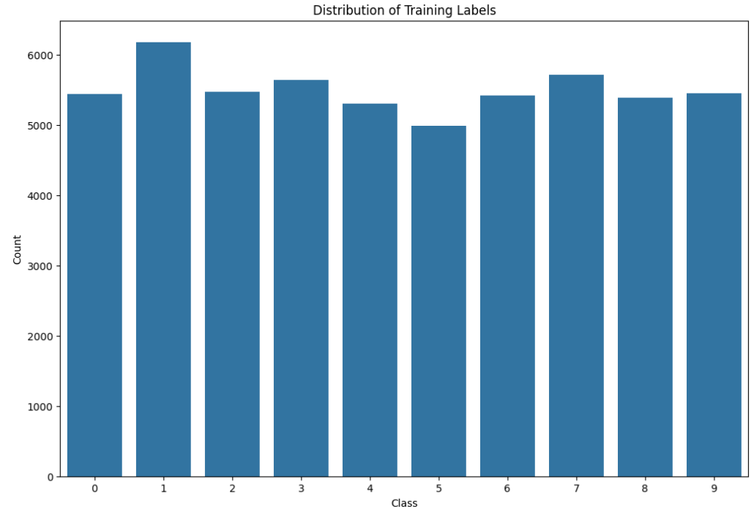
Figure A1. Distribution of Training Labels
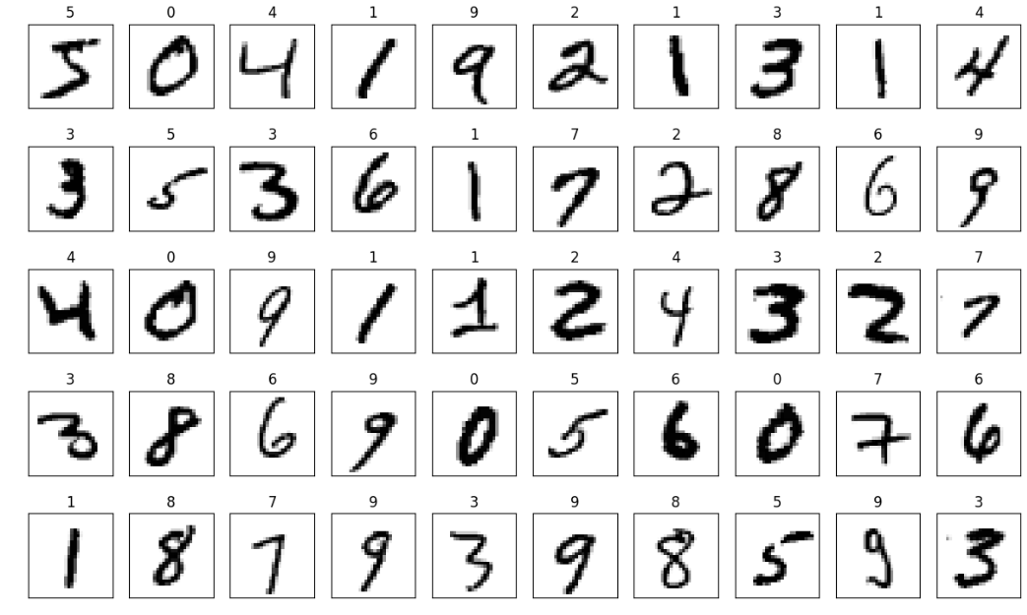
Figure A2. Displaying Sample of Training Samples

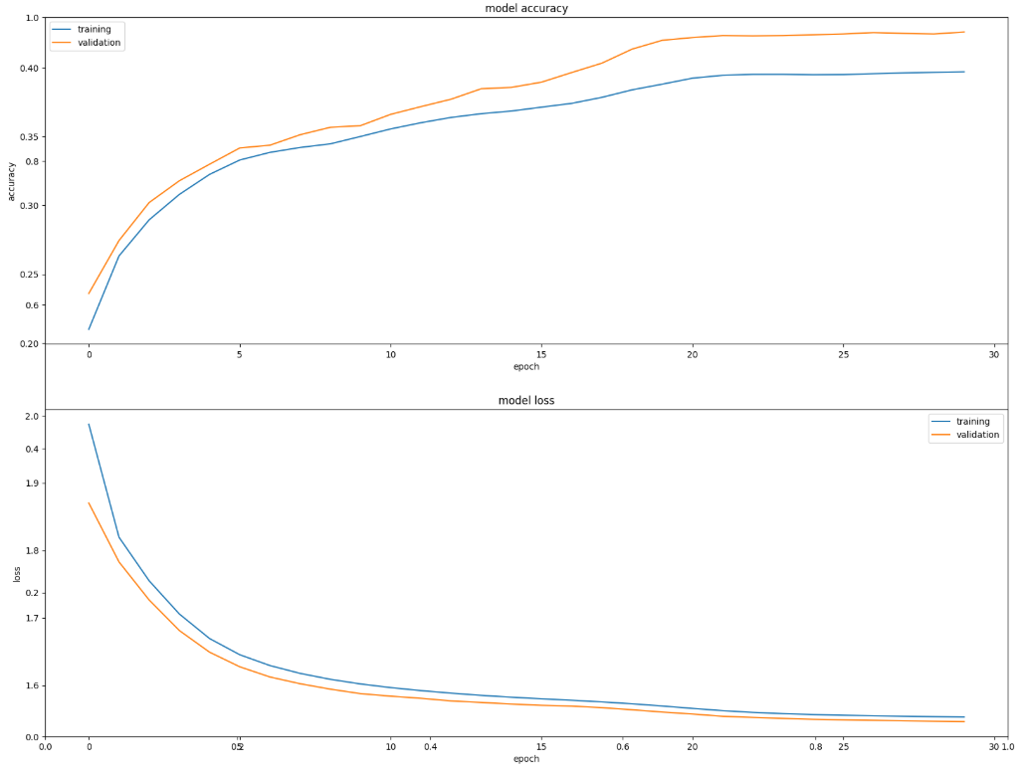
Figure A3. Training and Validation Model Accuracy and Loss, Experiment 1
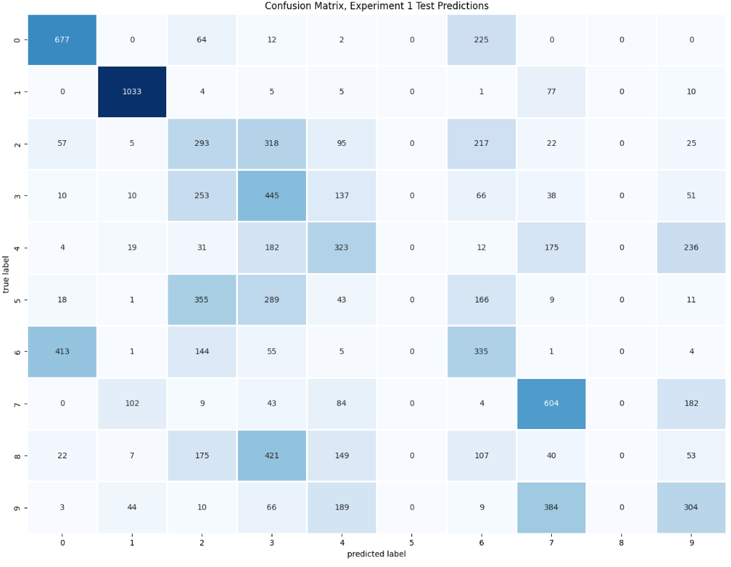

Figure A4. Confusion Matrix, Experiment 1
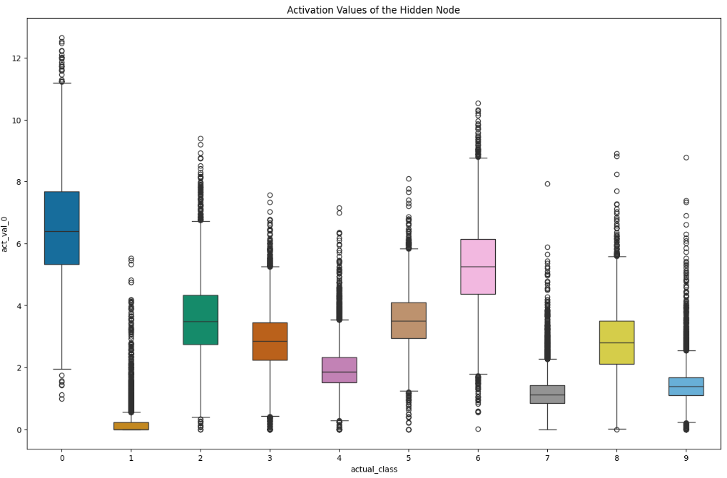
Figure A5. Boxplot of Activation Values of the Hidden Node, Experiment 1
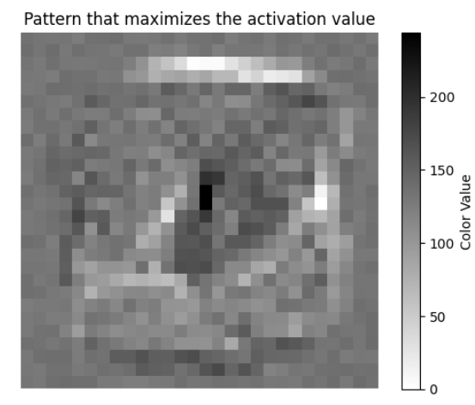
Figure A6. Pattern that Maximally Activates the Hidden Node, Experiment 1
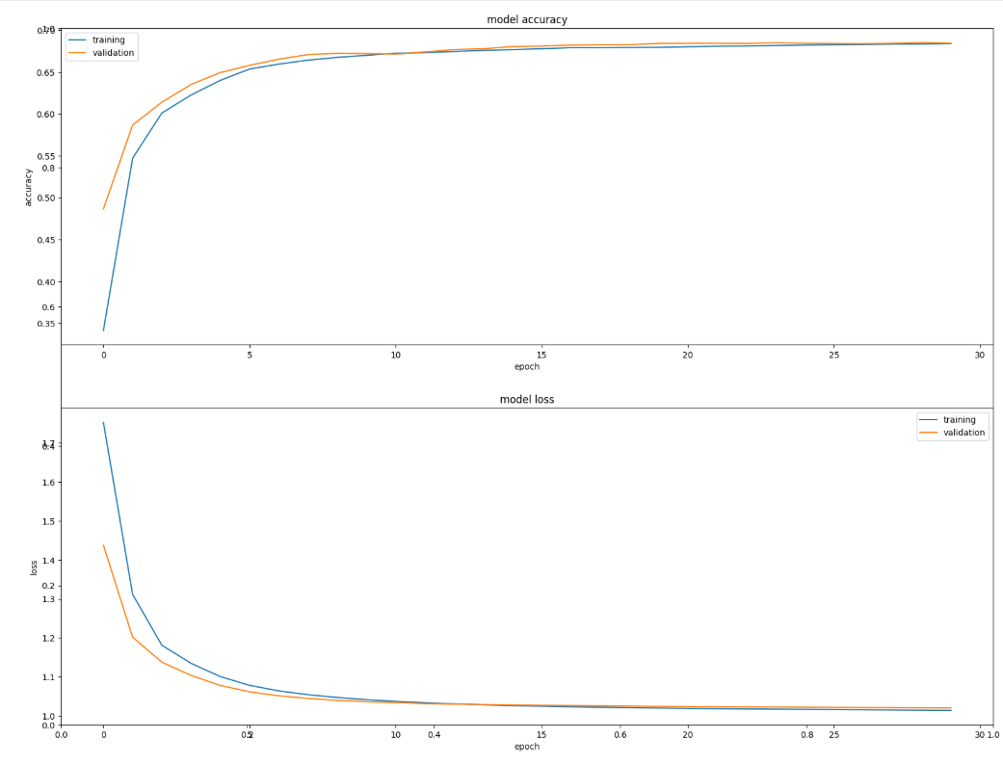
Figure A7. Training and Validation Model Accuracy and Loss, Experiment 2
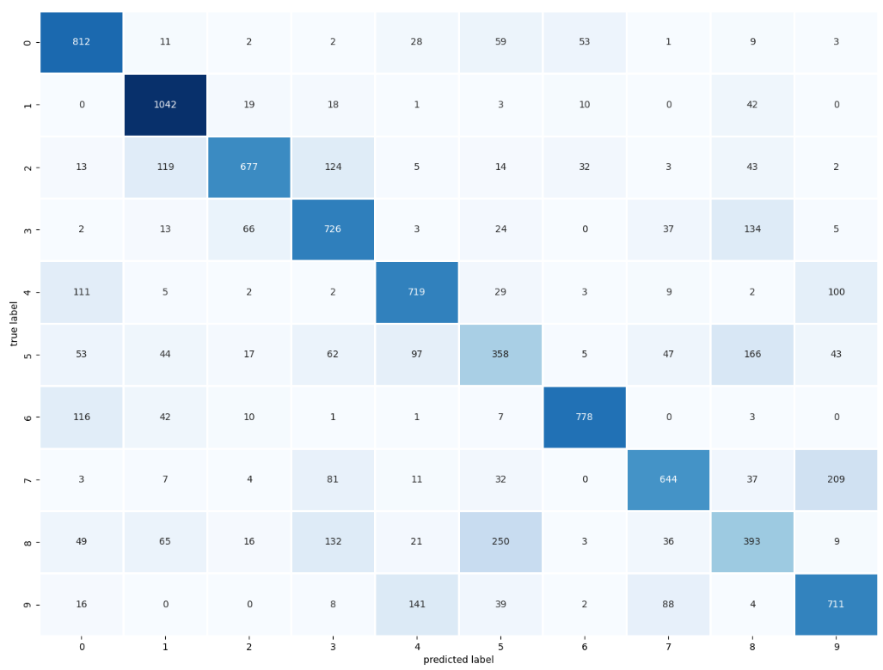
Figure A8. Confusion Matrix, Experiment 2
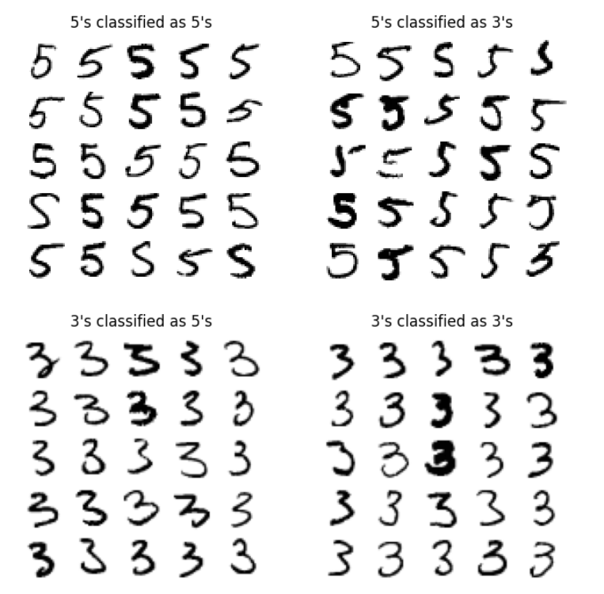
Figure A9. Misclassification Samples for Digits 5 and 3, Experiment 2
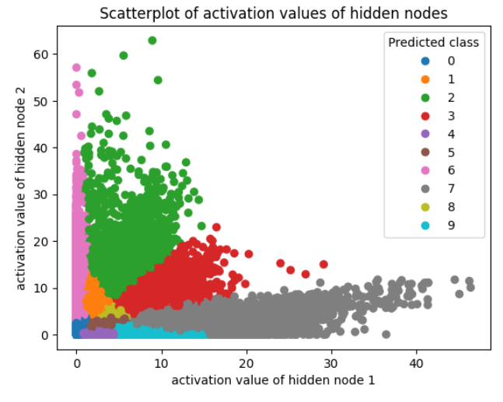
Figure A10. Scatterplot of Activation Values for Nodes 1 & 2, Experiment 2
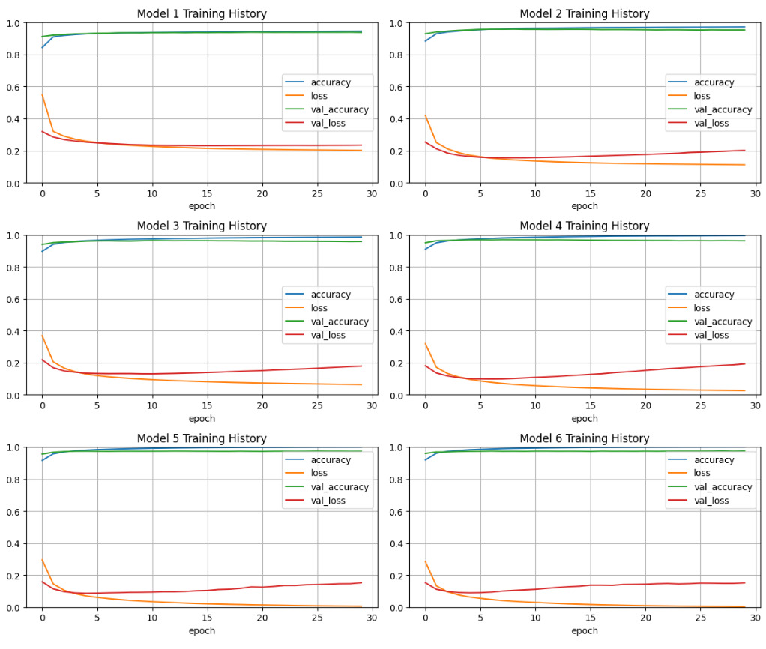
Figure A11. Training and Validation Model Accuracy and Loss by Testing Iteration, Experiment 3

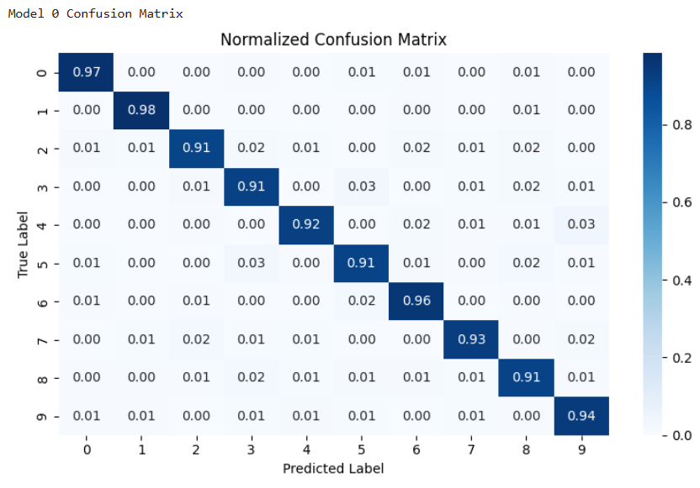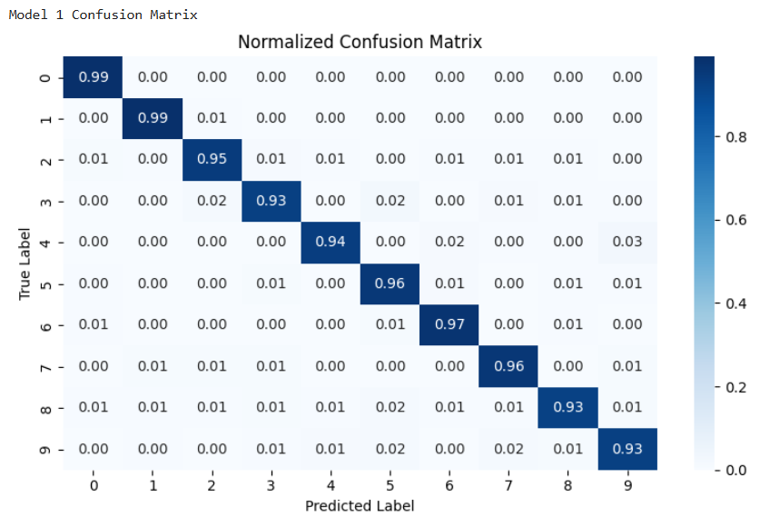

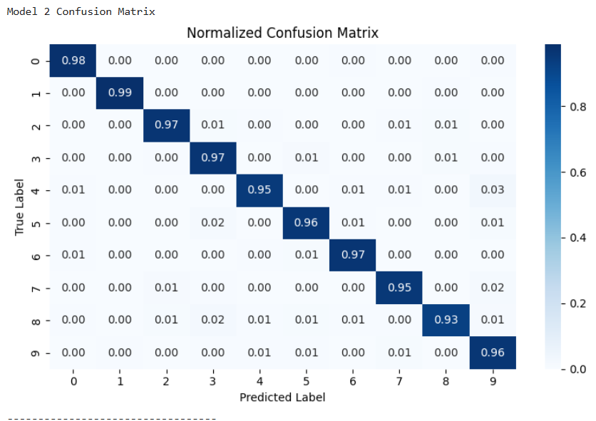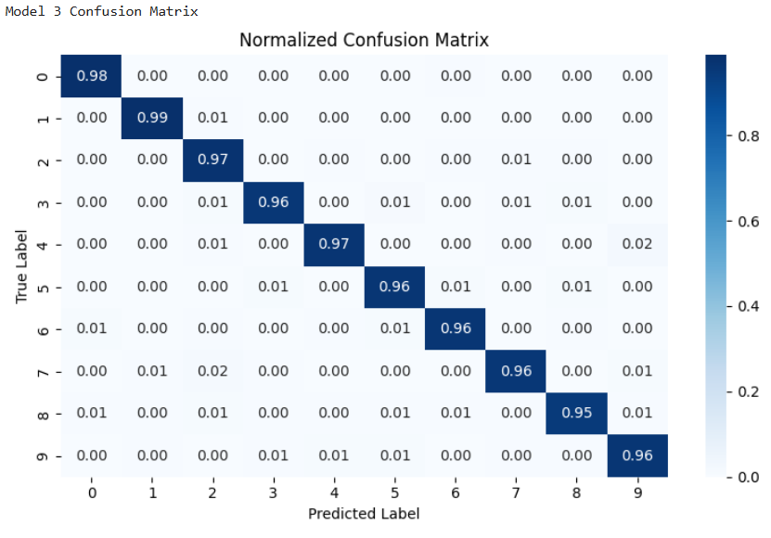
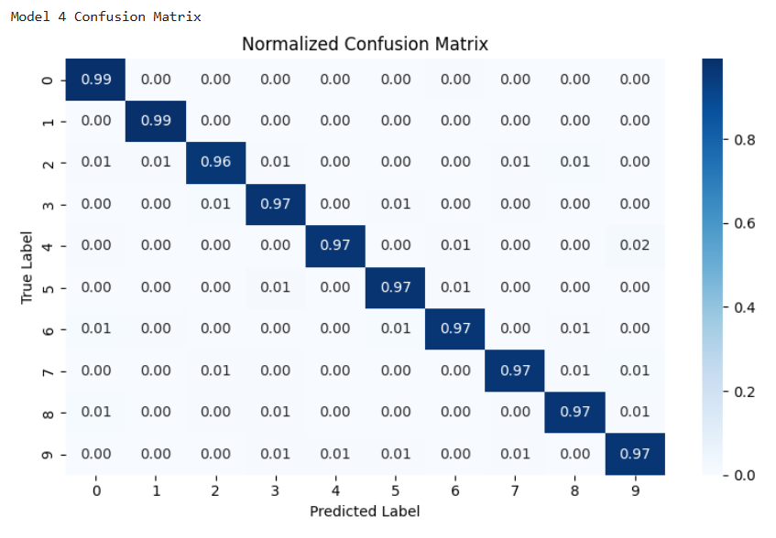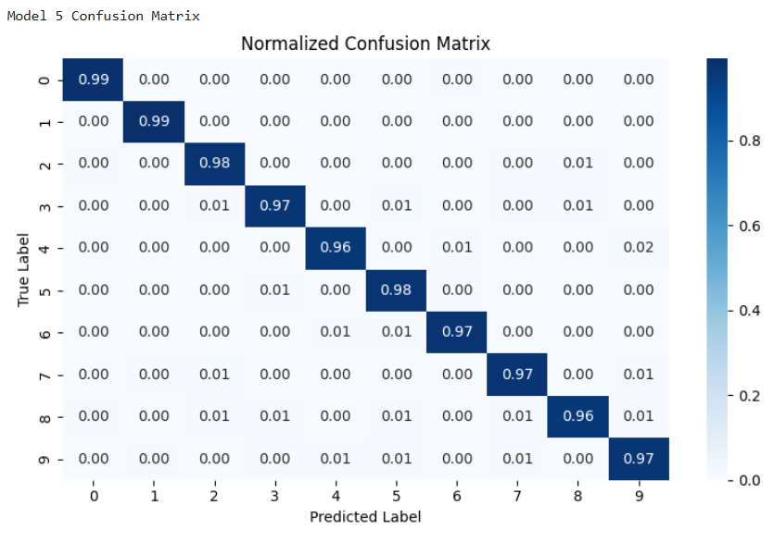

Figure A12. Confusion Matrices by Testing Iteration, Experiment 3
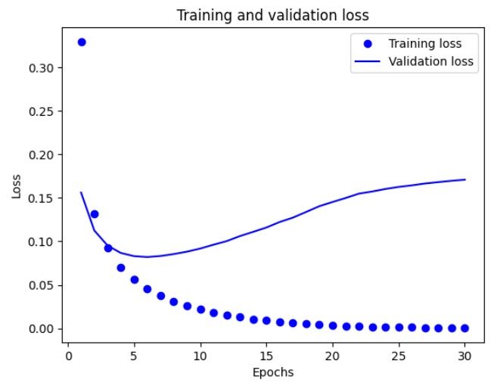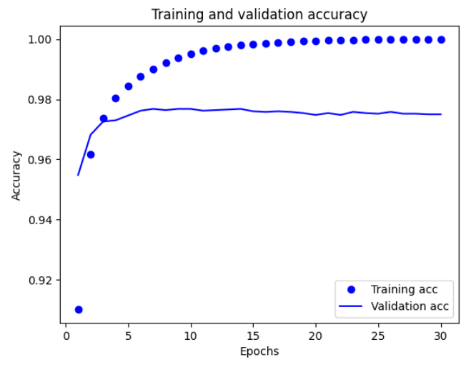
Figure A13. Training and Validation Model Accuracy and Loss, Experiment 4
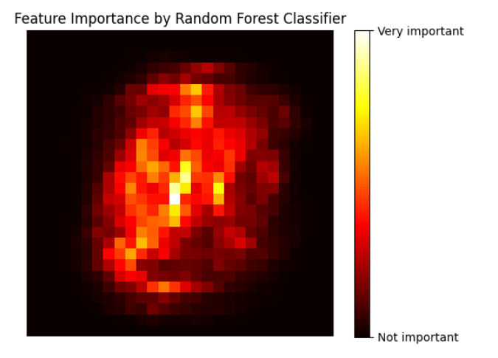
Figure A14. Pixel Importance by Random Forest Classifier, Experiment 5
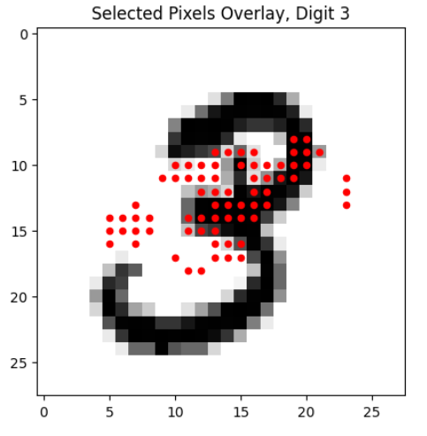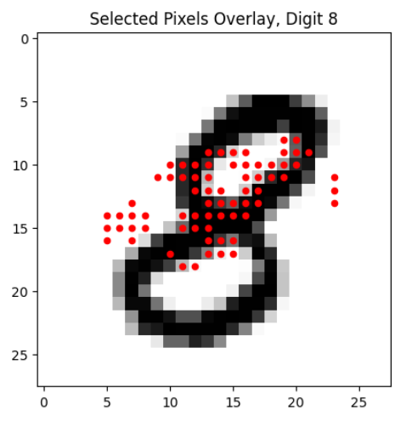
Figure A15. Selected Pixels Overlaying Digits 3 and 8, Experiment 5
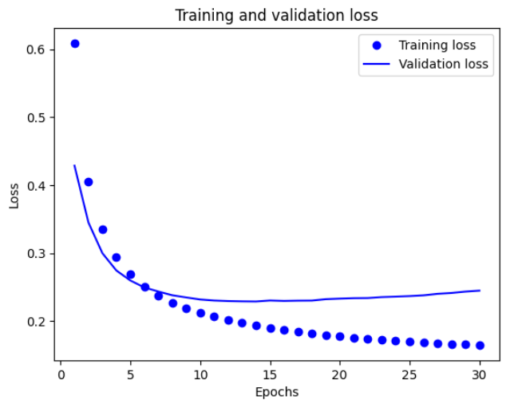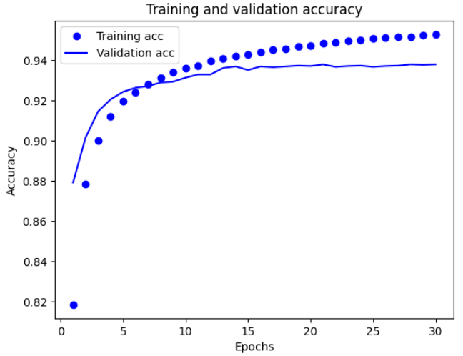
Figure A16. Training and Validation Model Accuracy and Loss, Experiment 4

