MSDS 458: Assignment 3
Evaluating NLP Neural Network Models for Potential Application in a Customer Service Chatbot

Soraya Butler
MSDS 458: AI & Deep Learning
February 22, 2026

1.0 Abstract
Conversational chatbots are widely used in customer service to facilitate customer interaction, and are notable for their ability to understand intent and respond in a human-like way. This paper describes a series of experiments using neural networks for sequential data to classify AG News articles, as a benchmark for model efficacy in a potential application to a customer service conversational chatbot. Four exploratory data analysis experiments were conducted to determine parameters for text vectorization. Afterwards, 12 experiments on neural network architectures were conducted, using varying topologies of sequential neural networks to measure trade-offs between accuracy, model fit, and training time. The results of this study demonstrate that L2 regularization is key to reducing overfitting in RNN and LSTM models, and that bidirectional structure has a negligible effect on performance. This study concludes that, because accuracy and model fit are of utmost importance for classifying customer intent in a chatbot, an LSTM model with 64 units, L2 regularization, and Early Stopping is the best choice. Future experiments are recommended to improve model accuracy, and further hyperparameter tuning or technique selection is recommended.

2.0 Introduction
This report describes a series of experiments using neural networks for AG News topic classification, to help address a broader management problem in conversational chatbot development for customer service. A series of 12 experiments was conducted to determine the neural network architecture that best balances accuracy and model fit for AG News topic classification. Exploratory data analysis is conducted on the AG News text data to determine vectorization parameters such as vocabulary size and sequence length. Various network topologies are applied towards the classification problem, including Recurrent Neural Networks (RNNs), Long Short-Term Memory (LSTMs), and 1 Dimensional Convolutional Neural Networks (1D CNNs). Benchmarked models are further evaluated for use in a production-ready conversational chatbot for customer service. The experiments were performed in Python on a Google Colab Pro notebook using TensorFlow Keras. Relevant figures for the study are in Appendix A, and the source code and model outputs are provided in Appendix B.

3.0 Literature Review
Early iterations of chatbots, such as ELIZA and PARRY, were developed in the 1960’s, when rule-based pattern-matching enabled limited, human-like conversation, specifically for psychotherapy (Eleni and Lefteris 2020). Artificial intelligence (AI) for chatbots was introduced in the late 1980s, and previous conversations were matched against as context for responses. In the early 2000’s, chatbots were made available within online messaging systems, including America Online (AOL) and Microsoft (MSN), where more practical information-retrieval applications were successfully deployed. The rapid development of artificial intelligence and Deep learning in the 2010’s enabled chatbots to produce even more conversational, intelligent, and human-like responses, with chatbots like Siri and Cortana becoming integrated into everyday life for tasks such as navigation, question answering, reminders, and more. When used in the context of customer service, conversational chatbots understand user input intent to respond to inquiries regarding the business (TeamDynamix n.d.) These chatbots are notable for their benefits in customer engagement, information availability, and reduction in operational costs.
The introduction of natural language processing (NLP) resolved the primary issue with rule-based conversational bots: the need for manual rule creation. Instead, NLP methods using artificial neural networks (ANNs) and recurrent neural networks (RNNs) rely on training over large corpora to identify useful information from user input. Neural networks can be used for multiple applications in chatbot development, such as entity recognition in natural language understanding (NLU) or generating user responses.
Even though the objective of this paper is to modify the neural network architecture for text sequence classification, rather than directly improving chatbot performance, benchmarking on the AG News dataset provides insight into model performance for chatbot natural language understanding. Similar studies have been conducted in this effort, in which architectures such as LSTM, CNN, and Transformer are benchmarked on the AG News dataset to evaluate performance in potential applications like sentiment analysis and sequence generation (Ozdemir 2024). In one such study, a Transformer model using bidirectional encoder representations from transformers (BERT) achieved the highest accuracy at 0.9442. While similar in methodology and objective to previous benchmarking studies using AG News, this study is distinguished by an iterative approach that isolates the effect of individual hyperparameters on model performance.
4.0 Methods
Keras and TensorFlow, running in a Google Colab Pro environment with an L4 GPU runtime, are used to develop and evaluate 12 neural network models. Several other Python libraries were required for experimentation, including Pandas, NumPy, scikit-learn, seaborn, and Matplotlib. Although networks varied in topology, some parameters were kept constant across experiments. All experiments use the ReLU activation function, softmax output activation, the Adam optimizer, and sparse categorical cross-entropy loss. When early stopping is not used, epoch count is maintained at 5. Otherwise, the epoch count can reach 200. All models output the same set of evaluation metrics and visualizations: test accuracy, test loss, a multi-line chart of validation accuracy/loss vs. training accuracy/loss, and a confusion matrix.
The AG News dataset is used to benchmark the 12 models for accuracy and performance in text classification. This dataset is loaded using the TensorFlow Datasets API and consists of 120k training and 7.6k test samples. Each sample consists of a news article, and training samples are labeled with one of four categories: “Sci/Tech”, “Sports”, “Business”, and “World”. A preliminary exploratory data analysis (EDA) is conducted to understand the dataset and examine for class balance. Four EDA experiments follow, where hyperparameters for text vectorization in downstream model development are evaluated. These four experiments analyze vocabulary composition and simple model accuracy as vocabulary, sequence length, or vocabulary size are adjusted.
The first EDA experiment evaluated the corpus of news articles after vectorization, without a custom vocabulary. For comparison, an EDA experiment is performed where stopwords are removed. The custom list of stopwords is downloaded from the nltk library and removes common phrases unlikely to help differentiate the content of a news article, such as “the”, “again”, “could”, and “few”. The architecture of EDA Experiment 2 is carried over to the next experiment, except that the sequence length is reduced. A fixed length of 96 is used. The first three EDA experiments use a bar chart to visualize the distribution of tokens per document, and a continuous bag-of-words model is used to see downstream testing accuracy. A continuous bag-of-words (CBOW) model aggregates context representations from the input vector to output a prediction (Geeksforgeeks 2025a). The final EDA Experiment iterated over different vocabulary sizes to evaluate their impact on corpus composition and testing accuracy, while holding all other vectorization and modeling parameters constant from EDA Experiment 3. Vocab sizes of 10, 100, 1000, and 10000 are evaluated. Out-of-vocabulary rates are monitored iteratively, and CBOW models are used to evaluate test accuracy.
After parameters for vocab size and sequence length are determined in EDA, model testing begins. The first six experiments modify an RNN architecture iteratively to evaluate the effect of hyperparameter or technique selection on performance. An RNN is a neural network that processes inputs sequentially, where pertinent information from every iteration in the sequence is maintained in a hidden state. At every step in a sequence, the hidden state is updated by combining its memory with the current input. In this case, the sequential input is text data, where language understanding from an earlier token informs understanding at a later position. Since the task for this study is text classification, the architecture has a many-to-one relationship, where hidden-state outputs at each step are used to summarize the entire sequence as an output label (Amidi and Amidi n.d.).
The first RNN experiment uses a SimpleRNN layer with 32 units to classify samples, without masking or regularization. The unit size determines the size of the hidden layer. The larger the unit size, the greater the model's capacity to capture patterns in the hidden state memory, at the potential cost of performance and model fit (Anantula 2023). The impact of masking to ignore padding for fixed sequences for classification is evaluated in Experiment 2, with all other hyperparameters held constant. Experiment 3 examined the effect of increasing the unit size to 64 on model performance. Experiment 4 introduces early stopping into the architecture to evaluate its effect on model computation time and the relevant trade-offs. Early stopping is a regularization technique that stops training when performance on a selected metric plateaus or worsens, subject to a “patience” parameter that waits a predetermined number of epochs before stopping (Brownlee 2019). Experiment 5 uses L2 regularization to seek improvement over model fit. L2 regularization is another technique used to reduce overfitting by penalizing features with large weights. Features with lower weights will have an even smaller impact, and features with higher weights will be reduced to improve generalization (Nagpal 2024). The final RNN experiment evaluates how bidirectionality, a technique in which sequential input is processed both forward and backward, affects model accuracy and performance (Geeksforgeeks 2021).
The following five experiments evaluate a more advanced version of RNN, LSTM, and incrementally adjust model parameters for comparison. LSTM is similar to an RNN in that it processes sequential input, but its memory gating features enable it to outperform an RNN on processing lengthy sequences (Anantula 2023). In addition to sequential input and short-term hidden-state information, each LSTM cell includes a cell state, a forget gate, an input gate, and an output gate. The cell state carries long-term memory across the sequence and is updated using the various gates. The forget gate decides which cell state information to disregard for the current input. The input gate decides which information to add to the long-term memory cell state, and the output gate decides how much of the cell state to include in the short-term hidden state. Because the cell state is updated through largely additive operations that are regulated by these gates, this architecture addresses the vanishing/exploding gradient problem in RNNs, where backpropagated weights can vanish to 0 or explode to very high values.
Experiment 7 uses the first LSTM in the study, with a hidden state vector size of 32 units. Experiment 8 increases the LSTM architecture's unit count to 64 to compare performance and accuracy. Experiment 9 introduces early stopping to Experiment 8’s architecture. Experiment 10 aims to understand how L2 regularization affects model fit and accuracy in the LSTM architecture. Experiment 11 introduces bidirectionality into the architecture for evaluation.
The very last experiment iterates over only a single version of a 1D CNN, for comparison with RNN and LSTM model performance in AG News classification. A CNN uses convolutional layers to extract patterns from input in a hierarchical manner. The most common application of a CNN is for image data, where a 2D CNN is used to extract patterns at varying levels of complexity, enabling image classification regardless of image translation (Challot 2021). When used for text classification, however, a 1D CNN is employed, in which convolutional kernels slide over sequences of tokens or their embeddings, and filters identify patterns to produce feature maps for classification (Jain 2025). The 1D CNN model in Experiment 13 uses 32 filters, with a kernel size of 3, and max pooling for downsampling. Dropout is also incorporated for model fit and early stopping for model performance. This experiment is conducted solely for comparison with later RNN and LSTM experiments, such as Experiment 11 and Experiment 6.

5.0 Results
The key results from all 4 EDA and 12 experiments are shown in Appendix A, Figures A1 and A2. From a brief analysis of the text sequence composition in Figure A3, it can be observed that the text is in English, although certain characters are represented by ASCII/Unicode. For example, “#39” is present before any apostrophes, and dollar signs are escaped using the backslash. News stories vary widely for the investigated subset, with stories labeled “Science/Tech” ranging from updates on computer processors to scientist employment in Britain to giant panda rescue efforts. This variance in news article content within a single label must be adequately captured by the “best” model for successful text classification. In a small test of class balance, it was found that all four categories are equally represented in the training set.
The first EDA experiment, which vectorized data without custom stopwords, identified 3677503 words. Each article contained between 3 and 173 tokens. The vocabulary consisted of 93145 unique words, the most common of which are shown in Figure A4. The tokens-per-document distribution is roughly normal, slightly skewed to the right, with the median around 30 (Figure A5). When used to train a CBOW model, training time was 62 seconds, and test accuracy was 0.903.
In EDA Experiment 2, stopwords are removed. With this vectorization architecture, 2426381 words with a unique vocabulary of 92996 were found in the corpus. The first 50 vocabulary words differ from EDA Experiment #1 in that many words are now not present. These include “the”, “a”, “to”, and more (Figure A6). However, many tokens are consistent in the vocabulary despite the removal of stop words, such as ASCII/Unicode “39s”, “two”, and “Wednesday”. The distribution of tokens per document is even more right-skewed here, with the median shifted closer to 20 (Figure A7). After testing the vectorization with a CBOW model, the test accuracy was 0.902.
In the following experiment, a fixed length of 96 is used, resulting in a corpus with a word count of 11520000. The count of unique vocabulary words is unchanged from EDA Experiment #2, at 92996. The distribution of tokens per document shows a single value of 96 (Figure A8). When the vectorization was used to train a CBOW model, the test accuracy reached 0.902.
The last experiment iterates over varying vocabulary sizes. The size of the vocabulary had an inverse effect on the OOV rate, where the greater the vocabulary size, the lower the number of OOV tokens present (Figure A9). When CBOW models are trained for different vocabulary sizes, larger vocabularies correspond to higher accuracy. Accuracy for vocab sizes of 10, 100, 1000, and 10000 was 0.35, 0.63, 0.86, and 0.90, respectively.
Given the results of the EDA experiments, a sequence length of 96 and a vocabulary size of 1000 were determined, with stopwords removed. Since sequence length limitations are a known challenge in the architectures to be evaluated, such as RNNs, parameters were selected to minimize sequence length while maximizing CBOW accuracy (Meegle 2025). In comparing Experiment 1 and Experiment 2, removing stopwords resulted in minimal changes in accuracy, so the design with the smaller vocabulary is selected. From Experiment 3, the reduction in sequence length is shown to have a negligible effect on model accuracy, and so is selected to hedge against potential issues with long sequences. Similarly, a vocab size of 1000 was selected to balance CBOW accuracy while reducing future model input size. The difference in CBOW accuracy between sizes 1000 and 10000 is very small, so a size of 1000 is deemed adequate for future experimentation.
Moving forward, the first experiment aimed to benchmark RNN performance without masking or regularization. Training time elapsed was 139 seconds, and testing accuracy was 0.75. When plotting model validation accuracy/loss against training accuracy/loss, the gap between lines converges and then diverges between epochs 3 and 4, with validation accuracy lower than training accuracy at the final epoch (Figure A10). Label 1, “Sports,” yielded the highest accuracy at 93.1%, while label “Business” had the lowest at 61.7%. “Business” true labels were frequently misclassified as “World” using this model (Figure A11).
In Experiment 2, the effect of masking to ignore the padding in input sequences is evaluated. Training time took 145 seconds, and accuracy improved to 0.83. This is an improvement in accuracy of 10.7% compared to Experiment 1, without any detriment in training time. However, model fit is affected here. Multiline charts in Figure A12 show that training and validation accuracy diverge widely from the 1st epoch onward, with training accuracy higher than validation accuracy. This means the model overfits on unseen data. As in Experiment 1, the correlation matrix shows the best accuracy with the label “Sports” at 91.5% and the worst with “Business” at 70.9%, and “Business” was frequently misclassified as “World” (Figure A13). Future experiments will seek to improve accuracy and model fit while maintaining the low training time.
Experiment 3 increased the number of units to 64. Training time and accuracy were similar to Experiment 2, at 148 seconds and 0.83, respectively. The increase in unit size did not affect model fit either, with validation accuracy still diverging from training accuracy (Figure A14). However, the correlation matrix shows a slight difference: the label “Business” is better classified at 79.6% accuracy, while “World” is nearly tied at 78.2% (Figure A15). More experiments are needed to reach accuracy and model fit goals.
Experiment 4 introduces early stopping. While early stopping is frequently used to reduce training time, that was not the case in this experiment, which took 177 seconds. This is because a higher epoch count was used to achieve a more accurate measured epoch count. Early stopping resulted in an epoch count of 6. Testing accuracy is maintained at 0.83 from previous models. Model fit still suffers from overfitting, with training and validation accuracies diverging and training accuracy exceeding validation accuracy (Figure A16). The confusion matrix here shows that the “Business” label has higher accuracy than the “World” label, at 80.6 and 74.4, respectively (Figure A17).
Experiment 5 aims to evaluate the effect of L2 regularization on the RNN model architecture. The training time was 178 seconds, and testing accuracy increased slightly to 0.84. Figure A18 shows that the model fit is much improved due to regularization. Here, validation and training accuracy are closer together, with a difference of less than 0.4% at the final epoch. The confusion matrix more closely resembles that from Experiment 2, with the label “Business” at the lowest classification of 77.6%, though here the labels “Sci/Tech” and “Sports” are nearly tied at 89.2% and 87.5%, respectively (Figure A19). L2 regularization appears to have successfully reduced model fit issues, while maintaining model performance and accuracy from previous iterations.
The final RNN model experiments with bidirectionality. Training time is nearly doubled in this experiment, to 309 seconds, while testing accuracy improves by only around 1%, to 0.85. Training accuracy and validation accuracy show a similar fit to Experiment 5, with a difference of only 0.5% at the last epoch (Figure A20). However, the training and validation losses nearly converge for this model at the last epoch, at 0.506 and 0.504, respectively. The confusion matrix shows little difference in accuracy by label compared to previous experiments (Figure A21). Altogether, while the added model complexity introduced by bidirectionality may have slightly improved fit, given the convergence of the training and validation losses, the tradeoff was a much longer training time for little improvement in accuracy.
Experiment 7 is the first iteration of an LSTM model for the study and uses masking with 32 units. Training time elapsed was 116 seconds, and testing accuracy increased slightly to 0.86. As seen in RNN experiments, when L2 regularization was not used, this model overfitted on the training data, and the training accuracy diverged from the model accuracy by 2.7% in the final epoch (Figure A22). The confusion matrix closely resembles that of previous experiments, with the greatest misclassification between the labels “Business” and “World”, and the least between “Sports” and “World” (Figure A23). Experiment 7 is comparable to Experiment 2 when compared to an RNN of a similar architecture and achieves better accuracy and lower training time. However, more complex RNN architectures show better model fit at little change to accuracy.
Experiment 8 increases the LSTM unit count to 64. Training time was maintained at around 115 seconds, and testing accuracy was maintained at 0.86. Training and validation accuracy and loss continue to diverge, with a 3.3% difference in the last epoch (Figure A24). The confusion matrix is similar to previous classification matrices in terms of label accuracy (Figure A25). The increase in unit size here did not serve to improve accuracy or model fit compared to Experiment 7. Compared with its RNN counterpart (Experiment 3), this experiment shows a slight improvement in accuracy and a lower training time.
Experiment 9 introduced early stopping to evaluate its effect on model performance and accuracy. Training time did increase to 162 seconds, with a total epoch count of 7 before stopping. Testing accuracy maintained at 0.86. However, model fit shows an even greater divergence between testing and validation accuracy when compared to previous LSTM experiments. Validation accuracy dropped to 0.85 at the last epoch, while training accuracy increased to 0.9 (Figure A26). The confusion matrix is similar to those of previous experiments (Figure A27). Compared to Experiment 4, the RNN with the most similar architecture, this model has higher accuracy and shorter training time, but worse model fit.
L2 regularization was introduced in Experiment 10 to successfully address LSTM overfitting. However, training time increased by 50% to 243 seconds, and accuracy decreased slightly to 0.85. Figure A28 shows that both accuracy and loss converge across validation and training, with identical values of 0.85 and 0.514, respectively. The confusion matrix continues to show labeling confusion between “Business” and “World” labels, and the best classification for the label “Sport” (Figure A29). Compared to the RNN model in Experiment 5, which also uses L2 regularization, this LSTM model takes longer to train. However, accuracy is slightly higher, and model fit metrics are much better with this model.
Experiment 11 evaluates how bidirectionality affects LSTM model metrics. Training time is dramatically increased to 733 seconds, and training elapsed 21 epochs–the highest epoch count for a model seen thus far. The increase in training time did little to improve testing accuracy, which remained at 0.83. Model fit, as measured by training and validation accuracy, is slightly worse than in Experiment 10, with a difference of 0.48% (Figure A30). The validation and training losses are nearly converged here at 0.542 and 0.540, respectively. The confusion matrix is similar to those of previous experiments (Figure A31). As seen in Experiment 6, where bidirectionality was used in an RNN architecture, bidirectionality increased model complexity for this LSTM model without corresponding improvements in model accuracy, at the cost of increased training time.
The last experiment aims to compare a 1D CNN with Dropout and Early Stopping to LSTM and RNN models in later experiments, such as Experiment 6 and 11. This model took 392 seconds to train and achieved a test accuracy of 0.84. Model fit visualizations show a slightly worse fit than LSTM in Experiment 10, with a 0.35% divergence between training and validation accuracy (Figure A32). The confusion matrix shows no noticeable difference in label classification performance between RNN and LSTM experiments, with label “Sport” best classified at 94.7% and label “Business” worst classified at 78.3% (Figure A33).

6.0 Conclusions
The 12 experiments conducted in this study evaluated the trade-offs among model accuracy, training time, and model fit across varying sequential neural network topologies, benchmarked on the Ag News dataset for use in a conversational customer service chatbot. Broadly speaking, LSTM methods show a slight improvement over RNN methods in terms of training time and accuracy. Both LSTM and RNN models suffer from overfitting until L2 regularization is introduced. The CNN model is comparable to both LSTM and RNN models in later experiments, although the LSTM model shows slight improvement in accuracy and model fit. Across all models but one, the “Business” label had the worst classification success, and was frequently misclassified as “World”. All models identified the “Sport” label the best. Notably, increasing model complexity did not always correspond to an improvement in model metrics; the introduction of bidirectionality did not improve them, and training time increased.
In practice, when applying the model to a customer service chatbot, accuracy and model fit are very important. If used in intent analysis, for example, to classify customer messages, a model needs to accurately identify whether a customer inquiry is “angry” or “pleased” (TeamDynamix n.d.). Additionally, a model needs to be generalizable and perform well on unseen data, given the wide, nearly infinite range of possible user inputs to the chatbot. Given these requirements in production, the “best” model from this study is Experiment 10: an LSTM with 64 units, early stopping, and L2 regularization. While a few other experiments show slightly better accuracy, this experiment has comparable accuracy and the best model fit metrics.
However, many improvements to the model must be made before it can reach production-readiness, particularly to improve accuracy. Further enhancements to hyperparameter tuning and technique selection can be attempted, including data augmentation, larger unit sizes, dropout, transfer learning, and more. Vectorization hyperparameter decisions can be adjusted, and pre-trained embeddings can be tested. Transformer architecture may also be experimented with for comparison with LSTM, RNN, and 1D CNN models. Additionally, an ensemble of neural networks may provide further gains in prediction accuracy. These findings emphasize the need to balance complexity with generalization when designing deep learning models, especially when targeting accuracy and model fit for a customer service chatbot.

References
Amidi, Amidi. n.d. “Recurrent Neural Networks (RNN) Cheatsheet.” Stanford University CS 230 Teaching Materials. https://stanford.edu/~shervine/teaching/cs-230/cheatsheet-recurrent-neural-networks/

Anantula, Arya. 2023. “Deep Learning Notes: RNNs and More.” HackMD. December 27, 2023. https://hackmd.io/@Arya333/B1-rWZrwT

Adamopoulou, Eleni, and Lefteris Moussiades. 2020. "Chatbots: History, technology, and applications." Machine Learning with Applications 2: 100006. https://doi.org/10.1016/j.mlwa.2020.100006.

GeeksforGeeks. 2025a. “Bidirectional Recurrent Neural Network.” GeeksforGeeks. December 17, 2025. https://www.geeksforgeeks.org/deep-learning/bidirectional-recurrent-neural-network/

GeeksforGeeks. 2025b. “Continuous Bag of Words (CBOW) in NLP.” GeeksforGeeks. July 23, 2025. https://www.geeksforgeeks.org/nlp/continuous-bag-of-words-cbow-in-nlp/

Brownlee, Jason. 2017. “Dropout for Regularizing Deep Neural Networks.” MachineLearningMastery.com. https://machinelearningmastery.com/dropout-for-regularizing-deep-neural-networks/

Brownlee, Jason. 2019. “Early Stopping to Avoid Overtraining Neural Network Models.” MachineLearningMastery.com. https://machinelearningmastery.com/early-stopping-to-avoid-overtraining-neural-network-models/

Challot, François. 2021. Deep Learning with Python. 2nd ed. Shelter Island, NY: Manning. Chapters 5–6.

Jain, Abhishek. 2025. “Understanding the 1D Convolutional Layer in Deep Learning.” Medium, January 15, 2025. https://medium.com/@abhishekjainindore24/understanding-the-1d-convolutional-layer-in-deep-learning-7a4cb994c981

Meegle. 2025. “Overfitting in Sparse Models.” Meegle. October 28, 2025. https://www.meegle.com/en_us/topics/overfitting/overfitting-in-sparse-models

Nagpal, Anuja. 2024. “L1 and L2 Regularization Methods, Explained.” Built In, October 3, 2024. https://builtin.com/data-science/l2-regularization
Ozdemir, Serkan. 2024. "News Classification with State-of-the-Art Deep Learning Methods." 2024 8th International Artificial Intelligence and Data Processing Symposium (IDAP) 3: 649-5. https://doi.org/10.1109/IDAP64064.2024.10710921.

Appendix A
Experiment | Experiment Description | Testing Accuracy (percent)
1 | Vectorization without removing stopwords | 90.38
2 | Vectorization with stopwords removed | 90.12
3 | Vectorization with stopwords removed, sequence length of 96 | 90.12
4a | Vectorization with stopwords removed, sequence length of 96, vocab size of 10 | 35.20
4b | Vectorization with stopwords removed, sequence length of 96, vocab size of 100 | 63.17
4c | Vectorization with stopwords removed, sequence length of 96, vocab size of 1000 | 85.54
4d | Vectorization with stopwords removed, sequence length of 96, vocab size of 1000 | 90.12

Figure A1. Key Results from 4 EDA Experiments

Experiment | Model Description | Testing Accuracy (percent) | Testing Loss | Training Time (seconds) | Percent Difference, Training Accuracy to Validation Accuracy
1 | RNN, No Masking, 32 units | 75.17 | 0.66 | 139.77 | 2.61
2 | RNN, 32 units | 82.79 | 0.49 | 145.53 | 3.53
3 | RNN, 64 units | 83.50 | 0.47 | 148.08 | 3.65
4 | RNN, 64 units, Early Stopping | 83.11 | 0.52 | 177.75 | 3.76
5 | RNN, 64 units, Early Stopping, L2 regularization | 84.17 | 0.52 | 177.99 | 0.47
6 | RNN, 64 units, Early Stopping, L2 regularization, Bidirectionality | 84.55 | 0.52 | 309.05 | 0.47
7 | LSTM, 32 Units | 86.25 | 0.39 | 116.03 | 2.74
8 | LSTM, 64 units | 86.0 | 0.41 | 115.54 | 3.32
9 | LSTM, 64 units, Early Stopping | 85.56 | 0.46 | 162.12 | 6.48
10 | LSTM, 64 units, Early Stopping, L2 Regularization | 84.54 | 0.52 | 243.95 | 0
11 | LSTM, 64 units, Early Stopping, L2 Regularization, Bidirectionality | 83.21 | 0.55 | 733.73 | 0.48
12 | 1D CNN, 32 Filters, Dropout, Early Stopping | 83.84 | 0.56 | 392.47 | 0.35
Figure A1. Key Results from 12 Model Architecture Experiments


Figure A3. Samples of Ag News Dataset, for Visual Analysis
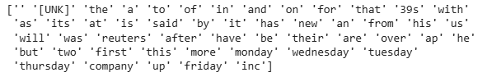
Figure A4. Top 50 Vocab Words for Vectorization, EDA Experiment 1
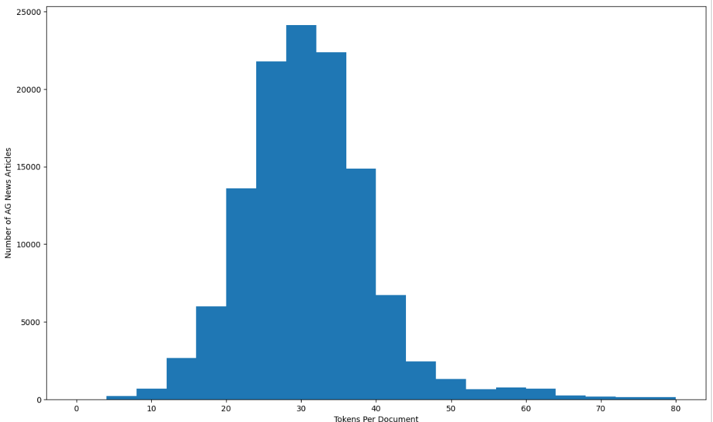
Figure A5. Tokens per Document Distribution, EDA Experiment 1

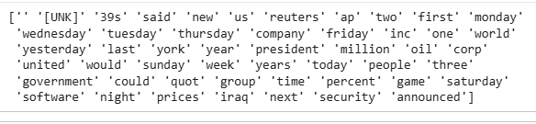
Figure A6.Top 50 Vocab Words for Vectorization, EDA Experiment 2
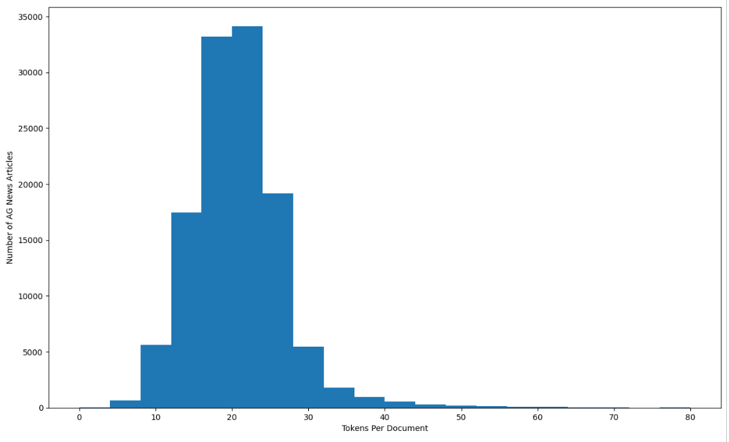
Figure A7. Tokens per Document Distribution, EDA Experiment 2
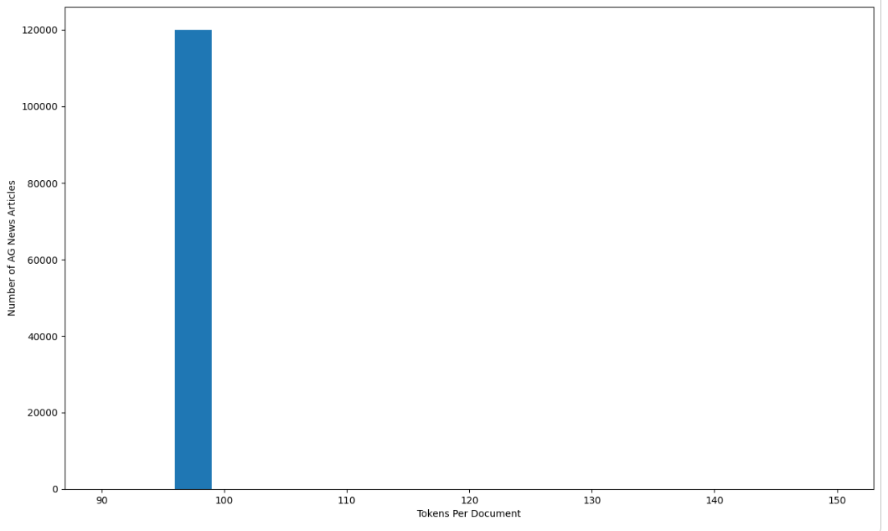
Figure A8. Tokens per Document Distribution, EDA Experiment 3
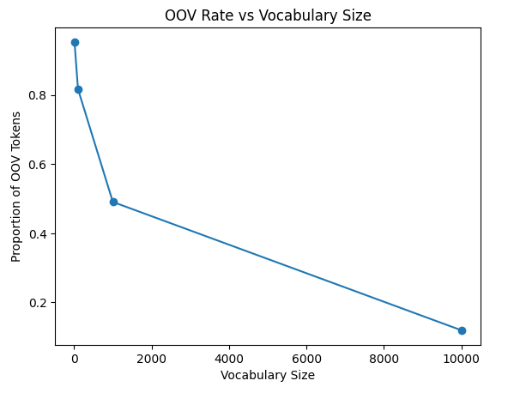
Figure A9. OOV Rate versus Vocab Size, EDA Experiment 4
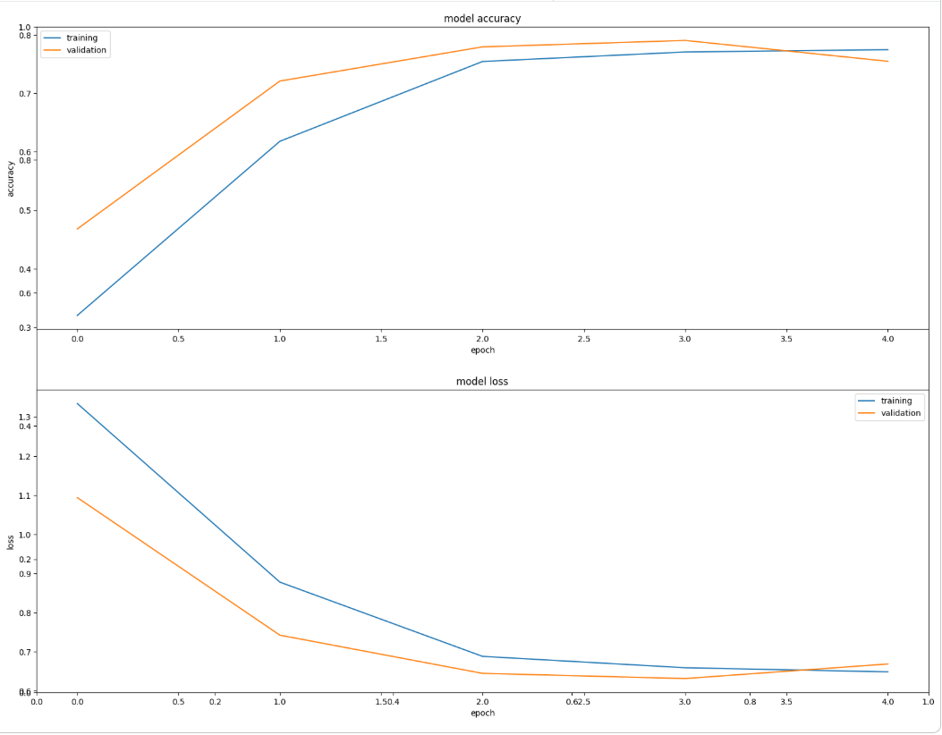
Figure A10. Training and Validation Model Accuracy and Loss, Experiment 1
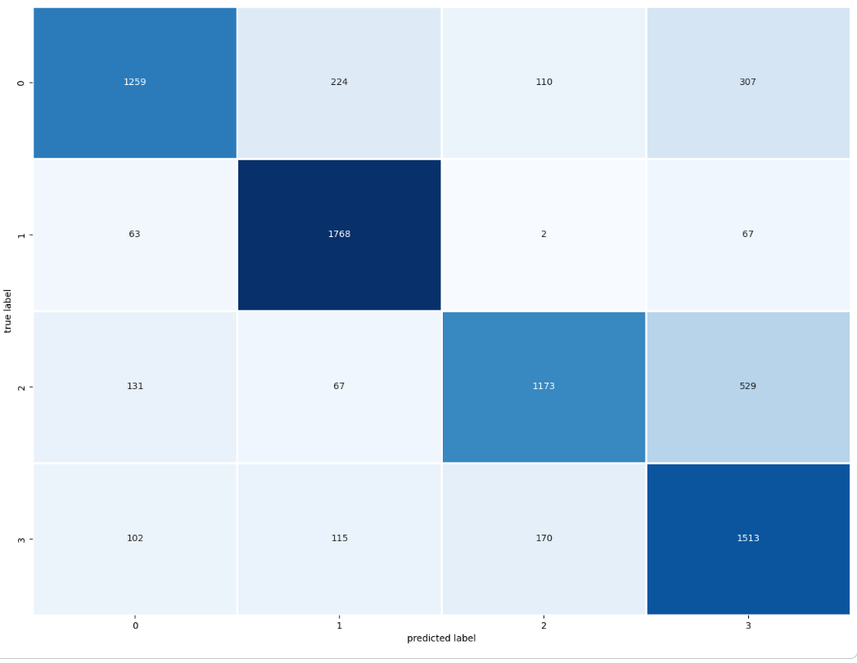
Figure A11. Confusion Matrix, Experiment 1
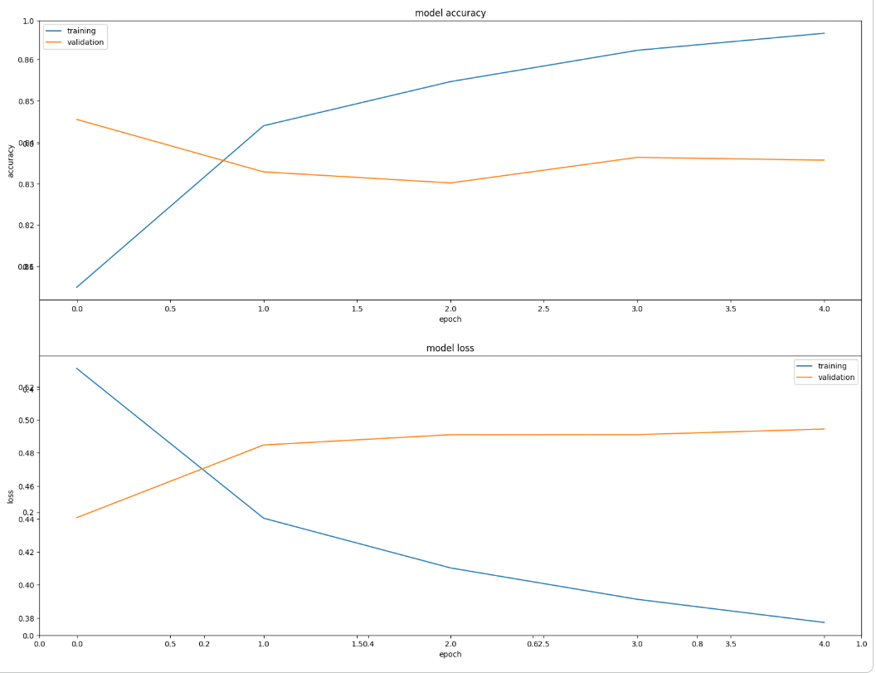
Figure A12. Training and Validation Model Accuracy and Loss, Experiment 2
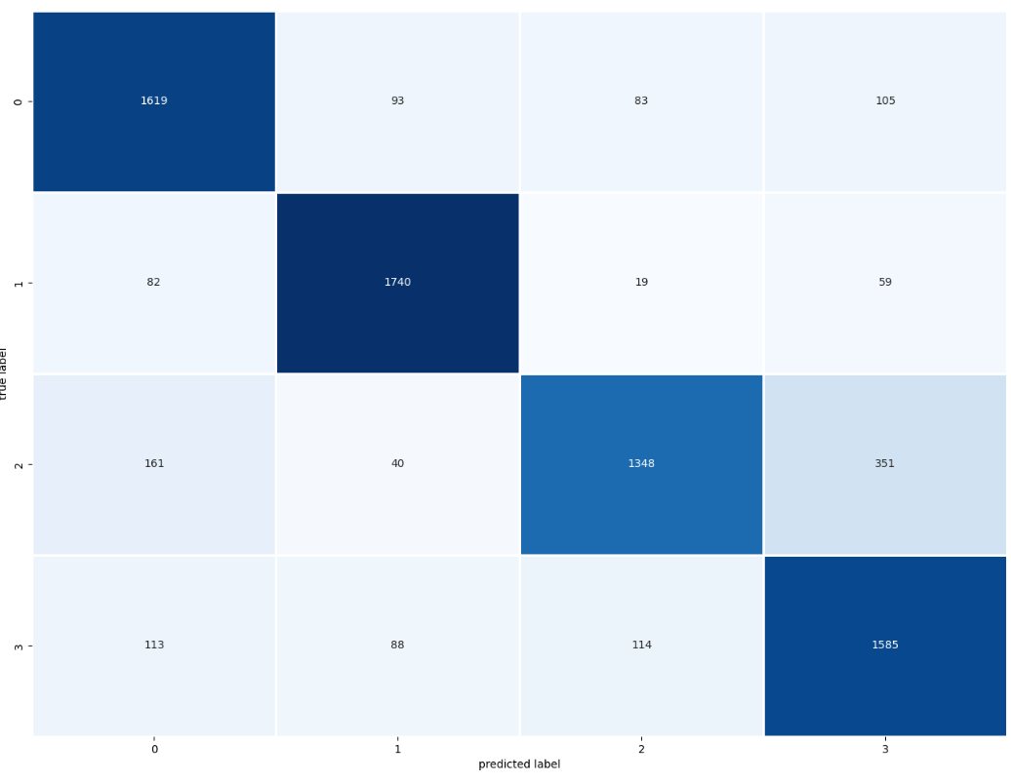
Figure A13. Confusion Matrix, Experiment 2
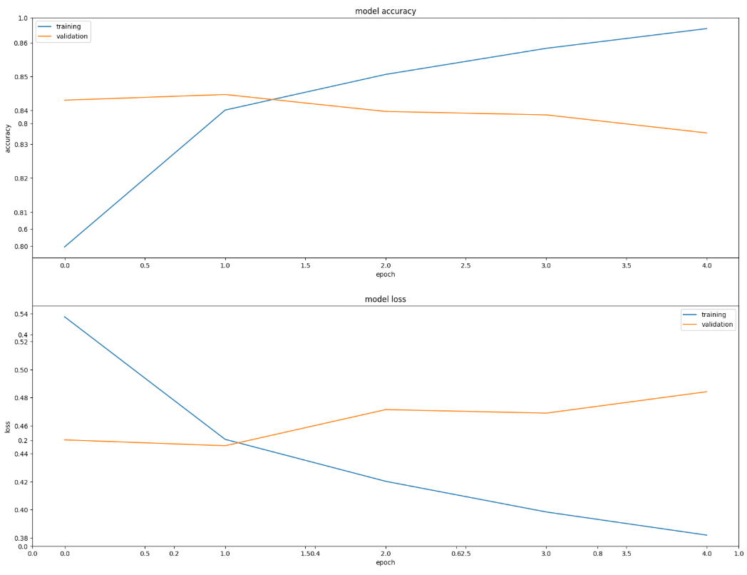
Figure A14. Training and Validation Model Accuracy and Loss, Experiment 3
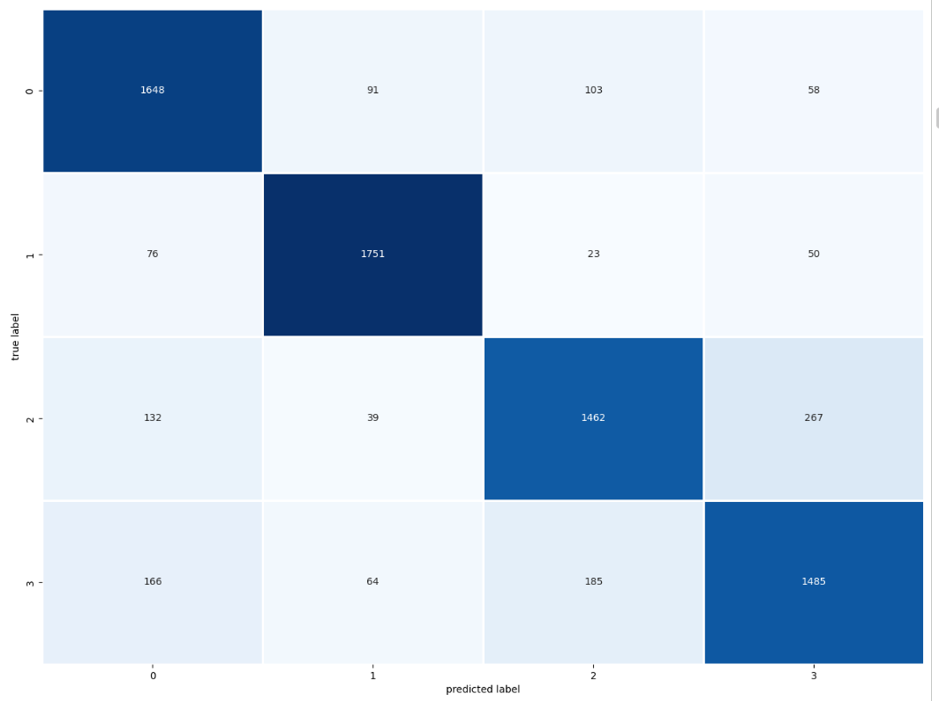
Figure A15. Confusion Matrix, Experiment 3
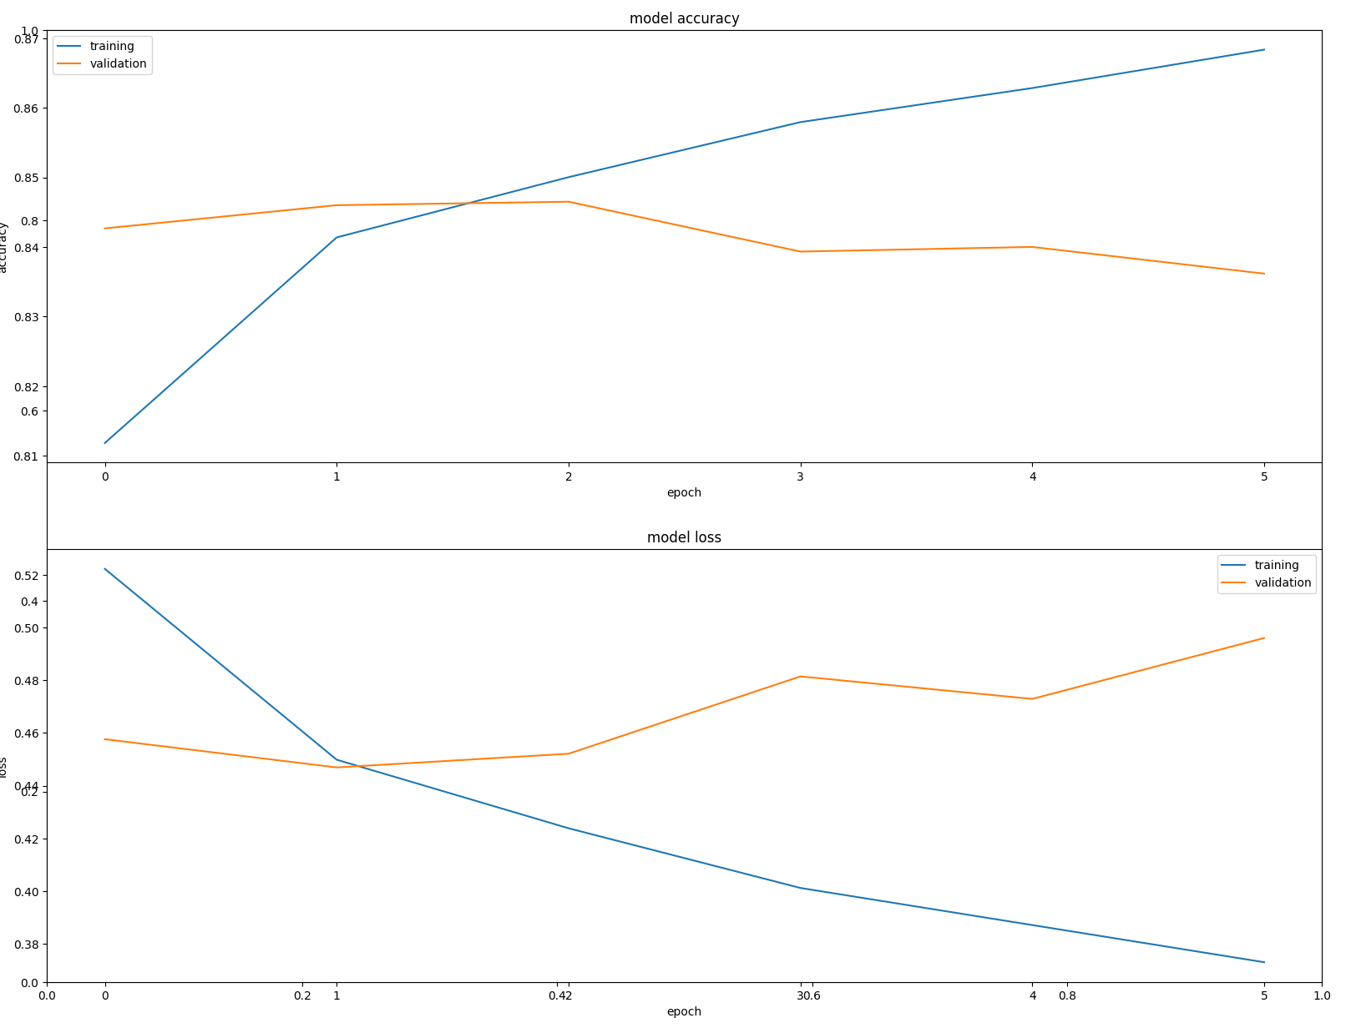
Figure A16. Training and Validation Model Accuracy and Loss, Experiment 4
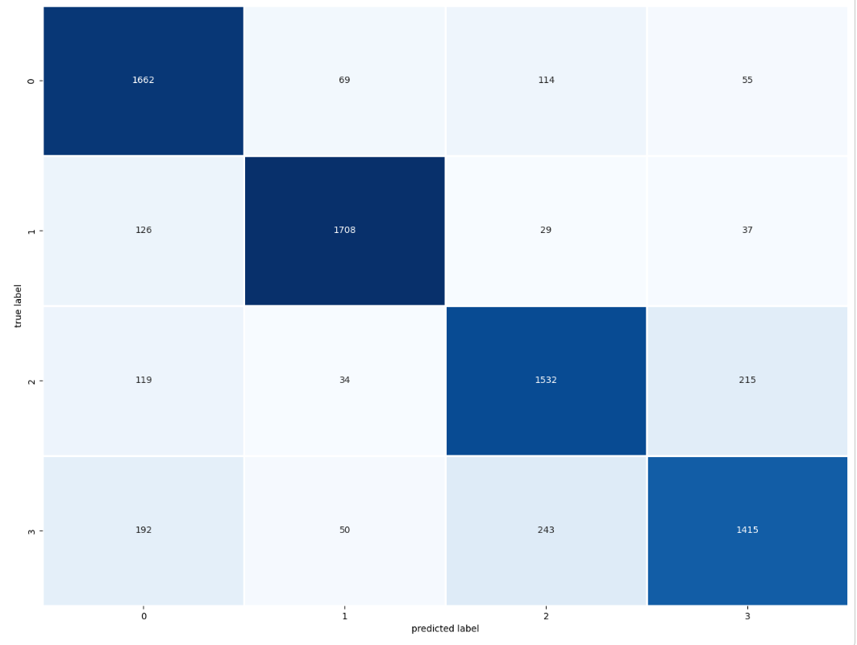
Figure A17. Confusion Matrix, Experiment 4
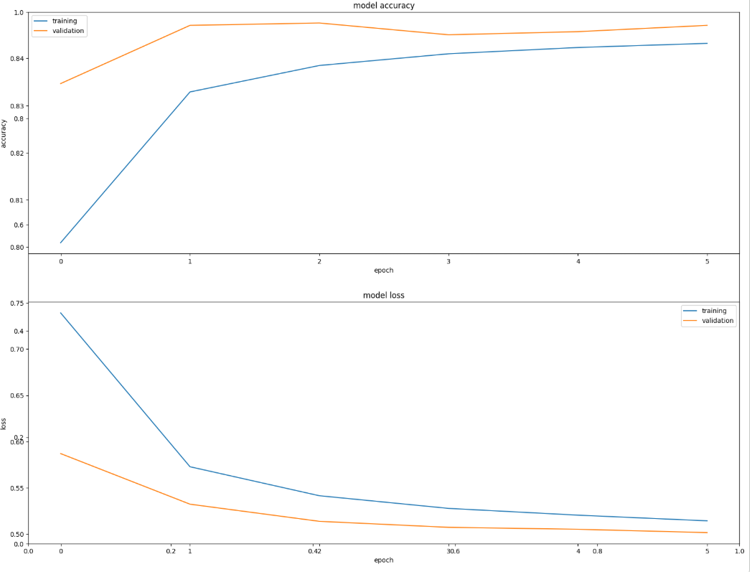
Figure A18. Training and Validation Model Accuracy and Loss, Experiment 5
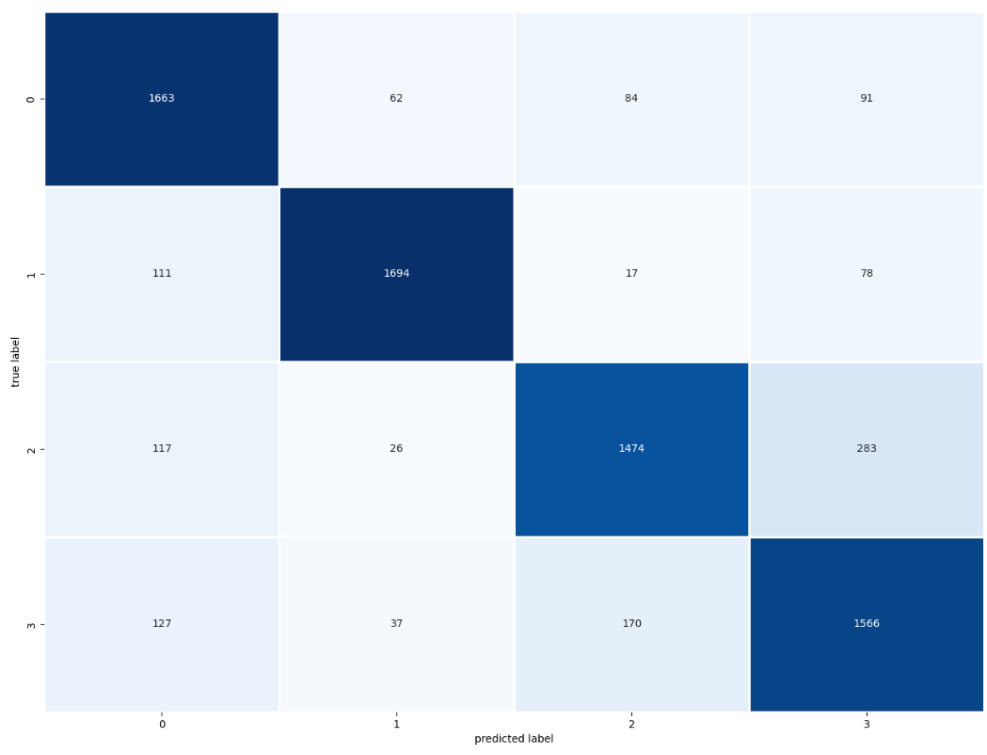
Figure A19. Confusion Matrix, Experiment 5
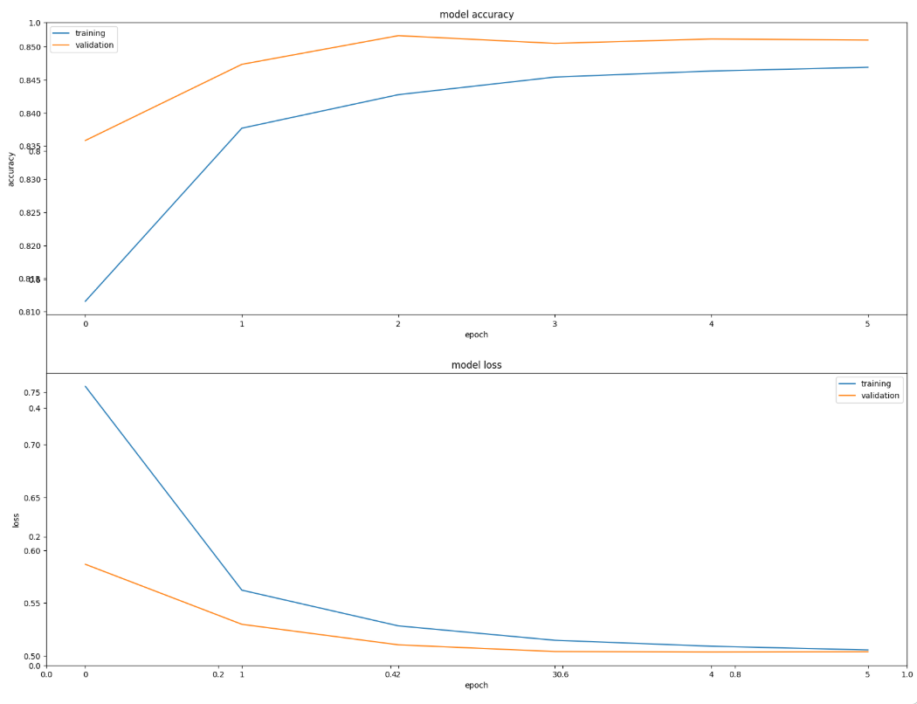
Figure A20. Training and Validation Model Accuracy and Loss, Experiment 6
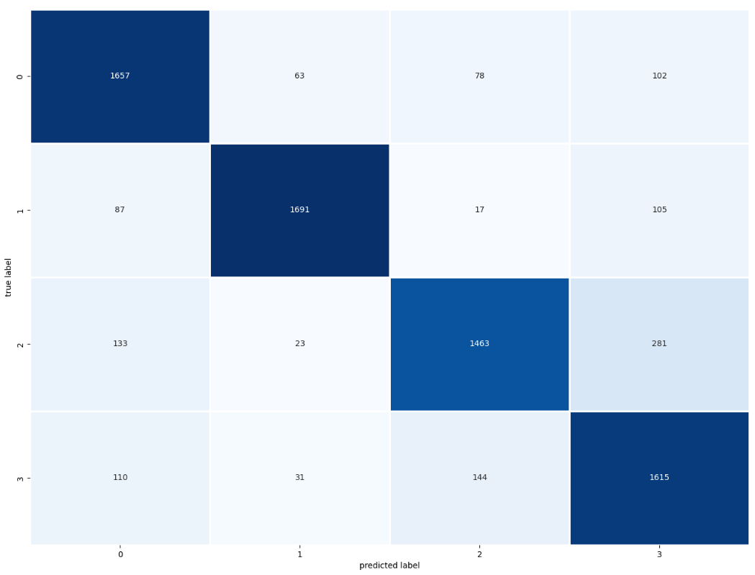
Figure A21. Confusion Matrix, Experiment 6
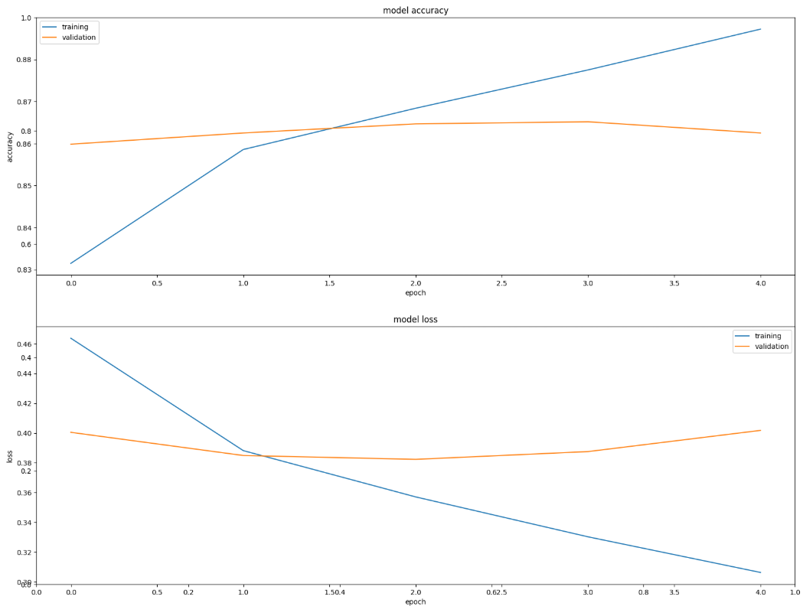
Figure A22.Training and Validation Model Accuracy and Loss, Experiment 7
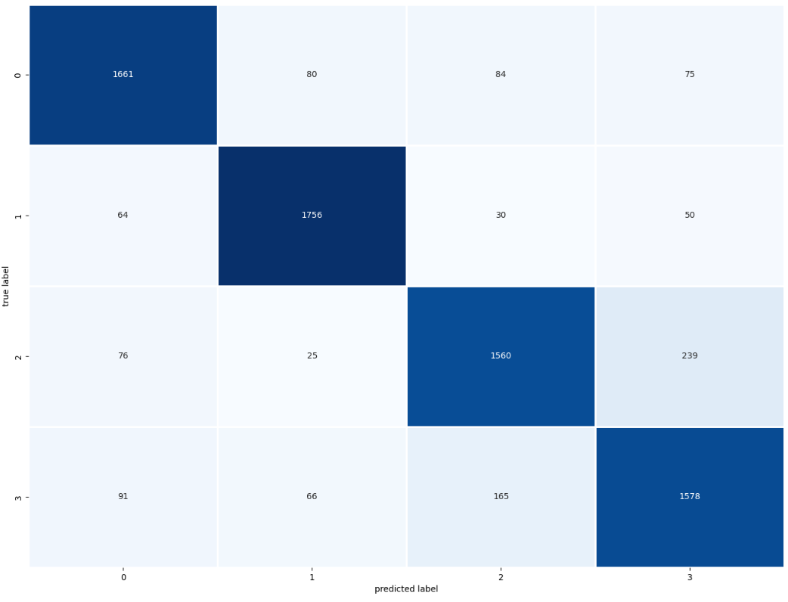
Figure A23. Confusion Matrix, Experiment 7
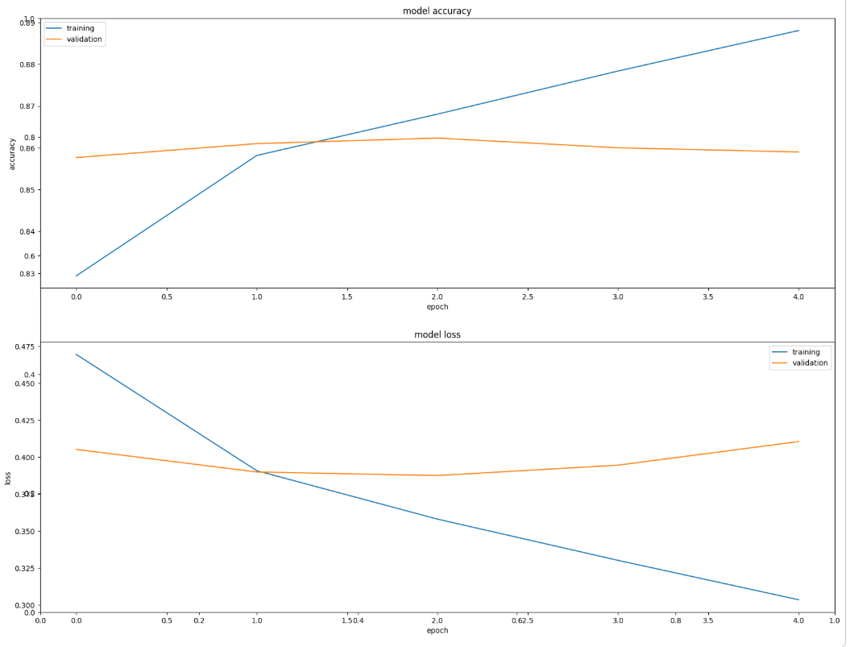
Figure A24. Training and Validation Model Accuracy and Loss, Experiment 8
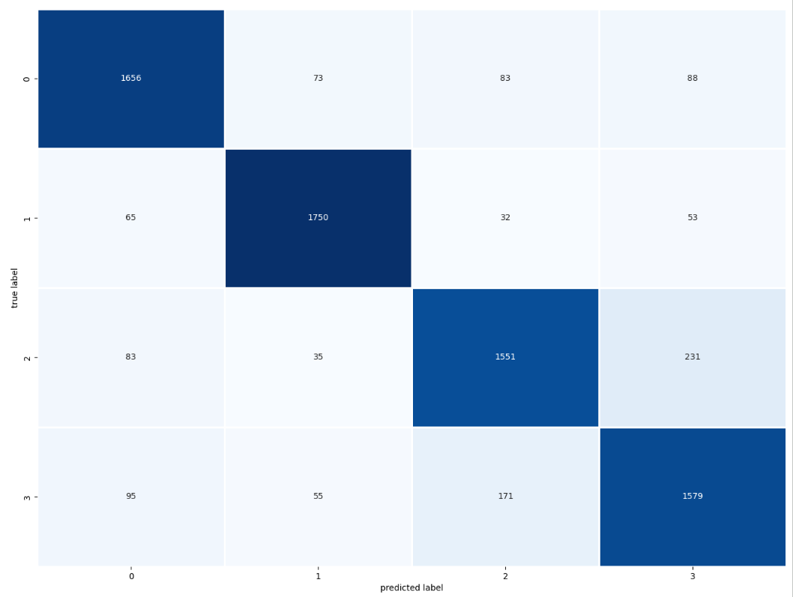
Figure A25. Confusion Matrix, Experiment 8
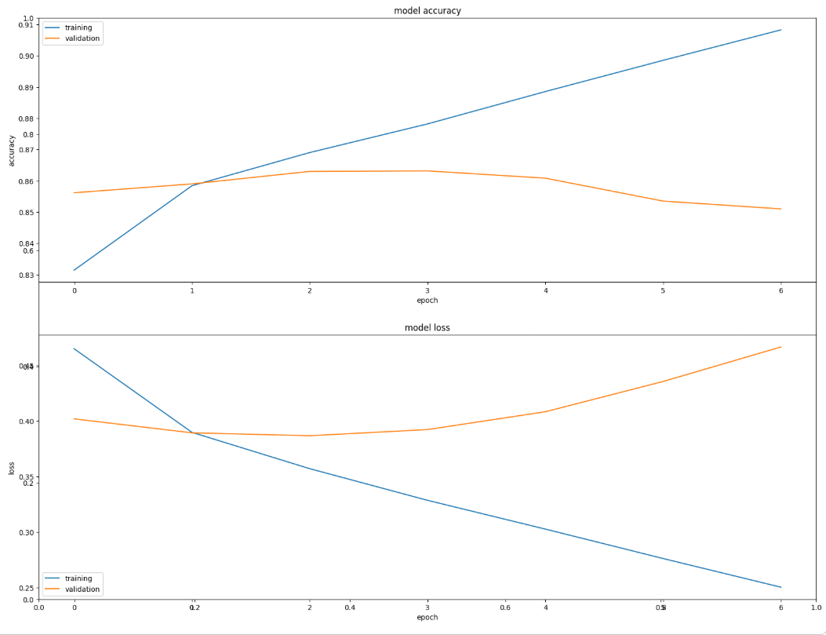
Figure A26. Training and Validation Model Accuracy and Loss, Experiment 9
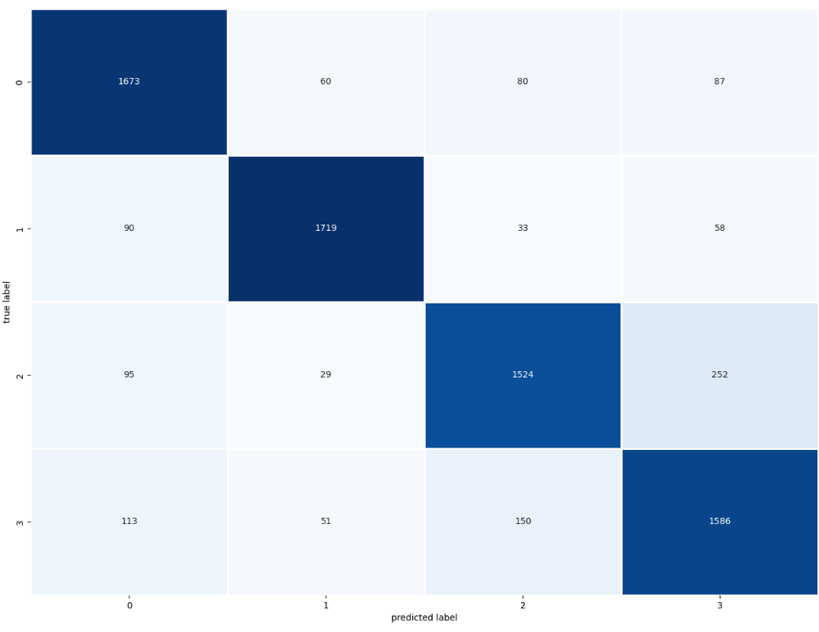
Figure A27. Confusion Matrix, Experiment 9
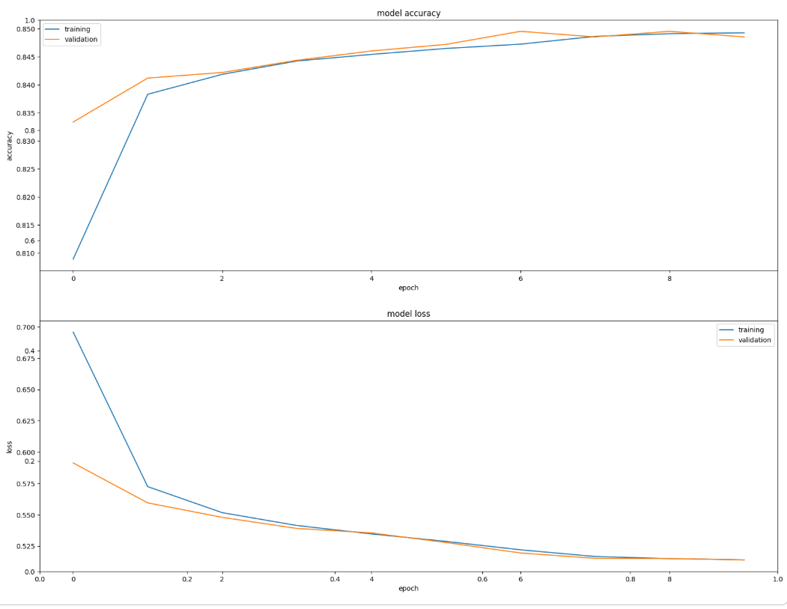
Figure A28. Training and Validation Model Accuracy and Loss, Experiment 10
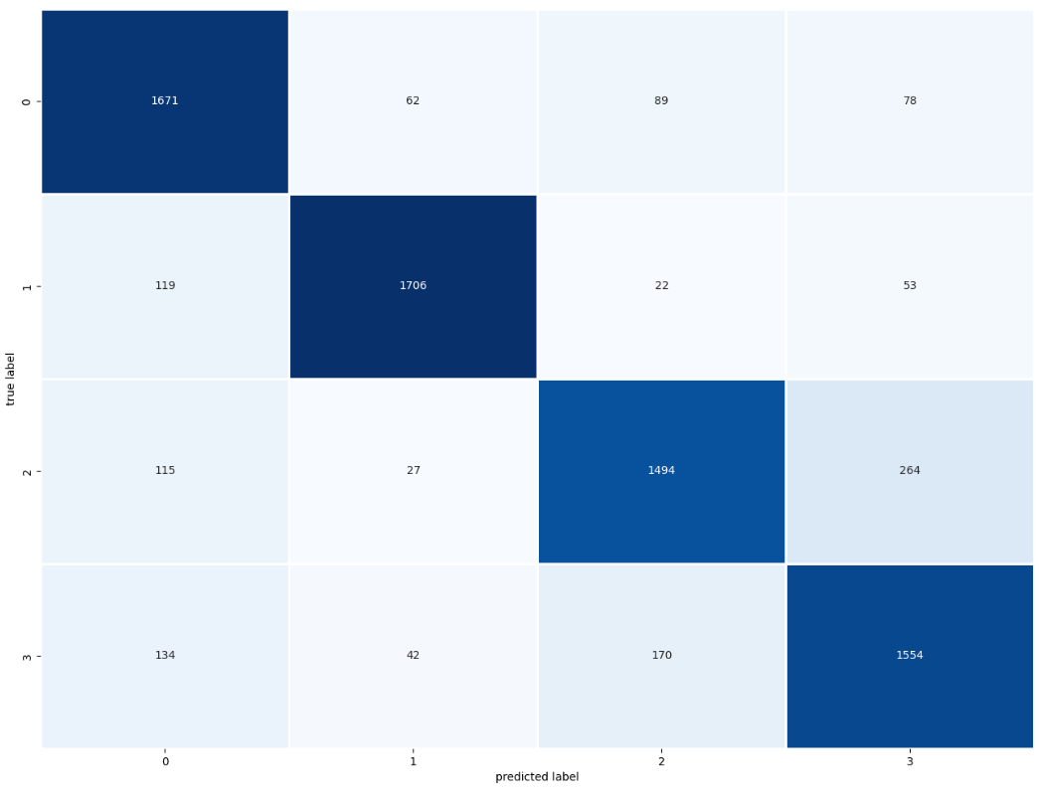
Figure A29. Confusion Matrix, Experiment 10
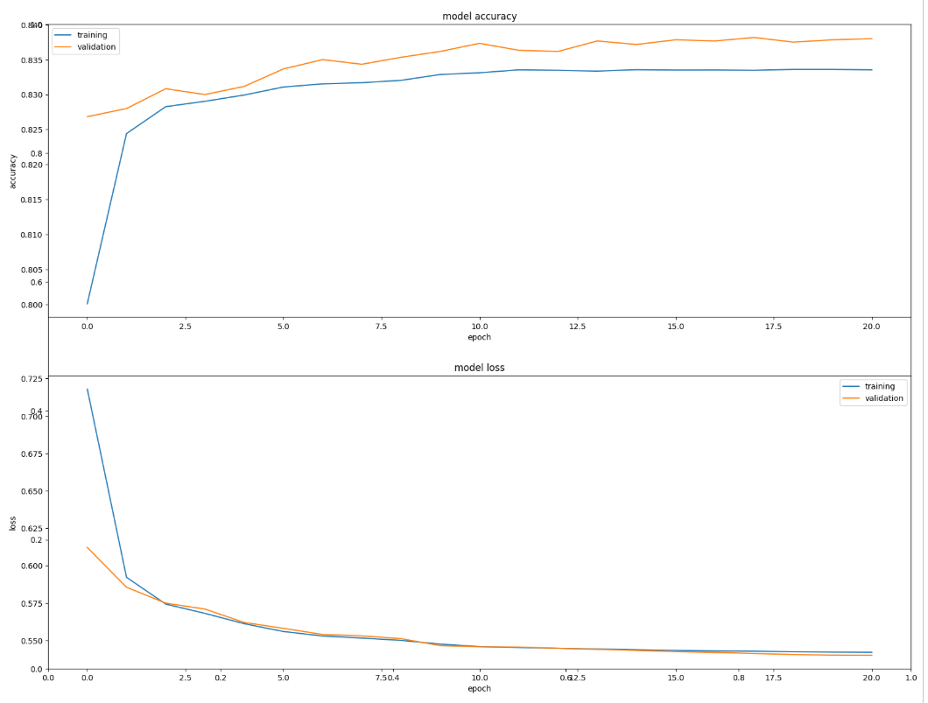
Figure A30. Training and Validation Model Accuracy and Loss, Experiment 11
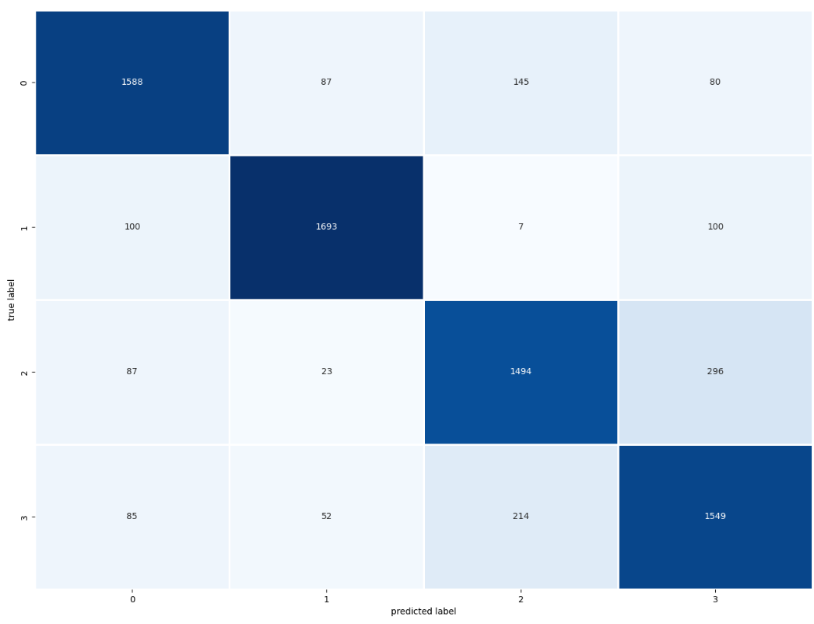
Figure A31. Confusion Matrix, Experiment 11
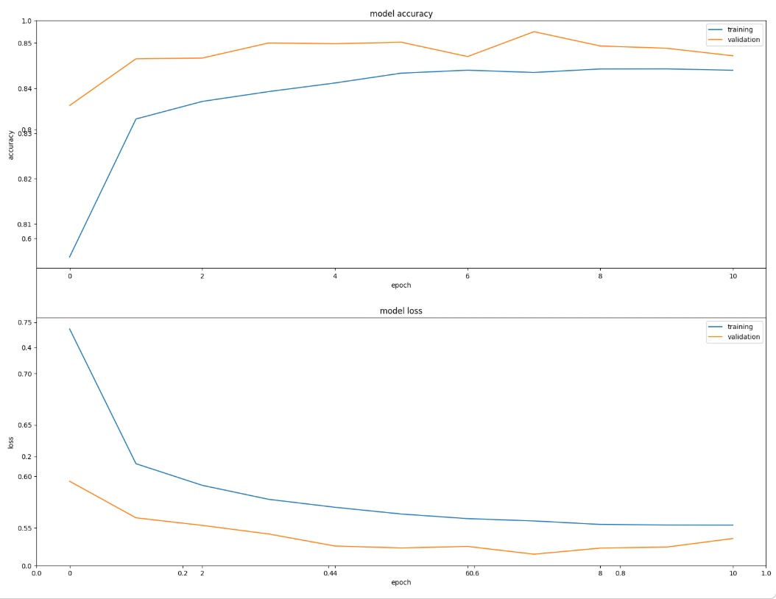
Figure A32. Training and Validation Model Accuracy and Loss, Experiment 12

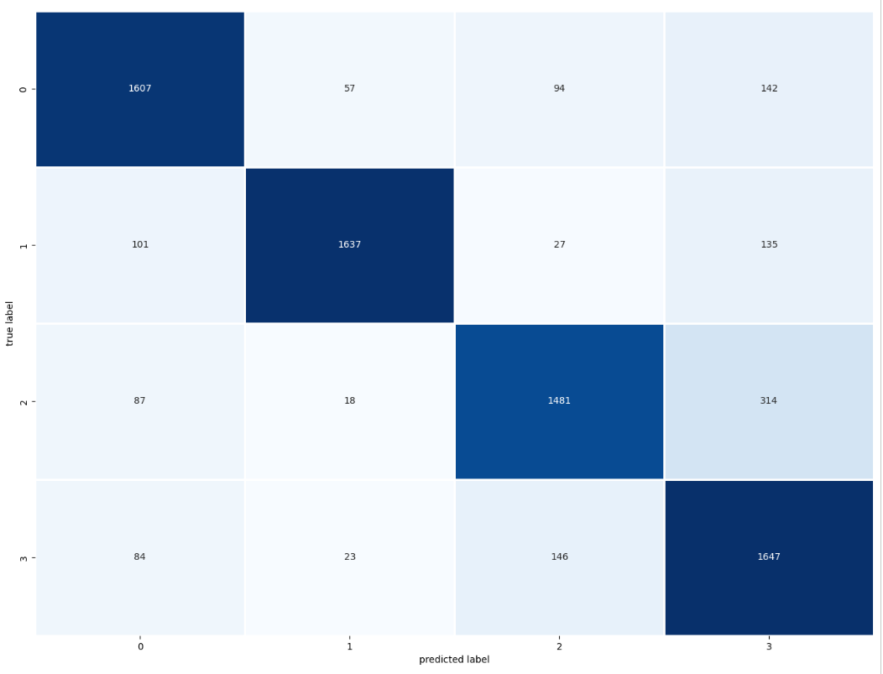
Figure A33. Confusion Matrix, Experiment 12

