**P1 D: Use VSLOOKUP function to retrieve information from a different worksheet or table**

1. Create dataset of your choice

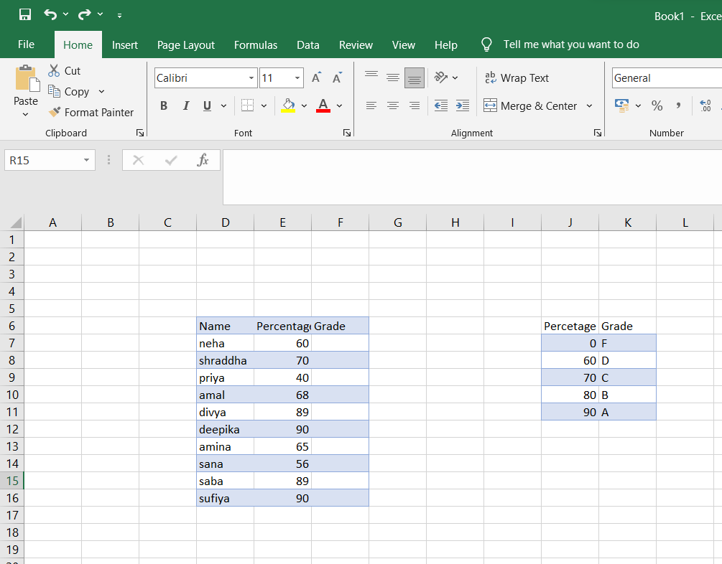

1. Use VSLOOKUP Function to calculate the grade

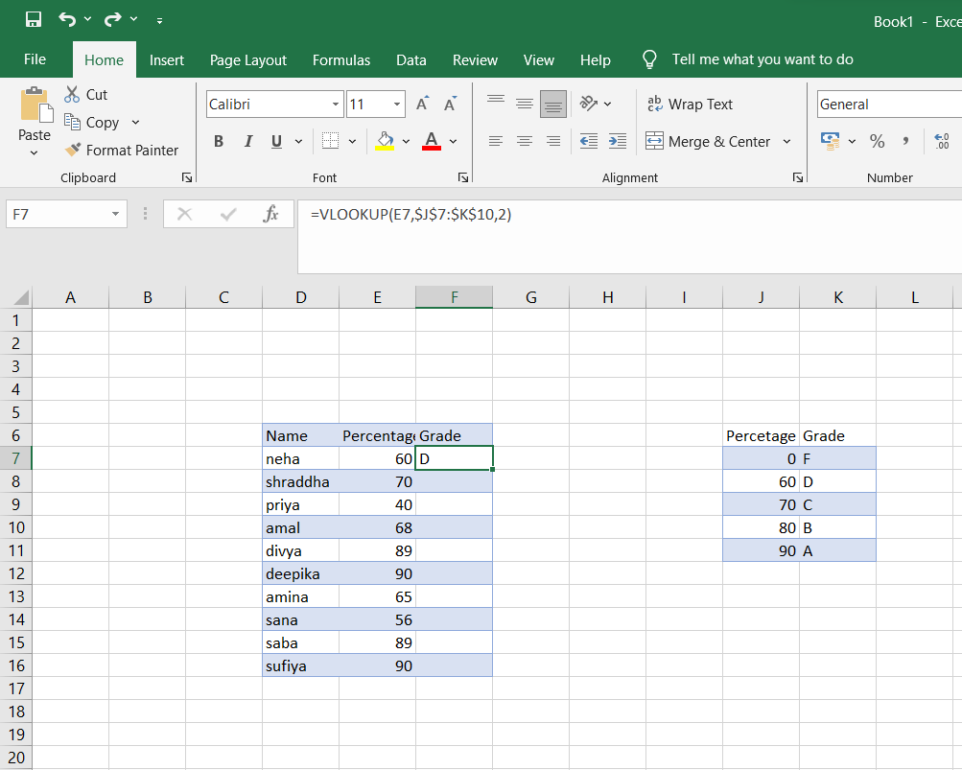

1. Here is the calculated grade using VSLOOKUP

