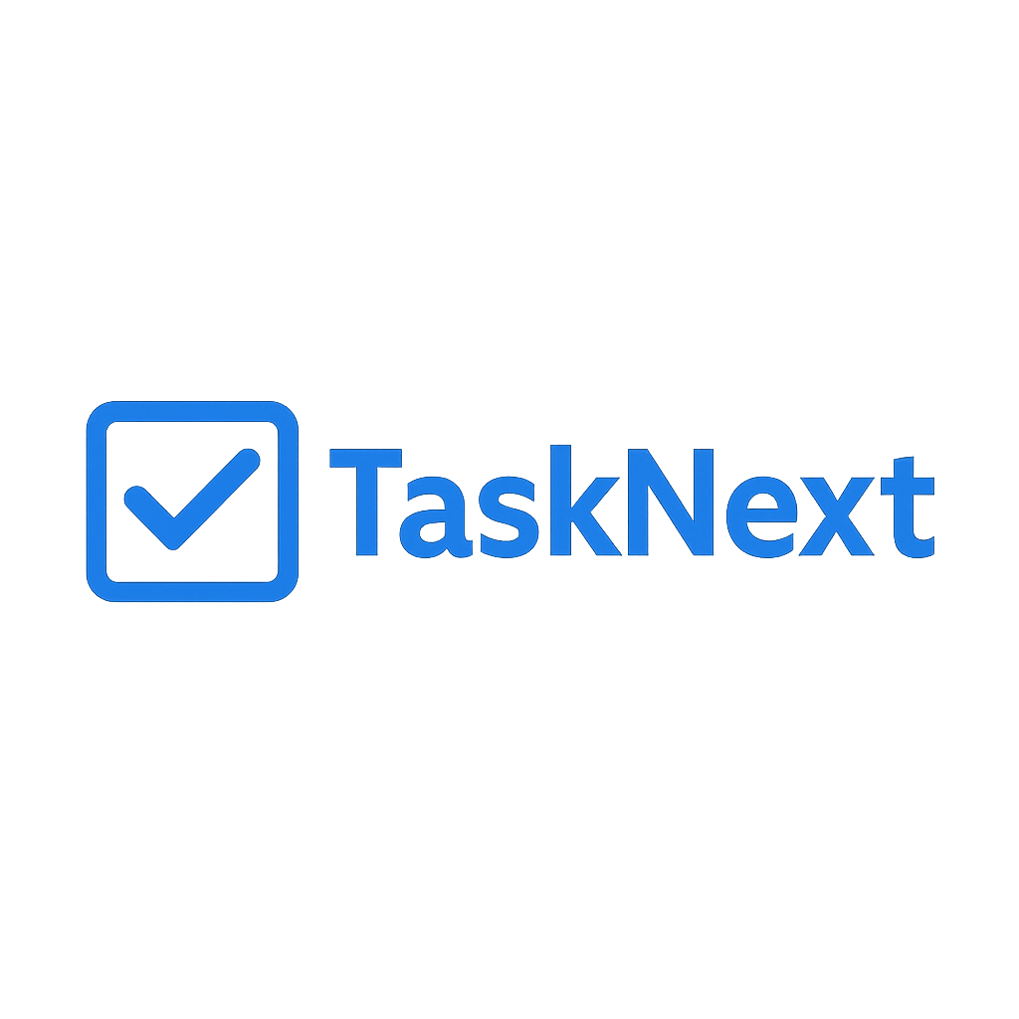

This project is a **Flask-based user authentication and task management system** connected to **MongoDB**.

* Both login.html and register.html use a **shared CSS file** for styling, which includes a **background image** and a **logo**. All static assets (CSS and images) are located in the static/ directory, and referenced using Flask's url_for() function.
* User data is stored in the **user collection** in MongoDB.  
  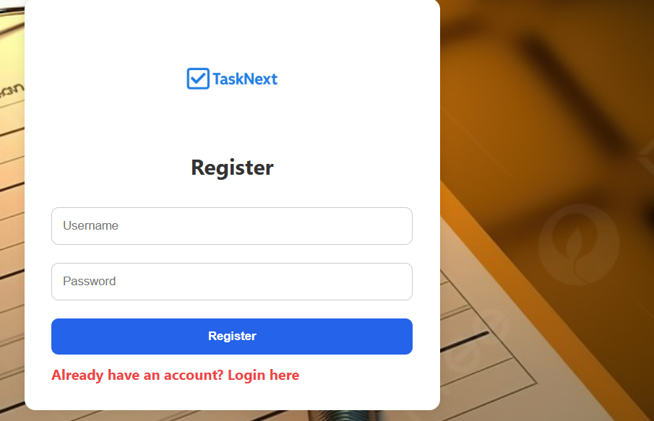

**Registration (register.html)**

* Checks if the entered username already exists in the database.
* If it does, an error message is displayed: *"Username already exists"*.
* If it doesn’t, the new user is registered.  
  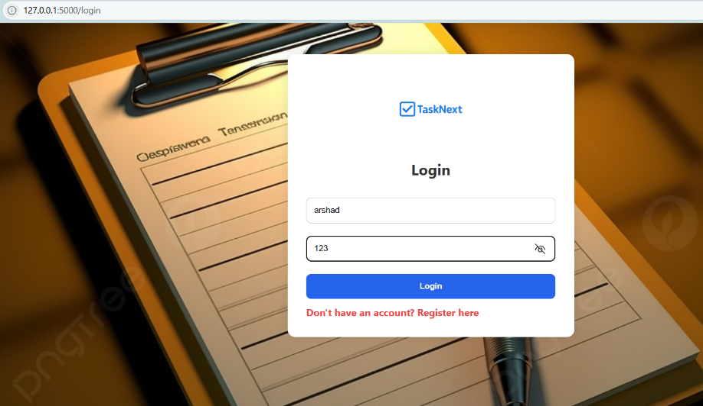

**Login (login.html)**

* Checks if the username and password match a record in the user collection.
* If the credentials are valid, the user is redirected to the **dashboard**.

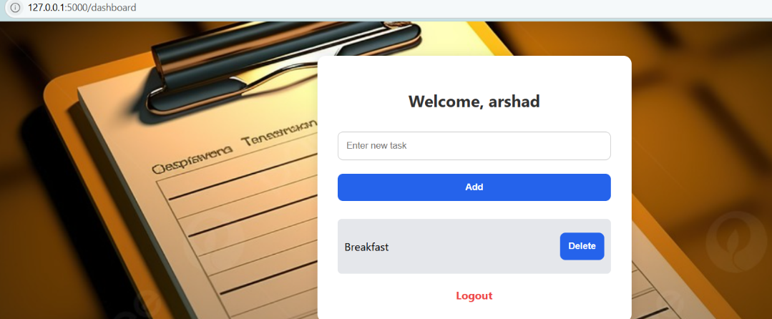  
**Dashboard (after login)**

* Allows users to **add tasks** by entering a task name.
* Tasks are stored in the **task collection** in MongoDB and associated with the logged-in user.
* Users can **delete tasks** when they are completed by clicking a "Delete" button.