Exam Registration System

Description

The website that allows to apply for exams with authenticated user accounts.

SpringBoot

Spring Boot is a powerful framework for building Java-based applications with ease, emphasizing convention over configuration and providing robust out-of-the-box features for rapid development and deployment.

Tools & Technologies

* Java
* Spring boot
* MVC Model
* REST API
* Maven
* SQL
* HTML
* Booststrap

Functionalities

Exam Controller

* Add or Create Exam
* Delete Exam
* Update Exam Details
* Issue Hallticket

Candidates

* Register
* Apply for exams
* Hallticket generation

Specialities

Upgrade Account

This website includes an additional functionality “Upgrade Account” that allows candidates to change their account credentials and personas.

Email Notification

This website notifies the candidate through email about the exam registration details and confirmation.

Output

Index page

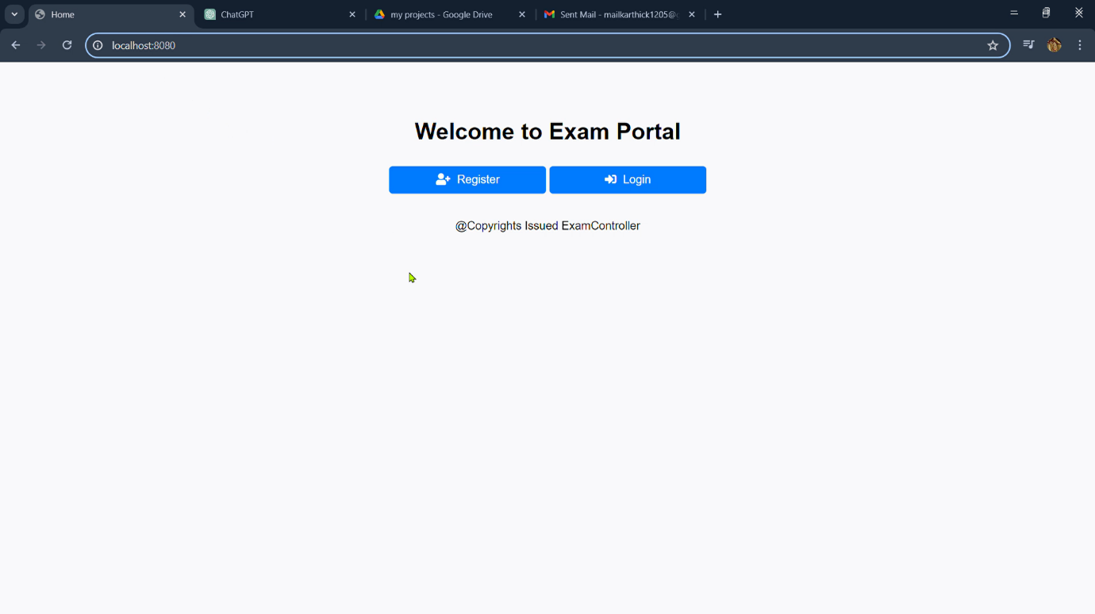

Register page

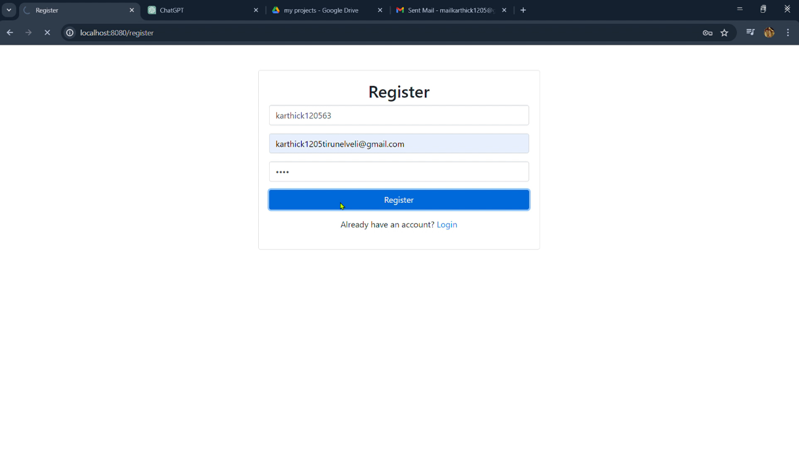

Home Page

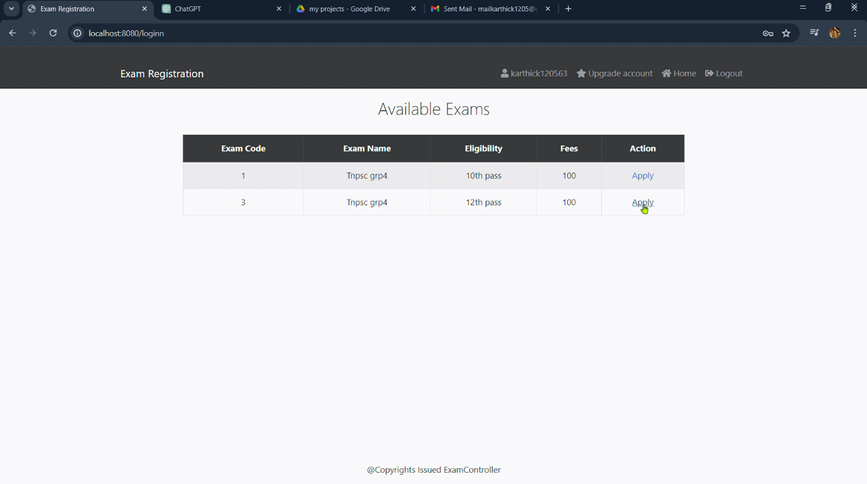

Exam Application page

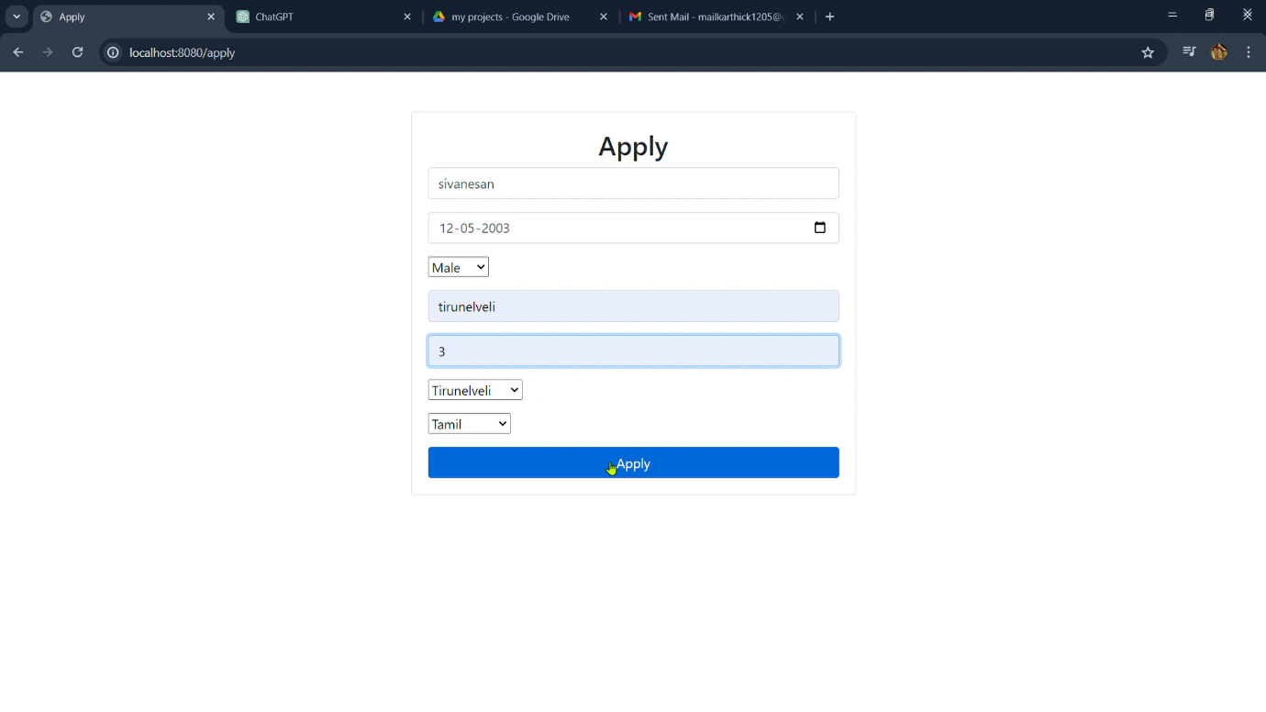

Hallticket page

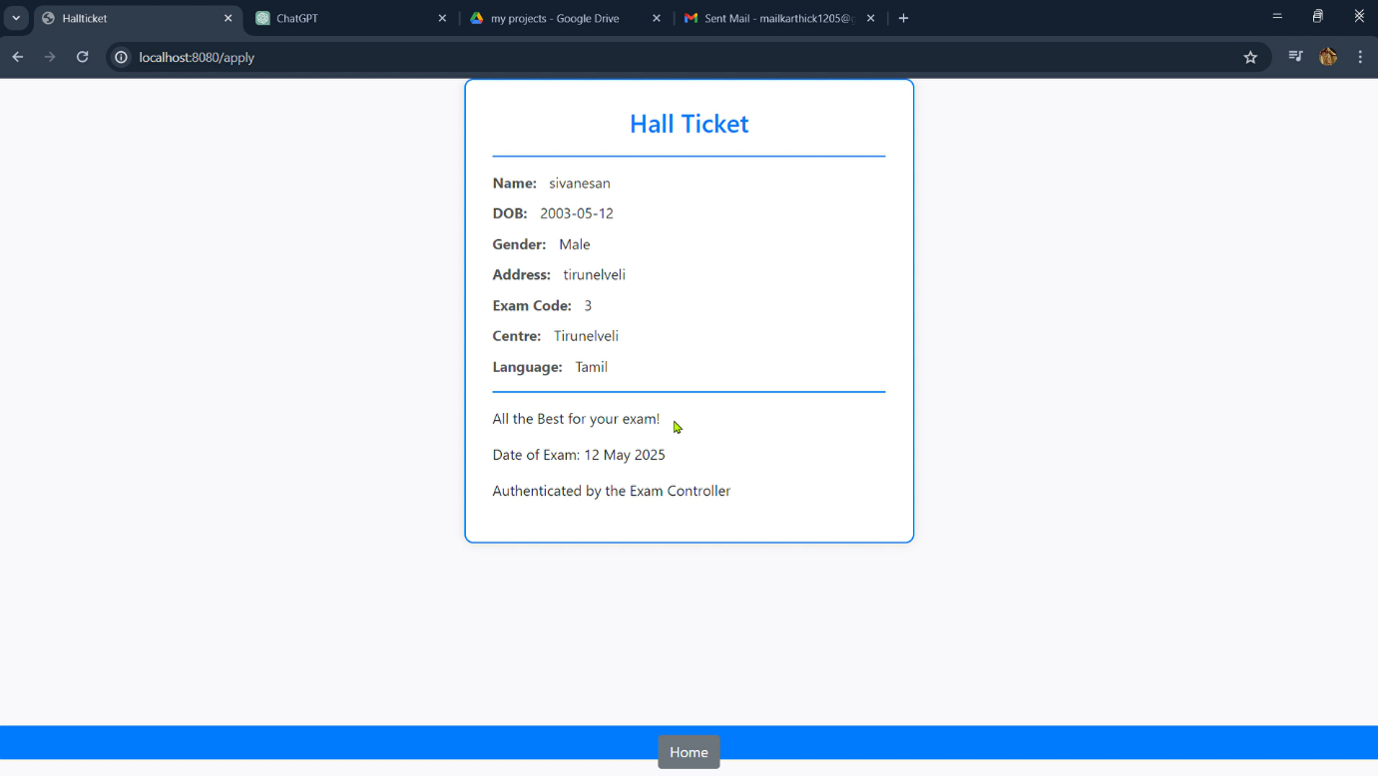

Upgrade account page

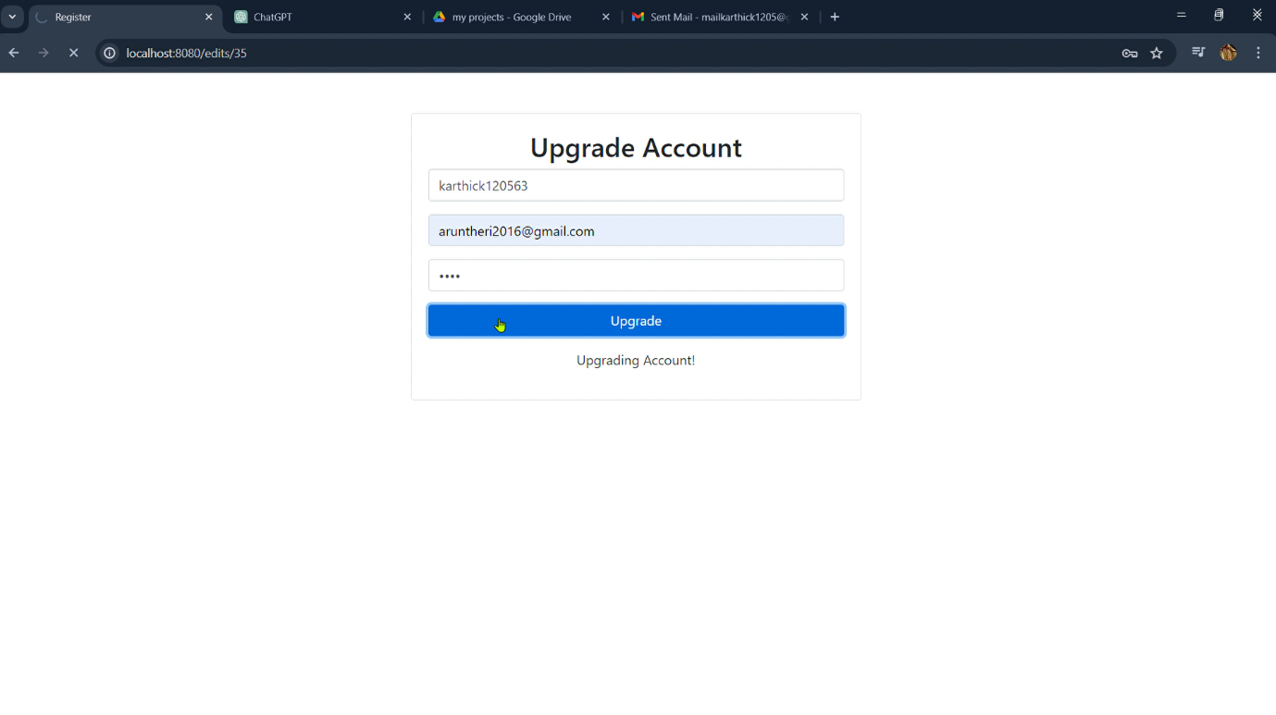

Email notification

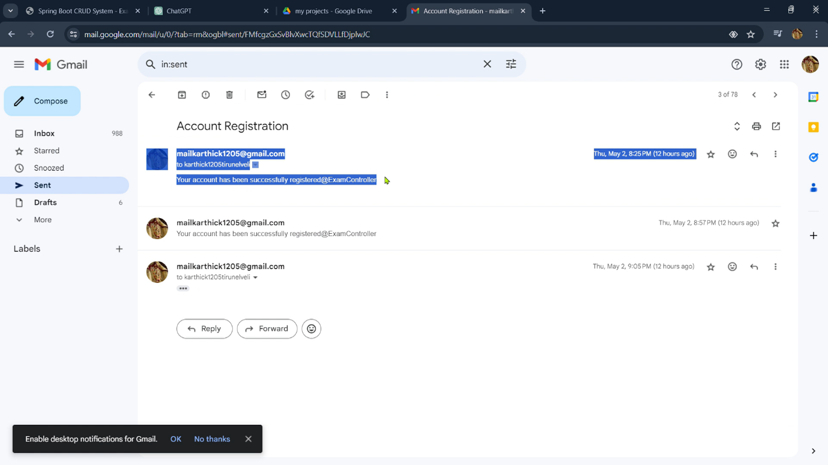Exam controller page

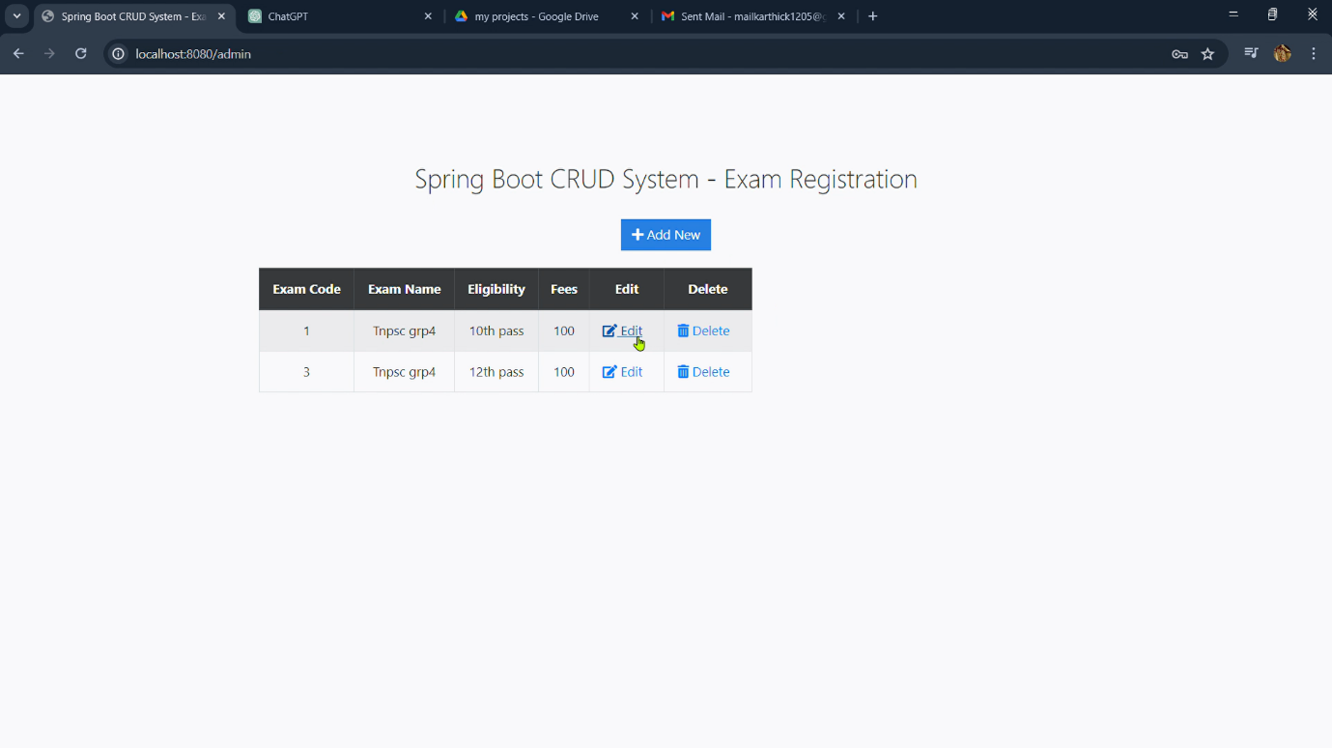

Create exam page

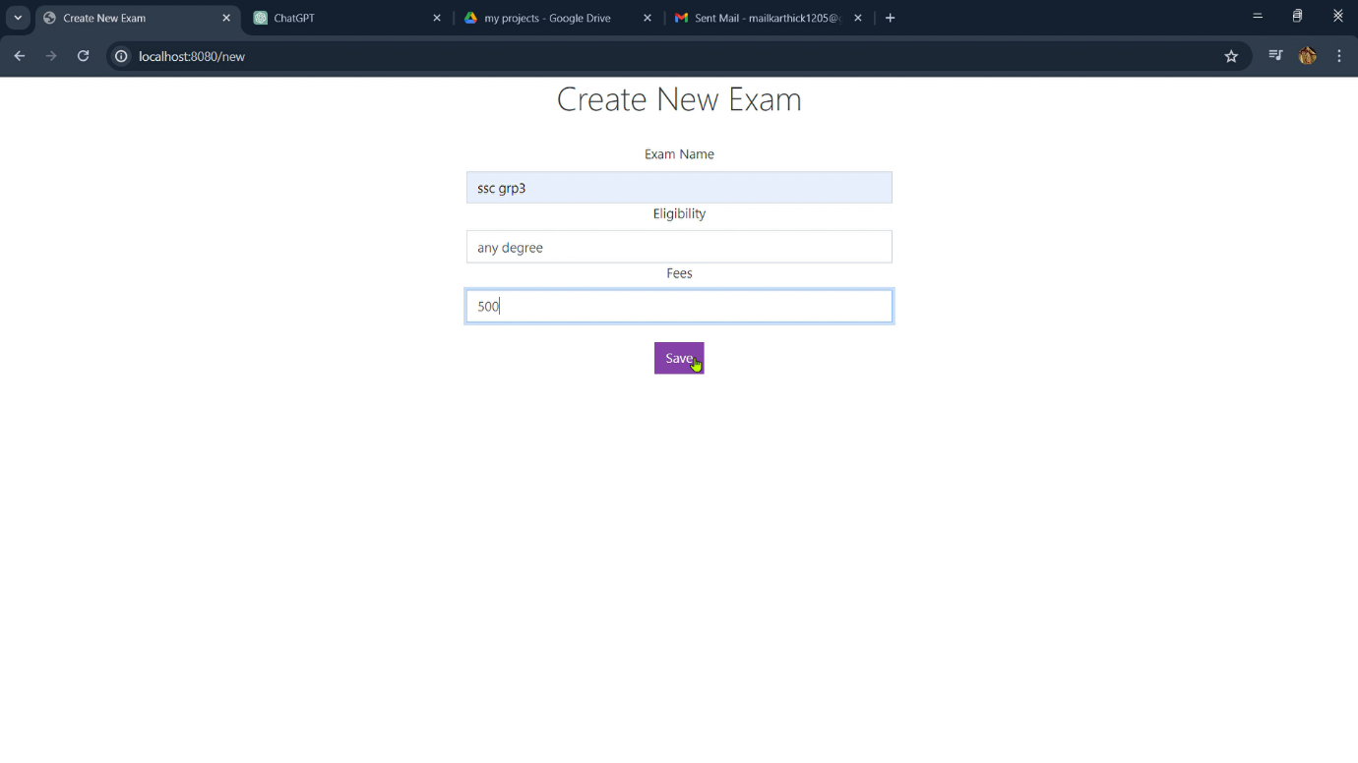

Performing operations

