Senthilkumar Karunakaran
Assignment 3:
Used digits 3 & 4 from training set to build the classifier and used test data to test the classifier.
- Data set used for training by filtering for digits 3 & 4.
Total size: 60000
Number of 3s: 6131
Number of 4s: 5842
- After PCA, original and reconstructed images. Reconstructed image doesn’t compromise the identity of the samples, they are still readable to human eye.

Original:
Reconstructed:
- Scatter plot for the PCA of digits 3 & 4. Digit 3 is plotted in RED and 4 in BLUE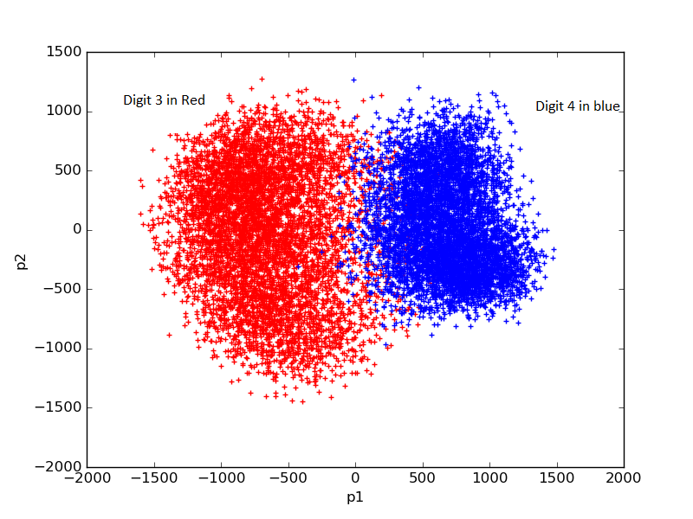

- Classifier results with histogram & Bayesian
Test data has 1010 number of 3s and 982 number of 4s.
Ground truth: 3 is (-) , 4 is (+)
From Testing Set | Histogram ( Correct / Wrong / Indeterminate) | Bayesian ( Correct / Wrong / Indeterminate)
Digit – 3 | 979 / 28 / 3 | 986 / 24 /0
Digit – 4 | 972 / 8 / 2 | 975 / 7 /0
Digits 3 & 4 | 1951 / 36 /5 | 1961 / 31 /0

Output Class--------------->> | Positive |  | Negative
Ground Truth | Histogram | Bayesian | Histogram | Bayesian
Positive | 972 | 975 | 8 | 7
Negative | 28 | 24 | 979 | 986

For digits 3 & 4 (first 2 rows above), both histogram & Bayesian classifier were able to classify the digits with error. Bayesian is able to classify all without any indeterminate state.
For all other digits excluding 3 & 4 (Row 4), both histogram & Bayesian classifiers failed. They classified all the inputs to either 3 or 4. Since the input is not 3 & 4, all are classified to wrong class labels.

- Examples of correct & incorrect classifications
Histogram output | Bayesian output | Image tested
Incorrectly classified as 4 | Incorrectly classified as 4
Correctly classified as 3 | Incorrectly classified as 4
Incorrectly classified as 3 | Correctly classified as 4
Correctly classified as 3 | Correctly classified as 3
Correctly classified as 4 | Correctly classified as 4

- Metrics
Ground truth: 3 is (-) , 4 is (+)
Metric | Histogram | Bayesian
Accuracy | 0.9818 | 0.9844
Sensitivity | 0.9918 | 0.9928
Specificity | 0.9721 | 0.9762
PPV | 0.9720 | 0.9759

Both histogram and bayesian classifiers were effective for PCA. Histogram had few indeterminate cases for some test input.

