Docker Image Tagging as pushing to Docker Hub

Before going further , ensure we have an account on hub.docker.com with a single sign up.

**What is docker image:**

Docker image is a set of binaries and dependencies required to run an app it also contains meta data about image and how to run an image.

Inside image there is not a complete OS , there is not Kernel, no kernel modules it is just binaries we need to run an application., infact the host provide the kernel that makes containers unique.

**What is docker hub.?**

Docker hub is place where all docker images are maintained, and all of its versions.

**docker image pull [image_name]** : if version is not specified , by default latest version is installed.

If any specific version is to be downloaded , then

We can do like below:

**docker image pull [image_name : version]:**

Basically docker images can have multiple tags, on docker hub. If we see the search an image of nginx on docker hub in version section . we can see we have multiple tags of same version.

Look at below screenshot : 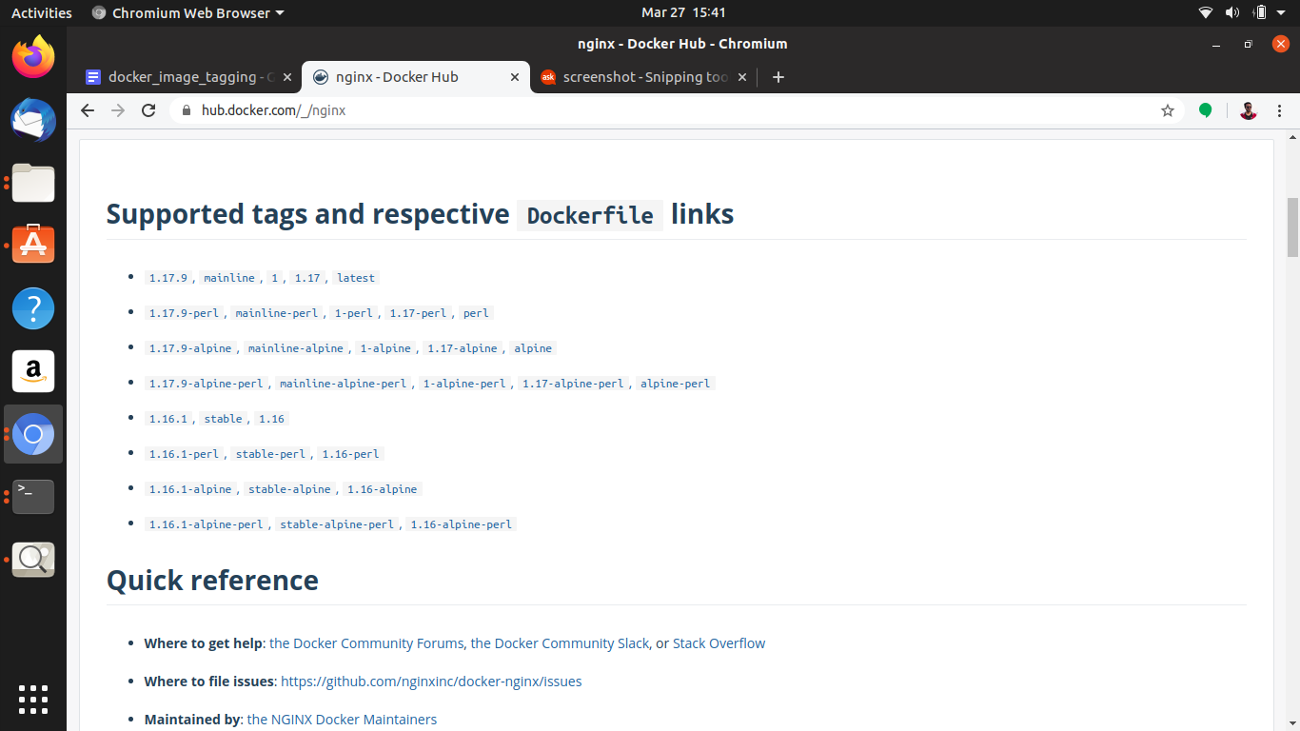

To prove this in below image , look at the highlighted part both nginx image is same, but they have different tag.

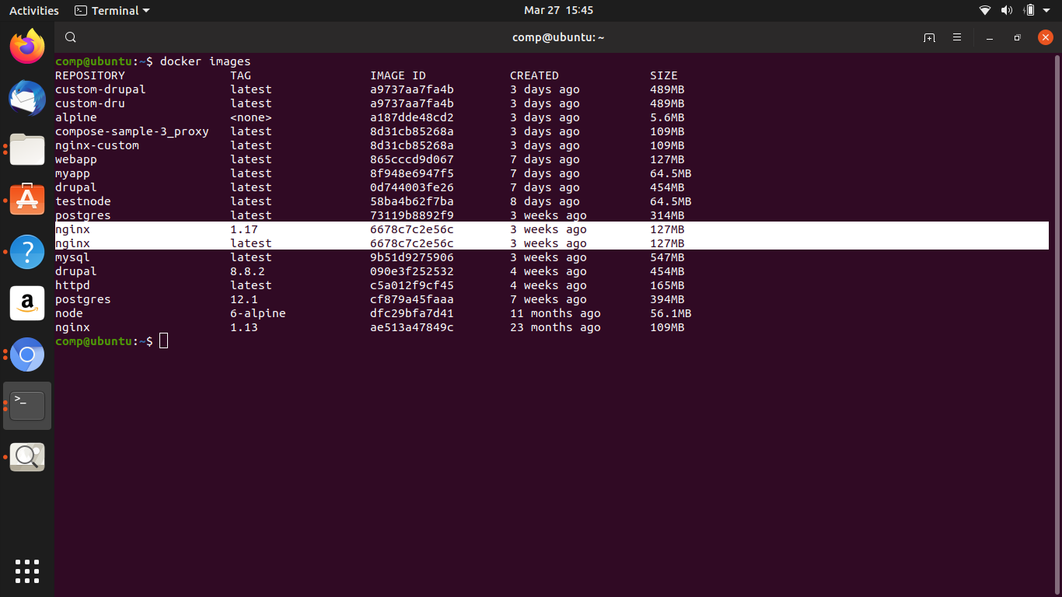

Link for all docker file and their images:

[**https://github.com/docker-library/official-images/tree/master/library**](https://github.com/docker-library/official-images/tree/master/library)

**Docker image Tagging and pushing them to docker Hub:**

Image tagging: images don’t technically have name, they are identified by 2 parameters.

1. Repository
2. Tag

If we look for all images locally: by command

**docker images**

**We don’t see any name collumn in there , see below screenshot :**

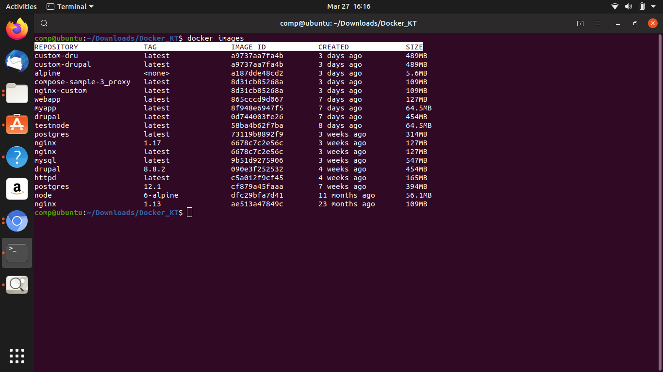

Now repository are made up of either the {username/organization_name}/image

So basically when we look for an image to pull lets say for example

Docker image pull **mysql**/**mysql-server**:**latest**

So **mysql** is name of user , **mysql-server** is name of docker image and **latest is the tag**

You can say **Tag** is pointer to specific version of commit.

To change the tag:

We will take an existing image to change the tag:

Syntax:

**docker image tag SOURCE_IMAGE[:TAG] TARGET_IMAGE[:TAG]**

Ex:

**Docker image tag nginx skarwa4491/nginx:latest**

Here new name should be in format username_of_docker_hub/repository_name:tag

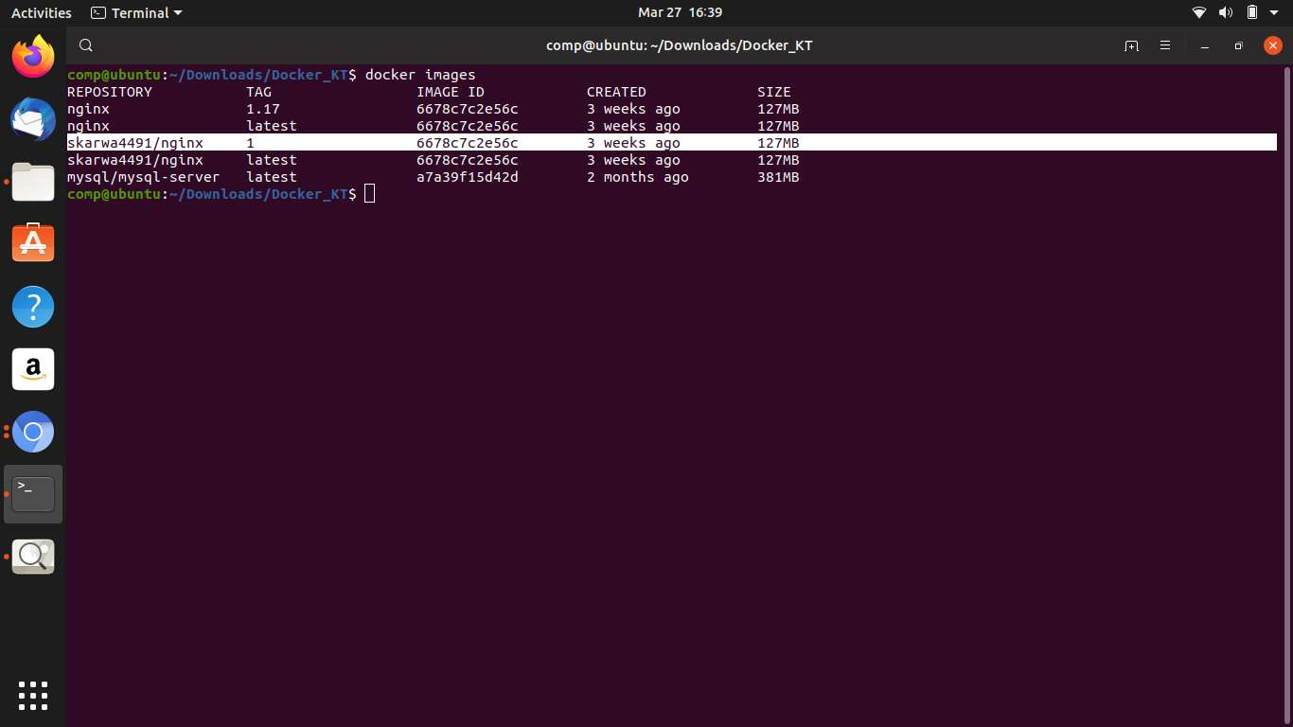

And if we want to push to docker hub

We have to login first to do so

**1.Docker login: will ask for docker hub account credentials to login**

**2.Docker push skarwa4491/nginx :** this will push the image to your docker hub account

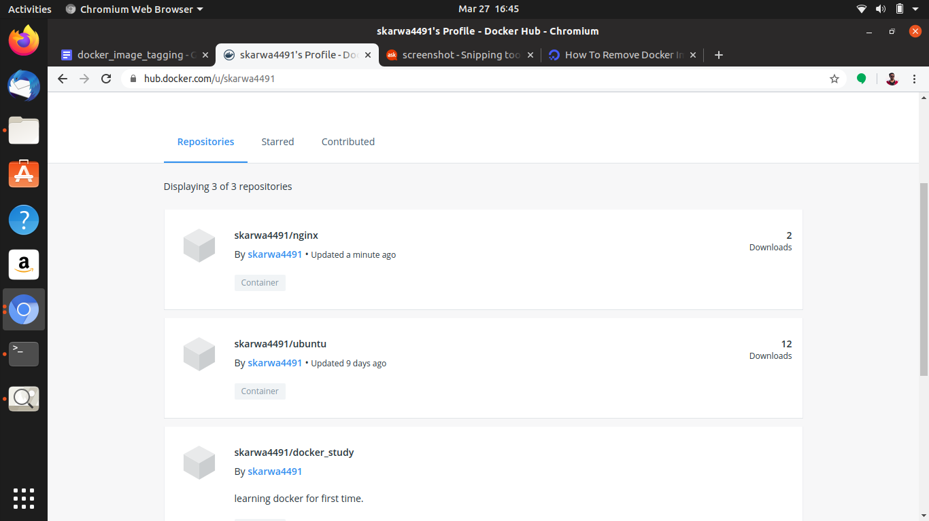

Once we do login :

A key is stored in a config file , to identify account details

To see the key type :

**cat .docker/config.json**

Output of above command:

{

"auths": {

"https://index.docker.io/v1/": {

"auth": "c2thcndhNDQ5MTpzd2FwbmlsMTk5MDQwNA=="

}

},

"HttpHeaders": {

"User-Agent": "Docker-Client/19.03.6 (linux)"

}

}

When we are done , just say **docker logout.**