**Enhancement/Customization:** E3 Export Bundle Segment Information for COMSOL

Customer: Trend Industries

**Objective:**

Provide the harness team with the ability to export bundle segment data on a selected harness segment, consisting of the outer and inner diameter of the cable and individual wires. The exported data shall consist of an Excel spreadsheet of the bundle segment.

**Background:**

The harness group is looking to use Zuken’s ability of displaying the minimum cross-section in order to import an Excel formatted file of a bundle segment cross-section into the COMSOL simulation tool in order to perform a thermal analysis.

E3.HarnessAnalyzer:

User selects segment:

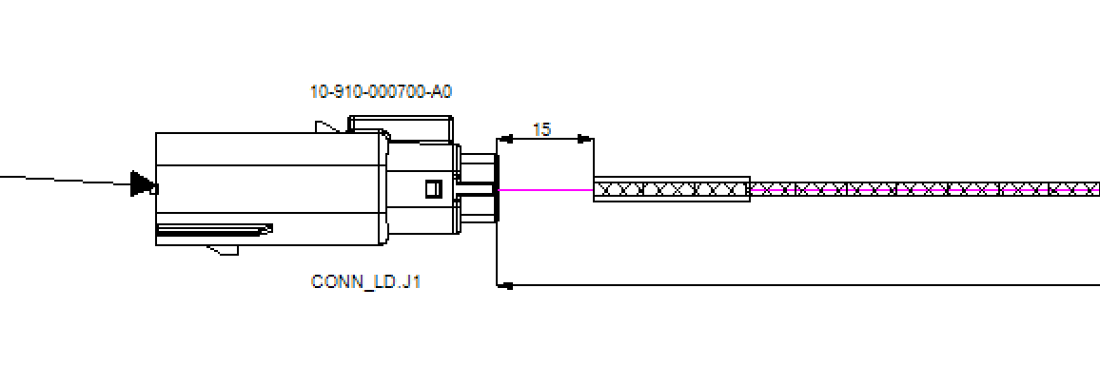

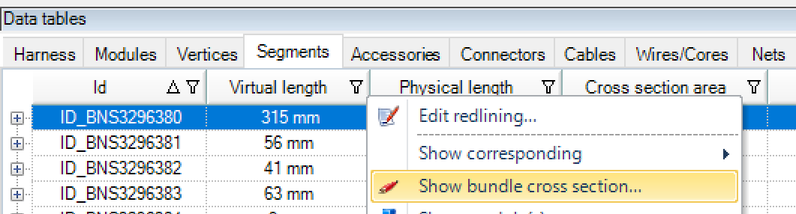

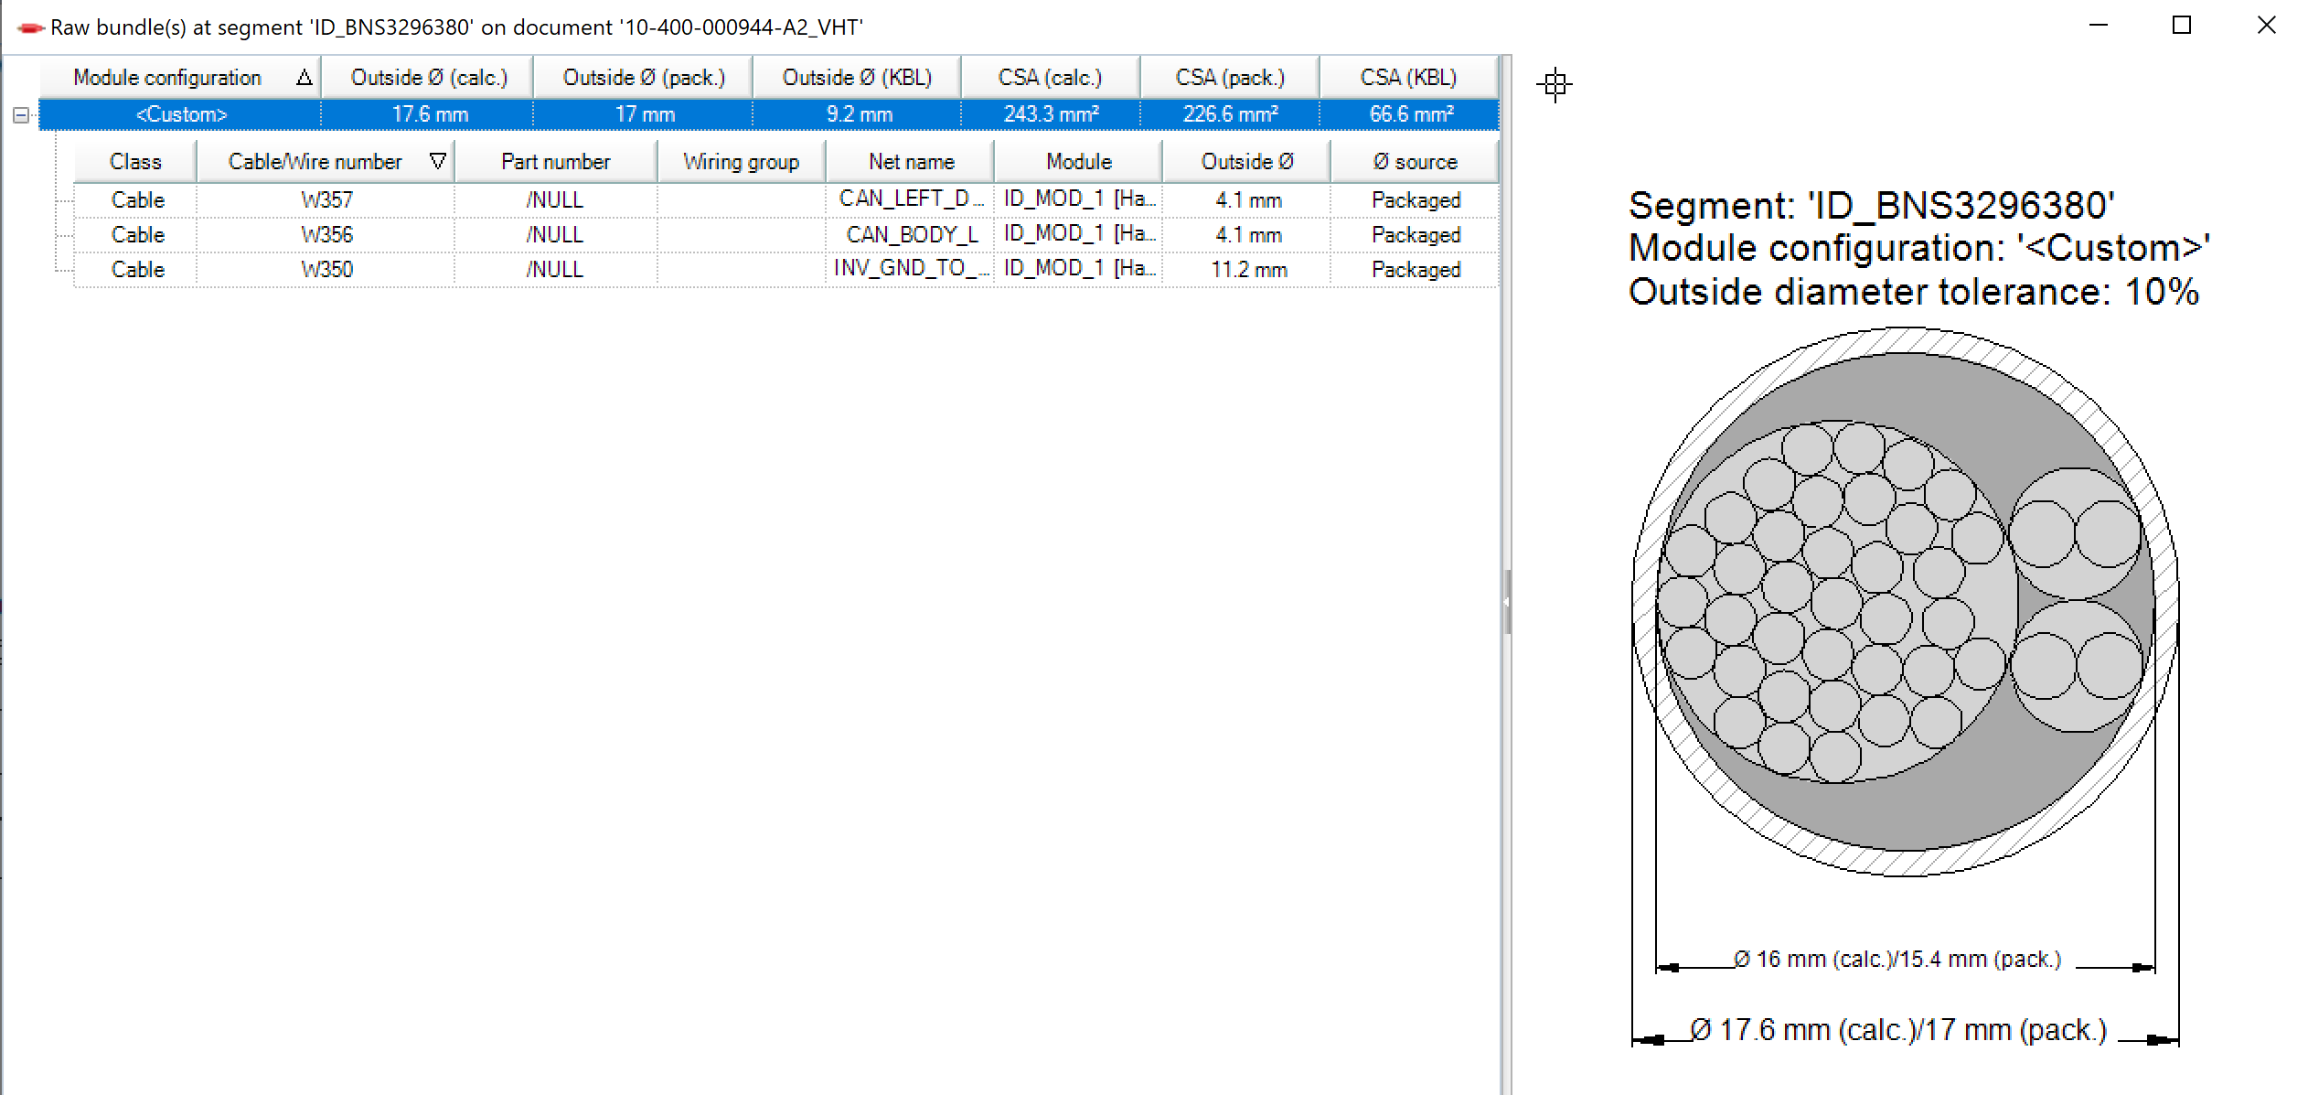

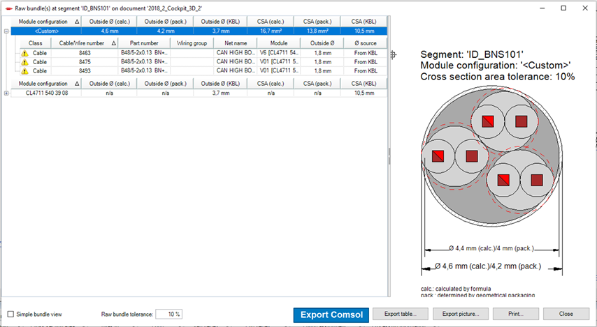

With pressing the “Export Comsol” – button the excel file is generated for the selected bundle in selected configuration (if there are multiple configuration).

*Note:* The graphical representation of the bundle segment is generated on-the-fly via an algorithm. It is not user modifiable.

**Detailed Requirements**:

The development and implementation of this enhancement shall be divided into multiple-phases.

*Note: Phase 2 is not committed yet. It will be reevaluated after Phase 1 completion.*

*Preliminary*

1. Provide a manually created Excel output to serve as a mock up, containing the X-axis and Y-axis for the circle for the inner and outer diameter of each wire. See Requirement #3 in Phase 1 below for format.

*Phase 1*

User must manually select the desired segment within E3.HarnessAnalyzer

1. **Excel:** Export an Excel document listing the radius, center x-axis, center y-axis values of the inner and outer diameter of each wire.

*The Wire ID column value shall be composed of the <Cable Device Designation>:<Wire Name> + ID or OD string

* 1. Example:
     1. W350:0532-0.50 mm²-Black ID
     2. W350:0532-0.50 mm²-Black OD

|  |  |
| --- | --- |
| **Column** | **Value** |
| Wire ID | List the inner and outer diameter per each wire ID in individual rows. *The wire ID must match the same on the Zuken E3.series side.* |
| Radius | Radius of circle |
| Center-X | Center X-axis coordinate of circle |
| Center-Y | Center Y-axis coordinate of circle |
| Signal Name | Net Name/Signal Name |

1. The file name for the Excel and DXF outputs shall consist of the following naming structure:
   * 1. <harness_filename>--segment_ID_<Segment name>.xlsx
     2. <harness_filename>-segment_ID_<Segment name>.dxf
     3. <harness_filename> refers to the HCV file name
        1. Note: User is responsible for naming the HCV file*
     4. <Segment name> refers to the Segment ID generated by E3.HarnessAnalayzer.

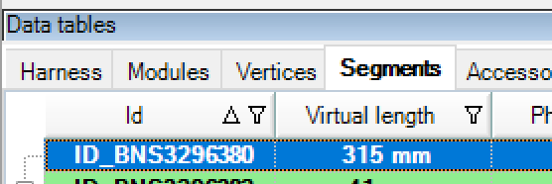

Example:

10-400-000123-A0-segment_ID_BNS3296380.xlsx

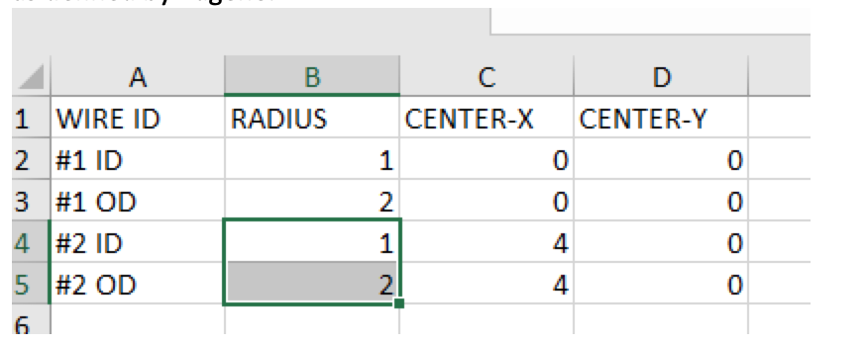

*Example: Original Excel Output required for COMSOL import*

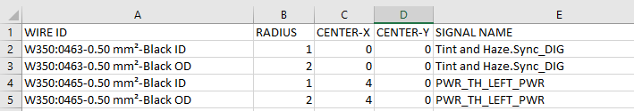

Example: E3 wire naming with Cable Device Designation

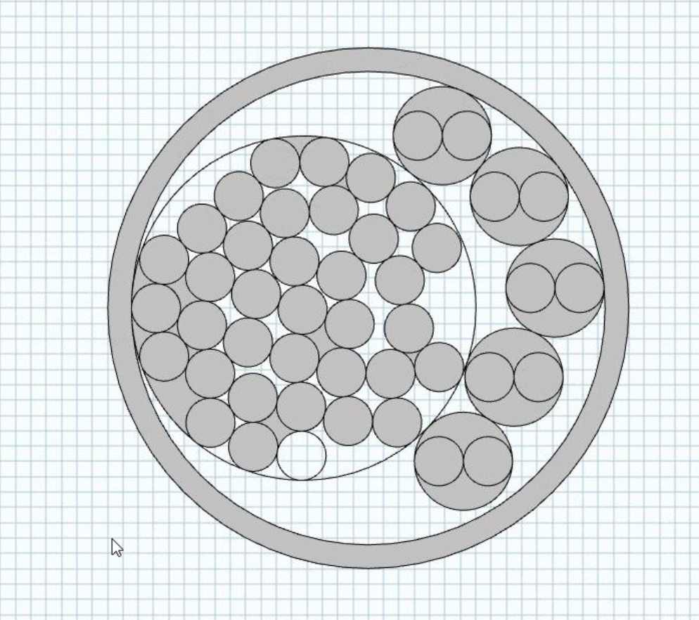

*Example view of COMSOL import of E3.HarnessAnalzyer Excel*

1. Develop a method for automating the naming and save path of exporting the HCV file via the E3.3DRoutingBridge
   1. User selects the active formboard sheet and runs the automated HCV method script
   2. File name: <Drawing Number>.HCV
      1. Where the attribute <Drawing Number> is derived from the active formboard sheet properties
   3. Provide a configurable export save path. The path shall be generated with the following parameters:
      1. \\<Server Path>\<E3 Project Name>\<Drawing Number>\
         1. Where the <E3 Project Name> value is derived from the E3 Project Name
         2. Where the attribute <Drawing Number> is derived from the active formboard sheet properties

*Phase 2*

*Important: as of April 15th, 2020 it is not possible to commit to the implementation of Phase 2. Zuken requires the harness team to verify that the results from Phase 1 meets expectations and can be loaded into COMSOL.*

1. Enhance the export capability to provide a batch export of every segment within the harness:

* Excel
  1. Each file name will consist:
     1. <harness_filename>--segment_ID_<Segment name>.xlsx

Example:

10-400-000123-A0-segment_ID_BNS3296380.xlsx

1. Provide a configurable setting for the batch export to save the files to a definable file directory on the network share.
   1. Generate a folder per harness file name
      1. Example: If the HCV file name is called 10-400-000123-A0.hcv
         1. Generate a folder called <network path>\10-400-000123-A0\
            1. Contents inside this folder:

10-400-000123-A0-segment_ID_BNS3296380.xlsx

10-400-000123-A0-segment_ID_BNS3296382.xlsx

1. ~~Provide a method for searching the Segment ID within E3.HarnessAnalyzer for troubleshooting purposes~~
   1. ~~Match Segment ID with Branch ID from E3.formboard.~~
   2. ~~Use case is if user is reviewing the Excel spreadsheet and needs to quickly determine which branch this references to.~~

~~10-400-000123-A0-segment_ID_BNS3296380.xlsx quickly be able to reference where ID_BNS3296380 is within the formboard drawing.~~

***Acceptance Criteria:***

Provide the Excel outputs of the selected bundle segments to harness team to import into COMSOL and test.