# General Settings

## When there is a document loaded

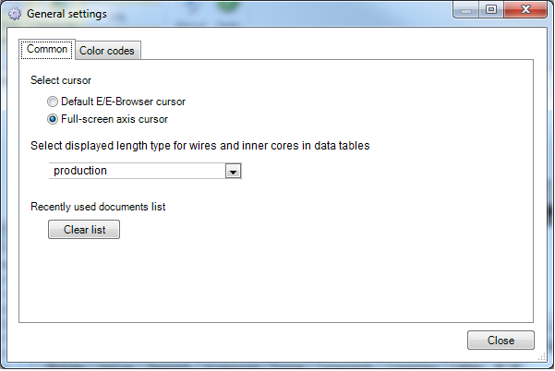

Activate DropDown and show up the currently saved setting.

If this length type is not present in current document, show it anyway. We won’t change setting automatically.

List all available length types in DropDown. When user changes selection, save it to XML.

When leaving settings dialog, update EEB to show up correct values/headers in data tables.

## When there is no document loaded

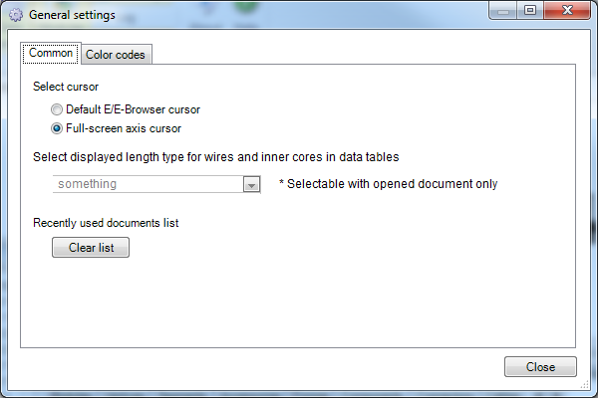

Deactivate DropDown but show up the currently saved setting.

Display a comment for the user helping him to understand situation.

# Data tables

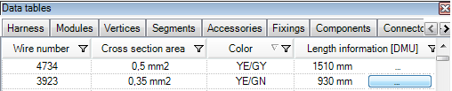

If there are multiple lengths in document:

add the current setting to column header

If we are viewing a fileformat (DSI, …) with only one length:

omit this information in column header as it might confuse the user.

If the wire/core has at least one more length:

show the ‘…’ button.

If the wire/core does not have a length of the selected type:

do not show a value but only the ‘…’ button.

## Details dialog

Pressing the ‘…’ button will open up this dialog:

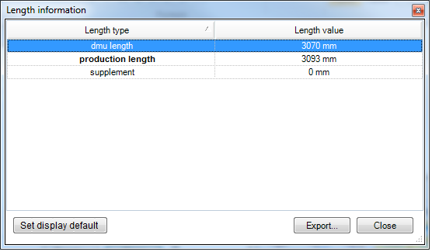

Bold font for the current default length type. If not present for this wire/core, do nothing.

Add button to set default. Activate button, if a length different from current default is selected. Disable button, if current default is selected.

If setting has been changed, update XML and EEB-GUI.

**Note:**

If too much effort for changing XML-Configuration from this dialog:

Let ‘Set display default’ open up the General Settings dialog. In this case, button stays enabled all the time.