**Created by:** MTC-Cabling-TP

**Phone:** +49 7031 90 68286

**Email:** MTC-Cabling-TP@Daimler.com

**Created at:** 04.08.2015

**Version: 6.1.0**

**Daimler Installation Manual**

**E3.HarnessAnalyzer**

**Installation Manual**

**Index**

1 Revision history 3

2 Prerequisites 3

3 Setup and Activation 3

4 Installation Instructions 3

5 Configuration License-Server 6

# Revision history

|  |  |  |  |
| --- | --- | --- | --- |
| Version | Date | Name | Description |
| 1.0 | 09.04.2015 | MTC-Cabling-TP | Initial Version |
|  |  |  |  |

# Prerequisites

E3.HarnessAnalyzer(64bit) needs the following components:

* Microsoft .NET Framework 4.5 Version 4.5.50709 (64bit)
* Microsoft Visual C++ 2008 Redistributable SP1 Version 9.0.30729.6161 (64bit)
* Microsoft Visual C++ 2013 Redistributable Package Version 12.0 (64bit)

# Setup and Activation

This document describes how to setup and activate E³.HarnessAnalyzer V6.1.0 at Daimler.

If there’s an instance of the E³.HarnessAnalyzer V6.0.x already installed on the client, it should be uninstalled before installing the version 6.1.0.

In case the E3.HarnessAnalyzer-x64-6.1.0.msi is used, all mandatory prerequisite packages must be already installed!

# Installation Instructions

You need administrative privileges to install E3.HarnessAnalyzer-x64-6.1.0.msi.

Start the installation:

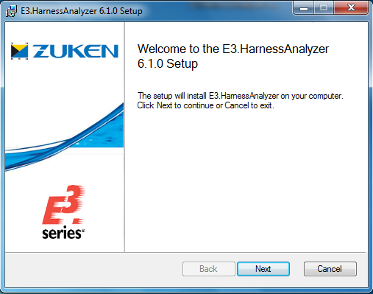

Accept the license agreement:

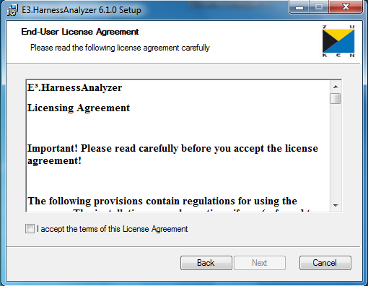

Confirm the default destination folder:

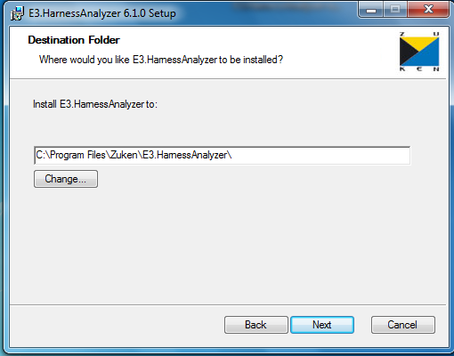

Press the install-button to install the E3.HarnessAnalyzer:

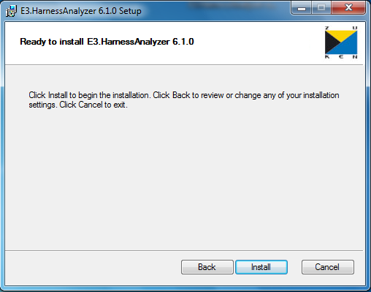

# Configuration License-Server

The license server has to be configured with the system variable:

ECADLM_LICENSE_FILE = [8026@FLXecad1.rd.corpintra.net,8026@FLXecad2.rd.corpintra.net,8026@FLXecad3.rd.corpintra.net](mailto:8026@FLXecad1.rd.corpintra.net,8026@FLXecad2.rd.corpintra.net,8026@FLXecad3.rd.corpintra.net)

Don’t delete after uninstall, because other products use the license server configuration.

Hints for MSI packaging:

1. Set MSI property “LM_LICENSE_FILE_TARGET” with bootstrapper to the required value

Setting the server for floating licenses (see also E3 HarnessAnalyzer_Installation.pdf, 6.4 Unattended Installation)

msiexec /i D:\Temp\E3.HarnessAnalyzer-x64-6.1.0.msi LM_LICENSE_FILE_TARGET=2700@MyLicenseServer