**Created by:** MTC-Cabling-TP

**Phone:** +49 7031 90 68286

**Email:** MTC-Cabling-TP@Daimler.com

**Created at:** 25.01.2016

**Version: 6.2.0**

**Daimler Installation Manual**

**E3.HarnessAnalyzer**

**Installation Manual**

**Index**

1 Revision history 3

2 Prerequisites 3

3 Setup and Activation 3

4 Installation Instructions 3

5 Configuration License-Server 6

# Revision history

|  |  |  |  |
| --- | --- | --- | --- |
| Version | Date | Name | Description |
| 1.0 | 09.04.2015 | MTC-Cabling-TP | Initial Version |
|  | 25.01.2016 |  | Added feature control on borrow |

# Prerequisites

E3.HarnessAnalyzer(64bit) needs the following components:

* Microsoft .NET Framework 4.5 Version 4.5.50709 (64bit)
* Microsoft Visual C++ 2008 Redistributable SP1 Version 9.0.30729.6161 (64bit)
* Microsoft Visual C++ 2013 Redistributable Package Version 12.0 (64bit)

# Setup and Activation

This document describes how to setup and activate E³.HarnessAnalyzer V6.1.0 at Daimler.

If there’s an instance of the E³.HarnessAnalyzer V6.0.x already installed on the client, it should be uninstalled before installing the version 6.2.0.

In case the E3.HarnessAnalyzer-x64-6.2.0.msi is used, all mandatory prerequisite packages must be already installed!

# Installation Instructions

You need administrative privileges to install E3.HarnessAnalyzer-x64-6.2.0.msi.

Start the installation:

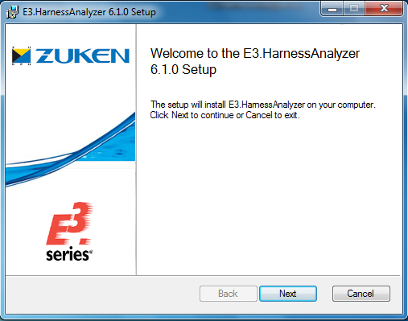

Accept the license agreement:

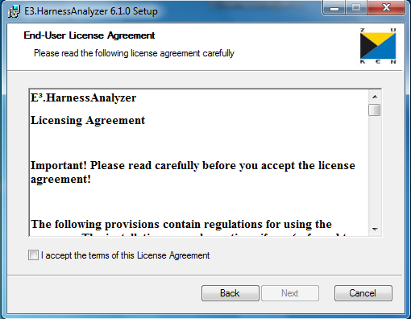

Confirm the default destination folder:

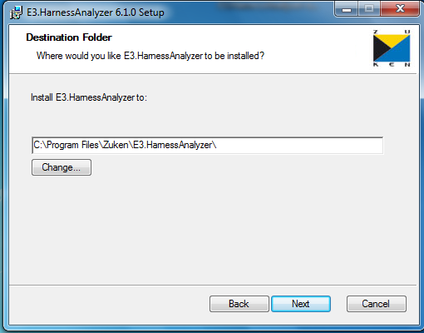

Press the install-button to install the E3.HarnessAnalyzer:

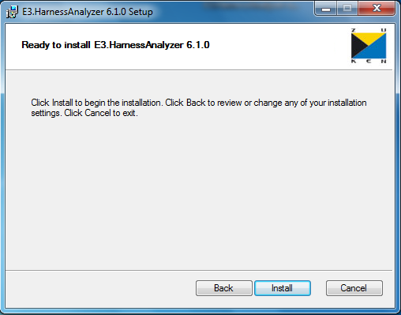

# Configuration License-Server

The license server has to be configured with the system variable:

ECADLM_LICENSE_FILE = [8026@FLXecad1.rd.corpintra.net,8026@FLXecad2.rd.corpintra.net,8026@FLXecad3.rd.corpintra.net](mailto:8026@FLXecad1.rd.corpintra.net,8026@FLXecad2.rd.corpintra.net,8026@FLXecad3.rd.corpintra.net)

Don’t delete after uninstall, because other products use the license server configuration.

Hints for MSI packaging:

1. Set MSI property “LM_LICENSE_FILE_TARGET” with bootstrapper to the required value

Additional hint:

HarnessAnalyzer 6.2.0 and future versions support add on features on top of the basic license. These add on features are used in conjunction with the basic license, only.

In order to control the usage of add on features, a mechanism is provided to restrict the query of such features depending on the individual user. A registry key can be used to suppress the query for a given add on feature for this user. In case this registry key is not set – this is the default - all add on features are queried and activated if they can be obtained from the server.

In case the registry key is set, it is located under:

HKEY_CURRENT_USER\Software\Zuken\E3.HarnessAnalyzer

Name: AvailableFeatures

Data: String

Value: a decimal number representation

0: no add on feature

2: query E3HarnessAnalyzerDSI

4: TBD

Setting the server for floating licenses (see also E3 HarnessAnalyzer_Installation.pdf, 6.4 Unattended Installation)

msiexec /i D:\Temp\E3.HarnessAnalyzer-x64-6.1.0.msi LM_LICENSE_FILE_TARGET=2700@MyLicenseServer

The registry key can be set by using the msi command and the argument AVAILABE_FEATURES:

msiexec /i D:\Temp\E3.HarnessAnalyzer-x64-6.1.0.msi LM_LICENSE_FILE_TARGET=2700@MyLicenseServer AVAILABLE_FEATURES=2