Standards and Policy Template
v1.5

1 Introduction to Ansible 2
How Ansible works 2
1.1. Generating .ppk from .pem of AWS EC2 3
1.2. Converting .Pem to .Ppk on Windows 4
1.3. Putty Settings with .pem & ppk 6
1.4. SuperPutty settings 7
2 Install Python & Ansible 9
2.1. Ubuntu AWS linux VM – Install Python & Ansible 9
2.2. Checking Ansible Version 9
3 Ansible Modules 9
3.1. Debug module 10
Ansible Navigator and Execution Environment 10
How do navigator and execution environments work? 11
Installing ansible-navigator with an execution environment ( ee ) on Linux 11
4 Handlers 11
4.1. Handler example 11
4.2. Handler examle2 12
5 Jinja Templates 12
Templating (Jinja2) 12
6 Block-rescue 14
7 Loops 16
8 Ansible Vault 16
8.1 Ansible Vault 17
9 Ansible AWS Tower 17
9.1. Introduction to AWX 17
9.1.1. EC2 VM creation 17
9.2. Install Ansible AWX Tower Ubuntu 20.04 19
9.2.1. Install Docker Engine 19
9.2.2. Install Docker Compose 20
9.2.3. Install Ansible 21
9.2.4. Install Node js 21
9.3. Install Ansible AWX Tower Ubuntu 20.04 21
9.4. Access Ansible AWX Web Interface 23
10. Dynamic Inventory - Ansible 24
10.1. Install Ansible AWX Tower Ubuntu 20.04 24
10.2. Creating IAM roles & Map to Ansible Control Node 25
10.2.1. Creating IAM roles & Map to Ansible Control Node 27
10.2.2. Process to generate aws_access_key & aws_secret_key 28
10.3. Setup Ansible AWS Dynamic Inventory 30
11. Asynchronous 34

Introduction to Ansible

Ansible is a software tool that provides simple but powerful automation for cross-platform computer support. It is primarily intended for IT professionals, who use it for application deployment, updates on workstations and servers, cloud provisioning, configuration management, intra-service orchestration, and nearly anything a systems administrator does on a weekly or daily basis. Ansible doesn't depend on agent software and has no additional security infrastructure, so it's easy to deploy.
Because Ansible is all about automation, it requires instructions to accomplish each job. With everything written down in simple script form, it's easy to do version control. The practical result of this is a major contribution to the "infrastructure as code" movement in IT: the idea that the maintenance of server and client infrastructure can and should be treated the same as software development, with repositories of self-documenting, proven, and executable solutions capable of running an organization regardless of staff changes.
While Ansible may be at the forefront of automation, systems administration, and DevOps, it's also useful to everyday users. Ansible allows you to configure not just one computer, but potentially a whole network of computers at once, and using it requires no programming skills. Instructions written for Ansible are human-readable. Whether you're entirely new to computers or an expert, Ansible files are easy to understand.

How Ansible works

In Ansible, there are two categories of computers: the control node and managed nodes. The control node is a computer that runs Ansible. There must be at least one control node, although a backup control node may also exist. A managed node is any device being managed by the control node.
Ansible works by connecting to nodes (clients, servers, or whatever you're configuring) on a network, and then sending a small program called an Ansible module to that node. Ansible executes these modules over SSH and removes them when finished. The only requirement for this interaction is that your Ansible control node has login access to the managed nodes. SSH keys are the most common way to provide access, but other forms of authentication are also supported.

https://www.redhat.com/en/resources/forrester-wave-infrastructure-automation-analyst-asset

We would be using AWS EC2 VMs with Ubuntu OS.

Generating .ppk from .pem of AWS EC2

After setting up 3 VMs in AWS EC2, it generate .pem [choose the name you prefer]

Example: ansiblepoc.pem

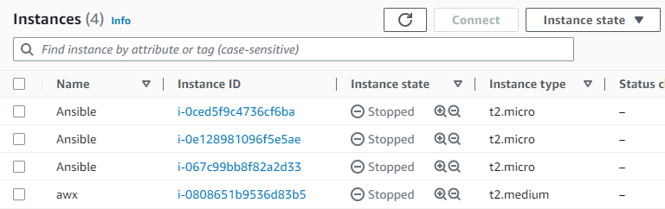

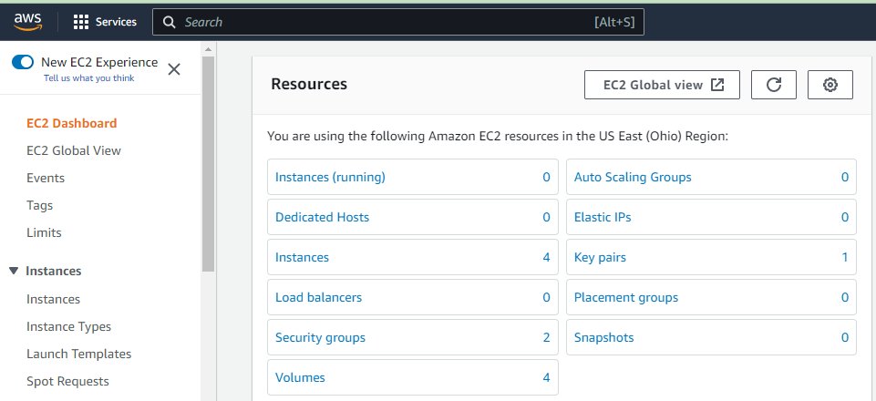

Converting .Pem to .Ppk on Windows

Step #1: Place the ansiblepoc.pem in folder. Assuming here the path as below:
D:\cohort_ansible

D:\cohort_ansible>dir

Directory of D:\cohort_ansible

25-03-2023 18:43 <DIR> .
    - :56 1,678 ansiblepoc.pem

Step #2: Launch puttyGen

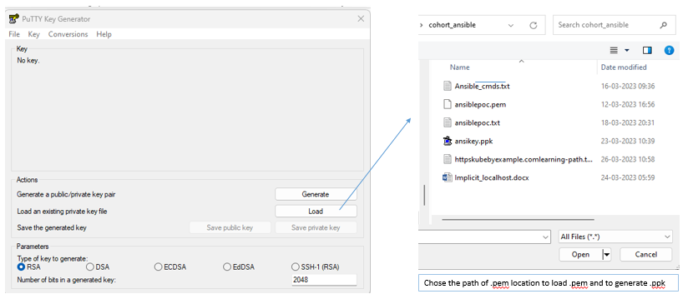

Step #3: Choose the path of .pem location to load .pem and generate .ppk.

Step #4: Save the private key

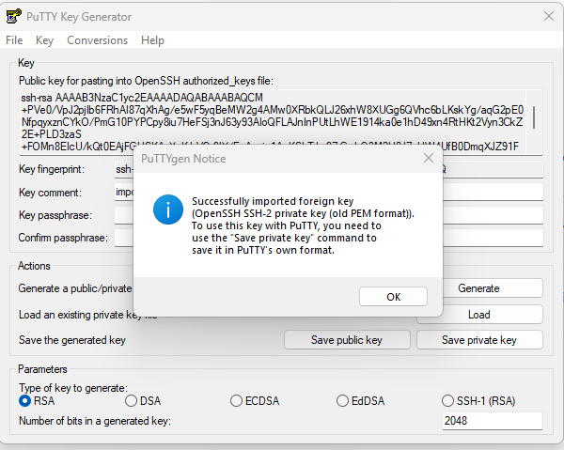

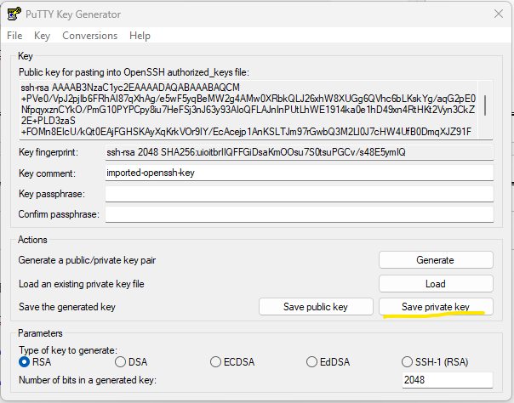

Step #5: Windows directory now has both .pem and .ppk

D:\cohort_ansible>dir

25-03-2023 18:43 <DIR> .
12-03-2023 16:56 1,678 ansiblepoc.pem
23-03-2023 10:39 1,462 ansikey.ppk

Alternative way to generate .ppk
https://repost.aws/knowledge-center/ec2-ppk-pem-conversion

Putty Settings with .pem & ppk

Launch Putty → SSH → Auth -> Credentials

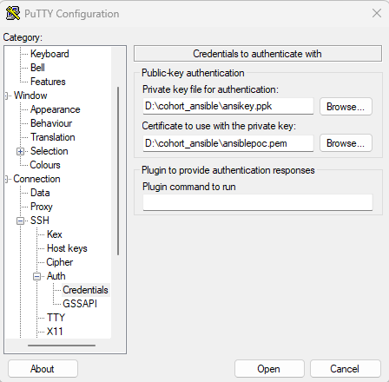

SuperPutty settings

Setting should be first set in Putty as below:

Launch Putty → SSH → Auth -> Credentials

Set the path for .ppk & .pem as show in section 1.3

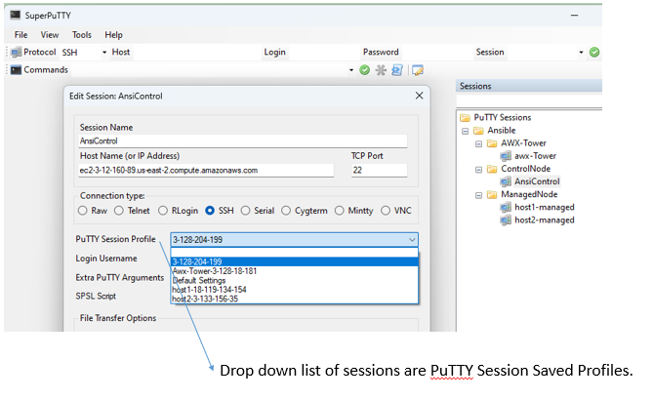

Install Python & Ansible

Ubuntu AWS linux VM – Install Python & Ansible

$ sudo apt-get install python -y
Installing Ansible → Log into the Ubuntu Server that will host Ansible & Install the necessary repository with the command

$ sudo apt-add-repository ppa:ansible/ansible
Update apt with the command
$ sudo apt-get update
$ sudo apt-get install ansible -y

Ansible Core provides significantly fewer Ansible plugins and modules than Ansible Engine. Ansible Engine contains around 3,387 modules compared to Ansible Core which contains approximately 127 modules.

Checking Ansible Version

$ ansible --version

ansible [core 2.14.3]
config file = /etc/ansible/ansible.cfg
configured module search path = ['/home/ubuntu/.ansible/plugins/modules', '/usr/share/ansible/plugins/modules']
ansible python module location = /usr/lib/python3/dist-packages/ansible
ansible collection location = /home/ubuntu/.ansible/collections:/usr/share/ansible/collections
executable location = /usr/bin/ansible
python version = 3.10.6 (main, Mar 10 2023, 10:55:28) [GCC 11.3.0] (/usr/bin/python3)
jinja version = 3.0.3
libyaml = True

Ansible Modules

Debug module

---
- hosts: localhost
remote_user: ubuntu
become: true
tasks:
- name: "usage of debug module"
debug:
msg: "Hello Ansible"
...

Installs and prints

---
- name: Installs a package and prints the result
hosts: web
remote_user: ubuntu
become: true
tasks:
- name: Install the package
apt:
name: apache2
state: latest
register: inst_result

- debug:
var: inst_result
...

Ansible Navigator is a tool and a part of the Ansible Automation Platform, which helps in creating playbooks. The content navigator can install it via the Python pip method. we can say the automation platform is a combination of different components like Ansible core and automation execution environment. The playbook run functionality is provided by core packages. Through the core package, ansible provides a large number of modules.
Here I am discussing two major components of the Automation Platform. The Content Navigator and Execution Environment installation and setup.

Ansible Navigator and Execution Environment
Navigator is a utility, which manages the work of different Ansible components like ansible-playbook, ansible-config, and inventory. The execution environment is a container form image that consists of different components like libraries, core packages, and ansible collections, which need to run your playbooks.

How do navigator and execution environments work?
When you run a playbookthe navigator selects the execution environment. In which all modules, collections, and libraries exist and process it.

Installing ansible-navigator with an execution environment ( ee ) on Linux
Here I am installing a navigator on the main control system machine, from where I can manage my managed remote hosts. And the execution environment ( ee ) needs its container image. So we need a prerequisite podman or docker utility to install. Only one utility will be installed. Below steps should support different Linux-based operating systems like CentOS Stream, Rocky, AlmaLinux, and Oracle Linux.

Handlers

A handler is just a special type of task, A task that “only” runs when notified by another task.

Handler example

Handlers are tasks that respond to a notification triggered by other tasks. Tasks only notify their handlers when the task changes something on a managed host. Each handler has a globally unique name and is triggered at the end of a block of tasks in a playbook. If no task notifies the handler by name then the handler will not run. If one or more tasks notify the handler, the handler will run exactly once after all other tasks in the play have completed. Because handlers are tasks, administrators can use the same modules in handlers that they would use for any other task. Normally, handlers are used to reboot hosts and restart services. Handlers can be considered as inactive tasks that only get triggered when explicitly invoked using a notify statement.

The following snippet shows how the Apache server is only restarted by the restart apache handler when a configuration file is updated and notifies it:

---
tasks: - name: copy demo.example.conf configuration template
template:
src: /var/lib/templates/demo.example.conf.template
dest: /etc/httpd/conf.d/demo.example.conf
notify: - restart apache
handlers: - name: restart apache

Handler examle2

##############
---
- name: Setting the hostname on host1
hosts: web
remote_user: ubuntu
gather_facts: false
become: yes
tasks:
- name: host1
hostname:
name: ansible_host1.solugenix.com
notify: remove_hosts
handlers:
- name: remove_hosts
file:
path: /etc/hosts
state: absent

Jinja Templates

Templating (Jinja2)
Ansible uses Jinja2 templating to enable dynamic expressions and access to variables and facts. You can use templating with the template module. For example, you can create a template for a configuration file, then deploy that configuration file to multiple environments and supply the correct data (IP address, hostname, version) for each environment. You can also use templating in playbooks directly, by templating task names and more. You can use all the standard filters and tests included in Jinja2. Ansible includes additional specialized filters for selecting and transforming data, tests for evaluating template expressions, and Lookup plugins for retrieving data from external sources such as files, APIs, and databases for use in templating.

All templating happens on the Ansible controller before the task is sent and executed on the target machine. This approach minimizes the package requirements on the target (jinja2 is only required on the controller). It also limits the amount of data Ansible passes to the target machine. Ansible parses templates on the controller and passes only the information needed for each task to the target machine, instead of passing all the data on the controller and parsing it on the target.

# Using Jinja Templates to Populate Host files on Ansible Managed hosts.
##############
---
- name: Setting the hostname on host1
hosts: web
remote_user: ubuntu
gather_facts: false
become: yes
tasks:
- name: host1
hostname:
name: ansible_host1.solugenix.com
notify: remove_hosts
handlers:
- name: remove_hosts
file:
path: /etc/hosts
state: absent

- name: managing our hosts file
hosts: web
remote_user: ubuntu
gather_facts: true
become: yes
tasks:
- name: Deploying host template
template:
src: hosts.j2
dest: /etc/hosts
...

$ cat hosts.j2
#################
# Managed by Ansible ##
####################

{% for host in groups['web'] %}
{{ ansible_hostname }}
{% endfor %}

Block-rescue

---
- name: Install vsftpd
hosts: server1
become: yes
vars:
anonymous_enable: yes
local_enable: yes
write_enable: yes
anon_upload_enable: yes
tasks:
- block:
- name: install vsftp
yum:
name: vsftpd
- name: take backup of existing config
copy:
src: /etc/vsftpd/vsftpd.conf
dest: /etc/vsftpd/vsftpd.conf.bkp
remote_src: yes
- name: use Jinja2 template to configure vsftpd
template:
src: vsftpd.j2
dest: /etc/vsftpd/vsftpd.conf
- name: This will fail
command: "ls -l /tmp/does-not-exist"

rescue:
- name: Recovery block
debug:
msg: "something failed, restoring vsftpd.conf from backup"
- name: Restoring vsftpd.conf
copy:
src: /etc/vsftpd/vsftpd.conf.bkp
dest: /etc/vsftpd/vsftpd.conf
remote_src: yes

always:
- name: Restarting vsftpd
service:
name: vsftpd
state: restarted

second use-case

$ cat task_failure.yaml
---
- name: Task failure Exercise
hosts: db
vars:
web_pkg: apache2
db_pkg: mysql-server
db_service: mysql
tasks:
- name: attempt to setup webserver
block:
- name: Install {{ web_pkg }} package
apt:
name: "{{ web_pkg }}"
state: present
rescue:
- name: Install {{ db_pkg }} package
apt:
name: "{{ db_pkg }}"
state: present
always:
- name: Start {{ db_service }}
service:
name: "{{ db_service }}"
state: started
...

Loops

Ansible supports iterating a task over a set of items using the loop keyword

Simple Loops
A simple loop iterates a task over a list of items. The loop keyword is added to the task, and takes
as a value the list of items over which the task should be iterated. The loop variable item holds the value used during each iteration.

$ cat createfile-loop.yaml
---
- hosts: web
remote_user: ubuntu
tasks:
- name: create files with names abc, xyc, file2, test3
file:
path: /tmp/{{ item }}
state: touch
loop:
- abc
- xyc
- file2
- test3
...

Ansible Vault

Ansible Vault

Ansible AWS Tower

Introduction to AWX

Ansible AWX is an open-source project which is easy to use UI, Rest API and provides an easier way to manage your ansible project in IT environments. AWX facilitates you to centrally manage Ansible playbooks, inventories and secrets, and scheduled jobs using a web interface. Ansible AWX is an upstream project which is sponsored by Red hat from which the Red Hat Ansible Tower project is derived. In this article, you are going to learn how to set up Ansible AWX on ubuntu 20.04

EC2 VM creation

- Ubuntu Server 20.04
- Proper internet connection to install packages
- A user account with sudo privileges.
- At Least 4GB Memory and 2 core CPU

About AWX:

https://cloudinfrastructureservices.co.uk/how-to-install-ansible-awx-tower-on-ubuntu-20-04-server/

https://www.ansible.com/products/awx-project/faq
https://www.ansible.com/resources/ebooks/mastering-ansible
https://www.ansible.com/integrations/containers/operators
https://galaxy.ansible.com/

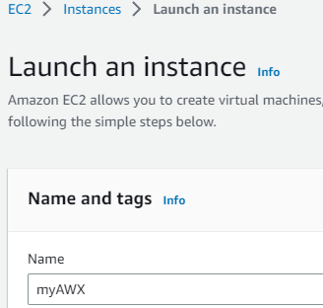

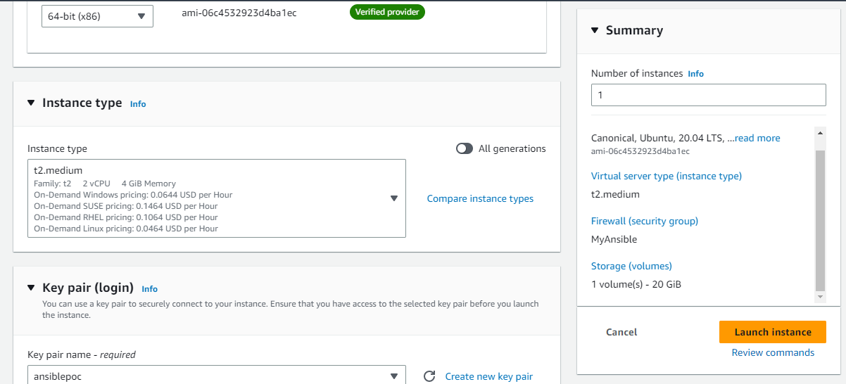

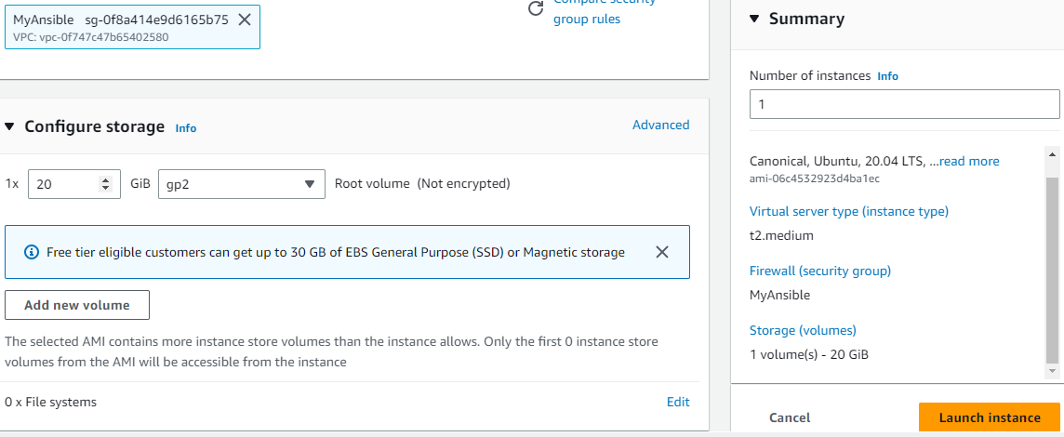

Install Ansible AWX Tower Ubuntu 20.04

https://cloudinfrastructureservices.co.uk/how-to-install-ansible-awx-tower-on-ubuntu-20-04-server/
https://github.com/ansible/awx
https://www.server-world.info/en/note?os=Ubuntu_22.04&p=ansible&f=12

Install Docker Engine

Before starting, you will need to install the Docker CE on your server. By default, the latest version of Docker CE is not included in the Ubuntu default repository so you will need to add the Docker’s official repository on your server.

First, install the required dependencies using the following command:

$ apt install software-properties-common curl gnupg2 wget –y

Next, download and add the Docker GPG key with the following command:

$ id
$ ubuntu
$ sudo -i
# curl -fsSL https://download.docker.com/linux/ubuntu/gpg | apt-key add -

Next, add the Docker CE repository to APT using the following command:

# add-apt-repository "deb [arch=amd64] https://download.docker.com/linux/ubuntu $(lsb_release -cs) stable"

Once the repository is added, update the repository cache and install the Docker CE using the following command:

# apt update -y
# apt install docker-ce docker-ce-cli containerd.io -y

After the successful installation, start the Docker service and enable it to start at system reboot:

# systemctl start docker
# systemctl enable docker

You can now verify the Docker service status using the following command:

# systemctl status docker

Install Docker Compose

You will also need to install the Docker Compose to your server. By default, the Docker Compose is available in the Ubuntu default repository. You can install it using the following command:

# apt install docker-compose -y

Once the Docker Compose is installed, you can verify the installation using the following command:

# docker-compose version

docker-compose version 1.25.0, build unknown
docker-py version: 4.1.0
CPython version: 3.8.10
OpenSSL version: OpenSSL 1.1.1f 31 Mar 2020

Install Ansible

$ sudo apt install ansible -y

Once the Ansible is installed, you can verify Ansible installation using the following command:

$ ansible –version

ansible 2.9.6
config file = /etc/ansible/ansible.cfg
configured module search path = ['/root/.ansible/plugins/modules', '/usr/share/ansible/plugins/modules']
ansible python module location = /usr/lib/python3/dist-packages/ansible
executable location = /usr/bin/ansible
python version = 3.8.10 (default, Nov 26 2021, 20:14:08) [GCC 9.3.0]

Install Node js

Next, install the Node.js and NPM package manager using the following command:

$ sudo apt install nodejs npm -y
$ sudo npm install npm --global

Following that please install Python dependencies using the following command:

$ sudo apt install python3-pip git pwgen -y

Next, install the Docker Compose Python module using the following command:

$ sudo pip3 install docker-compose==1.25.0 # compose version add accordingly with the version which has been installed in your EC2 Ubuntu VM.

Install Ansible AWX Tower Ubuntu 20.04

First, download the Ansible AWS from the Git repository using the following command:

$ wget https://github.com/ansible/awx/archive/17.1.0.zip

Once the download is completed, unzip the downloaded file with the following command:

$ unzip 17.1.0.zip

Next, change the directory to the extracted directory to the installer directory and generate the secrete key using the following command:

$ cd awx-17.1.0/installer
$ pwgen -N 1 -s 30

You will get the following key:

gBSBmZgb1CyuT6p6TZ4D0pF2oZMP4x

Please edit the inventory file with the following command:

$ vi inventory

admin_user=admin
admin_password=secureadminpassword
secret_key=gBSBmZgb1CyuT6p6TZ4D0pF2oZMP4x

Save and close the file when you are finished. Next, run the following to install the Ansible AWX Tower:

$ ansible-playbook -i inventory install.yml

Once the Ansible Tower is installed. You can verify the running container using the following command:

$ docker ps

CONTAINER ID IMAGE COMMAND CREATED STATUS PORTS NAMES
8e210d7f15db ansible/awx:17.1.0 "/usr/bin/tini -- /u…" 46 seconds ago Up 43 seconds 8052/tcp awx_task
db01e784479f ansible/awx:17.1.0 "/usr/bin/tini -- /b…" 3 minutes ago Up 42 seconds 0.0.0.0:80->8052/tcp, :::80->8052/tcp awx_web
330cf7a6e81e postgres:12 "docker-entrypoint.s…" 3 minutes ago Up 42 seconds 5432/tcp awx_postgres
3f4ccefd5395 redis "docker-entrypoint.s…" 3 minutes ago Up 43 seconds 6379/tcp awx_redis

To see all downloaded Docker images, run the following command:

$ docker images

REPOSITORY TAG IMAGE ID CREATED SIZE
postgres 12 bc02a3fd9d66 7 days ago 373MB
redis latest 53aa81e8adfa 7 days ago 117MB
centos 8 5d0da3dc9764 8 months ago 231MB
ansible/awx 17.1.0 599918776cf2 15 months ago 1.41GB

Access Ansible AWX Web Interface

- Open your web browser and access the Ansible AWX web interface using the URL http://your-server-ip. You will be redirected to the Ansible AWX login page:

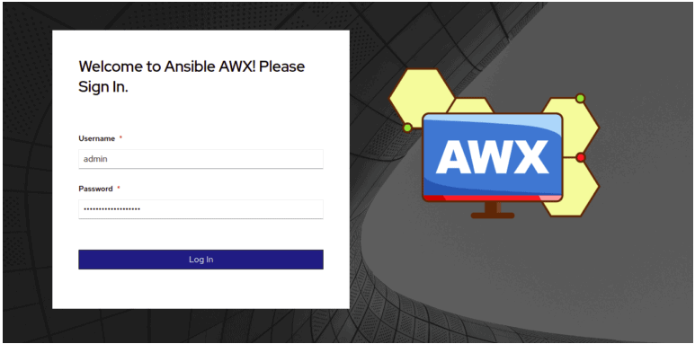

Dynamic Inventory - Ansible

Install Ansible AWX Tower Ubuntu 20.04

https://devopscube.com/setup-ansible-aws-dynamic-inventory/

When you are using Ansible with AWS, maintaining the inventory file will be a hectic task as AWS has frequently changed IPs, autoscaling instances, and much more.
However, there is an easy solution called ansible dynamic inventory. Dynamic inventory is an ansible plugin that makes an API call to AWS to get the instance information in the run time. It gives you the ec2 instance details dynamically to manage the AWS infrastructure.

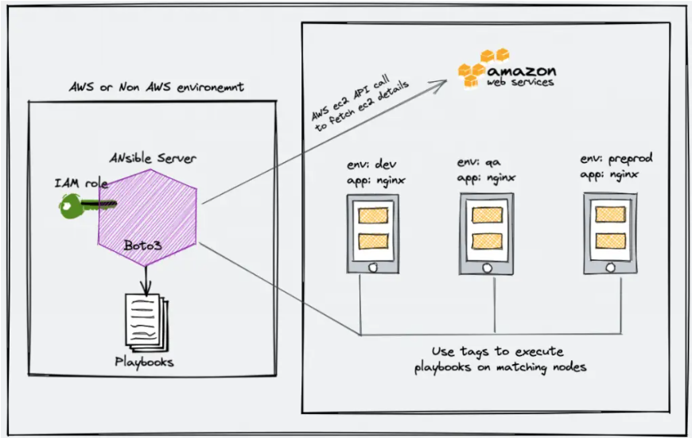

Creating IAM roles & Map to Ansible Control Node

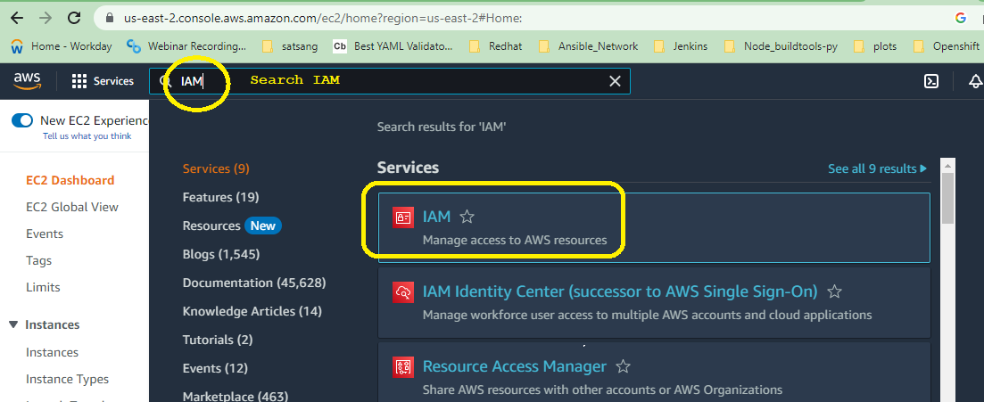

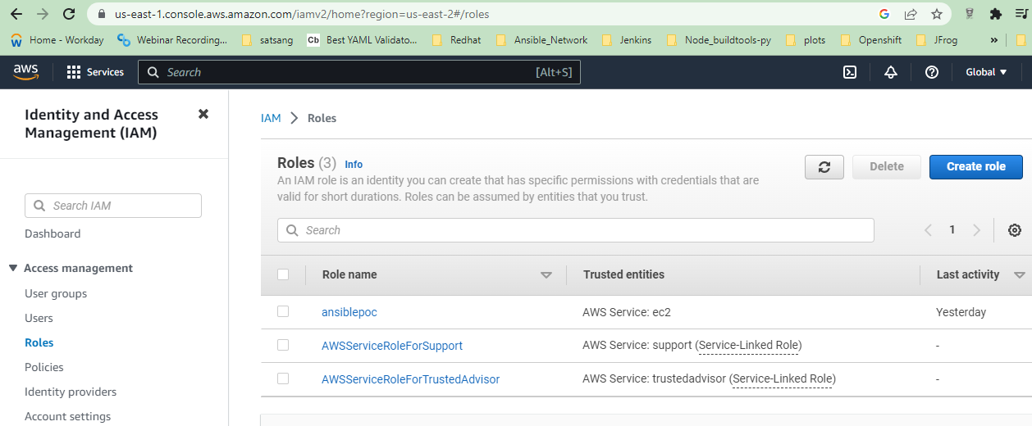

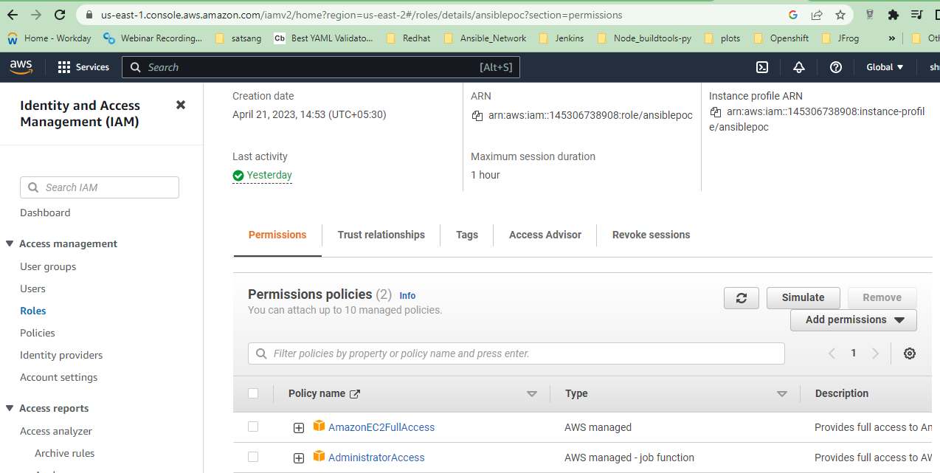

Creating IAM roles & Map to Ansible Control Node

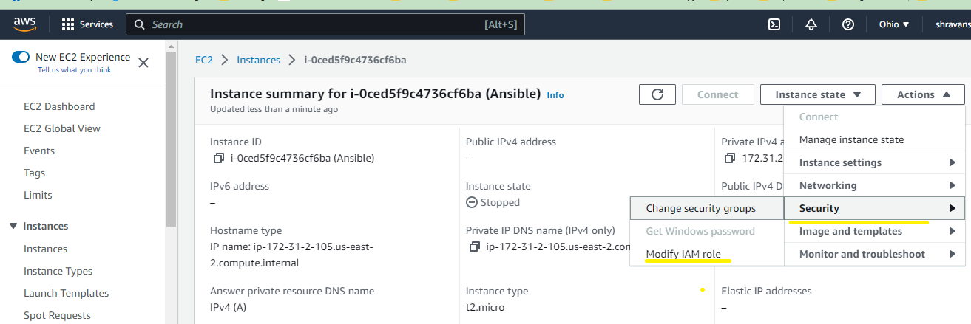

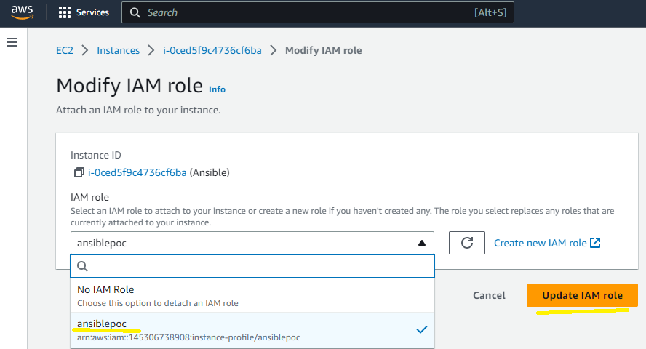
IMPORTANT NOTE: Either map role to EC2 VM or use aws_access_key & aws_secret_key for dynamic Inventory.

Process to generate aws_access_key & aws_secret_key

Creating Group
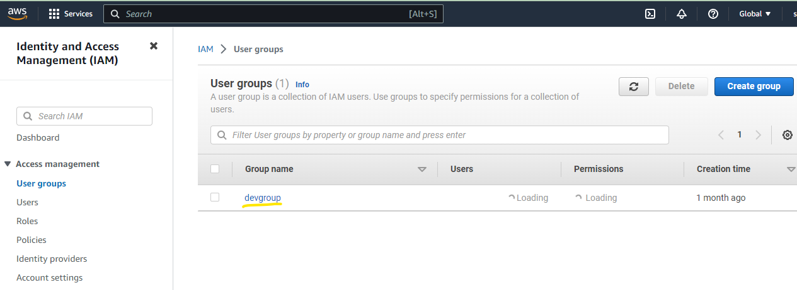

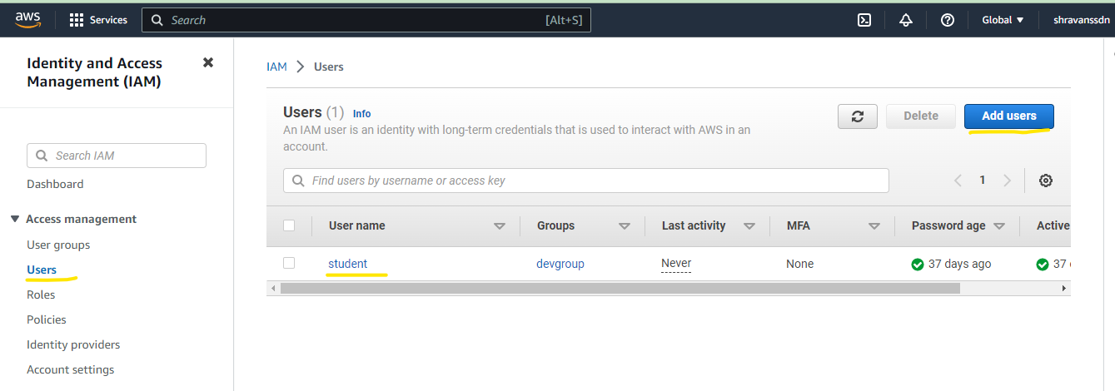

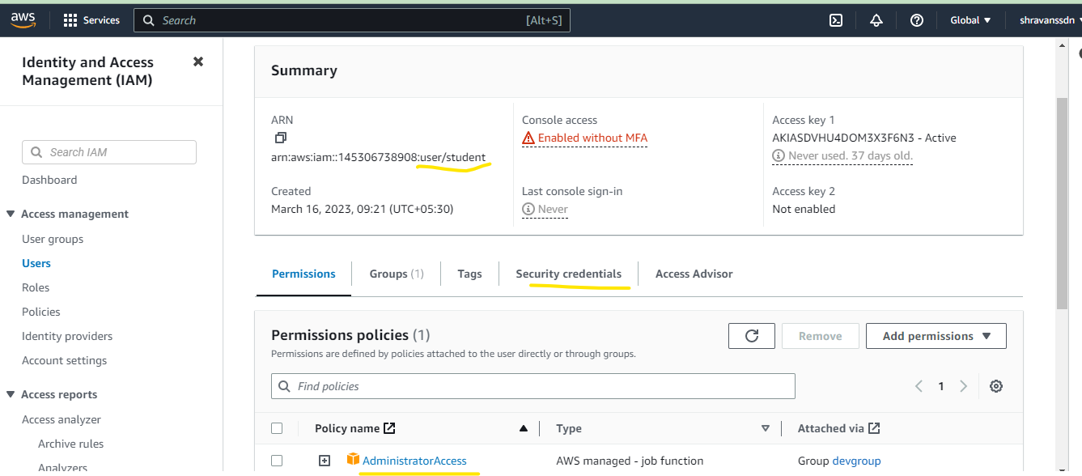

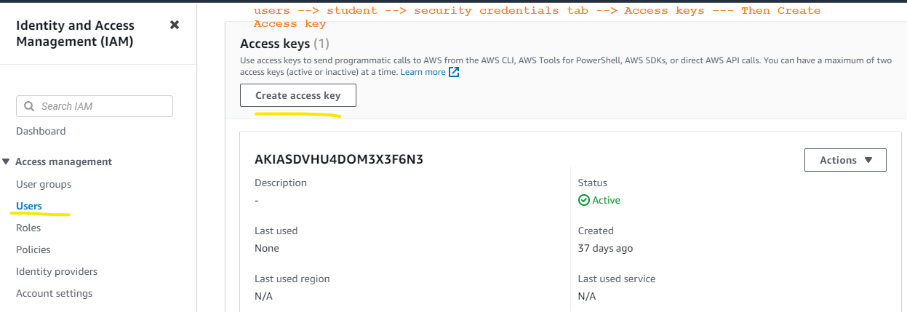

Setup Ansible AWS Dynamic Inventory

In this tutorial, you will learn how to set up a dynamic inventory on AWS using boto and the AWS ec2 Ansible plugin.
Follow the steps carefully for the setup.

Step 1: Ensure you have python3 & pip3 installed in your Ansible server.
Most Linux operating system comes with phyton3. You can validate it using the following command.

$ python3 --version

If you don’t have python3, you can install it using the following command.
For centos, Redhat,Ubuntu

For Debian, Ubuntu,

$ sudo apt install python3 –y
$ sudo apt install python3-pip –y

Step 2: Install the boto3 library. Ansible uses the boot core to make API calls to AWS to retrieve ec2 instance details.

$ sudo pip3 install boto3

If you have used the Ansible ppa for installation, install pip using the following command.

$ sudo apt-get install python-boto3

or else you might see the following error.

ERROR! The ec2 dynamic inventory plugin requires boto3 and botocore.

Step 3: Create an inventory directory under /opt and cd into the directory.

$ sudo mkdir –p /etc/ansible/dynamic_inventory
$ sudo cd /etc/ansible/dynamic_inventory

Step 4: Create a file named aws_ec2.yaml in the inventory directory.

$ sudo vi aws_ec2.yaml

Copy the following configuration to the file. If you are running an ansible server outside the AWS environment, replace add your AWS access key and secret to the config file.
Important Note: Never commmit this file to public git repos.

---
Plugin: aws_ec2
aws_access_key: <YOUR-AWS-ACCESS-KEY-HERE>
aws_secret_key: <YOUR-AWS-SECRET-KEY-HERE>
Keyed_groups:
- key: tags
- prefix: tag

If your ansible server is running inside the AWS environment, attach an ec2 instance role with the required AWS ec2 permissions (Mostly describe instances). This way you don’t have to add the access and secret key in the configuration. Ansible will automatically use the attached role to make the AWS API calls.

Step 5: Open /etc/ansible/ansible.cfg file.

$ sudo vi /etc/ansible/ansible.cfg

Find the [inventory] section and add the following line to enable the ec2 plugin.

enable_plugins = aws_ec2

It should look something like this.

[inventory]
enable_plugins = aws_ec2

Step 6: Now let’s test the dynamic inventory configuration by listing the ec2 instances.

$ ansible-inventory -i /opt/ansible/inventory/aws_ec2.yaml --list

The above command returns the list of ec2 instances with all its parameters in JSON format.
If you want to use the dynamic inventory as a default Ansible inventory, edit the /etc/ansible/ansible.cfg file and search for inventory parameters under defaults. Change the inventory parameter value as shown below.

inventory = /etc/ansible/dynamic_inventory/aws_ec2.yaml

$ cat /etc/ansible/ansible.cfg

# Since Ansible 2.12 (core):
# To generate an example config file (a "disabled" one with all default settings, commented out):
# $ ansible-config init --disabled > ansible.cfg
#
# Also you can now have a more complete file by including existing plugins:
# ansible-config init --disabled -t all > ansible.cfg

# For previous versions of Ansible you can check for examples in the 'stable' branches of each version
# Note that this file was always incomplete and lagging changes to configuration settings

# for example, for 2.9: https://github.com/ansible/ansible/blob/stable-2.9/examples/ansible.cfg

[inventory]
enable_plugins = aws_ec2

[defaults]
host_key_checking = False
inventory = /etc/ansible/dynamic_inventory/aws_ec2.yaml
remote_user = ubuntu
ask_pass = false

Here is a minimal configuration for aws_ec2.yaml that uses a few keyed_groups and filters.
---
plugin: aws_ec2

aws_access_key: <YOUR-AWS-ACCESS-KEY-HERE>
aws_secret_key: <YOUR-AWS-SECRET-KEY-HERE>

regions:
- us-west-2

keyed_groups:
- key: tags
prefix: tag
- prefix: instance_type
key: instance_type
- key: placement.region
prefix: aws_region

Execute the following command to list the dynamic inventory groups.

$ ansible-inventory --graph

Asynchronous

Asynchronous mode allows us to control the playbook execution flow by defining how long-running tasks completes their execution.

To enable Asynchronous mode within Ansible playbook we need to use few parameters such as async, poll.

async - async keyword's value indicates the total time allowed to complete the task. Once that time is over the task will be marked as completed irrespective of the end result. Along with this async also sends the task in the background which can be verified later on its final execution status.

poll - poll keyword allows us to track the status of the job which was invoked by async and running in the background. Its value decides how frequent it would check if the background task is completed or not.

The Poll keyword is auto-enabled whenever you use async and it has a default value as 10 seconds.
When you use poll parameter's value set to positive Ansible will avoid connection timeouts but will still block the next task in your playbook, waiting until the async task either completes, fails or times out.
Use async_status within playbook

aync_status module can be used within the playbook as well.

Here is our playbook.

---
- name: async and poll example playbook
hosts: workers
become: true
remote_user: ansible_user
tasks:
- name: sleep for 20 seconds
command: /bin/sleep 20
async: 30 # the total time allowed to complete the sleep task
poll: 0 # No need to poll just fire and forget the sleep command
register: sleeping_node

- name: task-2 to create a test user
user: name=async_test-2 state=present shell=/bin/bash

- name: Checking the Job Status running in background
async_status:
jid: "{{ sleeping_node.ansible_job_id }}"
register: job_result
until: job_result.finished # Retry within limit until the job status changed to "finished": 1
retries: 5 # Maximum number of retries to check job status

Ansible Use-Case

https://www.ansible.com/use-cases/configuration-management

https://developers.redhat.com/products/ansible/getting-started

https://developers.redhat.com/courses/ansible/getting-started -- Hands-On labs

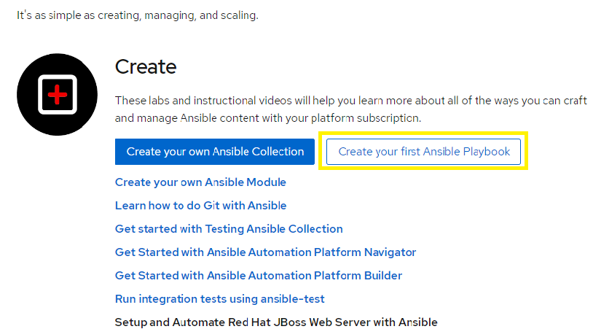

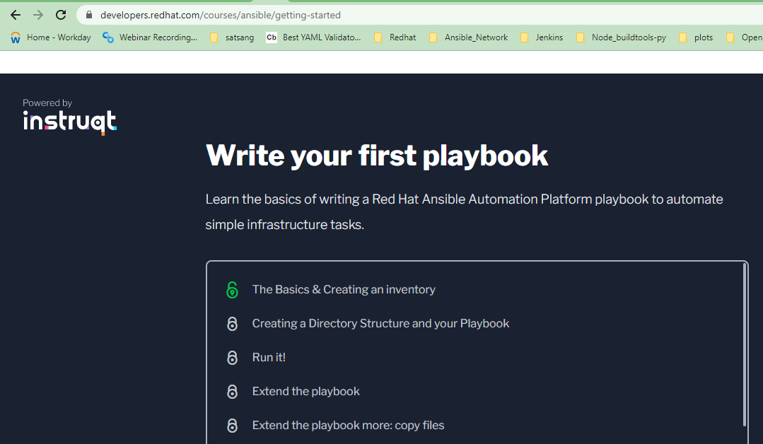

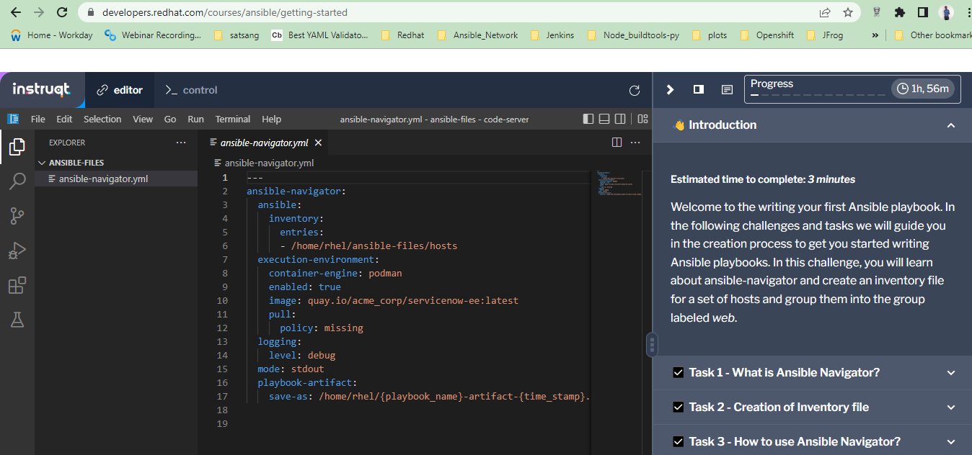

https://instruqt.com/blog/set-up-kubernetes-on-demand

