MECE Breakdown and Analytical Framework for Northwind Traders Power BI Dashboard

Prepared by: Kashish Singh

Introduction
The Northwind Traders Power BI Report has been designed to transform raw business data into actionable insights through dynamic and visually engaging dashboards. Northwind Traders, a fictitious company that imports and exports specialty foods across global markets, generates vast amounts of data spanning sales, customers, products, employees, and logistics. Managing and interpreting such data manually can be time-consuming and error-prone. This Power BI solution bridges that gap by consolidating multiple data sources into an interactive reporting environment that empowers business users to make informed decisions quickly and accurately.
The primary objective of this project is to apply the MECE (Mutually Exclusive, Collectively Exhaustive) framework to structure the analysis. The MECE principle ensures that each category of information — such as sales, customers, products, employees, and operations — is distinct (non-overlapping) while collectively covering all essential aspects of business performance. This structured approach eliminates redundancy and ensures that the dashboards provide a complete yet organized view of business activities. As a result, every metric contributes meaningfully to the overall story without duplication or data confusion.
Through this report, users can explore key performance indicators (KPIs) such as total revenue, profit margins, customer lifetime value, sales trends, and employee contributions across time and regions. The visualizations are designed to be intuitive and interactive, allowing stakeholders to filter, drill down, and uncover insights at multiple levels of granularity. From identifying top-performing products to evaluating customer retention and monitoring operational efficiency, each dashboard offers a unique perspective aligned with strategic decision-making objectives.
Ultimately, the Power BI report not only acts as a business intelligence tool but also as a decision support system. By providing real-time access to structured insights, it enables Northwind Traders’ management team to recognize opportunities, detect inefficiencies, and forecast future growth with confidence. The MECE-based breakdown ensures that the report remains scalable, adaptable, and relevant for future analytical expansions, thus positioning Northwind Traders as a data-driven organization ready to thrive in the competitive wholesale market landscape.

OBJECTIVE OF THE REPORT
The primary objective of the Northwind Traders Power BI Report is to deliver a unified and insightful data visualization platform that consolidates key business metrics into meaningful and actionable insights. The report aims to enable stakeholders to understand the company’s performance across multiple dimensions—sales, customers, products, employees, and logistics—while ensuring that every analysis adheres to the MECE (Mutually Exclusive, Collectively Exhaustive) principle. This approach guarantees that each aspect of the business is analysed independently yet contributes to the collective understanding of the organization’s overall performance.
One of the core goals of this report is to facilitate data-driven decision-making. By integrating interactive dashboards, stakeholders can easily explore business data without relying on static reports or manual analysis. Power BI’s advanced visualization and drill-through capabilities allow managers to identify performance trends, pinpoint inefficiencies, and recognize growth opportunities across regions, customer segments, and product categories. For example, decision-makers can monitor monthly sales trends, track customer retention rates, and evaluate the profitability of specific product lines—all in one comprehensive view.
Another key objective is to improve operational transparency and performance measurement. The dashboards provide a clear visualization of critical metrics such as sales volume, revenue growth, order fulfilment time, freight costs, and employee productivity. These insights not only help in evaluating historical performance but also in forecasting future outcomes. By visualizing patterns in customer behaviour and sales cycles, Northwind Traders can refine its marketing strategies, optimize supply chain operations, and enhance overall customer satisfaction.
Finally, the report aims to establish a scalable analytical framework that can evolve with the organization’s needs. As the business grows, new data sources, KPIs, and analytical modules can be seamlessly integrated without disrupting the existing structure. The MECE framework ensures that all new insights remain well-organized and non-redundant. In essence, this project not only provides a snapshot of the company’s current performance but also lays the foundation for continuous performance monitoring, predictive analytics, and strategic planning that will guide Northwind Traders toward sustainable growth.

DATASET OVERVIEW
The dataset used in the Northwind Traders Power BI Report is derived from the classic Northwind database, a well-known business dataset that simulates the operations of a global trading company dealing in specialty food products. The dataset serves as a realistic representation of business-to-business (B2B) operations, capturing the intricate relationships between customers, employees, products, suppliers, and orders. Its comprehensive structure makes it ideal for creating analytical models and business intelligence dashboards that reflect real-world commercial scenarios.
The Northwind database comprises multiple interrelated tables that collectively form a complete data model for business analysis. The key tables include Customers, Employees, Orders, Order Details, Products, Suppliers, Shippers, and Categories. Each table holds specific attributes that describe different aspects of the business process — from customer demographics and employee records to product specifications and shipping details. The data is interconnected through well-defined primary and foreign key relationships, enabling seamless data integration and cross-functional analysis within Power BI.
Below are an overview of the main tables and their significance:
- Customers Table – Stores details of clients who purchase products from Northwind Traders, including fields such as Customer ID, Company Name, Contact Name, Country, and Phone. This data is essential for understanding customer segmentation, purchase frequency, and geographic distribution.
- Employees Table – Contains information about company staff, including Employee ID, Name, Title, Hire Date, and Reports To. This helps assess employee performance, sales handled, and managerial hierarchies.
- Orders Table – Tracks all customer orders, featuring attributes like Order ID, Customer ID, Employee ID, Order Date, Shipped Date, Ship Via, and Freight. It serves as the backbone for sales and logistics analysis.
- Order Details Table – Stores granular data on each product within an order, including Product ID, Unit Price, Quantity, and Discount, which are crucial for calculating total revenue, profit margins, and product-level performance.
- Products Table – Contains product-related information such as Product ID, ProductName, Category ID, Supplier ID, Unit Price, Units In Stock, and Discontinued. This table supports analyses of product profitability, stock management, and sales trends.
- Suppliers Table – Lists supplier details including Supplier ID, Company Name, Contact Name, Country, and Home Page, facilitating supplier performance and sourcing efficiency evaluations.
- Shippers Table – Records shipping company details with Shipper ID, Company Name, and Phone, helping analyse shipping costs and logistics efficiency.
- Categories Table – Defines product categories through Category ID, Category Name, and Description, allowing aggregation and comparison of sales across different product groups.
In Power BI, these tables are connected through relationship modelling, where Customer ID, Employee ID, Product ID, and Order ID act as relational keys. This data model enables the creation of unified visuals that combine sales performance with customer and product insights. Before building the dashboards, necessary data transformations such as column renaming, date formatting, and calculated measures (e.g., Total Sales, Profit Margin, Average Freight Cost) were applied to ensure data consistency and accuracy.
Overall, the dataset provides a robust analytical foundation for exploring various dimensions of Northwind Traders’ business operations. Its diversity and relational depth make it suitable for evaluating key business questions — such as which products drive the most revenue, which customers are most valuable, how employee performance affects sales, and how shipping efficiency impacts profitability. The dataset thus plays a central role in enabling the MECE-based Power BI reporting structure, ensuring that all analyses are comprehensive, logically categorized, and free of overlap.

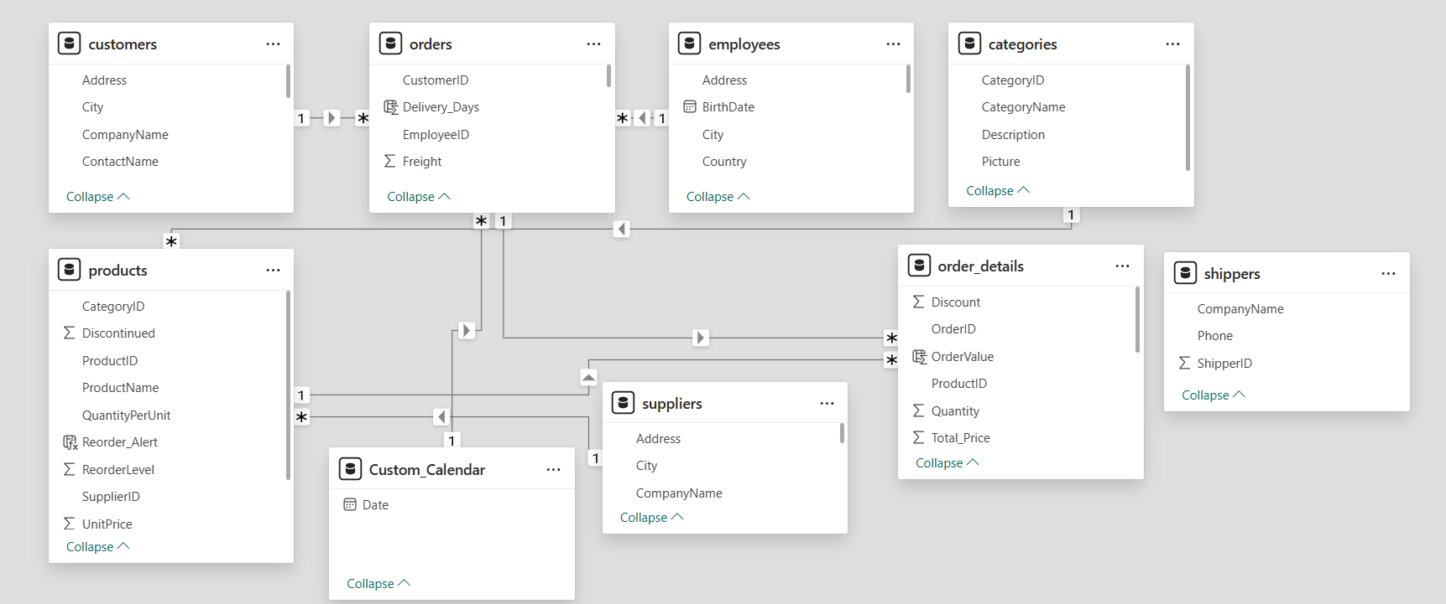
Sample Dataset Schema
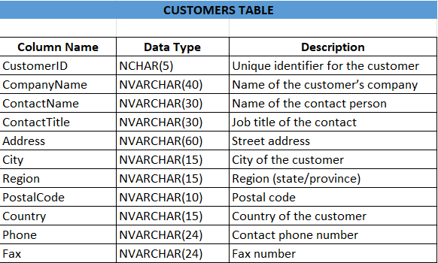

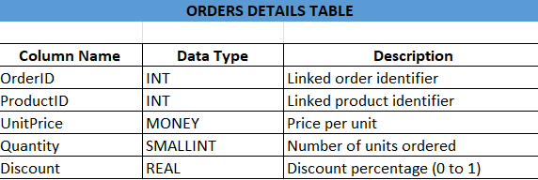

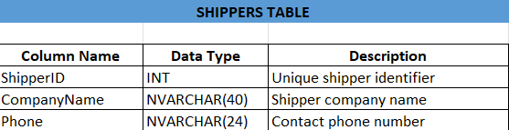

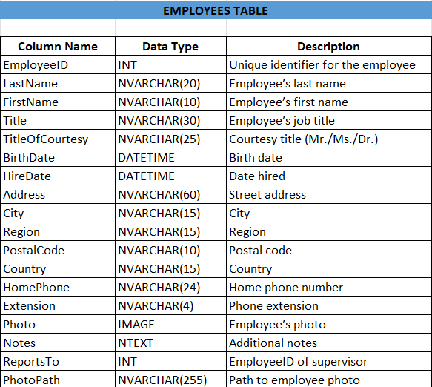

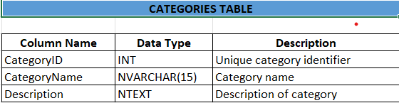

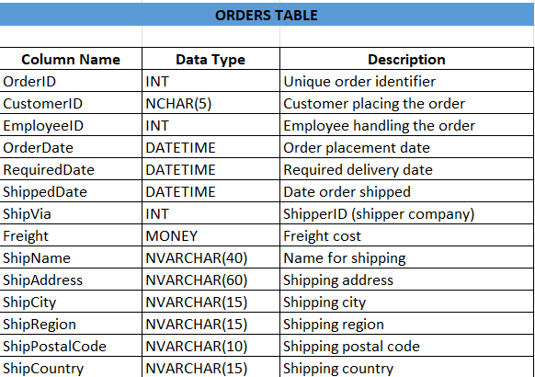

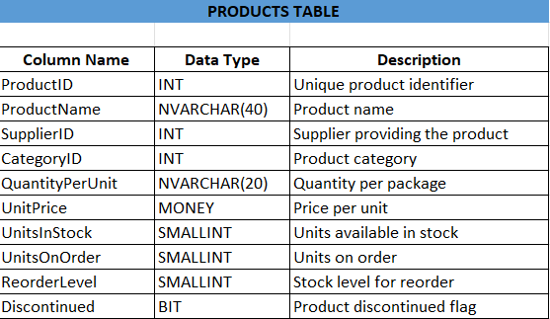

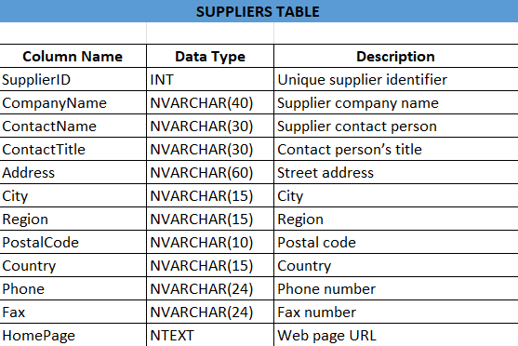

DATA EXTRACTION

Data extraction forms the backbone of this Power BI report. The Northwind dataset, which contains sales, customer, product, and order-related information, was queried using SQL to ensure clean and structured data import into Power BI. The goal was to extract only the required fields from normalized tables to improve efficiency and accuracy.

Objective

To retrieve and pre-process relevant datasets from the Northwind database, ensuring accurate relationships and meaningful insights in Power BI.

Process

Connecting to Database:
The SQL Server Management Studio (SSMS) was used to connect to the Northwind database.

Data Extraction:
SQL queries were used to join tables such as Orders, Order Details, Customers, and Products to generate fact and dimension tables.

Data Cleaning:
Missing values were handled, irrelevant fields were filtered, and columns were renamed for better readability in Power BI.

Data Loading:
The cleaned data was imported into Power BI using the “Get Data” feature (SQL Server connector).

EDA Questions and their Insights:

What is the average number of orders per customer? Are there high-value repeat customers?

Insight Drawn : 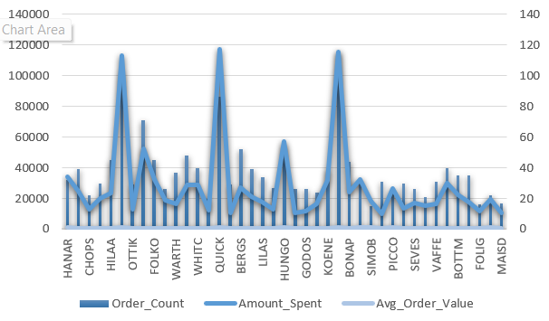

The customer analysis reveals that a small group of high-value customers, notably SAVEA, ERNSH, and QUICK, contribute a significant portion of total revenue through both frequent and high-value purchases, making them key drivers of business performance. Customers like SIMOB and PICCO, though less frequent buyers, exhibit high average order values, highlighting opportunities for personalized engagement and premium offerings. Overall, the positive correlation between order frequency and total spending indicates that encouraging repeat purchases can directly boost revenue. Focusing retention efforts on top-performing customers, while re-engaging low-frequency or low-spend customers through targeted promotions, can help Northwind Traders enhance customer loyalty, optimize marketing strategies, and achieve sustained sales growth.
- How do customer order patterns vary by city or country?

Insight Drawn:

While cities like Rio de Janeiro and São Paulo in Brazil have high order counts (34 and 31 respectively), their average order value and total revenue are significantly lower than cities in Europe and the USA, indicating smaller transaction sizes. In contrast, cities like Cunewalde (Germany), Boise (USA), and Graz (Austria) show moderate order counts but much higher average order values, resulting in higher total revenue per city. This suggests that customer behavior varies significantly by region: European and some North American customers tend to place fewer but higher-value orders, while Brazilian and UK customers place more frequent but smaller-value orders. Targeting marketing or upselling strategies differently for high-frequency, low-value markets versus high-value, moderate-frequency markets could optimize revenue.

3. Can we cluster customers based on total spend, order count, and preferred categories?

Insight Drawn:

Analysing customers by total spend, order count, and preferred category reveals three clear groups: high-value loyal customers like ERNSH, QUICK, and HANAR who frequently buy and spend heavily, mainly on Dairy Products and Beverages; moderate-value regulars such as BOLID, FRANK, and SUPRD who order regularly with mid-level spend, often in Seafood, Beverages, and Confections; and low-value occasional buyers like CENTC, LAZYK, and DUMON with few orders and low spend, mostly in Confections or Grains/Cereals. Overall, Beverages and Dairy Products dominate high-spend clusters, while Confections and Condiments are concentrated among lower-spend customers, indicating distinct customer segments for targeted marketing.

4.Which product categories or products contribute most to order revenue?

Insight Drawn:
The Beverages category, led by Côte de Blaye, contributes the most to order revenue, followed by Meat/Poultry and Dairy Products with top-selling items like Thüringer Rostbratwurst and Raclette Courdavault. Overall, a few high-revenue products dominate each category, indicating that focusing on these best-sellers could significantly boost total revenue.

- How frequently do different customer segments place orders?

Insight Drawn:
Customer order frequency varies widely, revealing distinct segments: very frequent buyers like SAVEA, ERNSH, and QUICK place 86–116 orders and contribute the highest total spend, representing loyal, high-value customers. Moderate-frequency buyers (20–55 orders) such as HUNGO, BERGS, and FRANK generate steady revenue, while low-frequency buyers with fewer than 15 orders, including CENTC and LAZYK, contribute minimally. This shows that a small segment of highly active customers drives most of the revenue.

- What is the geographic and title-wise distribution of employees?

Insight Drawn:
Most employees are concentrated in London, which hosts both Sales Representatives and the Sales Manager, indicating it’s the main sales hub. Other cities like Seattle, Kirkland, and Redmond have only one Sales Representative each, suggesting a smaller, regionally distributed support presence.
- What trends can we observe in hire dates across employee titles?

Insight Drawn :
Hiring trends show a steady increase in Sales Representatives from 1992 to 1994, indicating growing sales team expansion over time. Additionally, the introduction of the Sales Manager in 1993 and the Inside Sales Coordinator in 1994 suggests a gradual move toward a more structured and hierarchical sales organization.

- What patterns exist in employee title and courtesy title distributions?

Insight Drawn:
The data shows a balanced gender representation among Sales Representatives, with slightly more females (Ms./Mrs.) than males (Mr.). Additionally, both leadership and coordination roles—Sales Manager and Inside Sales Coordinator—are held by Mr. and Ms., indicating diversity across all employee levels.
9. Are there correlations between product pricing, stock levels, and sales performance?

Insight Drawn:
There’s a weak correlation between product price and sales performance—many moderately priced products (e.g., Camembert Pierrot, Raclette Courdavault, Gorgonzola Telino) achieve high sales, while very high-priced items like Côte de Blaye sell less despite strong revenue per unit. Products with low or zero stock but high units sold (e.g., Alice Mutton, Thuringer Rostbratwurst) indicate strong demand and possible stock shortages. Overall, mid-priced, consistently stocked products drive the bulk of sales volume, while premium items contribute to revenue through higher margins.
10. How does product demand change over months or seasons?

Insight Drawn:
Product demand shows strong seasonal fluctuations, with notable sales peaks around mid-year (April–May) and year-end (November–December), suggesting higher consumer activity during holiday or festive periods. Popular products like Gorgonzola Telino, Camembert Pierrot, and Raclette Courdavault consistently perform well across months, while specialty and premium items experience short seasonal spikes, reflecting both steady staples and event-driven buying patterns.

11. Can we identify anomalies in product sales or revenue performance?
Insight Drawn:
A few products—Côte de Blaye, Thüringer Rostbratwurst, and Raclette Courdavault—show exceptionally high total sales far above the average and standard deviation, marking them as clear positive anomalies and top performers. In contrast, products like Genen Shouyu, Geitost, and Chocolade fall well below the average, indicating underperformance. Overall, the data highlights a skewed sales distribution where a small number of premium products drive most of the revenue.
12. Are there any regional trends in supplier distribution and pricing?

Insight Drawn:
France stands out with the highest average sales per supplier, indicating premium or high-value products, while countries like Brazil and Denmark have the lowest, suggesting lower-priced or niche items. USA and Germany have more suppliers but moderate average sales, showing a diverse product range with mixed pricing, whereas smaller supplier bases in France, Australia, and Japan focus on high-value offerings.
13. How are suppliers distributed across different product categories?

Insight Drawn:
Supplier distribution is fairly balanced, with Beverages, Condiments, and Seafood having the highest supplier presence (8 each), indicating strong market competition and demand, while Dairy Products have the fewest suppliers (4), suggesting a more specialized or limited supply base.

14. How do supplier pricing and categories relate across different regions?

Insight Drawn:
Pricing patterns show clear regional and category-based variation — France and Germany lead with premium-priced categories like Beverages and Meat/Poultry, while Australia shows moderate pricing across diverse categories. In contrast, countries like Brazil and the UK offer lower-priced products, indicating cost-friendly or mass-market offerings. Overall, European suppliers dominate high-value categories, while others focus on affordable segments.

15. Are there any correlations between orders and revenue?

Insight Drawn:
The data shows a strong correlation between orders, revenue, and both customer location and product category. The USA and Germany dominate in total orders and revenue, particularly in Beverages, Dairy, and Meat/Poultry, while smaller markets like Poland, Norway, and Portugal have low orders and revenue across most categories. This suggests that high-demand products are concentrated in major markets, while less populated or niche regions generate limited sales.

16.Frequency of Orders on Monthly and Yearly basis by Customers

Monthly Sales

Yearly Sales

Insight Drawn:

The dataset provides a detailed view of customer order behavior over multiple years, capturing both monthly and yearly order counts along with corresponding spend amounts. Customers show varying purchasing patterns, with some placing frequent small orders and others making fewer but high-value purchases. Certain customers, like SAVEA, QUICK, and ERNSH, demonstrate consistently high order volumes and spending, while others have sporadic or low activity. Year-over-year trends indicate fluctuations in purchase frequency and spending, reflecting seasonal, product-specific, or customer-specific buying behaviors. Overall, the data highlights customer segmentation by order frequency and spend, useful for targeting loyalty programs, marketing strategies, and revenue forecasting.

POWER BI DASHBOARD DESIGN PRINCIPLES
A well-designed Power BI dashboard should prioritize clarity and simplicity. This means focusing on key metrics and avoiding unnecessary visuals that can distract the user. Every chart, graph, or KPI should be self-explanatory, with clear titles, labels, and legends. Consistency is equally important: using the same chart types for similar data, maintaining a consistent colour palette, and applying uniform font styles and sizes help users quickly understand the dashboard without confusion. Consistent design creates a professional look and allows users to recognize patterns across different sections of the dashboard efficiently.
(a) Sales Dashboard
The Sales Dashboard visualizes key sales metrics such as total revenue, monthly sales trends, top-selling products, and regional performance. Common visualizations include line charts for sales trends, bar charts for product-wise revenue, and KPIs for targets vs. actuals. It helps managers track sales performance, identify growth opportunities, and spot underperforming areas. Interactive filters, such as time periods, regions, or sales representatives, allow users to drill down into specific segments and make data-driven decisions.
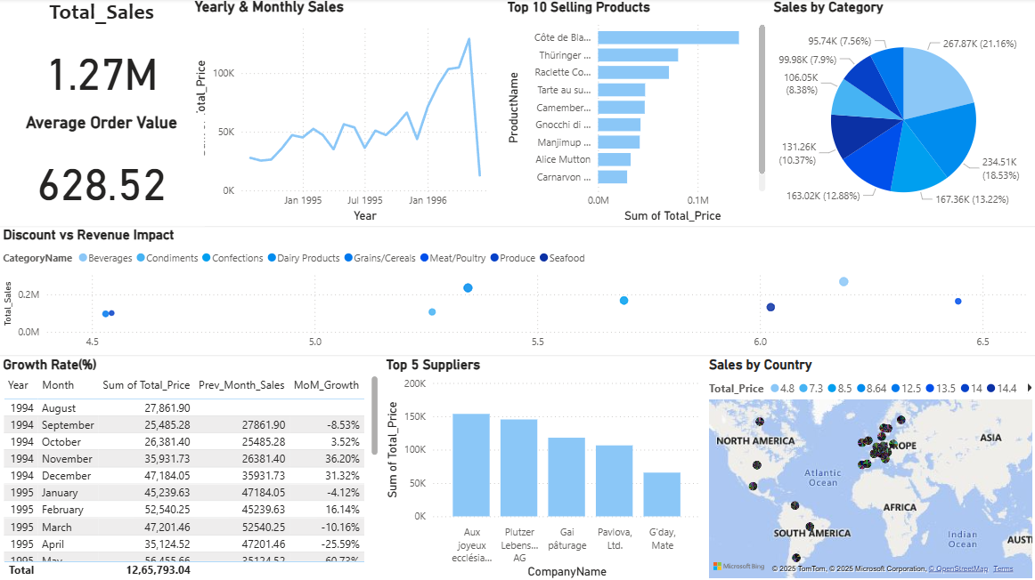

Insight Drawn:
Total sales reached 1.27M with an average order value of 628.52, showing steady growth through 1995–1996. Beverages led sales at 21.16%, while Côte de Blaye was the top-selling product. Europe emerged as the strongest market, supported by major suppliers like Aux joyeux ecclésiastiques and Plutzer Lebensmittelgroßmärkte AG. Despite some monthly fluctuations, overall sales trended upward, with moderate discounts (5–6%) driving higher revenue across key categories.
(b) Customer Dashboard
A Customer Dashboard focuses on customer-related metrics like the total number of customers, customer acquisition trends, customer retention rates, and segmentation by demographics. Visualizations may include pie charts for customer categories, maps for regional distribution, and line charts for retention trends. This dashboard helps marketing and sales teams understand customer behaviour, segment their audience effectively, and improve engagement strategies. It often includes filters for customer type, region, or purchase history.
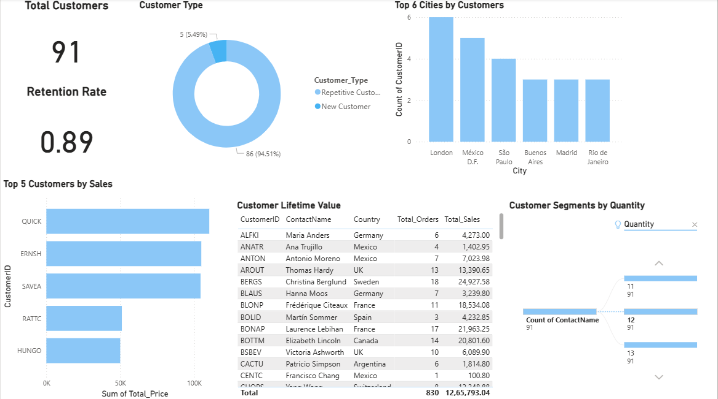

Insight Drawn:
The business maintains a strong customer base of 91 with an impressive retention rate of 0.89, indicating high loyalty. Most customers (94.5%) are repeat buyers, showing strong satisfaction and engagement. London and Mexico D.F. lead in customer count, while QUICK, ERNSH, and SAVEA are the top contributors to sales. High-value customers like Christina Berglund and Frédérique Citeaux drive significant revenue, highlighting the importance of nurturing long-term relationships with these repeat clients.

(c) Product Dashboard
The Product Dashboard highlights product performance metrics, such as inventory levels, product sales, return rates, and profit margins per product. Bar charts or stacked columns can show top-selling products, while KPI cards show stock status or reorder alerts. This dashboard helps product managers and inventory teams optimize stock, identify popular or underperforming products, and make informed procurement decisions. It may also include trend lines for seasonal product demand.
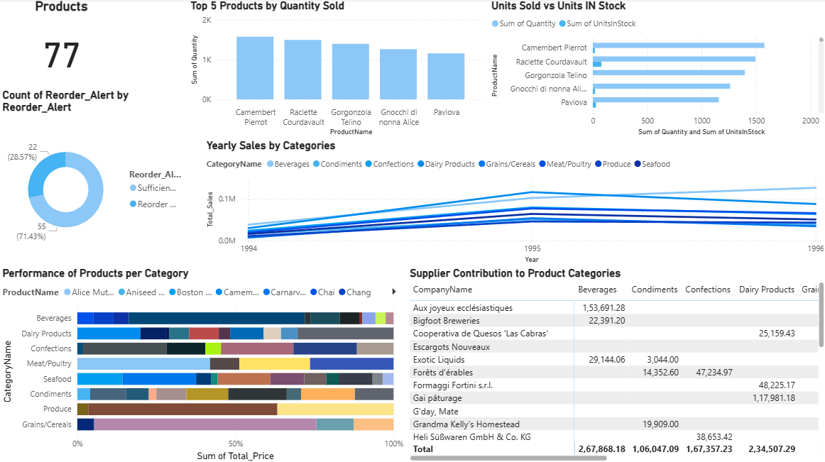
Insight Drawn:
The company manages 77 products, with 71% requiring reorder alerts, indicating high product turnover. Camembert Pierrot leads in quantity sold, closely followed by Raclette Courdavault and Gorgonzola Telino, reflecting strong demand for dairy items. Dairy Products and Confections show the highest yearly sales growth, while Aux joyeux ecclésiastiques and Formaggi Fortini s.r.l. are the top suppliers driving category performance. Overall, sales trends remain upward, but inventory management needs attention to maintain supply for high-performing products.

(d) Order Dashboard
The Order Dashboard tracks order processing and fulfillment metrics, including total orders, pending vs. completed orders, average processing time, and order trends. Visualizations such as funnel charts, tables, and line charts help track workflow efficiency. This dashboard is essential for operations and logistics teams to ensure timely order fulfilment, identify bottlenecks, and improve customer satisfaction. Interactive slicers can filter orders by date, status, or region.
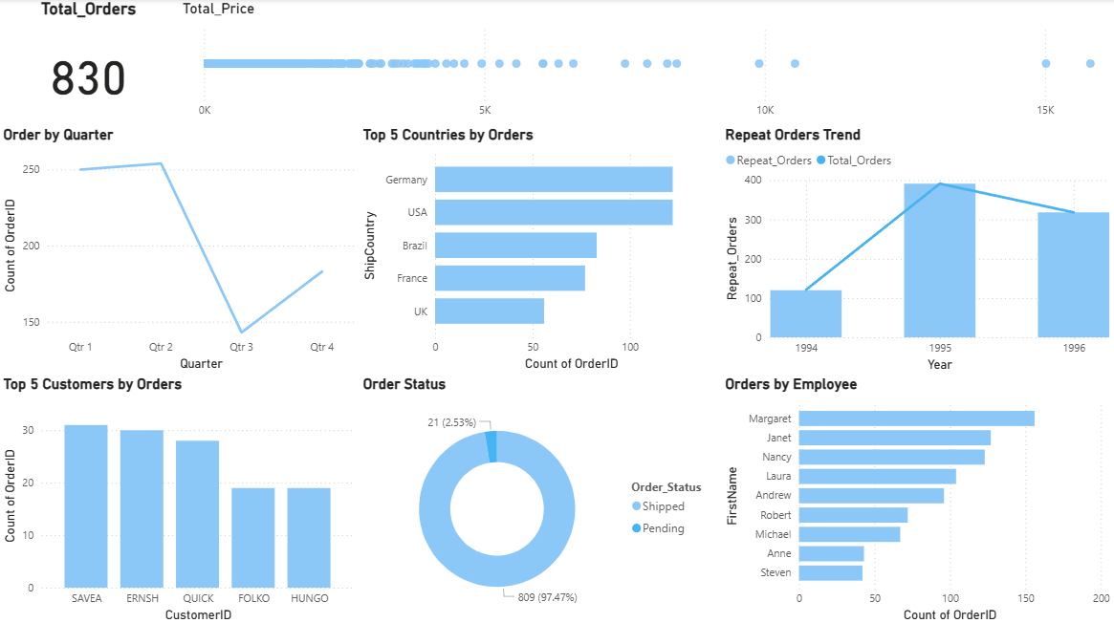

Insight Drawn:
A total of 830 orders were recorded, with 97% successfully shipped, reflecting strong operational efficiency. Germany and the USA lead in order volume, while SAVEA and ERNSH are the top customers by number of orders. Orders peaked in Q2 and dipped in Q3, showing possible seasonal variation. Repeat orders grew sharply from 1994 to 1995, indicating improved customer retention. Among employees, Margaret and Janet handled the highest number of orders, highlighting their key role in sales performance.

(e) Shipping Dashboard
The Shipping Dashboard monitors shipping and logistics performance, including on-time delivery rates, shipping costs, carrier performance, and delayed shipments. Visualizations often include maps for delivery routes, KPIs for delivery performance, and line charts for shipment trends. This dashboard enables logistics managers to track shipping efficiency, identify problem areas, and reduce delays or costs. Filters for shipping region, carrier, or order type allow for detailed operational analysis.
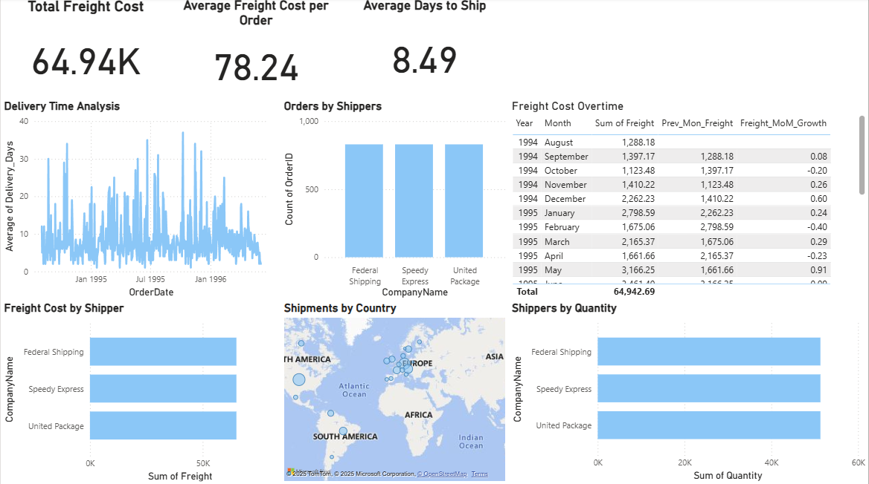
Insight Drawn:
The company incurred a total freight cost of 64.94K, averaging 78.24 per order, with an average shipping time of 8.49 days. Federal Shipping, Speedy Express, and United Package handled nearly equal order volumes and freight costs, ensuring balanced logistics performance. Delivery times fluctuated but generally improved toward 1996, showing better efficiency. Freight costs saw moderate month-over-month variation, peaking in late 1994 and early 1995, while Europe remained the central hub for shipments.

CONCLUSION
The MECE (Mutually Exclusive, Collectively Exhaustive) analytical approach has enabled Northwind Traders to examine its business operations in a structured and systematic manner, ensuring that all critical areas are analyzed without overlap or omission. By applying this approach, the company gains a clear, organized, and holistic view of key business functions, including sales, customer behaviour, product performance, order management, employee productivity, and shipping efficiency.
Leveraging Power BI dashboards and reports further enhances decision-making by transforming raw data into actionable insights through interactive visualizations, trend analyses, and KPI tracking. The dashboards allow management to quickly identify performance gaps, monitor operational efficiency, and respond to emerging business challenges with agility. Sound data modelling principles, such as proper relationships, calculated measures, and effective use of filters, ensure that the insights are accurate, reliable, and scalable for future analysis.
Ultimately, this integrated analytical framework equips Northwind Traders to make data-driven strategic decisions, optimize business processes, enhance customer satisfaction, and maintain a competitive edge in the market. By continuously monitoring and refining these dashboards, the company can foster a culture of informed decision-making, operational excellence, and sustainable growth.

