SALES PERFORMANCE ANALYSIS

Objective:
To analyze sales performance, identify high-performing categories and regions, and generate business insights.
Dataset Overview:
- Records: 9,994
- Columns: 21
- Missing Values: 0
Summary Statistics:
- Mean Sales: 229.86
- Median Sales: 54.49
- Mode Sales: 12.96

Visualizations: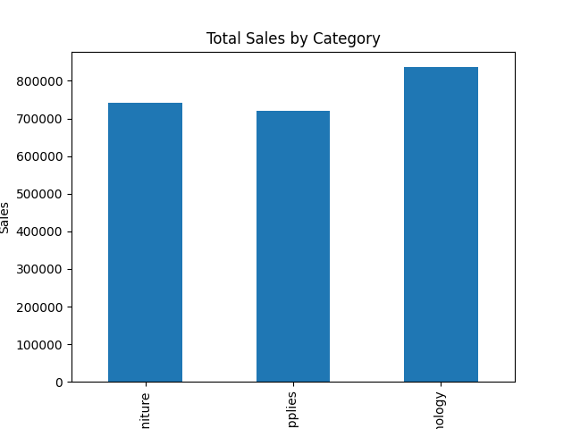

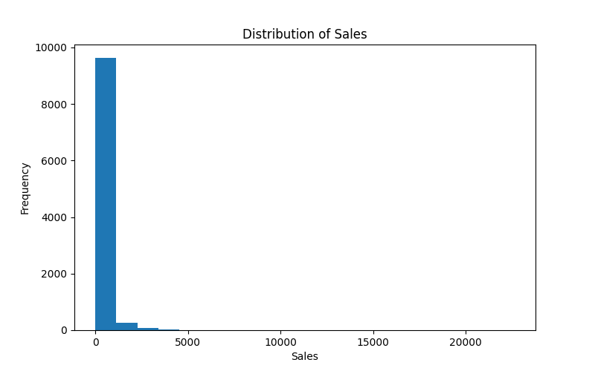
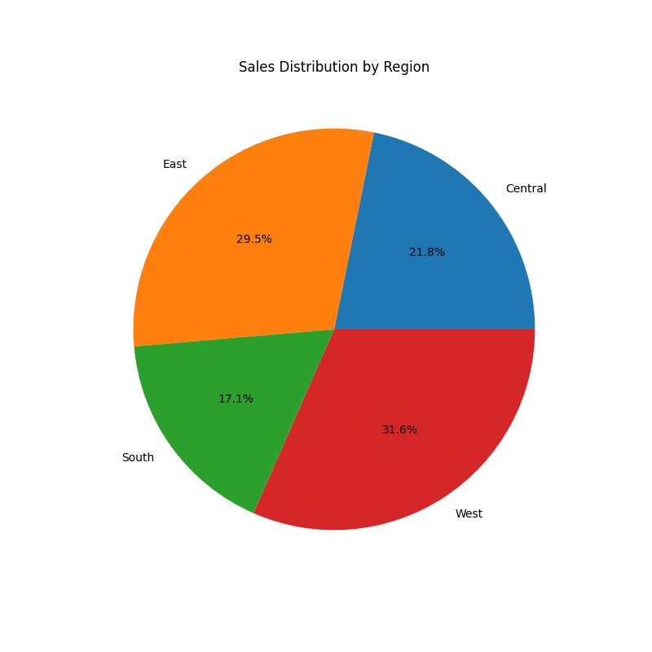
Key Findings:
- Technology generated the highest sales.
- West region contributed the highest revenue.
- Most sales orders were relatively small, while a few orders generated very high sales.
Recommendations:
- Increase marketing for Technology products.
- Replicate successful sales strategies from the West region.
- Focus on high-value products and customer segments.
Conclusion:
The Technology category and West region are major revenue contributors. These insights can help improve sales strategy and business growth.

