CUSTOMER BEHAVIOR ANALYSIS

Objective:
To understand customer demographics, purchasing behavior, and product preferences.
Dataset Overview:
- Records: 3,900
- Columns: 19
- Missing Values: 0
Summary Statistics:
- Mean Age: 44.07 years
- Average Review Rating: 3.75
- Average Previous Purchases: 25

Visualizations:

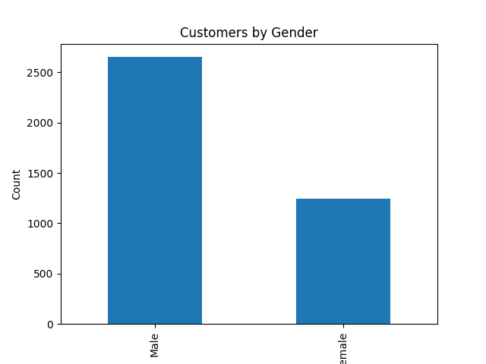

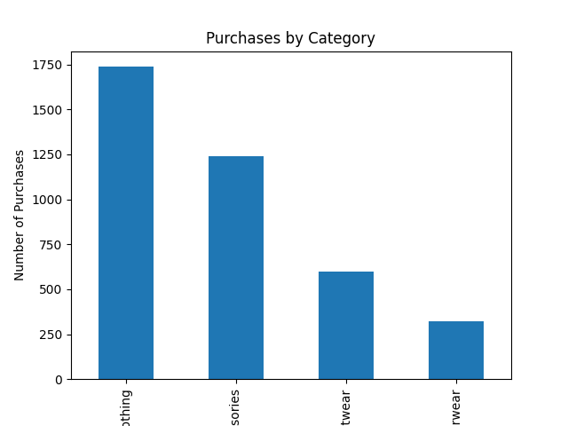

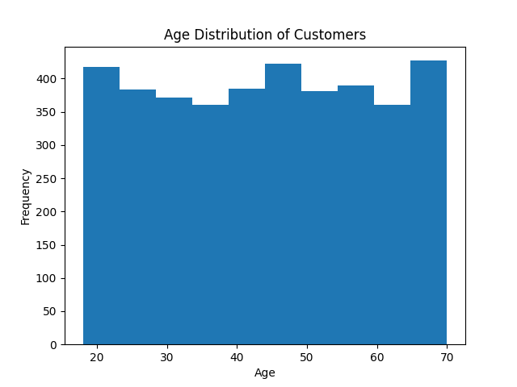
Key Findings:
- Male customers represent the larger customer segment.
- The average customer age is approximately 44 years.
- Customer purchasing patterns reveal clear product preferences.
Recommendations:
- Target marketing campaigns toward major customer segments.
- Improve customer retention through loyalty programs.
- Focus promotional efforts on high-demand product categories.
Conclusion:
Understanding customer demographics and behavior helps improve marketing effectiveness and customer satisfaction.

