WEBSITE TRAFFIC ANALYSIS

Objective:
To analyze visitor behavior, traffic sources, engagement, and conversion performance.
Dataset Overview:
- Records: 2,000
- Columns: 7
- Missing Values: 0
Summary Statistics:
- Average Page Views: 4.95
- Average Session Duration: 3.02
- Average Conversion Rate: 98.2%

Visualizations:

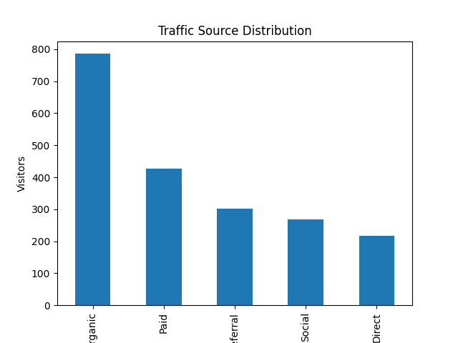

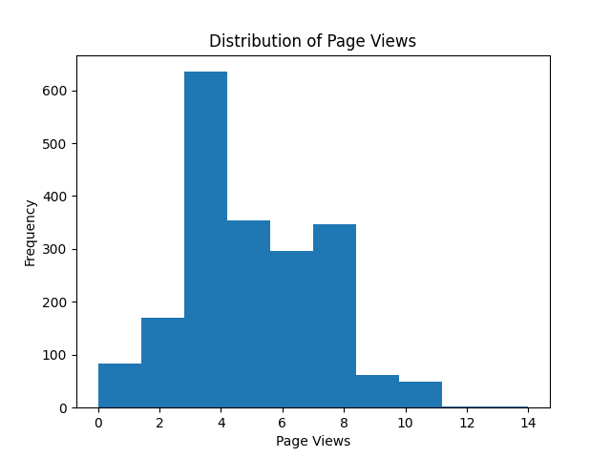

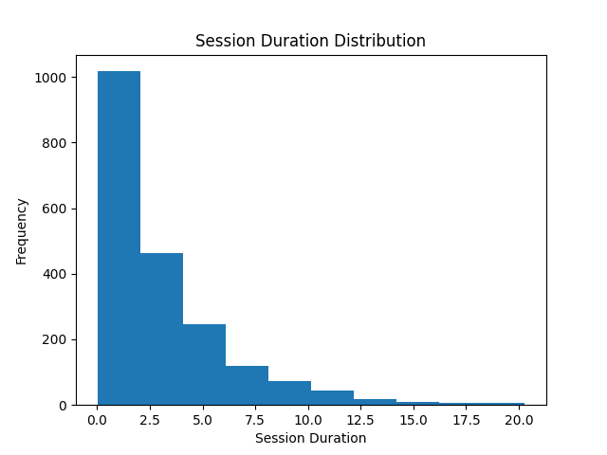
Key Findings:
- Organic traffic is the largest source of website visitors.
- Visitors view approximately 5 pages per session.
- Visitors spend about 3 minutes per session on average.
Recommendations:
- Invest more in organic traffic strategies.
- Improve website content to increase engagement.
- Optimize landing pages to maintain strong conversion rates.
Conclusion:
The website demonstrates strong engagement and conversion performance, with organic traffic contributing the largest share of visitors.

