|  |
| --- |
| DMS H7 Import |
| System guide |

|  |
| --- |
| System Guide H7 May 2021 |
|  |

# Document version

|  |
| --- |
|  |
| Document version:   |  |  |  |  | | --- | --- | --- | --- | | Version nr. | Dato | Created by | Updates | | 1.0 | 11.05.2021 | Bjarke Runz Jensen |  | |  |  |  |  | |  |  |  |  | |

DMS Impo

guide

Contents

1 Document version 1

2 Introduction 3

3 Submit H7 declaration 3

4 H7 Correction 3

5 H7 Amendment 3

6 H7 Invalidation 3

7 H7 Remission and Repayment 3

8 H7 Invalidation and Repayment 4

9 I2 Goods Presentation 4

10 Notifications 4

10.1 Notification Request Design Suggestion 4

10.2 Flow of declarations, and related notifications 5

10.3 Submit IMA declaration notifications 6

10.4 Submit IMD declaration notifications 7

10.5 Invalidation notifications 8

10.6 H7 Correction notifications 8

10.7 H7 Amendment notifications 9

10.8 I2 notifications 10

10.9 List of notifications, error codes, warnings, and their text descriptions 11

10.10 Detailed notification code description 13

10.10.1 CWMTAX 13

11 Getting access 14

11.1 Trader portal 14

11.2 System to system 14

12 Verifying functionality 14

# Introduction

This guide is a work in progress. Currently it only describes notifications, as the details for this are essential. Later releases of this guide will include descriptions of the entire functionality of the new Import System.

# Submit H7 declaration

H7 declarations can be submitted either through the Portal UI, as well as through the system-to-system interface in an XML format. In both cases the data to provide is given by the EUCDM standard based on WCO. All schemas used on DMS are available in [an annotated version here](https://github.com/skat/dms-public).

Declarations can either be filled out as a standard (IMA), or as pre-lodged (IMD) declaration. IMA declarations are only sent to DMS and must therefore include a goods location. Whereas an IMD are pre-lodged, and goods must be reported to Manifest, and presented to Manifest upon arrival.

The system-to-system interface is described in detail by the annotated XML schema, and how to submit the declarations are described in the supplied connectivity guide.

# H7 Correction

An H7 correction can be submitted either through the Portal UI, as well as through the system-to-system interface in an XML format. A correction is possible when the declaration is pre-lodged and has not yet been accepted.

Corrections are sent to the system, using the same schema as the submit H7 declaration schema. Details for how to fill out fields are annotated in the H7 schema.

# H7 Amendment

An H7 Amendment can be submitted either through the Portal UI, as well as through the system-to-system interface in an XML format. An amendment is possible when the declaration is accepted, up until and after the declaration is released (CWMCLE).

Amendments are sent to the system, using the same schema as the submit H7 declaration schema. Details for how to fill out fields are annotated in the H7 schema.

# H7 Invalidation

Invalidation is done either through the Portal UI, or by sending in a valid invalidation XML towards the invalidation-service. See details on fields in the provided schema, as well as how to submit an invalidation request in the provided connectivity guide.

# H7 Remission and Repayment

Currently not available as a separate functionality. Is tentatively planned for Release 2 – 2023.

# H7 Invalidation and Repayment

Invalidation with Repayment is done either through the Portal UI, or by sending in a valid XML towards the invalidation and repayment-service. See details on fields in the provided schema, as well as how to submit an XML in the provided connectivity guide.

# I2 Goods Presentation

Most EO’s will not use this, as the main presentation notification are to be delivered through Manifest. Please only implement and use the I2 Presentation notification if expressly told during your onboarding process.

The I2 Presentation notification towards DMS is for some specific scenarios but contains similar information as the one delivered to Manifest – the difference is purely related to where and how the goods are stored until they are presented.

The presentation notification follows the I2 EUCDM definition, where details on specific fields, and their usage can be seen in the provided schema.

# Notifications

Notifications provides the status of a declaration and are pulled from DMS. It is the responsibility of the Economic Operator (EO) to pull, process and react according to the delivered notifications. The notification both gives information of the declaration and describes “state changes” on a declaration. Those state-changes include rejection and acceptance of the declaration.

## Notification Request Design Suggestion

It is advised that the sending system requests notifications, using the time stamp from the last received notification to set the start of the range and the sending time of the request as the end of the range. For instance, this simplified example below (seconds and milliseconds are omitted for simplicity):

|  |  |  |  |  |  |
| --- | --- | --- | --- | --- | --- |
| **Action #** | **Time** | **Request** | **Response** | **Time range** | **Comment** |
| 1 | 12:00 | 1 |  | 11:55 - 12:00 | A request is sent with a 5-minute time range. |
| 2 | 12:00 |  | 1 |  | A response is received at 12:00. |
| 3 | 12:05 | 2 |  | 12:00 - 12:05 | A request is sent with the start of the range at time stamp from response 1 at Action #2 |
| 4 | 12:05 |  | 2 |  | A response is received 12:05 |
| 5 | 12:10 | 3 |  | 12:05 - 12:10 | A request is sent with the start of the range at time stamp from response 2 at Action #4 |
| 6 | 12:10 |  | None |  | A no response is received due to some unforeseen error. |
| 7 | 12:15 | 4 |  | 12:05 - 12:15 | A request is sent with the start of the range at time stamp from response 2 at Action #4 |
| 8 | 12:15 |  | 4 |  | A response is received 12:15 |

## Flow of declarations, and related notifications

This section describes which notifications the system produces, and when in the flow the notification is produced.

The diagrams in the coming sections follow the annotation shown on Figure 1

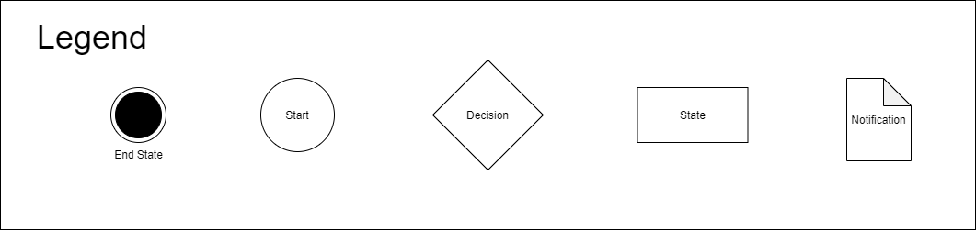

Figure 1 – Overview of diagram notation.

The End State represents a state where the flow is terminated in some respect and will no longer continue. An End State can trigger a notification in some cases, in most cases an End State signifies that the declaration was rejected, accepted, or converted to another flow.

The Start State signifies the start point of a flow, therefore there are only transitions out of a Start State, and it is not possible to return, in technical terms. The state is the first state from which it is possible for the system to issue notifications which the notification service can retrieve, meaning that it is past the semantic validation in Axway.

A Decision State is a state from which it is possible to take one of many transitions, only one transition will be used, and each transition out of the Decision State will be clearly labelled with the conditions necessary to take that transition. Most Decision States relate to a significant analysis performed in the flow, such as validation.

A State is the simplest construct in that it only offers one transition out, which means that transition will always be taken.

A Notification, signified by the paper symbol, is not a state it is therefore not possible to transition into a Notification. An arrow from any of the other symbols in the diagram to a Notification signifies that that symbol will issue a Notification which can be retrieved by the Notification service.

## Submit IMA declaration notifications

The flow for IMA (standard declarations) is shown below in Figure 2.

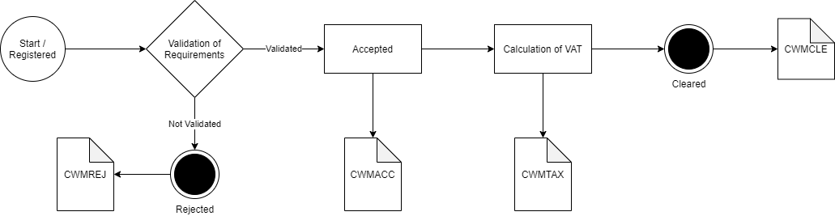

Figure 2 – The flow for an IMA declaration. The provided notifications for each state, are shown by the paper symbol.

As shown in the diagram, an IMA declaration, can generate the following notifications:

|  |  |  |
| --- | --- | --- |
| Title | Code | Description |
| Declaration Accepted Notification | CWMACC | The submitted declaration is accepted. |
| Declaration Rejection Notification | CWMREJ | Declaration has been rejected |
| CustomsDebt Trader Notification | CWMTAX | Notification of customs debt |
| Declaration Clearance Notification | CWMCLE | Procedure is accepted and goods can be released. |

The first given notification includes the Master Reference Number (MRN).

## Submit IMD declaration notifications

The flow for IMD (pre-lodged declarations) is shown below in Figure 3.

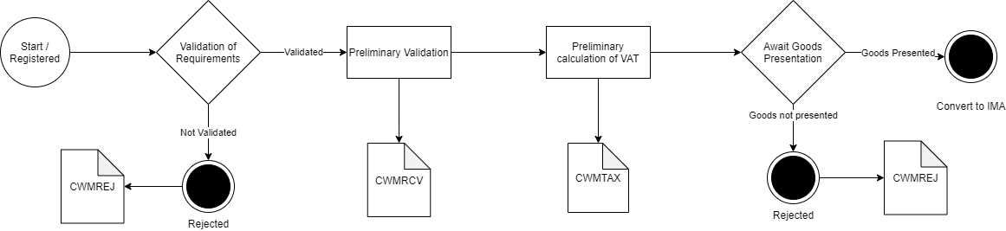

Figure 3 – The flow for an IMD declaration. The provided notifications for each state are shown by the paper symbol.

|  |  |  |
| --- | --- | --- |
| Title | Code | Description |
| Declaration Accepted Notification | CWMRCV | The submitted declaration is received. |
| Declaration Rejection Notification | CWMREJ | Declaration has been rejected |
| CustomsDebt Trader Notification | CWMTAX | Notification of customs debt |

The CWMRCV notification includes the MRN.

An IMD declaration is pre-lodged which means that information about the declaration is sent to the system before the declaration has arrived in the country. An IMD therefore also has preliminary validations and calculations of VAT. The IMD declaration is converted to an IMA when a goods presentation declaration has been declared. From this point the declaration therefore follows the just presented IMA declaration, and will therefore also produce the same notifications. To sum up, will an IMD declaration both have preliminary validation and calculation of VAT and a finale validation and calculation of VAT.

## Invalidation notifications

The flow for Invalidation of an IMD (pre-lodged declaration) is shown below in Figure 4.

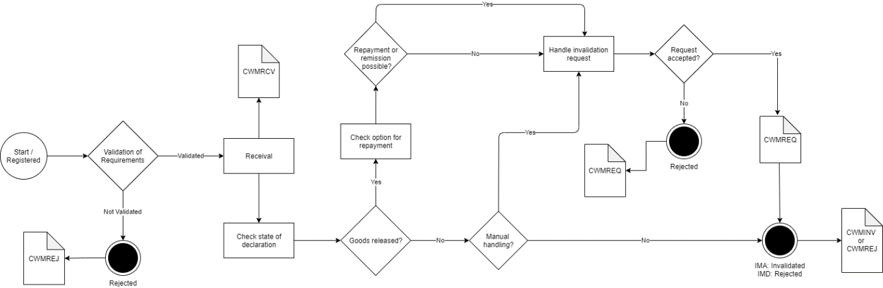

Figure 4 – the flow for an Invalidation

|  |  |  |
| --- | --- | --- |
| Title | Code | Description |
| Declaration Accepted Notification | CWMRCV | The submitted invalidation application is received. |
| Declaration Rejection Notification | CWMREJ | Invalidation application has been rejected. |
| Customs Position on Message Notification | CWMREQ | Decision on invalidation application. |
| Declaration Invalidation Notification | CWMINV | Invalidation of IMD declaration. |

## H7 Correction notifications

Flow for Correction of a declaration is shown in Figure 5.

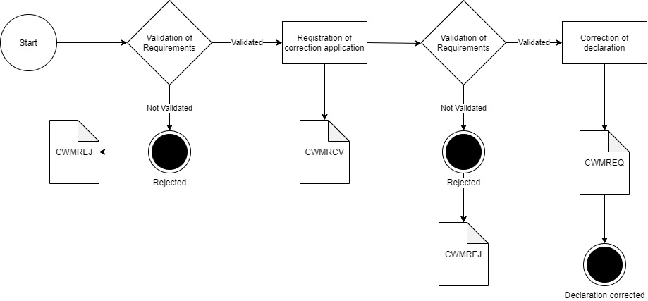

Figure 4 – the flow for a Correction

|  |  |  |
| --- | --- | --- |
| Title | Code | Description |
| Declaration Accepted Notification | CWMRCV | The submitted correction application is received. |
| Declaration Rejection Notification | CWMREJ | Correction application has been rejected. |
| Customs Position on Message Notification | CWMREQ | Decision on correction application. |

## H7 Amendment notifications

Flow for Amendment of a declaration is shown in Figure 6.

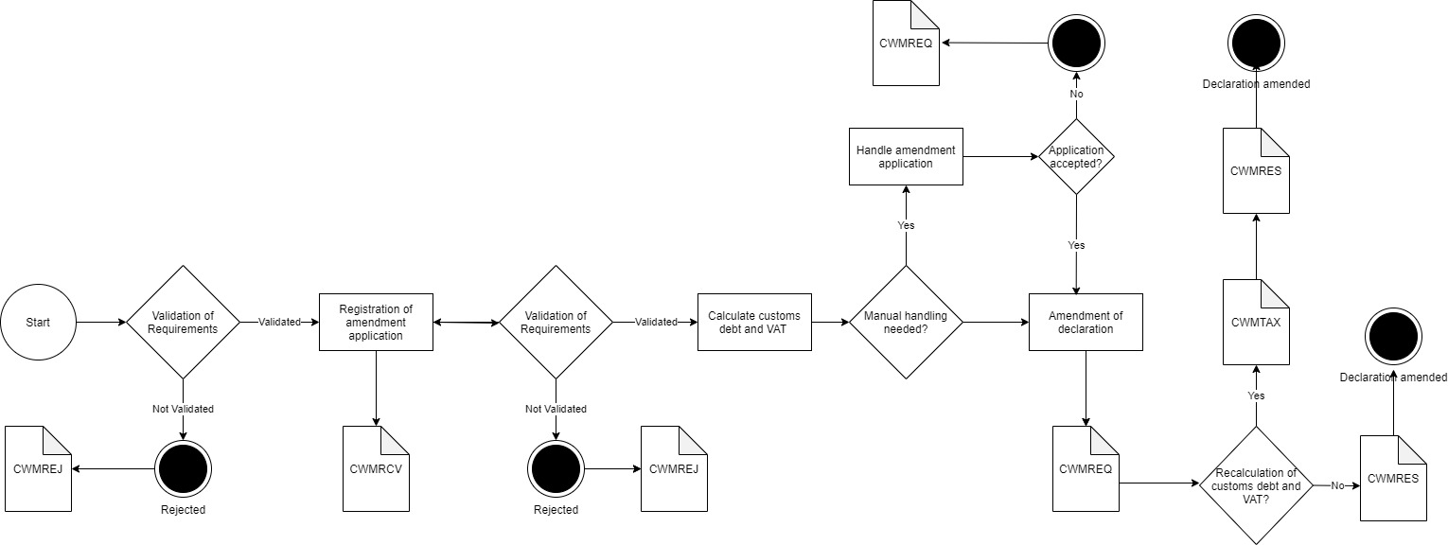

Figure 6 – the flow for an Amendment

|  |  |  |
| --- | --- | --- |
| Title | Code | Description |
| Declaration Accepted Notification | CWMRCV | The submitted amendment application is received. |
| Declaration Rejection Notification | CWMREJ | Amendment application has been rejected. |
| Customs Position on Message Notification | CWMREQ | Decision on amendment application. |
| CustomsDebt Trader Notification | CWMTAX | Notification of customs debt. |
| Corrected Declaration Notification | CWMRES | The result of the amendment to the declaration. |

## I2 notifications

The flow for an I2 Presentation Notification flow is shown below in Figure 7.

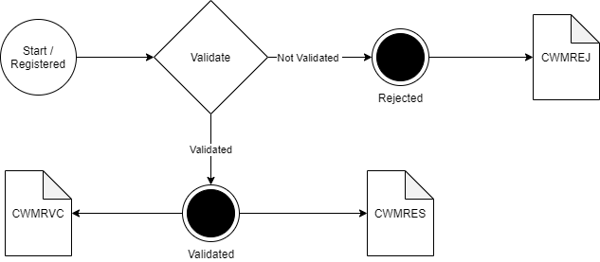

Figure 7 – Flow for an I2 Presentation Notification

|  |  |  |
| --- | --- | --- |
| Title | Code | Description |
| Declaration Accepted Notification | CWMRCV | The submitted I2 is received. |
| Declaration Rejection Notification | CWMREJ | Declaration has been rejected. |
| Corrected Declaration Notification | CWMRES | The result of the correction to the declaration the I2 was submitted against. |

## List of notifications, error codes, warnings, and their text descriptions

Here is a list of all notifications the system can produce, as well as a description of when and how they are issued.



In case the declaration is rejected, or a warning is produced, a specific error code is given. The list below describes the entire list of all codes available in the system.



Double click on the file above, to open.

Note that this document describes both error codes, and warnings. Both are delivered in the error-structure of the XML, but the usage of the codes, are determined by the NotificationEventType.

Example of a rejection (CWMREJ), and the error code, provided by the XML:

1. <Notification>
2. <NotificationEventType>CWMREJ</NotificationEventType>
3. <NotificationSID>44ca3772-6dd7-4ecc-aebd-34a06dac0e29</NotificationSID>
4. <Declaration>
5. <MRN>21DKBBGE7CMMOHDMR6</MRN>
6. <LRN>EM060551</LRN>
7. <VersionID>1</VersionID>
8. <SubmitterReferenceNumber>EM060551</SubmitterReferenceNumber>
9. <RejectionDateTime>
10. <DateTimeString formatCode="304">20210507074555+01</DateTimeString>
11. </RejectionDateTime>
12. </Declaration>
13. <Error>
14. <ValidationCode>DK1051</ValidationCode>
15. <ValidationText>Error in "Exporter country" (3/1) the country code does not exist.</ValidationText>
16. <Pointer>
17. <DocumentSectionCode>$.consignmentShipment[?(@.sequenceNumber == 1)].goodsItems[?(@.sequenceNumber == 1)]</DocumentSectionCode>
18. </Pointer>
19. </Error>
20. <NotificationCreatedDate>
21. <DateTimeString formatCode="304">20210507074555+01</DateTimeString>
22. </NotificationCreatedDate>
23. </Notification>

Example of an accepted declaration (CWMRCV), with warnings attached in the response:

1. <Notification>
2. <NotificationEventType>CWMRCV</NotificationEventType>
3. <NotificationSID>97bbec09-f6e8-429e-9291-a186364d27d5</NotificationSID>
4. <Declaration>
5. <MRN>21DKMKYEVU7FC2NVR0</MRN>
6. <LRN>EM060558</LRN>
7. <SubmitterReferenceNumber>EM060558</SubmitterReferenceNumber>
8. </Declaration>
9. <Error>
10. <ValidationCode>DKW1055</ValidationCode>
11. <Pointer>
12. <DocumentSectionCode>$.consignmentShipment[?(@.sequenceNumber == 0)].goodsItems[?(@.sequenceNumber ==1)].procedureCombination.specialProcedures</DocumentSectionCode>
13. </Pointer>
14. </Error>
15. <Error>
16. <ValidationCode>DKW1056</ValidationCode>
17. <Pointer>
18. <DocumentSectionCode>$.consignmentShipment[?(@.sequenceNumber == 0)].goodsItems[?(@.sequenceNumber ==1)].procedureCombination.specialProcedures</DocumentSectionCode>
19. </Pointer>
20. </Error>
21. <Error>
22. <ValidationCode>DKW1055</ValidationCode>
23. <Pointer>
24. <DocumentSectionCode>$.consignmentShipment[?(@.sequenceNumber == 0)].goodsItems[?(@.sequenceNumber ==1)].procedureCombination.specialProcedures</DocumentSectionCode>
25. </Pointer>
26. </Error>
27. <Error>
28. <ValidationCode>DKW1056</ValidationCode>
29. <Pointer>
30. <DocumentSectionCode>$.consignmentShipment[?(@.sequenceNumber == 0)].goodsItems[?(@.sequenceNumber ==1)].procedureCombination.specialProcedures</DocumentSectionCode>
31. </Pointer>
32. </Error>
33. <NotificationCreatedDate>
34. <DateTimeString formatCode="304">20210507132824+01</DateTimeString>
35. </NotificationCreatedDate>
36. </Notification>

## Detailed notification code description

Some of the notifications provide specific details only delivered in certain scenarios – this section describes the codes in detail.

### CWMTAX

An example of a CWMTAX notification is given below:

1. <Notification>
2. <NotificationEventType>CWMTAX</NotificationEventType>
3. <NotificationSID>7a256b23-934d-49b5-91f8-bedef98878d2</NotificationSID>
4. <Declaration>
5. <MRN>21DKQ3BMCYQKBA0IR0</MRN>
6. <LRN>EMHA14042104</LRN>
7. <VersionID>1</VersionID>
8. <SubmitterReferenceNumber>EMHA14042104</SubmitterReferenceNumber>
9. <DutyTaxFee>
10. <Payment>
11. <ReferenceID>Preliminary Calculation</ReferenceID>
12. <PaymentAmount currencyID="DKK">71.3825</PaymentAmount>
13. <TaxAssessedAmount>0</TaxAssessedAmount>
14. </Payment>
15. </DutyTaxFee>
16. <GoodsShipment>
17. <GovernmentAgencyGoodsItem>
18. <SequenceNumeric>1</SequenceNumeric>
19. <Commodity>
20. <DutyTaxFee>
21. <Payment>
22. <PaymentAmount currencyID="DKK">71.3825</PaymentAmount>
23. <TaxAssessedAmount currencyID="DKK">71.3825</TaxAssessedAmount>
24. </Payment>
25. <SpecificTaxBaseQuantity unitCode="DKK">285.53</SpecificTaxBaseQuantity>
26. <DeductAmount currencyID="$reliefUnitType">0</DeductAmount>
27. <TaxRateNumeric>25.0</TaxRateNumeric>
28. <TypeCode>B00</TypeCode>
29. </DutyTaxFee>
30. </Commodity>
31. </GovernmentAgencyGoodsItem>
32. </GoodsShipment>
33. </Declaration>
34. <IssueDateTime>
35. <DateTimeString formatCode="304">20210414133633+01</DateTimeString>
36. </IssueDateTime>
37. </Notification>

As seen in the sample, the notification contains the following sections:  
  
On declaration level:  
Duty Tax Fee:

Payment:

ID: Payment ID

Payment Amount: The actual amount paid, or to be paid for all items in the declaration.

Tax Assessed Amount: Assessed amount of duty/tax/fee (includes all types of charges and duties). Assessed per duty/tax/fee type by declaration.

On item level (under GovernmentAgencyGoodsItem):

Duty Tax Fee:

Payment:

Payment Amount: The actual amount paid, or to be paid for the specific item

Tax Assessed Amount: Assessed amount of duty/tax/fee (includes all types of charges and duties). Assessed per duty/tax/fee type by item

Specific Tax Base Quantity:  The quantity on which a duty or tax or fee will be assessed (FreightChargeAmount + CustomsValueAmount)

Deduct Amount: Amount of deduction from a duty or tax

Tax Rate Numeric: Rate of duty or tax or fee applicable to commodities or of tax applicable to services (25.00 = 25%)

Type Code: Code for type of tax to be applied (B00 is VAT)

# Getting access

This part of the guide is not done, and will be filled in future versions

## Trader portal

## System to system

# Verifying functionality

In order to verify that your system is able to use features and functionality provided by DMS Import, you must do the following:

#Decorative

|  |  |  |  |
| --- | --- | --- | --- |
|  | www.ufst.dk  ISBN |  | Udviklings- og Forenklings- styrelsen er en del af  Skatteforvaltningen |