Lab 05: TCP Congestion Control
Due date: October 22, 2018
Points: 500
Questions: 40

Checklist (points in each section are only awarded if all bullet points are met)
Feel free to make use of this checklist as your own sanity check.
Complete [140 pts] | All questions are answered. Each complete question is worth 5 points
Correct [350 pts] | Responses demonstrate that you have thought about your answer and that your answer is unique to you as an individual. Each correct question is worth 12.5 points
Name [10 pts] | Your name and NAU email are on the assignment

The purpose of this lab is to help you examine the impact of the TCP congestion control algorithm on things like TCP window values and performance metrics, particularly in the face of network congestion. This lab is critical for ensuring you have a fundamental understanding of one of the most widely used protocols in the Internet AND it introduces you to something of an experimental design set up for networks experiments.

Part 0: Identification
Name: | Austin Kelly
NAU Email: | ak678 @ nau.edu

Part 1: Setting up Mininet
In this lab, we will be using Mininet, a virtual network that allows you to run networked applications realistically on your own computer.

Specifically, you will need to write a custom Mininet configuration file that uses the network topology below. Use the following topology with 10Mbits on all links.
h1 h2
\ /
\ /
sw1-------------sw2
/ \
/ \
h3 h4

For a template on how to create a custom topology, use the following:
http://mininet.org/walkthrough/#custom-topologies

I will be assuming you title your topology file as topo_sw2_host4.py

You can test your topology and assign 10Mbps to each link using the following command on your VM:
sudo mn --custom topo_sw2_host4.py --topo mytopo --link tc,bw=10 --test pingall

The test was successful if 0% of packets were dropped.

Now start Mininet session with your custom topology:
sudo mn --custom ~/mininet/custom/topo_sw2_host4.py --topo sw2host4 --link tc,bw=10

And start xterm for each host:
mininet> xterm h1 h2 h3 h4

Part 2: TCP Reno and throughput
From a terminal into your VM, select Reno as your TCP congestion control algorithm
sudo sysctl net.ipv4.tcp_congestion_control=reno

Start Wireshark and start a capture on interface h2-eth1.

Start iperf3 servers on the xterms for h2.

Get ready to start iperf3 clients in the xterms for h1. Configure the iperf3 client to run for 60 seconds (use the man command if you don’t know how to do this: man iperf3). Start the iperf3 clients as simultaneously as possible.

When both clients have finished, stop capturing on Wireshark. Now, use Wireshark to filter the TCP conversation by right clicking on one of the TCP packets that have been generated and selecting “Conversation Filter” > “ F5 TCP” and save your capture session as lab05_reno.pcapng.

Run the following in the terminal

sudo tshark –r lab05_reno.pcapng –t ad –T fields –E separator=, -e frame.time -e tcp.analysis.bytes_in_flight > lab05_reno_alone.csv

The bytes-in-flight refers to the number of bytes a TCP sender actually sent over the line. Remember, this is determined by cwnd and rwnd.

Use RStudio (or another data analysis and graphing tool) to create a line graph of packet size over time with lab05.csv. Label the x-axis as “Time (s)” and the y-axis as “Bytes in flight.”
Q0. Paste an image of the graph below:
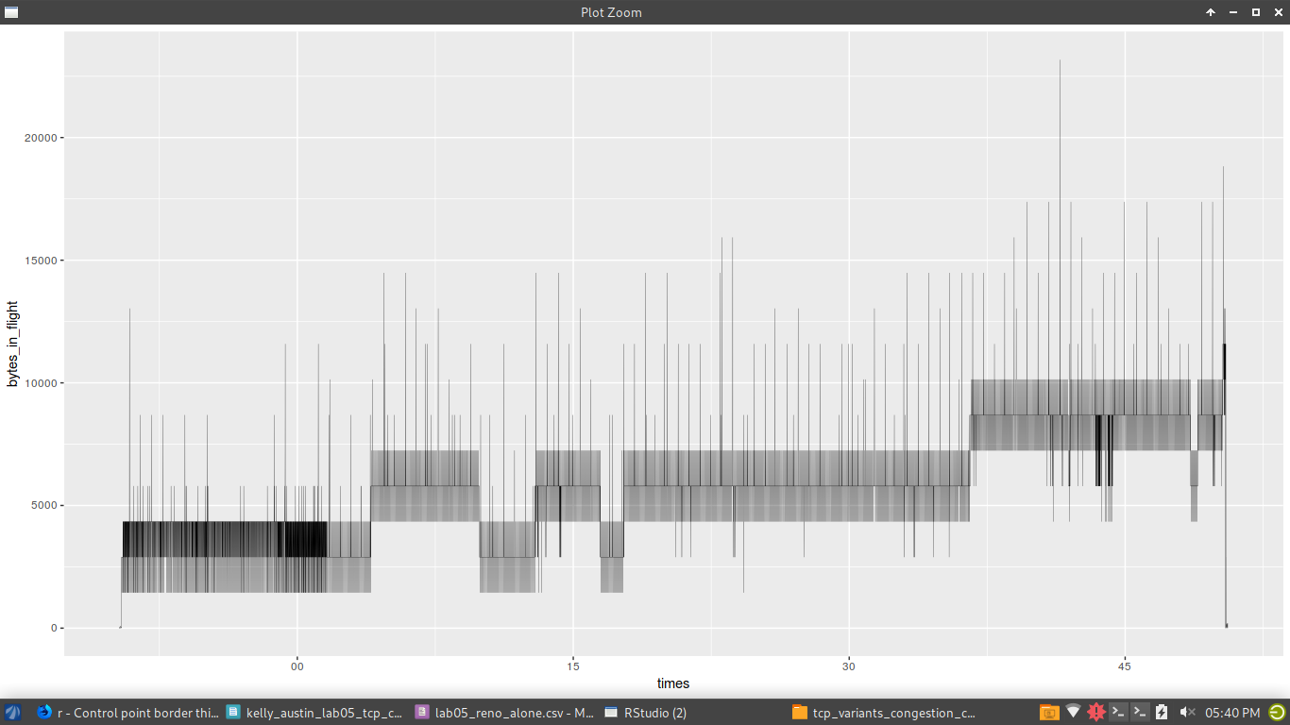

Q1. What is the mean bytes-in-flight across the entire capture length?
5766
Q2. What is the median bytes-in-flight across the entire capture length?
5792
Q3. What is the standard deviation bytes-in-flight across the entire capture length?
2066.744
Q4. What kind of trend do you notice with the bytes-in-flight over time?
There is a gradual increase overall
Q5. How many times does a congestion event happen, based on your data?
A congestion event hap pens each time there is a sudden drop in the graph
Q6. Are these congestion events sensed by timeouts or triple duplicate ACKs? How can you tell?
They are all triple duplicate ACKs because TCP Reno drops to 0 on timeouts and that only happens at the very end of the sequence.
Q7. Based on the experiment setup, what is the cause of congestion?
As this is on its own, there isn’t much congestion other than the natural progression of the congestion windows

Part 3: TCP Reno and UDP
Start Wireshark and start a capture on interface h2-eth1.

Start iperf3 servers on the xterms for h2 and h4.

Get ready to start iperf3 clients in the xterms for h1 (client of h2) and h3 (client of h4). Configure the iperf3 clients to run for 60 seconds (use the man command if you don’t know how to do this: man iperf3). The iperf3 client on h3 should use UDP rather than TCP. Start the iperf3 clients as simultaneously as possible.

When both clients have finished, stop capturing on Wireshark.

When both clients have finished, stop capturing on Wireshark. Now, use Wireshark to filter the TCP conversation by right clicking on one of the TCP packets that have been generated and selecting “Conversation Filter” > “ F5 TCP” and save your capture session as lab05_reno_udp.pcapng.

Run the following in the terminal

sudo tshark –r lab05_reno_udp.pcapng –t ad –T fields –E separator=, -e frame.time -e tcp.analysis.bytes_in_flight > lab05_reno_udp.csv

The bytes-in-flight refers to the number of bytes a TCP sender actually sent over the line. Remember, this is determined by cwnd and rwnd.

Use RStudio (or another data analysis and graphing tool) to create a line graph of packet size over time with lab05.csv. Label the x-axis as “Time (s)” and the y-axis as “Bytes in flight.”

Q8. Paste an image of the graph below:

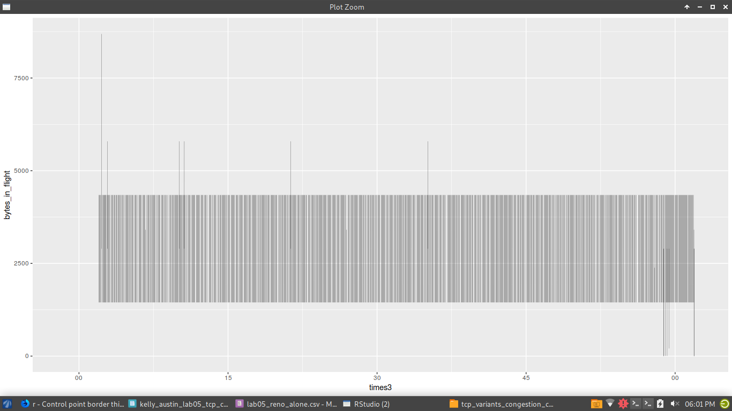

Q9. What is the mean bytes-in-flight across the entire capture length?
2890
Q10. What is the median bytes-in-flight across the entire capture length?
2896
Q11. What is the standard deviation bytes-in-flight across the entire capture length?
434.4423
Q12. What kind of trend do you notice with the bytes-in-flight over time?
Based on my plot, it stays generally the same.
Q13. How many times does a congestion event happen, based on your data?
Every time there is a sudden drop in the plot. Only from the TCP elements
Q14. Are these congestion events sensed by timeouts or triple duplicate ACKs? How can you tell?
There mostly seem to be triple duplicate ACKS, but there are a few timeouts near the end where the bytes drop to 0.

Q15. Based on the experiment setup, what is the cause of congestion
UDP doesn’t have congestion control, but TCP is affected by the conflicting traffic
Q16. At what time was congestion first detected? Write the timestamp associated.
2018 21:58:58.551300303 MST
Q17. How long did it take to recover from the first congestion event? How can you tell?
The first example is when the CSV indicates 37 bytes at 2018 21:58:58.550692348 MST and 1 at 2018 21:58:58.551300303 MST. This is roughly 0.000607955
Q18. Describe any differences in the number and types of congestion events that occur in Part 2 and Part 3.
Based on my graph, The UDP/TCP graph is more consistent and contains more timeouts near the end.

Part 4: TCP Reno and another TCP Reno stream
Start Wireshark and start a capture on interface h2-eth1.
Start Wireshark and start a capture on interface h4-eth1.

Start iperf3 servers on the xterms for h2 and h4.

Get ready to start iperf3 clients in the xterms for h1 (client of h2) and h3 (client of h4). Configure the iperf3 clients to run for 60 seconds (use the man command if you don’t know how to do this: man iperf3). The iperf3 client on h3 should use TCP. Start the iperf3 client on h1 and then about 10 seconds later, start the iperf3 client on h3.

When both clients have finished, stop capturing on Wireshark on both h2 and h4.
Now, use Wireshark to filter the TCP conversation by right clicking on one of the TCP packets that have been generated and selecting “Conversation Filter” > “ F5 TCP” and save your capture sessions as lab05_reno_h1.pcapng and lab05_reno_h3.pcapng.

Run the following in the terminal on h2:

sudo tshark –r lab05_reno_h1.pcapng –t ad –T fields –E separator=, -e frame.time -e tcp.analysis.bytes_in_flight > lab05_reno_h1.csv

Run the following in the terminal on h4:

sudo tshark –r lab05_reno_h3.pcapng –t ad –T fields –E separator=, -e frame.time -e tcp.analysis.bytes_in_flight > lab05_reno_h3.csv

The bytes-in-flight refers to the number of bytes a TCP sender actually sent over the line. Remember, this is determined by cwnd and rwnd.

Use RStudio (or another data analysis and graphing tool) to create a line graph of packet size over time with with two lines; one line corresponds to data from lab05_reno_h1.csv and one line corresponds to data from lab05_reno_h3.csv. Label the x-axis as “Time (s)” and the y-axis as “Bytes in flight.” Include a legend that labels each of the two lines.

Q19. Paste an image of the graph below:
H1
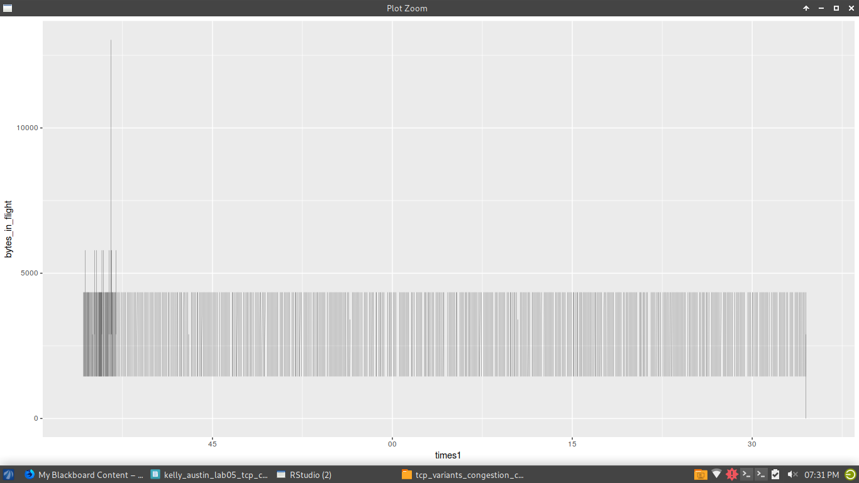
H3
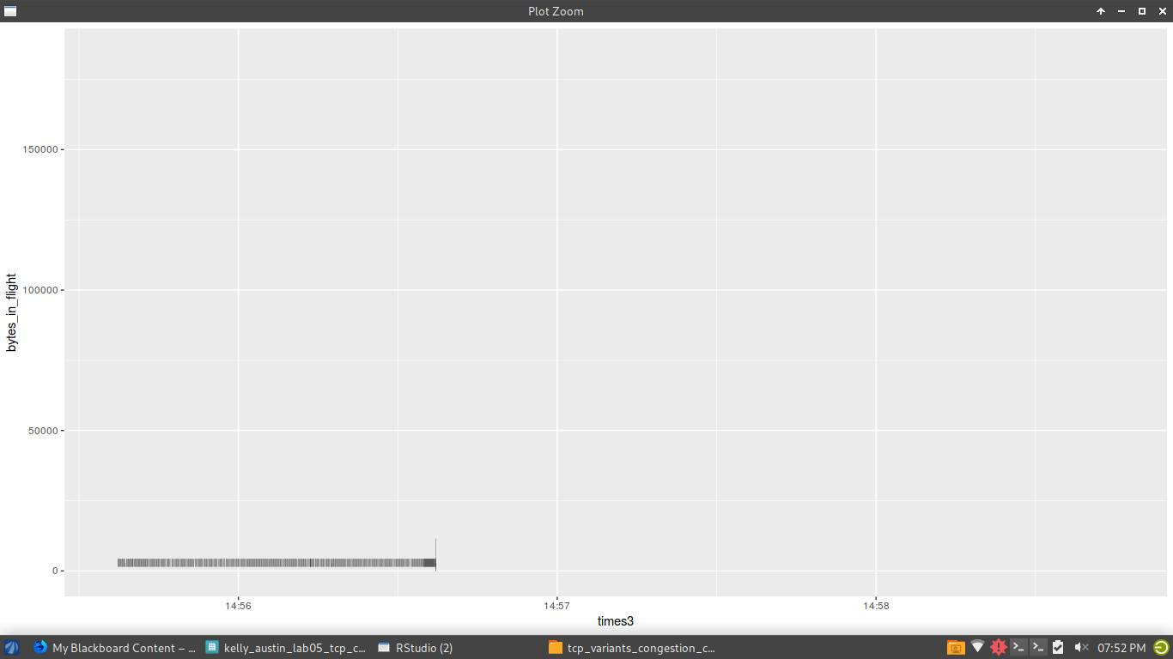

Q20. What is the mean bytes-in-flight for the h1 stream?
2907
Q21. What is the mean bytes-in-flight for the h3 stream?
3331
Q22. What is the median bytes-in-flight for the h1 stream?
2896
Q23. What is the median bytes-in-flight for the h3 stream?
2896
Q24. What is the standard deviation bytes-in-flight for the h1 stream?
478.6579
Q25. What is the standard deviation bytes-in-flight for the h3 stream?
7362.009
Q26. What kind of trend do you notice with the bytes-in-flight over time for both streams in relationship to each other?
Although they were supposed to be exactly simultaneous, you can see the difference in each line, at the beginning of h1 and end of h3, when they start and stop conflicting. Overall they both follow the same general path, yet h3 is much more spread out which can also be determined by its much higher standard deviation.
Q27. Describe differences you observe between the flow you observed in Q8 and the flows you observe in Q19.
Although it is difficult to visualize, we can see timeouts in the graph from Q8 and it keeps a more consistent flow than Q19. There seems to be a similar steady flow to be followed with each graph overall, but the times of congestion events, and patterns differentiate more

