A partnership prospectus
The Pet Page
Local newspapers, local shelters, and a better world for pets
Mars Petcare · The Middleburg Page · Fauquier Times · The Georgetowner
In partnership with the Middleburg Humane Foundation

Prepared by The Middleburg Page · The Plains, Virginia · July 2026

The partnership
Mars Petcare and three community newspapers are running a twelve-month test of a simple proposition: that local news organisations can carry a national brand’s message further, and more credibly, than the brand can carry it alone — and that doing so can fund the journalism and the shelters at the same time.
Once a month, a full page appears in the Fauquier Times and The Georgetowner. One half is a reported animal rescue story from the Middleburg Humane Foundation. The other half explains how Mars makes its pet food and the science behind it. Along the bottom runs a row of eight reader-submitted pet photographs, each paid for by the family whose pet appears.
The page is produced by The Middleburg Page, which also acts as central syndicator for community newspapers elsewhere in the country that adopt the model.

At a glance
Term | Twelve months, one full page per month
Commitment | $15,000 for the year, payable to States News Service
Launch | Timed to Mars Global Adoption Weekend
Print | Fauquier Times and The Georgetowner — plus the Georgetowner’s ‘In Country’ section
Rescue partner | Middleburg Humane Foundation
Rescue reporting | Dana Priest, Pulitzer Prize winner, Washington Post
Formats | Print page, phone, web, postcard, and 9:16 video — all from one source
Expansion | Syndicated to community papers near Mars sites, via state press associations

Why it works
Mars’s corporate message is that Mars is local. That claim cannot be proved by a national buy — a network spot announcing that you are local argues against itself. But the same sentence, printed in the Fauquier Times next to the school board coverage and a story about a dog somebody in town actually adopted, is not an argument. It is a demonstration.
There are hundreds of community newspapers in hundreds of communities, and every one of them has a local animal rescue organisation and a local pet food store. Mars has 38 factories across the United States and a presence in 49 states. Those two maps overlap almost everywhere.

The partners
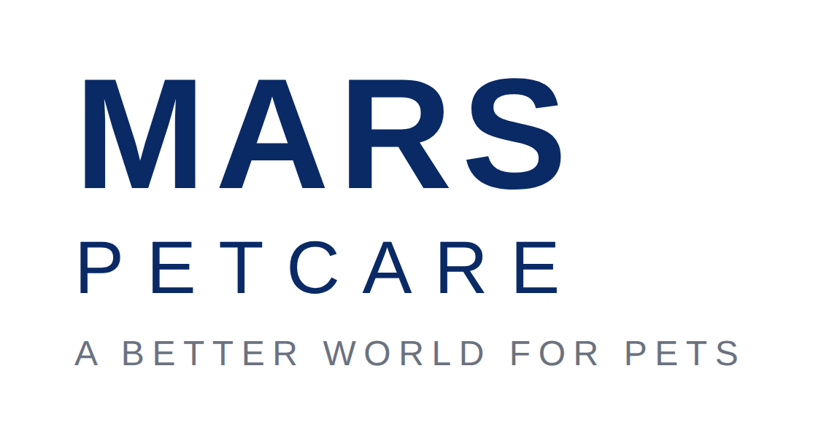
Mars, Incorporated is a family-owned business with more than 150,000 associates worldwide. Mars Petcare is its largest segment: over 100,000 associates in more than 130 countries, a portfolio that includes PEDIGREE, WHISKAS, IAMS, EUKANUBA, ROYAL CANIN, CESAR, SHEBA, TEMPTATIONS, GREENIES, NUTRO, ORIJEN and ACANA, and a veterinary network of roughly 3,000 clinics caring for more than 35 million pets a year.
Its stated purpose is A BETTER WORLD FOR PETS — a world where they are healthy, happy and welcome. Mars is the national partner and the source of the science and company content on the page.

The Middleburg Page was started to test whether particular groups of readers would rally around, and fund, particular beats of coverage. It is published by Leland Schwartz from The Plains, Virginia, and printed inside the Fauquier Times and The Georgetowner.
In this partnership it is the publisher, the editorial producer, and the central syndicator for papers that adopt the model elsewhere.
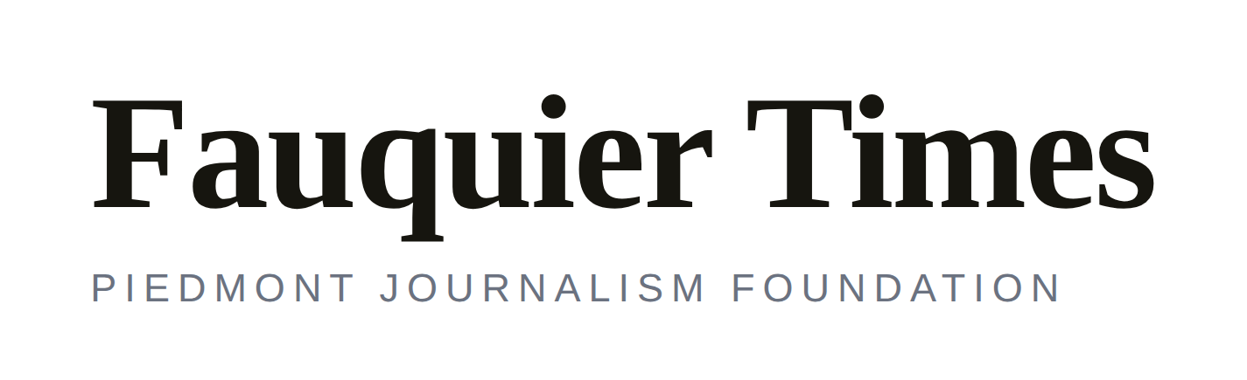
The Fauquier Times serves Fauquier County and the surrounding Virginia Piedmont. It is published by the Piedmont Journalism Foundation, a nonprofit — a structure that makes the community-service argument for this page unusually easy to make to a board.
It is the primary print partner and the paper of record for the rescue reporting.
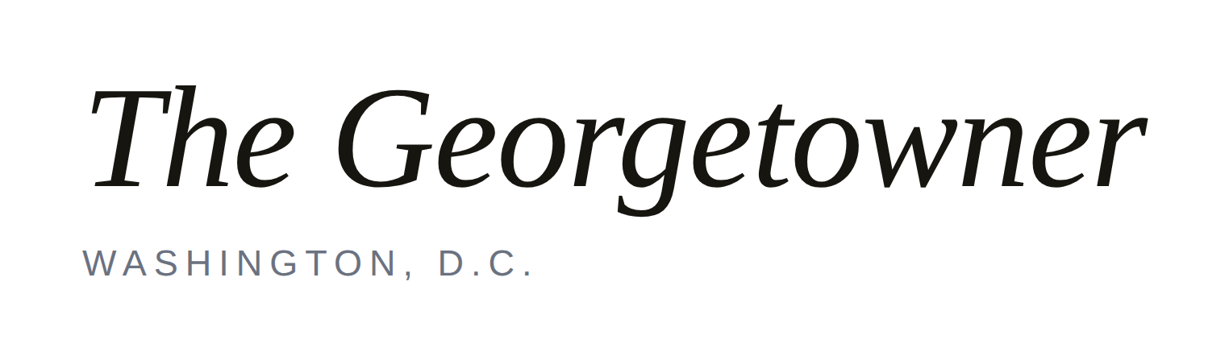
The Georgetowner has covered Washington, D.C. for decades and carries the page into the capital through its ‘In Country’ section — part of a deliberate effort to build a news, events and advertising bridge between Hunt Country and Washington.
It is the second print partner and the urban half of the readership.

Middleburg Humane Foundation
The rescue partner. The Foundation supplies the animals, the access and the outcomes that the reporting is built on, and receives a share of the reader revenue the page generates. Every story on the page begins in its kennels.

Mars Petcare: the content engine
Half of every page is Mars. Not advertising — reporting, about a company most readers know only as a chocolate bar, and about a body of pet science almost nobody outside the industry knows exists. This section is the raw material.

A better world for pets
Mars Petcare’s purpose statement is not a tagline invented for this campaign; it is the operating principle of the segment and the frame for everything on the Mars side of the page. Three strands run through it: what pets eat, what care they receive, and whether they have a home at all.

The Waltham Petcare Science Institute
Mars has been running pet nutrition research since the early 1950s, formalised in 1973 as a dedicated institute at Waltham on the Wolds in Leicestershire, England. It studies the nutrition and wellbeing of dogs, cats, horses and fish, and the benefits of pets to people. Its findings underpin PEDIGREE, ROYAL CANIN, WHISKAS, CESAR, NUTRO and SHEBA.
The institute has produced discoveries that are genuinely interesting to a general reader — which is precisely what makes them good newspaper stories:
- Working with the Monell Chemical Senses Center, Waltham scientists established in 2005 that cats cannot taste sweetness at all, because of a defective gene — a trait shared by every wild feline.
- With the National Human Genome Research Institute, they showed in 2007 that the enormous variation in dog size traces largely to mutations in a single gene, IGF-1.
- They developed diets targeting cancer and heart disease in 2001, and an arthritis formulation using green-lipped mussel in 2002.
- In 2016 they demonstrated that cats select food by macronutrient ratio rather than by flavour.
The institute also publishes Veterinary Focus, distributed internationally to practising vets in multiple languages.

The Global Innovation Center, Thompson’s Station, Tennessee
Mars Petcare’s $110 million research campus sits half an hour from Nashville and forty minutes from its North American headquarters in Franklin. It houses a Pet Feeding Center with capacity for up to 180 dogs and 120 cats, and serves as the global centre of excellence for dry cat and dog food across PEDIGREE, WHISKAS, ROYAL CANIN, IAMS and Banfield. Roughly 140 scientists and technicians work there.

Mars Veterinary Health
Banfield Pet Hospital, VCA Animal Hospitals, BluePearl, AniCura, Linnaeus and Antech Diagnostics together form the largest veterinary network in the world — about 3,000 clinics seeing more than 35 million pets a year. For a page about responsible pet ownership, this is an unusually deep bench of expertise to draw on, and it is local in a way readers can verify: most American towns have one of these clinics.

Pet homelessness and adoption
Mars runs the State of Pet Homelessness Project, described as the largest international study of pet homelessness yet undertaken, and holds an annual Mars Pet Adoption Weekend — now expanded into a global event — during which Mars and partner organisations cover adoption fees at participating shelters. Launching this series against that weekend gives every participating newspaper a national hook with a local answer: here are the animals in your town whose fees are covered this weekend.

The twelve-month editorial calendar
Each issue pairs a reported rescue story with a Mars science or company story. The rescue side is reported independently; the Mars side is developed jointly and approved by Mars. Subjects may move as news dictates — this is a plan, not a contract.
# | Month | Rescue story — reported locally | Mars story — developed jointly
1 | Sept | Tanner: the blind husky who went home to a husky and five cats | Who Mars actually is — 38 factories, 49 states, family-owned, and closer than you think
2 | Oct | Adoption weekend: the animals whose fees are covered | The State of Pet Homelessness Project — what the largest study of its kind found
3 | Nov | The foster network: the people who take them home first | What is actually in the bowl — seventy years of nutrition research at Waltham
4 | Dec | The senior dogs nobody adopts | Feeding an older animal: how nutritional needs change with age
5 | Jan | The surrender: why people give a pet up, and what happens next | The first thirty days — what a newly adopted animal needs
6 | Feb | The medical cases: what a shelter can and cannot afford | Dental health month — the science of plaque, and why it matters more than owners think
7 | Mar | Cats: the hardest animals in the shelter to place | Why cats cannot taste sweetness — the Waltham and Monell discovery
8 | Apr | The volunteers: an unpaid workforce holding it together | Preventive care, and what 35 million annual patient visits teach you
9 | May | Big dog, small dog: the ones overlooked by size | IGF-1 — how one gene explains the range from chihuahua to mastiff
10 | Jun | Summer: the season shelters dread | Heat, hydration and the animals that cannot tell you they are struggling
11 | Jul | Working animals: barn cats, farm dogs, and Hunt Country | Pets at work — inside a company that brings dogs to the office
12 | Aug | One year on: where they all ended up | What a year of this taught us, and what happens next

The first page
Issue one carries the launch explanation on the Mars side — what the partnership is and why it exists — alongside a company profile establishing Mars’s size, workforce, footprint and local presence. It is the page that makes ‘closer than you think’ concrete, and it is the page every other newspaper will be shown when we ask them to join.

One story, five formats
A newspaper page is a PDF, and a PDF on a telephone is unreadable — readers pinch, zoom, and give up. So the printed page is not the source. The story is written once as structured content, and the print page, the phone view, the web page, the postcard and the video are all generated from it. Nothing is retyped and nothing drifts out of sync.
Format | Specification | What it is for
Print page | 9.5 × 10.5 in live space; strip ad 9.5 × 1.25 in; 600–1200 DPI | The page of record, in the Fauquier Times and The Georgetowner
Phone | Single column, mobile-first | Where most readers will actually read it — the primary render, not the leftover
Web | Responsive; two columns above 900 px | The jump page for stories that run long — and the only render producing hard traffic numbers
Postcard | 6 × 4.25 in trim; 0.125 in bleed; 0.25 in safe zone; CMYK | Counter hand-outs for local pet food stores, and USPS direct mail
Video | 1080 × 1920, 9:16, captions burned in | Instagram Reels and Shorts — the format that produces the numbers a sponsor can verify

On the video
The animated portions cover only what could not be filmed — an animal’s life before rescue, for which no footage exists. Everything from the moment of rescue onward is real. The two registers are visibly different, so nothing animated can be mistaken for documentary. Animation is used to fill a genuine gap in the record, not to decorate footage that is already true.

Editorial standards
A sponsored page carrying reported journalism works only if the wall between the two is explicit. This is the standard, and it is printed on the page itself, in the same size type as everything else.
PRINTED ON EVERY PAGE
“Mars Petcare funds this page and reviews only its own company content. The Middleburg Page retains full editorial control of all rescue reporting.”

What this means in practice
- Mars approves Mars’s own content — the science, the company profile, the brand references, the strip advertisement.
- Mars sees the rescue reporting when readers do. It has no review, no approval and no notes on that half of the page.
- The disclosure appears on the printed page, on the web page, and in the video description. It is not a footnote.
- Reader photograph slots are clearly identified as reader-funded, with the amount stated on the page.
- Any partner newspaper adopting this model adopts this standard with it. It is a condition of the syndication, not a suggestion.
This is not a courtesy to the sponsor. It is the thing that lets the page exist at all. Disclosed plainly, it is a model any editor can defend to any board. Left implicit, it is a liability that travels with every copy printed — and it would put a Pulitzer Prize winner’s byline at risk to save a line of type.

Beyond Middleburg
The Fauquier pilot is worth doing on its own terms. But the reason to build it carefully is that the same page can run in any community that has a newspaper, a shelter and a pet food store — and Mars has facilities in most of them.

How the syndication works
The expensive, specialised work happens once, centrally: the Mars science story, the design system, the five output renders, the postcard artwork, the disclosure standard. Each participating paper supplies only what is genuinely local — its shelter, its rescue story, its reader photographs, its pages. The marginal cost of adding the fiftieth newspaper is close to nothing.

The map
Mars operates 38 factories in the United States and maintains a presence across 49 states, plus veterinary clinics, laboratories and regional offices. A prospecting list has been built against those locations, tiered by fit. The strongest candidates are small towns where a Mars plant is a major employer and an independent weekly still publishes — Aurora, Nebraska; North Sioux City, South Dakota; Lewisburg, Ohio; Temple, Texas — each of which closely resembles the Middleburg situation.
Two markets matter more than the rest: McLean, Virginia, where Mars has its global headquarters, and Franklin, Tennessee, where Mars Petcare has its North American headquarters. A page running in Mars’s own two hometown papers would be the most persuasive proof the campaign could have.

The route
- The Virginia Press Association, whose new executive director has been approached, and its 49 counterpart associations in other states.
- The National Newspaper Association, for the national layer.
- A joint press release from Mars and the partner papers, tied to the ‘Closer Than You Think’ campaign. This is the single asset that turns a cold approach into an invitation to join something already under way.

What we are asking Mars for
- The map or list of Mars facilities, so we can identify every community newspaper within reach of one.
- Agreement in principle to the joint press release.
- Approved brand assets — logos, the strip advertisement artwork, and the brand guidelines governing their use.
- A single point of approval for the Mars content, so twelve pages do not require twelve separate review cycles.

What we pay
These are the terms. They are fixed, they are the same for every newspaper that joins, and they are not negotiated market by market — a partner paper should be able to read this page once and know exactly what it is being offered.

What a partner newspaper receives
Item | Cost to the paper | Notes
The monthly Mars story, written and fact-checked | No charge | Supplied ready to run
The page template and all five output renders | No charge | Print, phone, web, postcard, video
Press-ready postcard artwork | No charge | Paper covers its own printing
The reader photo sell sheet and order form | No charge | Ready to hand to an ad rep
The editorial disclosure standard | No charge | Required, not optional
Syndication fee to The Middleburg Page | $0 — first year | No revenue share taken in year one

What the paper keeps
Revenue | Rate | Who keeps it
Reader pet photograph slots | $375 each | The paper keeps 100%
Slots available per page | 8 | —
Gross per issue at full sell-through | $3,000 | Before local costs
Recommended share to the local shelter | 25% | Paid by the paper, locally
Gross over twelve issues | $36,000 | At full sell-through

The Middleburg pilot, for reference
Mars committed $15,000 for the first year in Fauquier — $1,250 an issue. That national sponsorship is what funds the central content production every partner paper receives free. It is not a payment a partner paper should expect to receive directly, and the model is deliberately built so that it does not need to: at $375 a slot, eight slots a page, the reader revenue alone is roughly double the national sponsorship.
THE POINT
If the page only works when a national brand is paying, it is not a business — it is a favour, and it ends when the sponsorship does. Built on reader revenue, it stands on its own, and national sponsorship becomes upside rather than life support.

Rates to confirm before circulation: the $375 slot price and the 25% shelter share are the Middleburg figures. Set them to whatever you want every partner paper to run, then delete this line.

Contacts
Partner | Contact
Mars Petcare | Ben Anders — Ben.Anders@effem.com · Lindsay Kordik — lindsay.kordik@effem.com
The Middleburg Page | Leland Schwartz, Publisher — editor@themiddleburgpage.com · 540 422 1376  7170 Beverly Lane, The Plains, Virginia 20198
Fauquier Times | Kelly Tremaine — ktremaine@fauquier.com
The Georgetowner | Sonya Bernhardt — sonya@georgetowner.com
Rescue reporting | Dana Priest — Pulitzer Prize winner, board member, Piedmont Journalism Foundation
Public relations | Vicki Bendure — vicki@bendurepr.com
Social media | Red Thinking — shay@redthinkingllc.com

A note on the logos in this document. The partner marks shown here are typographic placeholders set for layout purposes only. Final artwork should be supplied by each partner — in particular, Mars brand assets and their permitted usage must come from Mars and be applied in accordance with Mars brand guidelines before this document or any page is published.

There are hundreds of local papers in hundreds of communities, and every single one has a local animal rescue organization. If we can’t deliver that, who can?
Leland Schwartz

