
End-to-End Techniques for Improving Sustainable Throughput in High-Concurrency Java Microservices


August 20, 2026
Lok Shang Ru
TP054534

Contents
Abstract 2
1. Introduction 3
2. Research Background 4
2.1. What Existing Research Shows 4
2.2. What Is Missing 4
2.3. How This Project Responds 4
3. Problem Statement 6
4. Research Questions 7
5. Aim and Objectives 8
5.1. Research Aim 8
5.2. Research Objectives 8
6. Scope of the Research 9
7. Significance of the Research 10
8. Research Methodology 11
8.1. Research Design 11
8.2. Experimental System and Setup 12
8.3. Experimental Configurations 13
8.4. Experimental Procedure 15
8.5. Measurement and Data Analysis 16
8.6. Experimental Results 17
8.6.1. C0 Synchronous Database Baseline 17
8.6.2. C1 Kafka-Based Sequential Processing 17
8.6.3. C2 In-Memory Order Matching 18
8.6.4. C3 Redis-Based Reservation 18
8.6.5. Overall Comparison 19
8.7. Discussion of Findings 20
8.8. Experimental Reliability and Limitations 21
9. Research Plan 22
10. Summary 23
11. References 24

Abstract
High-concurrency transaction-processing systems must complete transactions reliably rather than only accept requests quickly. This project investigated how staged architectural improvements affected the sustainable completed transactions per second (TPS) of Exchange Lab, a Java backend modelled on a stock exchange. A controlled quantitative experiment compared four configurations under consistent workload and measurement conditions: a synchronous MySQL baseline, Kafka-based sequential processing, in-memory order matching, and Redis-based cash and stock reservation. A rate was considered sustainable only when at least 98% of accepted asynchronous orders settled within the 30-second measurement window, the drain left zero unfinished work and zero Kafka lag, no request or iteration failed, and the database and Redis state remained correct. The highest sustainable target increased from 25 TPS for the baseline to 30 TPS with Kafka, 35 TPS with in-memory matching, and 55 TPS with Redis reservation, producing a 120% overall increase. Redis reservation delivered the largest incremental improvement, while each preceding change exposed a new bottleneck elsewhere in the transaction path. The findings demonstrate the value of evaluating end-to-end completion and correctness after every performance change. Although the measured limits apply only to Exchange Lab, its synthetic workload, and the selected local environment, the experiment provides a repeatable approach for evaluating throughput improvements in transaction-processing systems.

1. Introduction
Modern software systems often need to handle many requests at the same time. When demand increases, the system may become slow, return errors, or stop processing work reliably. Achieving high concurrency therefore means more than accepting a large number of requests. The system must complete a high volume of transactions consistently and continue doing so under sustained demand.

Many areas of a system can be improved to increase TPS, including the application, database, cache, messaging service, network, and use of computing resources. Each area offers different performance techniques, but their value depends on the system and workload. These techniques are tools for increasing TPS; they are not the final goal. Although this project evaluates one Java transaction-processing system, the general improvement approach may also be useful for systems developed with other languages and technologies. The experimental findings remain limited to the selected system.

The selected experimental system is Exchange Lab, a backend system modelled on a stock exchange. It supports limit buy and sell orders, in which a trader specifies the stock symbol, quantity, and maximum buying price or minimum selling price. Processing an order may require the system to reserve the trader's cash or stock, match compatible orders by price and submission time, record the resulting trade, and settle the affected balances. The system is used as a transaction-processing testbed; the research does not attempt to reproduce every function of a commercial stock exchange.

This research measures the system's baseline TPS and evaluates Kafka, in-memory matching, and Redis reservation one at a time. Each configuration was tested using the same workload and pass rules to show how far sustainable completed TPS increased within the defined environment. Latency, errors, unfinished work, and correctness are used to confirm that a higher TPS remains stable and meaningful. The following sections explain the research background, problem, questions, aim, objectives, scope, and significance before presenting the methodology, results, and research plan.

2. Research Background

2.1. What Existing Research Shows
Previous research shows that high concurrency depends on the complete system, not one programming feature or service. Studies have tested application-level concurrency, caching, asynchronous processing, traffic management, scaling, and overload control. Their results show that these techniques can improve performance, but their value changes with the workload, framework, system structure, and available dependency capacity (Henning & Hasselbring, 2024; Navarro et al., 2023; Xing et al., 2025; Zhang et al., 2024). The practical value of a technique depends on whether it produces a measurable increase in sustainable completed TPS in the system being tested.
These findings also show why a technique cannot be judged by its description alone. Increasing request concurrency helps only while the rest of the system can process the additional work. Caching or asynchronous processing may reduce immediate work, but completed TPS still depends on the full transaction path. The system must therefore be measured as a whole.

2.2. What Is Missing
Existing studies use different applications, environments, workloads, test durations, and performance measurements. Many evaluate one component in isolation and report a local improvement without showing the effect on the complete request path. An improvement may therefore move the bottleneck instead of increasing completed end-to-end throughput (Meijer et al., 2024). The available evidence does not clearly show how far sustainable completed TPS can be increased when relevant improvements are selected from system measurements and applied iteratively across the same Java transaction-processing system under consistent conditions.
Developers therefore have many possible techniques but limited guidance on which ones produce the largest gain in a particular system. A controlled end-to-end test is needed to connect each applied change to a measurable difference in TPS.

2.3. How This Project Responds
This project uses one Java transaction-processing system, a consistent workload, and the same measurements across all tests. It establishes the baseline, adds Kafka, in-memory matching, and Redis reservation separately, and retests the system after each change. The purpose is to determine how each technique affects sustainable completed TPS while latency, errors, unfinished work, and correctness remain acceptable.

A change is considered useful only when it increases sustainable TPS for the complete system. This keeps the project focused on the final result rather than the number or complexity of the techniques used.

3. Problem Statement
Many areas of a high-concurrency Java transaction-processing system can be improved to increase throughput. The problem is how to identify and apply the most effective improvements across the system to push sustainable completed TPS as high as possible.

The practical problem is not a shortage of performance techniques. It is determining which techniques genuinely raise the completed transaction rate of the selected system. Without a consistent baseline and repeated testing, an apparent improvement may only shift waiting work elsewhere or produce a short-lived peak that cannot be sustained.

Different parts of the system offer different opportunities for improvement. However, a technique that improves one system or workload may provide little benefit in another, and improving one area may change the behaviour of the remaining system. Each change must therefore be selected and measured according to its effect on completed end-to-end TPS (Henning & Hasselbring, 2024; Meijer et al., 2024).

The study compares the synchronous baseline with configurations that add Kafka, in-memory matching, and Redis reservation one at a time. Its primary outcome is the highest sustainable completed TPS achieved by each configuration. Latency, errors, unfinished work, and correctness determine whether a reported improvement is valid.

4. Research Questions
The study addresses the following research questions:
1. RQ1: What TPS can the current system sustain before any improvements?
2. RQ2: Which applied techniques increase sustainable TPS, and by how much?
3. RQ3: What is the highest sustainable TPS achieved after applying the relevant improvements?

5. Aim and Objectives

5.1. Research Aim
To maximise the sustainable TPS of the selected Java transaction-processing system.

5.2. Research Objectives
The research objectives are:
1. O1: To measure the system's current sustainable TPS.
2. O2: To identify suitable techniques for increasing TPS.
3. O3: To apply the selected techniques.
4. O4: To determine the highest sustainable TPS achieved.

6. Scope of the Research
This research focuses on improving the sustainable TPS of one selected Java transaction-processing system. It establishes the system's baseline TPS, then applies and tests relevant performance techniques in the same environment. The study determines the highest sustainable TPS achieved within the available project time and resources.

The work is limited to components available in the selected system and techniques implemented during the project. The findings explain what worked under the chosen workload and environment. They are not treated as a universal configuration for every Java system.

7. Significance of the Research
This research matters because a system that sustains a higher TPS can complete more transactions during heavy demand. Measuring the complete system shows whether an improvement produces a real end-to-end gain rather than only making one component faster (Henning & Hasselbring, 2024; Meijer et al., 2024). The final result shows how far TPS increased and the conditions under which that increase remained sustainable.

The practical value is a clear record of the changes that worked in the selected system. Developers can adapt the same measurement-based process when improving similar systems. The research also extends the Assignment 1 literature review by testing relevant techniques in a working system and producing experimental evidence.

8. Research Methodology

8.1. Research Design
This research uses a simplified stock-exchange backend simulator as the environment for evaluating concurrent transaction processing. The simulator models one core exchange workflow: receiving limit buy and sell orders, reserving cash or stock, matching compatible orders, recording trades, and settling completed transactions. It does not reproduce an entire real exchange or use real money, investors, or live market data. Instead, the trading workflow provides a realistic transaction scenario whose inputs, processing stages, and final records can be repeatedly measured and verified. This experimental system is referred to as Exchange Lab.

The study uses a controlled quantitative design to determine how architectural changes affect sustainable completed transactions per second (TPS). Four system configurations are evaluated in sequence, beginning with a synchronous database baseline and then adding Kafka, in-memory matching, and Redis reservation. Every configuration performs the same limit-order transaction under the same machine, test data, workload pattern, and measurement conditions. Completed TPS is the main result, while latency, errors, unfinished work, and correctness determine whether that result is valid. Comparing each configuration with its immediate predecessor makes the effect of each major technique clearer than testing only the final system.

8.2. Experimental System and Setup

Exchange Lab is the experimental testbed. It is a Java and Spring Boot backend that supports limit buy and sell orders. A limit order specifies the trader, stock symbol, quantity, side, and price. This workflow is used because every order passes through reservation, matching, trade recording, and financial settlement, producing a complete transaction that can be measured and verified.

Figure 1. Common limit-order transaction used in every configuration.

The internal implementation changes between configurations, but the input, required business result, and test conditions remain consistent.
Item | Common experimental setup
Execution environment | Windows 11 Enterprise; AMD Ryzen 7 7800X3D; 31.1 GB RAM; OpenJDK 26.0.1 with default JVM settings
Durable data | MySQL 8.4
Supporting platforms | Kafka 4.1.0 and Redis 7.4 only when required by the configuration
Test data | The same trader accounts, stock positions, and initial sell orders
Workload | The same k6 limit-buy-order workload and controlled request-rate pattern
Measurement window | 30 seconds, followed by a 5-second drain for C1-C3
Readiness | Fresh application processes; health checks and Kafka partition assignments confirmed before testing
Observation | Accepted and completed TPS, API latency, errors, dropped iterations, unfinished work, Kafka lag, and SQL/Redis correctness checks
Table 1. Common Experimental Setup
These environment, workload, readiness, measurement, and verification conditions remain fixed across the compared configurations.

8.3. Experimental Configurations
The experiment compares four staged configurations of the same exchange system. The internal order-intake, matching, and financial-processing responsibilities remain present throughout the experiment. Each configuration changes only the performance technique being evaluated.

C0: Synchronous Database Baseline

C0 establishes the reference result. Order intake, matching, and financial processing communicate synchronously and use MySQL.
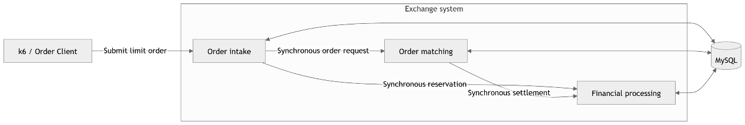
Figure 2. C0 synchronous database baseline.

C1: Kafka-Based Sequential Processing
C1 adds Kafka between order intake and matching and between matching and financial settlement. One consumer processes submitted orders sequentially.
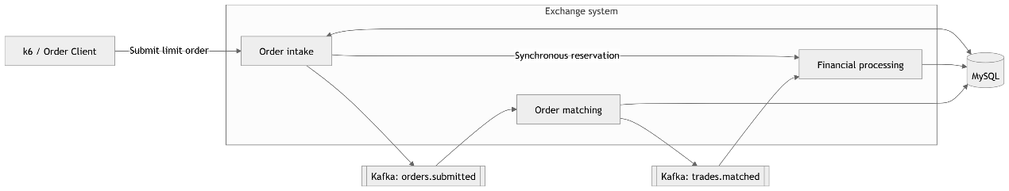
Figure 3. C1 configuration with Kafka-based sequential processing.

C2: In-Memory Order Matching
C2 retains Kafka and adds an in-memory price-time order book. MySQL continues to store orders and trades durably.
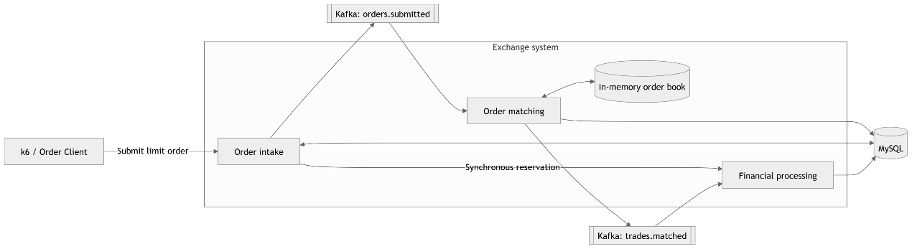

Figure 4. C2 configuration with in-memory order matching.
C3: Redis-Based Reservation
C3 retains Kafka and in-memory matching while adding Redis for atomic cash and stock reservation. MySQL remains the durable store.
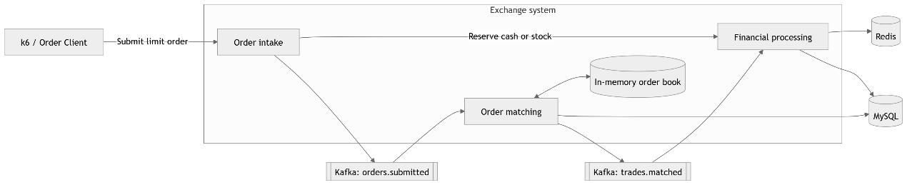
Figure 5. C3 configuration with Redis-based reservation.

8.4. Experimental Procedure
Each configuration follows the same three-phase procedure:
Figure 6. Experimental procedure used for every configuration.
Phase 1: Prepare the Configuration
- Load the required configuration from its recorded Git commit or an isolated worktree and start its required infrastructure.
- Keep MySQL and Kafka running between measured rates. Before every rate, stop the active application processes, wait until the old Kafka consumers have left their groups, confirm zero Kafka lag, reset MySQL and Redis where applicable, and load the same seed data.
- Start the single C0 application or, for C1-C3, start finance, match, and exchange services. Health endpoints alone do not prove Kafka readiness, so both new consumer groups must own their partitions with zero lag before the fixed readiness delay starts. Begin k6 only after that delay. Do not reuse any application process between measured rates.

Phase 2: Run the Load Test
- Use k6 to submit the standard limit-buy-order workload at the selected target request rate.
- Repeat the load test at each predefined request rate using the same measurement period.
- Stop new requests, allow asynchronous work to drain for the fixed period, and collect the performance measurements.

Phase 3: Verify and Record the Result
- Use SQL checks to verify cash, stock, reservations, order states, and trade records. Discard the run if the data is incorrect or the system is unstable.
- Repeat the highest passing rate at least twice under the same conditions.
- Store the verified setup and results for analysis.

8.5. Measurement and Data Analysis
The experiment uses three TPS measures. Target TPS is the request rate configured in k6. Accepted TPS is the number of orders accepted by the system per second. Completed TPS is the number of settlements completed per second and is the primary result. In this controlled workload, each accepted buy order produces one trade and one settlement.
Completed TPS is calculated from the settlement-counter increase recorded at the end of the measurement period, before the drain wait. The post-drain counter and Kafka lag are used only to record unfinished work.

A tested rate passes only when:
- Completed TPS keeps pace with accepted TPS.
- No unfinished work continues to accumulate, and the fixed drain period clears the remaining work.
- No requests or k6 iterations fail, all SQL correctness checks pass, and C3's Redis availability matches MySQL.

For asynchronous C1-C3, keeping pace means that at least 98% of accepted orders complete during the measurement period, while the drain period must leave zero unfinished orders and zero Kafka lag.
Each result row represents one tested request rate. The passing row for each configuration reports the median of its confirmation runs, while the failed row reports the nearest tested rate that did not meet the pass rules. The sustainable TPS of a configuration is the highest target rate that passes at least two repeated confirmation runs.
The improvement between consecutive configurations is calculated as follows:
TPS improvement = (new sustainable TPS - previous sustainable TPS) / previous sustainable TPS x 100%

8.6. Experimental Results
The following results show the highest passing rate and the nearest failed rate for each configuration. Detailed rate-search and confirmation runs are retained in the project records.

8.6.1. C0 Synchronous Database Baseline
The synchronous MySQL configuration was tested before Kafka, in-memory matching, or Redis reservation was added. Using 5-TPS boundary resolution, 25 TPS passed all three confirmation runs. The next tested rate, 30 TPS, completed every request but failed the cash and stock conservation checks.

Target TPS | Accepted TPS | Completed TPS | Completion ratio | p95 latency | Errors / dropped iterations | Unfinished work after drain | SQL checks | Decision
25 | 25.03 | 25.03 | 100.00% | 21.01 ms | 0 / 0 | 0 | 5/5 pass | Pass
30 | 30.00 | 30.00 | 100.00% | 19.78 ms | 0 / 0 | 0 | 3/5 pass | Fail
Table 2. C0 synchronous database baseline results.

8.6.2. C1 Kafka-Based Sequential Processing
The rebuilt three-service C1 configuration sustained 30 TPS in both confirmation runs. At 35 TPS, only 52.24% of accepted orders settled during the measurement period and unfinished order work remained after the fixed drain, so the higher rate failed.
Target TPS | Accepted TPS | Completed TPS | Completion ratio | p95 latency | Errors / dropped iterations | Unfinished work after drain | SQL checks | Decision
30 | 30.02 | 30.00 | 99.95% | 18.95 ms | 0 / 0 | 0 | 5/5 pass | Pass
35 | 35.03 | 18.30 | 52.24% | 33.83 ms | 0 / 0 | 308 | 5/5 pass | Fail
Table 3. C1 Kafka-based sequential processing results.

8.6.3. C2 In-Memory Order Matching
The rebuilt C2 configuration added a startup-rebuilt in-memory order book and sustained 35 TPS in both confirmation runs. A 40 TPS trial passed once but failed its repeatability check because only 73.67% of accepted orders settled during the measurement period. Therefore, 40 TPS was rejected.

Target TPS | Accepted TPS | Completed TPS | Completion ratio | p95 latency | Errors / dropped iterations | Unfinished work after drain | SQL checks | Decision
35 | 35.02 | 35.00 | 99.95% | 18.65 ms | 0 / 0 | 0 | 5/5 pass | Pass
40 | 40.00 | 29.47 | 73.67% | 18.27 ms | 0 / 0 | 0 | 5/5 pass | Fail
Table 4. C2 in-memory order matching results.

8.6.4. C3 Redis-Based Reservation
The rebuilt C3 configuration was tested using an automated fresh-start procedure. The procedure stopped all three applications, waited for old Kafka members to leave, reset MySQL and Redis, started fresh applications, and confirmed both Kafka partition assignments before k6. A 60 TPS run completed 96.78% in-window and therefore failed the 98% rule. The 55 TPS candidate passed twice with zero unfinished work, zero Kafka lag, and correct MySQL and Redis state.
Target TPS | Accepted TPS | Completed TPS | Completion ratio | p95 latency | Errors / dropped iterations | Unfinished work after drain | SQL / Redis checks | Decision
55 | 55.00 | 54.93 | 99.88% | 18.11 ms | 0 / 0 | 0 | 5/5 / 5/5 pass | Pass
60 | 60.00 | 58.07 | 96.78% | 17.78 ms | 0 / 0 | 0 | 5/5 / 5/5 pass | Fail
Table 5. C3 Redis-based reservation results.

8.6.5. Overall Comparison
The table compares the highest verified result for each configuration.
Configuration | Highest passing target TPS | Median completed TPS | Change from previous configuration | Finding
C0: Synchronous database baseline | 25 | 25.03 | Baseline | Verified at 5-TPS boundary resolution
C1: Kafka sequential processing | 30 | 30.00 | +19.86% | Database matching became the bottleneck above 30 TPS
C2: In-memory matching | 35 | 35.00 | +16.67% | In-memory matching improved throughput; finance database work became the next bottleneck
C3: Redis reservation | 55 | 54.93 | +56.94% | Sustained 55 TPS with zero unfinished work and correct MySQL/Redis state
Table 6. Overall configuration comparison.

8.7. Discussion of Findings
The highest sustainable target increased from 25 TPS in C0 to 55 TPS in C3, an overall increase of 120%. More importantly, every passing configuration maintained the required completion ratio, cleared unfinished work, and passed its correctness checks. The result therefore represents increased end-to-end transaction completion rather than faster request acceptance alone.

C0 established that the synchronous MySQL implementation sustained 25 TPS. Although the 30 TPS run completed its requests, it failed the cash and stock conservation checks, showing that throughput cannot be accepted when transaction correctness is lost. C1 raised the verified result to 30 TPS by separating order intake, matching, and settlement through Kafka. Its 35 TPS run accumulated unfinished matching work, indicating that database-backed matching had become the next bottleneck.

C2 increased sustainable throughput to 35 TPS after moving price-time order matching into memory. The failed 40 TPS repetition showed that faster matching alone did not allow the remaining financial processing to keep pace. C3 then moved cash and stock reservation to Redis and produced the largest incremental improvement, reaching 55 TPS. At 60 TPS, the system eventually drained its work but completed only 96.78% within the measurement window, below the required 98%; therefore, 55 TPS remained the sustainable boundary.

The findings answer the research questions directly:
Research question | Answer from the experiment
RQ1: Baseline sustainable TPS | The synchronous C0 configuration sustained 25 TPS.
RQ2: Effective techniques and improvement | Kafka increased median completed TPS by 19.86%, in-memory matching by 16.67%, and Redis reservation by 56.94% over the preceding configuration.
RQ3: Highest sustainable TPS | C3 achieved the highest verified target of 55 TPS, with median completed throughput of 54.93 TPS.
Table 7. Research questions and experimental answers.

8.8. Experimental Reliability and Limitations
The comparison was made repeatable by using the same machine, seed data, workload, measurement period, and pass rules for every configuration. Application processes, MySQL test data, and Redis state where applicable were reset before each measured rate, and the highest passing asynchronous rate was confirmed twice. Completed settlements were measured instead of accepted requests, while the completion ratio, Kafka lag, errors, and SQL/Redis checks prevented queued or incorrect work from being reported as sustainable throughput.

The experiment used only synthetic accounts, balances, stock positions, and orders; it involved no human participants, personal data, real money, or live market activity. Its results are limited to Exchange Lab, the selected workload, one local machine, and 30-second measurement windows. The reported TPS values therefore support comparison between C0-C3 but should not be treated as universal limits for Java, Kafka, Redis, MySQL, or commercial exchanges.

9. Research Plan
The project activities are organised across six weeks, as shown in the Gantt chart below.
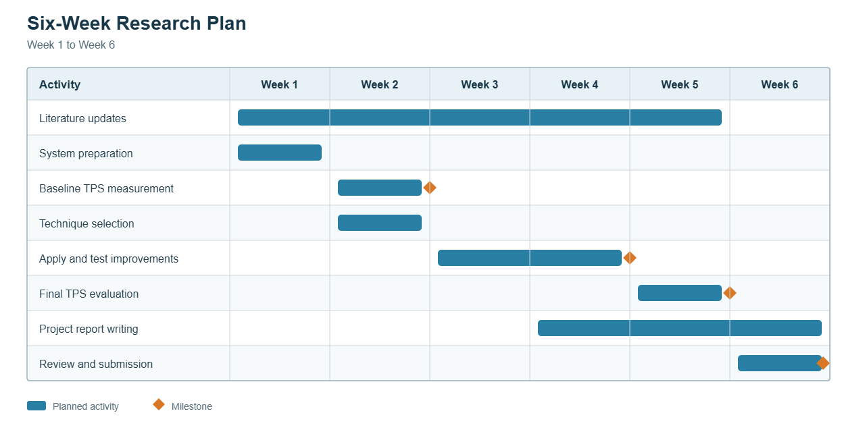
Figure 7. Six-week research plan from preparation through review and submission.

10. Summary
This project examined how staged architectural improvements affected the sustainable completed TPS of Exchange Lab, a Java transaction-processing system modelled on a stock exchange. A controlled quantitative experiment compared four configurations under consistent conditions: a synchronous MySQL baseline, Kafka-based sequential processing, in-memory order matching, and Redis-based reservation. Each configuration was evaluated using completed TPS, completion ratio, latency, errors, unfinished work, Kafka lag, and data-correctness checks so that queued or incorrect transactions were not reported as successful throughput.

The highest sustainable target increased from 25 TPS in C0 to 30 TPS in C1, 35 TPS in C2, and 55 TPS in C3. This represents a 120% increase over the baseline, with Redis reservation producing the largest incremental improvement. The findings also showed that each change moved the performance constraint to another part of the transaction path, confirming the importance of measuring the complete system after every improvement. Although the measured limits apply only to Exchange Lab and its controlled test environment, the project provides a repeatable approach for selecting, applying, and evaluating throughput improvements while preserving transaction correctness.

11. References
Henning, S., & Hasselbring, W. (2024). Benchmarking scalability of stream processing frameworks deployed as microservices in the cloud. *Journal of Systems and Software, 208*, Article 111879. https://doi.org/10.1016/j.jss.2023.111879

Meijer, W., Trubiani, C., & Aleti, A. (2024). Experimental evaluation of architectural software performance design patterns in microservices. *Journal of Systems and Software, 218*, Article 112183. https://doi.org/10.1016/j.jss.2024.112183

Navarro, A., Ponge, J., Le Mouël, F., & Escoffier, C. (2023). Considerations for integrating virtual threads in a Java framework: A Quarkus example in a resource-constrained environment. In *Proceedings of the 17th ACM international conference on distributed and event-based systems* (pp. 103-114). ACM. https://doi.org/10.1145/3583678.3596895

Xing, J., Giannoukos, A., Loh, P., Wang, S., Qiu, J., Demoulin, H. M., Kallas, K., & Lee, B. C. (2025). Rajomon: Decentralized and coordinated overload control for latency-sensitive microservices. In *22nd USENIX symposium on networked systems design and implementation (NSDI 25)* (pp. 21-36). USENIX Association. https://www.usenix.org/conference/nsdi25/presentation/xing

Zhang, H., Kallas, K., Pavlatos, S., Alur, R., Angel, S., & Liu, V. (2024). MuCache: A general framework for caching in microservice graphs. In *21st USENIX symposium on networked systems design and implementation (NSDI 24)* (pp. 221-238). USENIX Association. https://www.usenix.org/conference/nsdi24/presentation/zhang-haoran

