* Create a Repository in GitHub
* Add your Project Code
* To check the shared runner
  + Go to Actions
  + Click on Configure on Java with Maven Template
  + It creates .github/workflows folder with the yaml file
  + Go through the file and remove optional code
  + Commit the Changes
  + Job should trigger and completes successfully
* To run on our own Runner
  + Click on Actions 🡪 Settings
  + Left side click on Actions 🡪 Runners
  + Click on New Self Hosted Runner
  + Select Runner Image as Linux
  + Create AWS EC2 Instance with
    - Ubuntu AMI
    - t2.medium
    - 25 GiB Disk Space
    - Make sure below inbound rules are added to Security Group

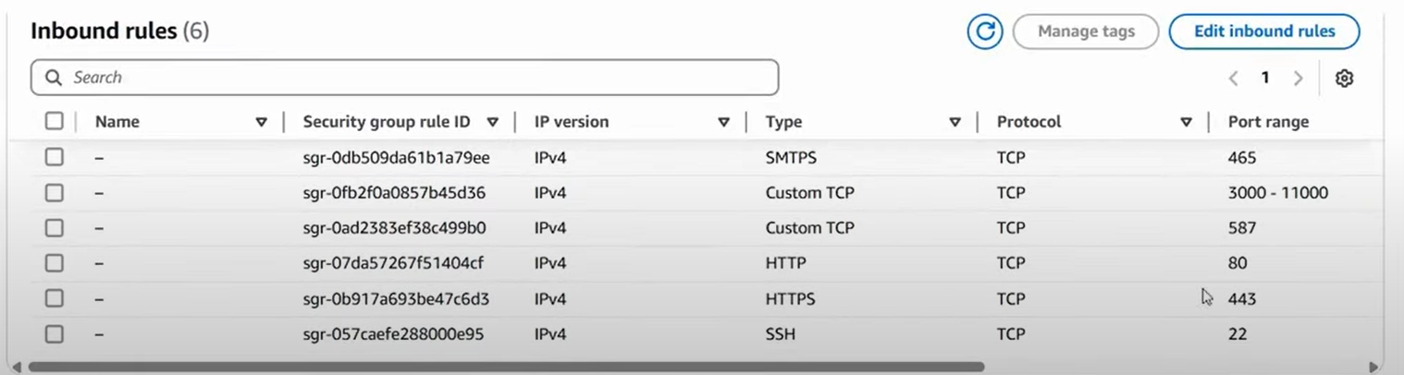

* + - Login to EC2 Instance
    - Execute sudo apt update
    - sudo apt install unzip
    - Install Maven
      * sudo apt install maven
    - Execute all the commands listed under **Download** and **Configure** of New Linux runner in Github Actions
    - Once the Runner becomes active
* Modify the workflow
  + Change the label from ubuntu-latest to self-hosted and commit the changes
  + Monitor the triggered job
* Set up EC2 Instance to make it sonarqube server
  + Ubuntu AMI
  + t2.medium
  + 25 GiB Disk Space
  + Add port 9000 to inbound rules
  + Login to EC2 Instance
    - sudo apt update
    - sudo apt install docker.io -y
    - sudo usermod -aG docker ubuntu
    - newgrp docker
    - docker run -d --name sonar -p 9000:9000 sonarqube:lts-community
    - login to sonarqube server from browser
      * admin/admin
      * Change the password
      * Administrator 🡪 Security 🡪 Users
      * Generate Token for Administrator user
    - Add sonar-project.properties to github project
    - Github Project 🡪 Settings 🡪 Secrets and Variables
      * Add Secrets
        + SONAR_TOKEN
      * Add Variable
        + SONAR_HOST_URL
    - Install docker on Runner EC2 Instance
      * sudo apt install docker.io -y
      * sudo usermod -aG docker ubuntu
      * newgrp docker
    - Github Project 🡪 Settings 🡪 Secrets and Variables
      * Add Secrets
        + DOCKERHUB_TOKEN
      * Add Variable
        + SONAR_HOST_URL