Contents

Project Name: 1

**Description**: 1

Flow Diagram: 1

DevOps Tools Used 1

Steps to Implement 2

Jenkins Server 2

Ansible Server 3

Validation test 5

Tomcat Configuration 5

Output: 6

# Project Name:

Continuous Integration to deploy the applications in Tomcat using Ansible

# **Description**:

Create a Continuous Integration Job that Pulls the Code from GitHub repository, Builds the application with Maven, Copies the application package (in war/jar format) into Ansible Control server and triggers the playbook (Playbook installs Tomcat on Node server and copies the package into Node Server and starts the Application).

# Flow Diagram:

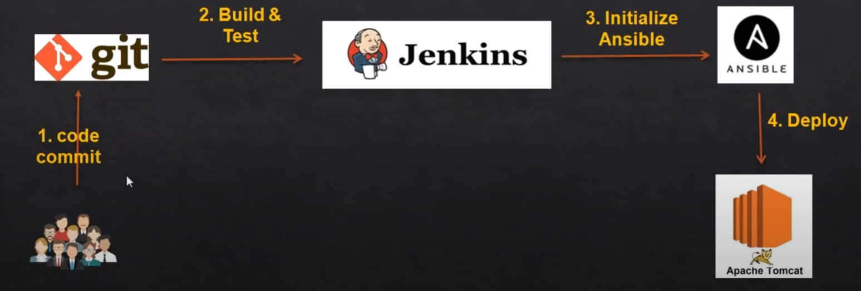

# DevOps Tools Used

* Git
* Maven
* Jenkins
* Ansible
* Tomcat

# Steps to Implement

## Jenkins Server

* Create EC2 Instance with Redhat EL8
* Login to EC2 Instance from your local system using Git Bash or any other tools and execute below commands to install Java, git, Maven

**sudo yum install wget java-1.8.0-openjdk-devel git maven -y**

* Install Jenkins

**sudo wget -O /etc/yum.repos.d/jenkins.repo** [**https://pkg.jenkins.io/redhat-stable/jenkins.repo**](https://pkg.jenkins.io/redhat-stable/jenkins.repo)

**sudo rpm --import** [**https://pkg.jenkins.io/redhat-stable/jenkins.io.key**](https://pkg.jenkins.io/redhat-stable/jenkins.io.key)

**sudo yum install jenkins -y**

* + - if any errors and Jenkins is not installed then execute below command
    - **sudo yum install jenkins --nobest**

**sudo service jenkins start**

**sudo chkconfig jenkins on**

* + Once Jenkins is installed, Open the browser new tab and access http://<Public-IP of the Server>:8080 in a browser
  + Unlock the Jenkins by following the instructions
  + Install Suggested Plugins
  + Create Admin user

## Ansible Configuration

**Installation on Control Server** (Redhat Enterprise OS)

* Create EC2 Instance with AMI as Redhat Enterprise Linux 8
* Login to EC2 instance using Git Bash/Terminal and execute below commands from Git Bash window

**sudo -i** 🡪 to become the root user

**yum install ansible -y 🡪 to install Ansible**

**ansible --version**

**adduser ansible**

**passwd ansible**

* + (To set the password) ex: DevOps@123)

**echo "ansible ALL=(ALL) NOPASSWD: ALL" >> /etc/sudoers**

**sed -ie 's/PasswordAuthentication no/PasswordAuthentication yes/' /etc/ssh/sshd_config**

**sudo service sshd reload**

**cd /etc/ansible**

**mv hosts hosts.original**

**touch hosts**

**chown ansible:ansible hosts**

**exit**

**su - ansible** 🡪 Switch user to ansible, it is going to prompt the password that you set for ansible user

**ssh-keygen 🡪 To generate the ssh key**

* + **Press Enter for all the prompts (like Enter Paraphrase name etc)**

**Create another EC2 Instance for Node**

**sudo -i**

**adduser ansible**

**passwd ansible** (To set the password) DevOps@123

**echo "ansible ALL=(ALL) NOPASSWD: ALL" >> /etc/sudoers**

**sed -ie 's/PasswordAuthentication no/PasswordAuthentication yes/' /etc/ssh/sshd_config**

**sudo service sshd reload**

**After Creating the Node, come back to Control Server and type below command**

* **ssh-copy-id <Node-private-ip>**
* **vi /etc/ansible/hosts**
  + Add the Private IP of the Node server

Jenkins Integration

On Jenkins Server

* + Once you logged into Jenkins
    - Go to Manage Jenkins 🡪 Manage Plugins 🡪 Available Tab
    - Search for **Publish Over SSH** then install the Plugin
  + Manage Jenkins 🡪 Configure System
    - Add SSH Server
    - Configure Ansible Control Server Details
      * Hostname: Private IP of Ansible Control server
      * Username
      * Password
      * Username and password is the user credentials you created in Ansible Control Server to manage playbooks

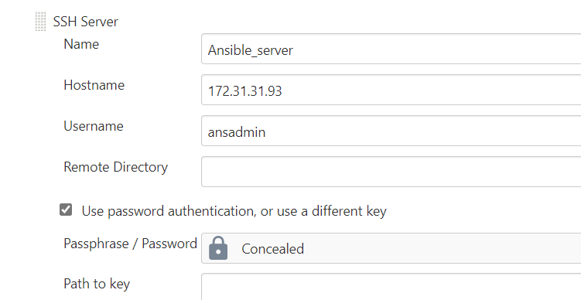

* + Create Free Style job in Jenkins
  + Integrate Git, Some of the Git Projects to be considered
    - <https://github.com/daticahealth/java-tomcat-maven-example.git>
  + Integrate Maven
  + Add Post Build Action to Integrate with Ansible and select **Send Build Artifacts over SSH**
* In our case
  + Source files – target\java-tomcat-maven-example.war
  + Remove prefix – target
  + Remote Directory -- //home//ansible
  + Exec Command – cd /home/ansible; ansible-playbook Jenkins-Ansible-Tomcat.yaml
* Create the playbook in Ansible Control Server under /home/ansible folder and name of the Playbook is
  + Jenkins-Ansible-Tomcat.yaml
* Before you trigger the Job, make sure Ansible server is configured and **Jenkins-Ansible-Tomcat.yaml** file is created to install the tomcat, Copy the Package and start the tomcat service
* Trigger the Job

# Output:

* Once the Build Job is executed successfully from Jenkins
  + The war file gets copied from Jenkins Server to Ansible Control Server and the Jenkins Job triggers the Ansible Playbook
    - Ansible Playbook installs tomcat and copies the war file into Tomcat server and starts the Tomcat
  + Copy Public IP of Tomcat Server(Ansible Node Server) with port 8080 and access it from Browser to see if you can access the application
  + http://<PublicIP of Node Server>:8080/java-tomcat-maven-example