Subject: Partslist

**Date:** 26.04.2021

**Author:** Kim Skåtun

# Introduction

This document is meant some guide to best practise of how to generate item list from creo. This can be used to order components, but is mainly created to generate stickers to be used while picking parts for assembly

# Step 1

You need to import the treetool mapkey created by Erik Varg Høyberg, this is located as always at Z:\Dokumentstyring\Creo\Mapkeys

This basically just set the visibility of the model tree, (remove features and suppressed objects), then export it to your working directory as a textfile(only option), note that it does not correctly put your visibility back to how it was before running the mapkey. In some cases an update of the model will do this. This is something **SOMEONE** should look into, also it would be nice to prompt for saving folder instead of just working dir.

# Step 2

Now that you have you complete model tree file it’s a good time to look at it in notepad++, make sure that it looks alright. A tip can be to export out several of these files instead of just for the top assy, i.e one for each sub assy below the top. This means that you will have several sub assy with level1 in the final output sheet. In the future **SOMEONE** should program in that you get asked at which level the treetool file is at.

# Step 3

Now its time to open the simen.xlsm file with highest version number, navigate to the Output sheet

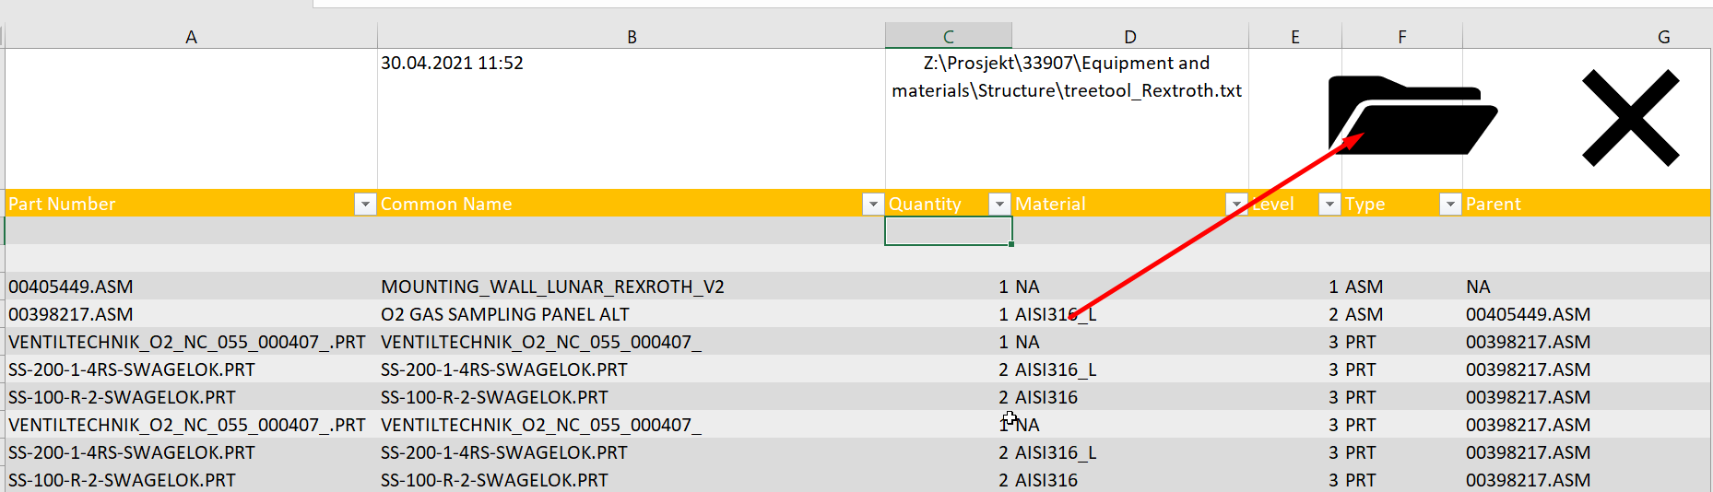

Press the buttom and the magic happens, the oddly formatted textfile now gets nicely formatted and you can easily find all parts in 316L or all assembly etc by applying your filter.

Btw you can pick several files by holding down the ctrl key.

# Step 4

The output sheet now contains all parts and assembly found in creo, however most likely this is way more than what we need. For instance we are not interested in bolts from a bought component. So to get rid off all this crap head over to DeleteUnique sheet and add those part there.

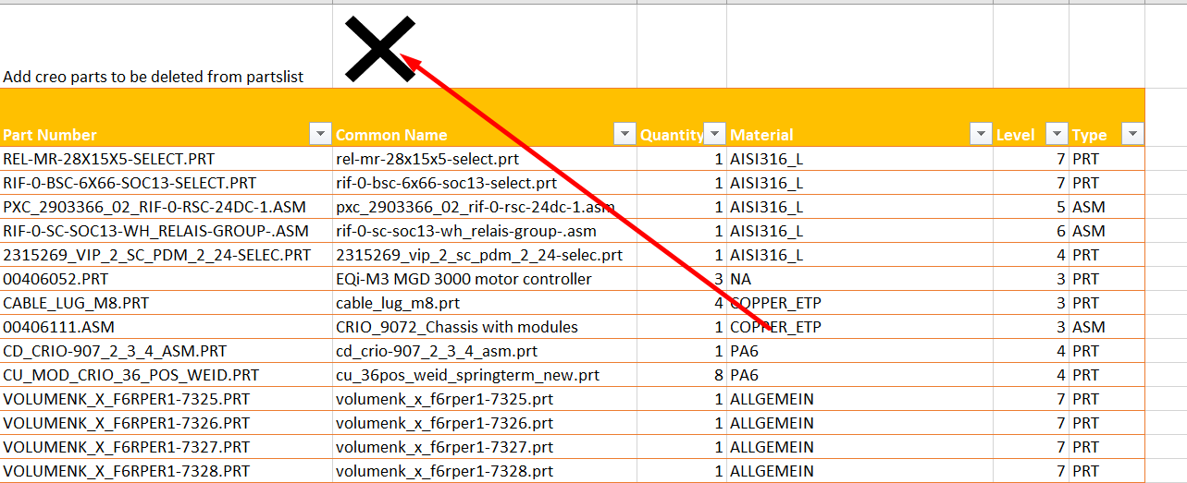

To find which parts to add to this sheet a quick way is to sort on material and remove all parts which does not has our material library. Since a part can be listed twice it’s a good idea from time to time to remove duplicates from this list.

# Step 5

We now have to do similar exercise on the parts we actually want, we want to be able to rename all fasteners for instance to type IFX so that we easily can order all IFX. Similar we can do the same for ASM which are bought components(IPT) where sub parts has been added to the delete sheet, so that we just keep one item. All this can be done in the Imported sheet.

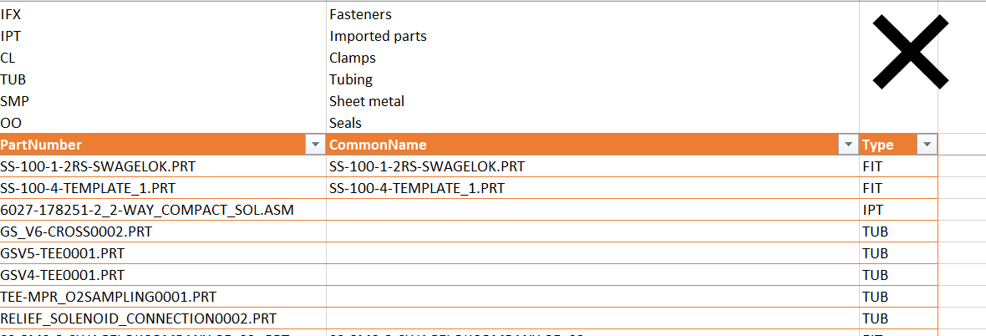

As time goes by these two sheets will get more and more complete and less and less manual work is needed.

# Step 6

What to do if we there is items not in CAD but that we want to add? Well head over to the components sheet and add them here.

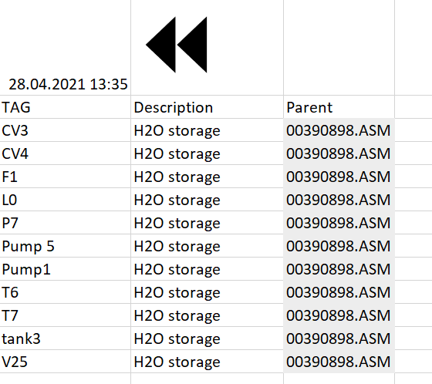

Type in parent at these item will be inserted directly below the parent and with level one higher than parent.

# Step 7

No head over to the Output sheet again and we can now remove and rename types by simply clicking the delete button. This will also do the same for the total BOM sheet

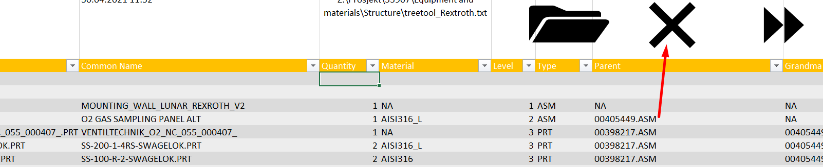

Your output sheet should now look perfect and you can start using it.

# Step 8

Now head over to Total BOM sheet and you can use this for ordering seal, fasteners,tubing,sheet metal etc…

# Step 9

We want to assemble it efficiently and also do a quality check that we have all parts, so to do this we will create labels with label making printer we have. We can make a single label or multiple labels. Simply go to the Output sheet and click on the Assembly you want to make label for, then click the button in the picture

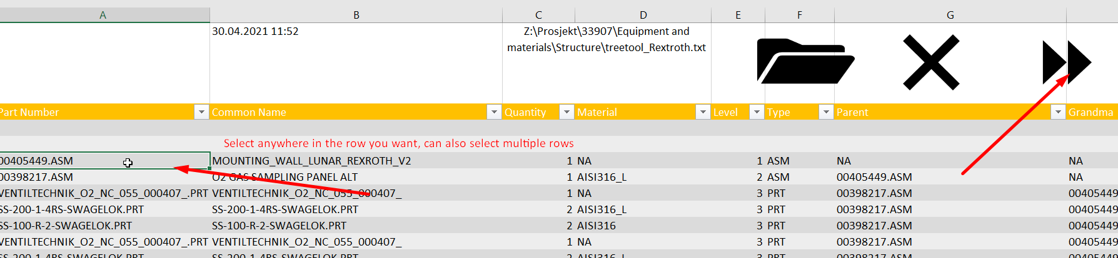

This will then make it over to the label sheet,

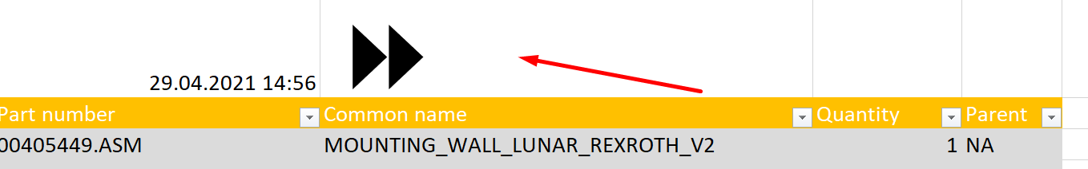

# Step 10

We can now make labels for this assembly note it will add sub assy on the fly so after you press the button it might look like this

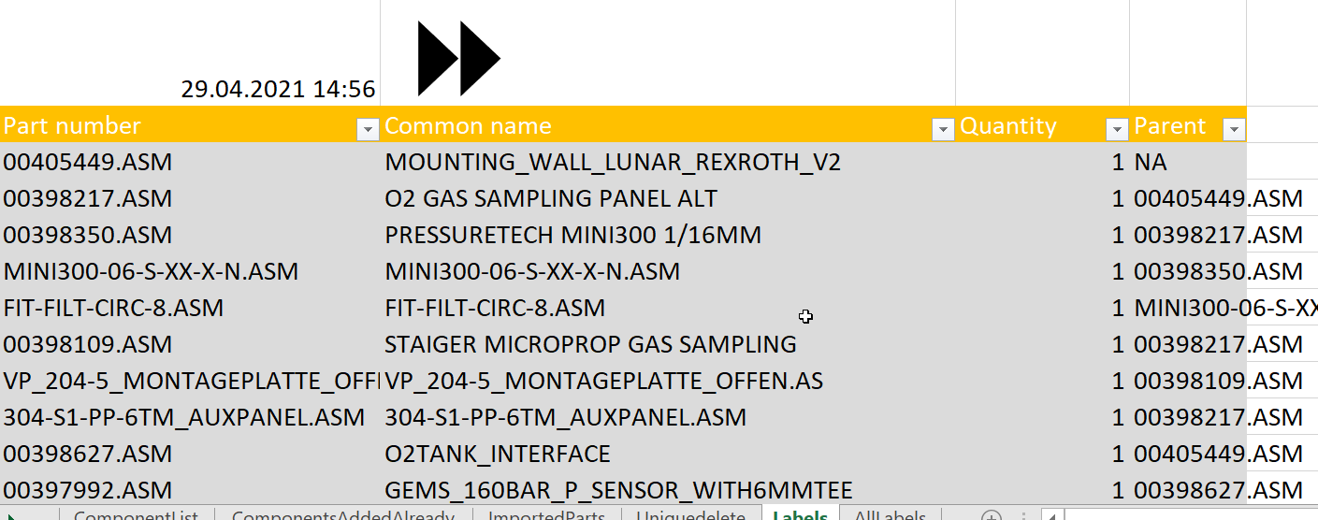

# Step 11

Now head over to the all labels sheet, this contains the labels that will actually be printed. Edit the labels as needed manual if you want to. Do a test print of one label first by selecting one label and the 420 label printer. The macro formats the paper size and columns width so that it looks nice, it prints selection by selection to ensure header is always on top of the page, it also moves printed labels over to printed sheet so that you can keep track of what you have printed and not.

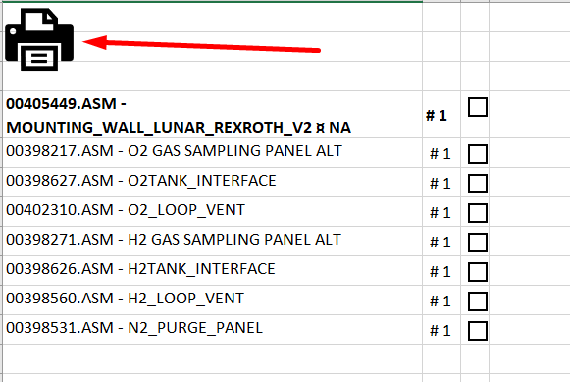

# Step 12

Stick the label on to bags and check off as you pick parts, when the bag is missing parts make sure to mark it with a red marker and note down missing parts, if its complete mark it with yellow marker and when finished assembled mark it with a green pen.

# Future ideas

There are some minor bugs with patterns of subassemblies and duplicates not directly below each other. Jon would like to color the CAD depending on the colors above, a macro for opening and closing each parts is currently included in the excel, the only missing part is to generate a trail file for coloring the items.

This tool should be included in the partslist but that’s not in our hands!!

# Acknowledgement

Written by Simen and Kim for the Lunar RFSC project but applicable for others as well, a big thanks to Jonas and Jon for practical input and Kjersti and https://stackoverflow.com/users/12704593/cdp1802