# Phases

* Phase 0 Detail design of cabin
* Phase1 Construction of cabin
* Phase 2 Wiring, plumbing and furniture installation of cabin
* Phase 3 Detail design of catamaran hulls
* Phase 4 construction of catamaran hulls
* Phase 5 Connect cabin to hull
* Phase 6 Autodocking and instrumentation of electrical hardware
* Phase 7 Add auto leveling of boat
* Phase 8 Add second floor of boat
* Phase 9 Add wheels for transport
* Phase 10 Add Kite to the boat
* Phase 11 Add foils to the boat
* Phase 12 Add flapping foils to the boat
* Phase 13 Automate navigation
* Phase 14 Auto maintains of Boat

<zcxzc

# Container size

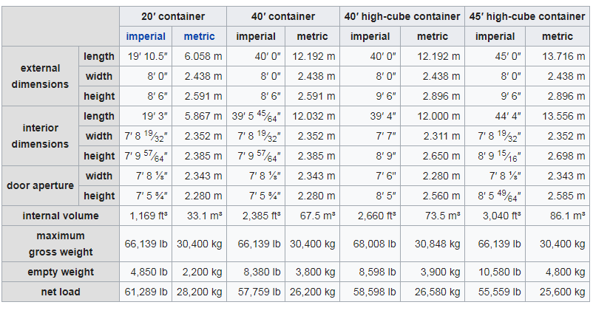

# Links

<https://www.youtube.com/watch?v=3crCxq2XVwQ>

<https://www.traktor.no/nyhet/fire-av-ti-bonder-bruker-aldri-setebelte-i-traktoren/>

<http://oaktrust.library.tamu.edu/bitstream/handle/1969.1/5521/ESL-IC-06-11-58.pdf?sequence=4>

<https://en.wikipedia.org/wiki/Window_film>

https://www.sunreef-yachts.com/en/supreme-68-sailing

# Sunreef

## Sunreef 65

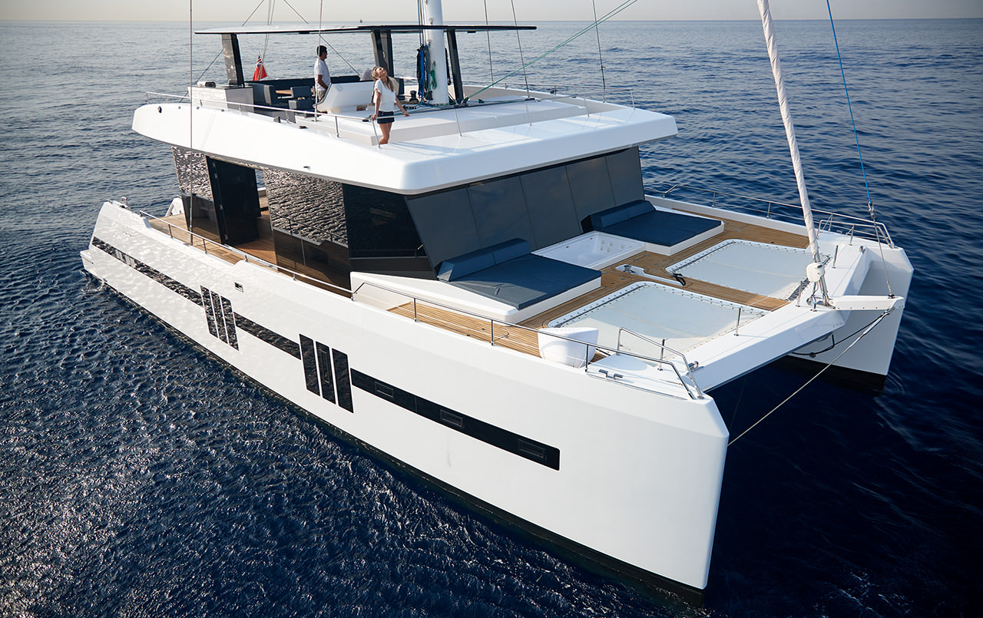

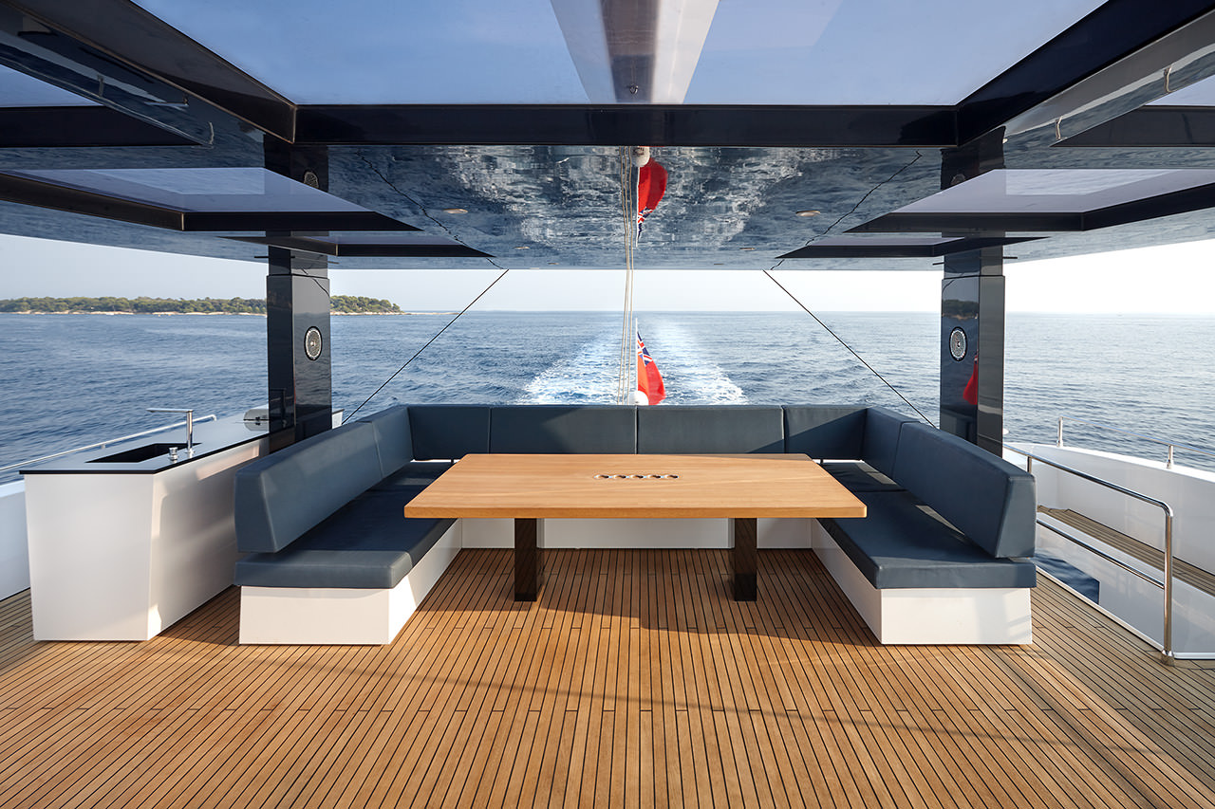

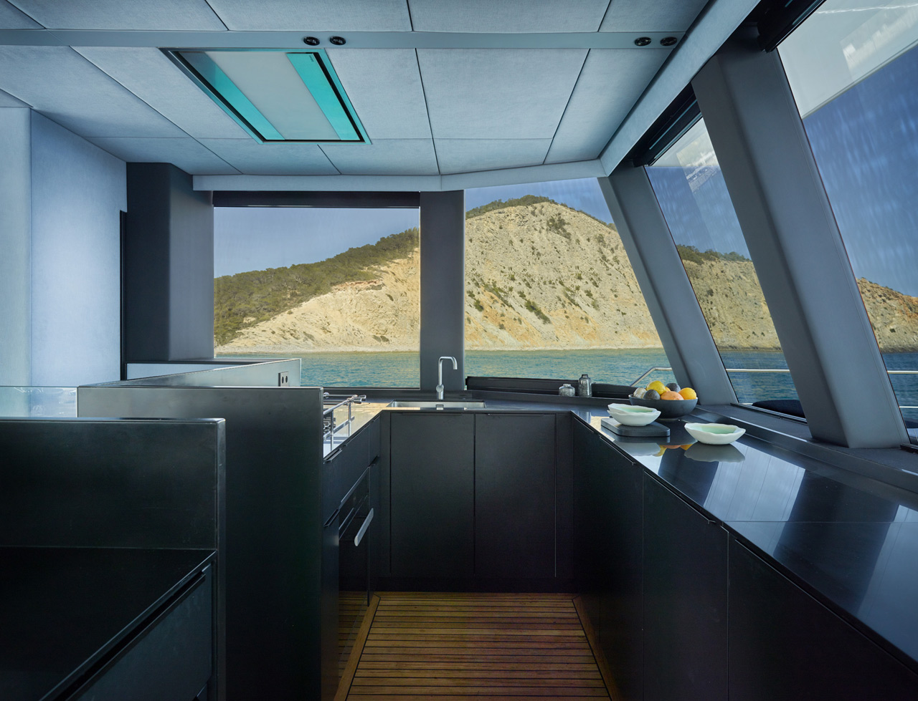

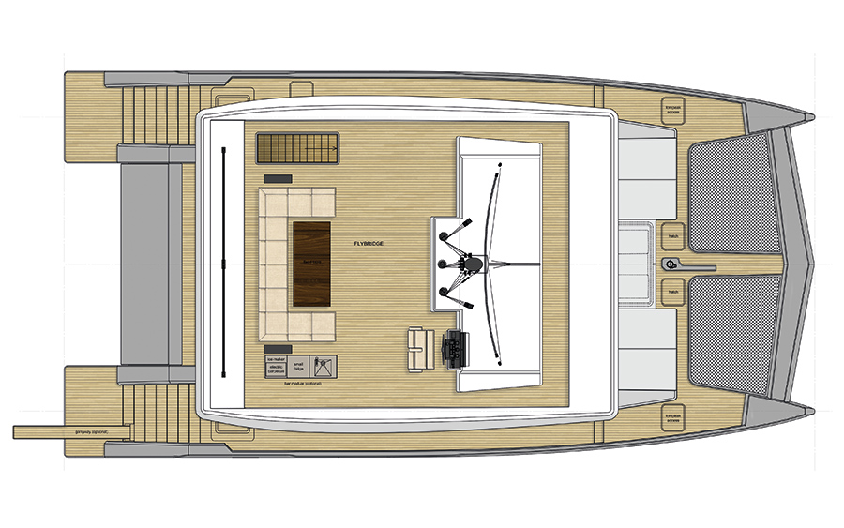

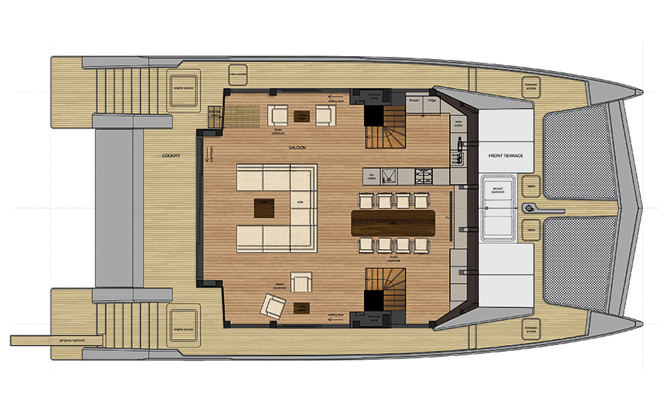

## Sunreef 88

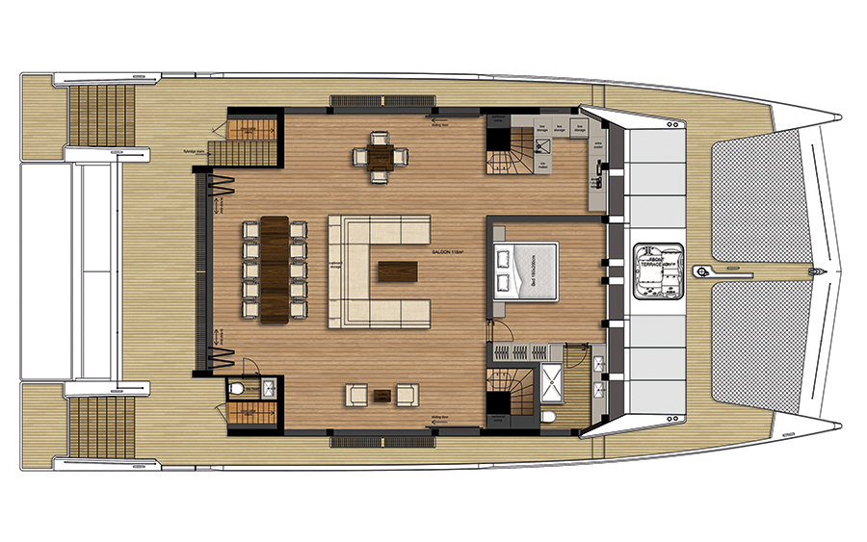

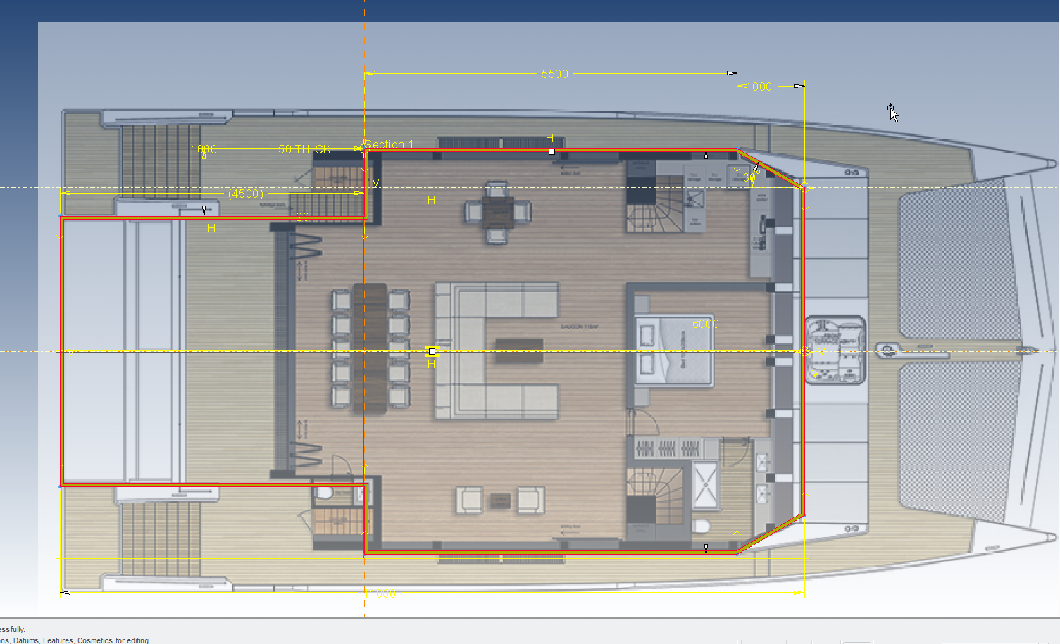

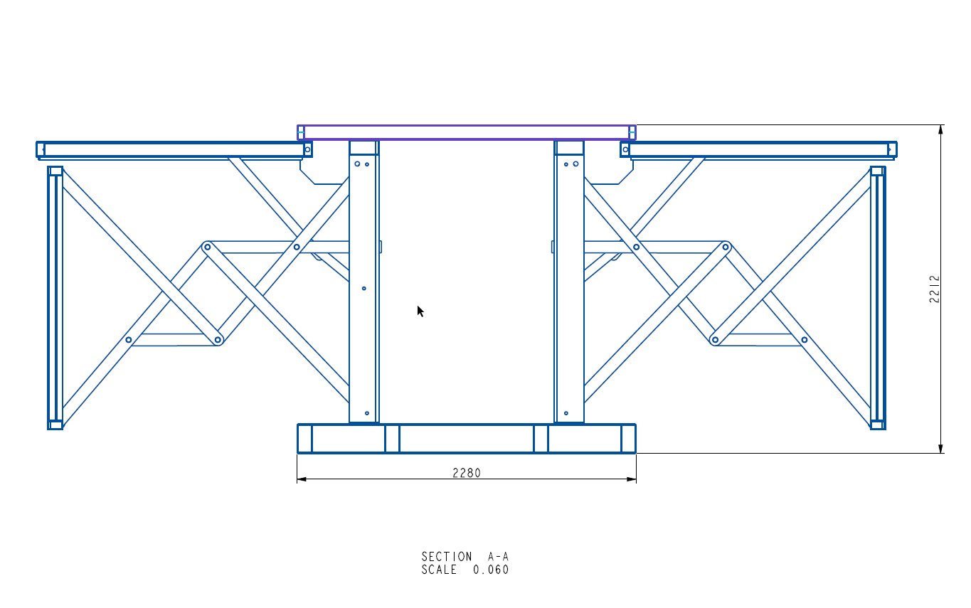

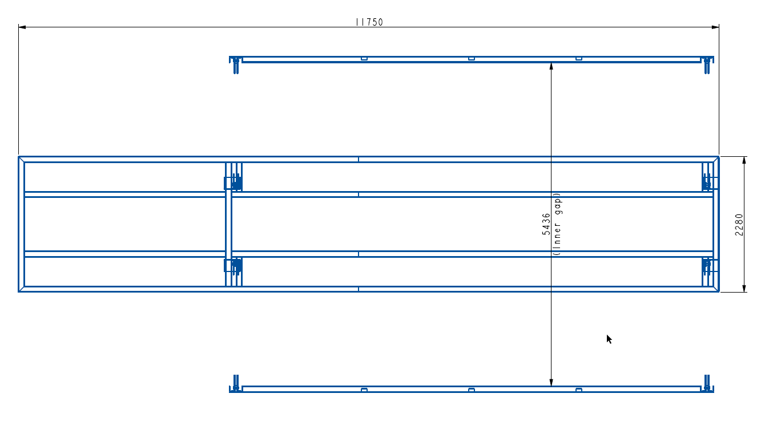

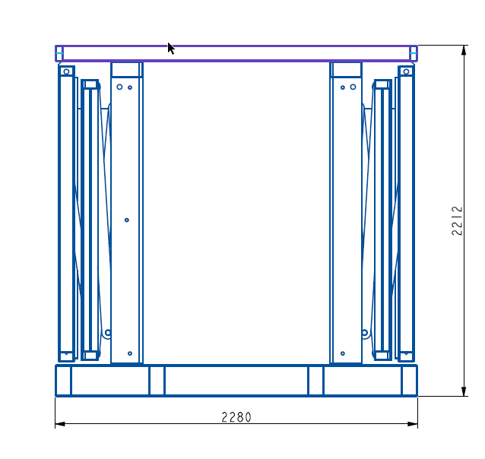

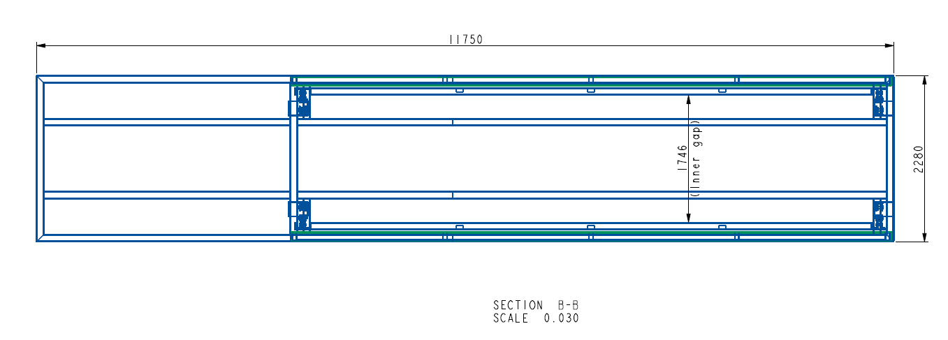

## CL

Well it is experimental, and most likely you need to apply high lift devices, below lift off for 10kt:  
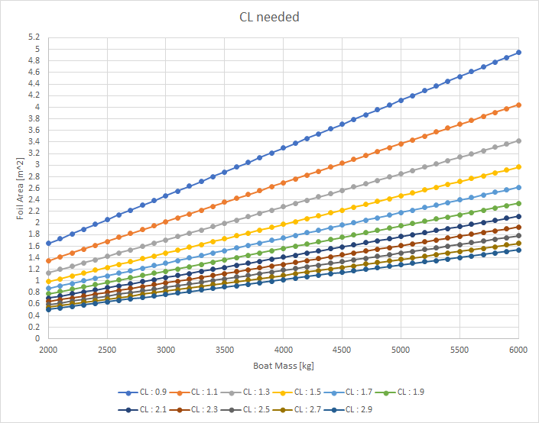

## Boatmass

