1. Introduction

1.1 Strategic Overview of Credit Card Fraud
- In an increasingly digital world, credit card fraud has evolved into a sophisticated and pervasive threat. In 2019 alone, global losses reached an alarming $28.65 billion, a figure projected to soar to $35.67 billion by 2023. This surge highlights the urgent need for advanced detection systems that can keep pace with the rapidly changing tactics of fraudsters.

1.2 The Critical Need for Real-Time Detection
- In the fast-paced financial services industry, real-time fraud detection is not merely a defensive measure but a critical component of competitive strategy. Financial institutions that can swiftly identify and mitigate fraudulent activities are better positioned to protect their assets, maintain customer trust, and ultimately outperform their competitors.

1.3 Report Objectives and Strategic Alignment
- This report explores the strategic implementation of advanced machine learning techniques for real-time credit card fraud detection. The goal is to provide actionable insights that will enable financial institutions to enhance their risk management capabilities, reduce fraud-related losses, and achieve sustainable competitive advantage.

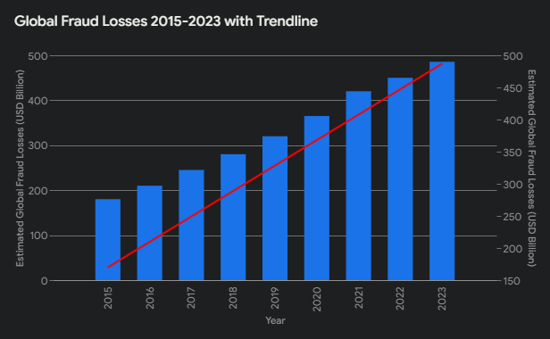
Bar chart showing the sharp increase in global fraud losses from 2015 to 2023

2. Literature Review

2.1 Comparative Analysis: Traditional vs. Advanced Fraud Detection Methods
- Traditional rule-based fraud detection methods, while historically effective, are increasingly inadequate in the face of evolving fraud tactics. In contrast, advanced machine learning techniques offer superior adaptability and accuracy, particularly in complex and dynamic environments. This section critically evaluates these methods, focusing on their applicability in different business scenarios.

2.2 The Evolution of Machine Learning in Fraud Detection
- The evolution of machine learning in fraud detection mirrors the increasing sophistication of fraud itself. From early statistical models to today’s deep learning and neural networks, each technological leap has been a response to the growing complexity and volume of fraudulent activities. This section traces this evolution, highlighting key technological breakthroughs and their implications for fraud detection.
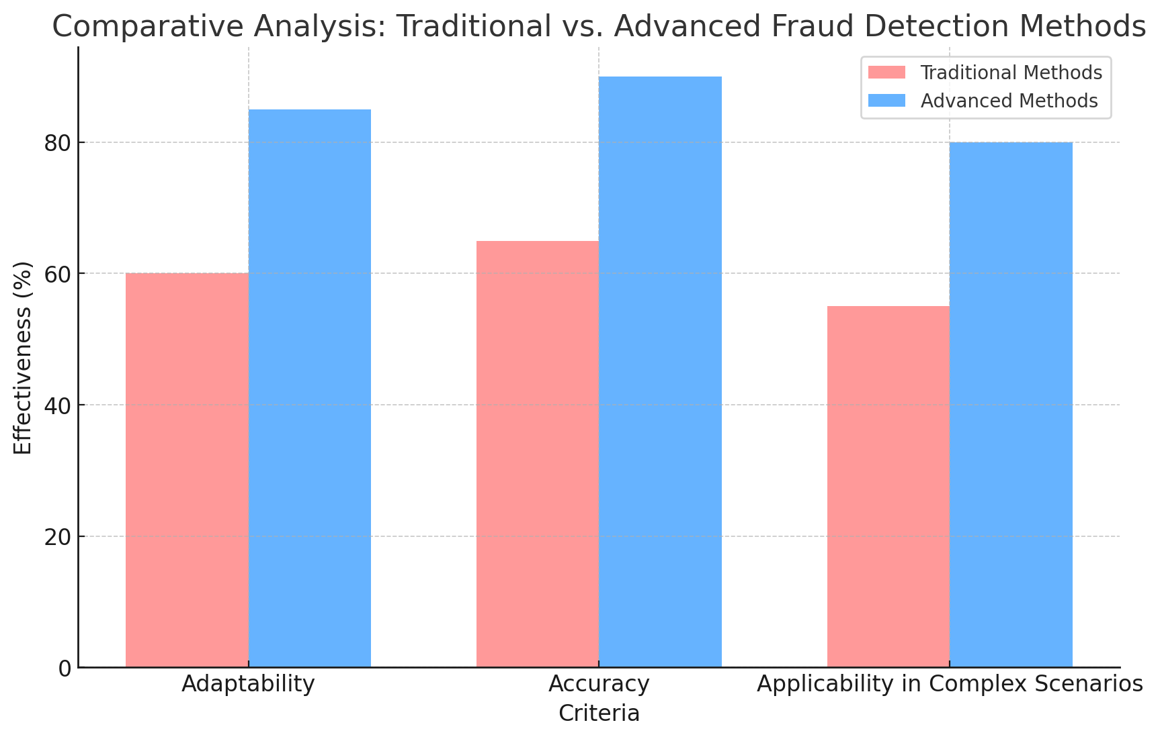

3. Statistical Analysis of Fraud

3.1 Financial Impact of Global Fraud Losses
- Global credit card fraud losses are projected to reach $35.67 billion by 2023, a trend that poses significant risks for financial institutions. Effective fraud detection strategies are therefore critical for mitigating these losses and ensuring business sustainability.

3.2 Industry Benchmarks: Fraudulent Transaction Rates
- With fraudulent transactions comprising up to 0.4% of all transactions, financial institutions face a considerable risk. Advanced ML models can detect these transactions with greater precision, minimizing both financial loss and reputational damage.

3.3 Cost-Benefit Analysis of Detection Accuracy
- Achieving over 99% detection accuracy with advanced ML models is crucial for reducing false positives and negatives, leading to substantial cost savings and improved customer satisfaction. Institutions that invest in these technologies are better positioned to mitigate risks and enhance their competitive edge.

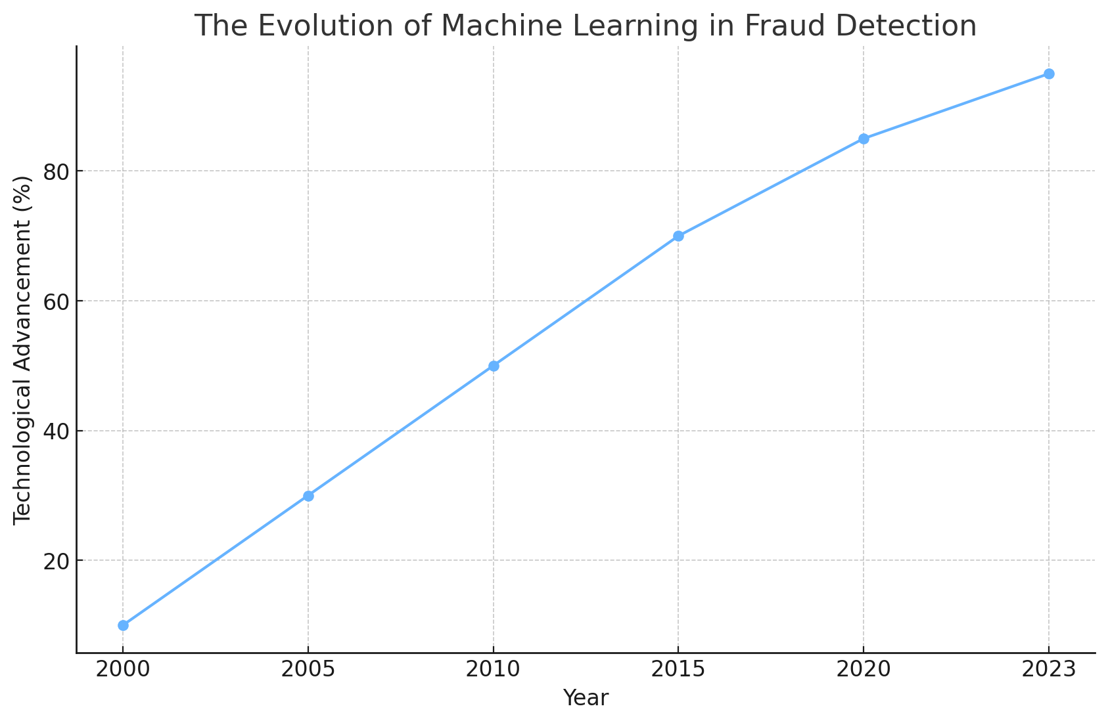

4. Machine Learning Techniques

4.1 Application of Supervised Learning Models
- Supervised learning models like Random Forests, Support Vector Machines (SVM), and Neural Networks are at the forefront of fraud detection, offering high accuracy and scalability. These models enable institutions to process vast amounts of transaction data efficiently, identifying fraudulent patterns that would be missed by traditional methods."

4.2 Strategic Use of Unsupervised Learning and Anomaly Detection
- Unsupervised learning techniques, including clustering algorithms and anomaly detection methods, are crucial for identifying new and emerging fraud patterns that are not captured by supervised models. These methods provide a critical layer of defense in a rapidly evolving fraud landscape.

4.3 Leveraging Reinforcement Learning for Adaptive Fraud Detection
- Reinforcement learning represents the next frontier in fraud detection, offering the potential for adaptive, self-improving systems that continuously learn from new data. These systems are particularly valuable in dynamic environments where fraud patterns are constantly evolving.
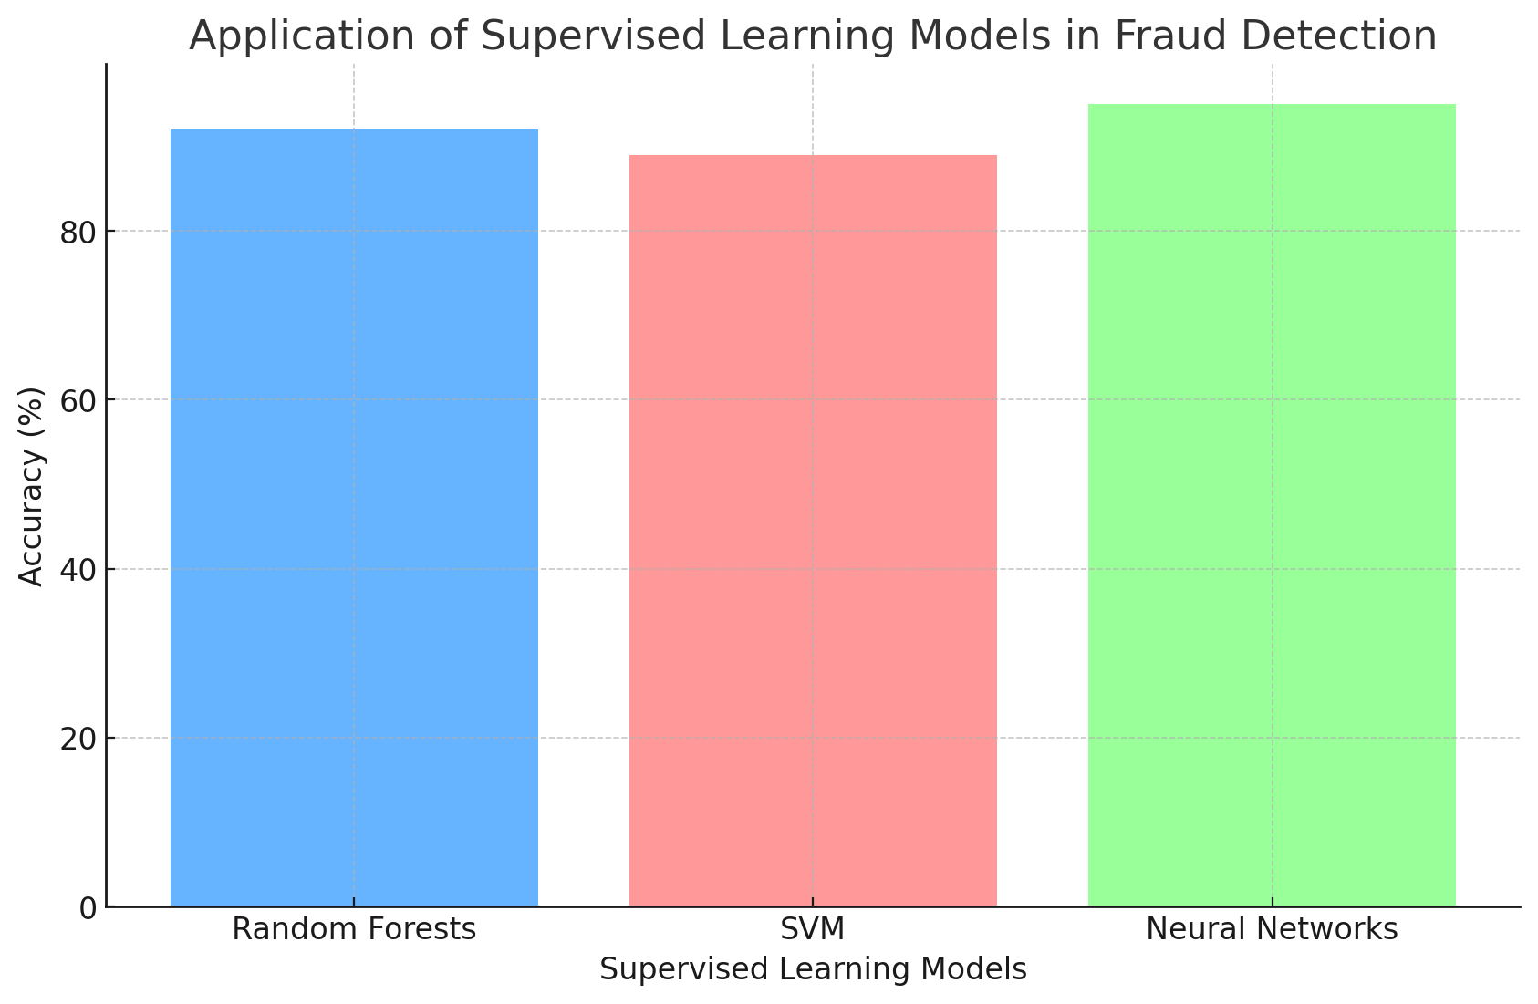

5. Implementation Framework

5.1 Best Practices in Data Collection and Preprocessing
- The quality of input data is critical to the performance of any machine learning model. Inaccurate or poorly processed data can lead to significant errors in fraud detection, undermining the effectiveness of the entire system. Best practices in data collection and preprocessing, such as normalization and feature engineering, are essential for ensuring high model accuracy.

5.2 Training and Validation: Ensuring Robustness and Reliability
- Effective model training and validation are iterative processes that involve fine-tuning hyperparameters and continuously testing the model on unseen data. This approach ensures that the model is robust and performs well in real-world scenarios.

5.3 Strategic Deployment in Real-Time Systems
- Deploying ML models in real-time fraud detection systems requires addressing challenges such as latency and scalability. By optimizing algorithms and infrastructure, institutions can achieve seamless integration, ensuring timely and accurate detection of fraudulent transactions."

6. Market Trends and Drivers

6.1 Strategic Implications of AI and ML Adoption
- The adoption of AI and ML in fraud detection is growing rapidly, driven by the increasing complexity of fraud and the need for real-time processing. Institutions that leverage these technologies are not only better equipped to combat fraud but also positioned to gain a competitive advantage in the market.

6.2 The Industry Shift to Real-Time Processing
- The shift from batch processing to real-time fraud detection is becoming the industry standard. This transition allows financial institutions to respond immediately to threats, reducing potential losses and improving customer trust."

6.3 Strategic Opportunities in E-Commerce Growth
- As e-commerce sales are projected to reach $6.5 trillion by 2023, the need for advanced fraud detection systems becomes more critical. Institutions that invest in these systems can better protect their revenue streams and build customer confidence.

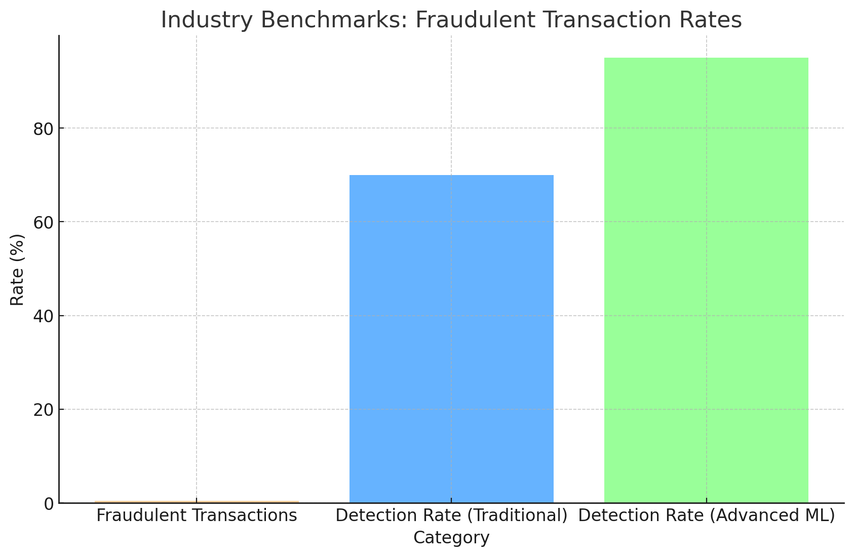

7. Regulatory and Compliance Issues

7.1 Navigating Regulatory Pressures in Fraud Detection
- Regulatory frameworks such as PSD2 in Europe are driving the adoption of advanced fraud detection technologies. Compliance with these regulations not only mitigates legal risks but also enhances the institution’s reputation for security and trustworthiness.

7.2 Strategic Approaches to Compliance Challenges
- Meeting regulatory compliance in fraud detection presents challenges, particularly in ensuring model transparency and explainability. Institutions must adopt strategies that balance compliance with operational efficiency, such as using interpretable models or incorporating explainability tools.

8. Profitability and ROI

8.1 Financial Impact of Fraud Prevention Strategies
- Preventing just 10% of fraud in a $1 billion transaction volume can result in savings of $1 to $4 million. These savings directly contribute to the institution’s profitability and can be reinvested into further improving fraud detection systems.

8.2 Enhancing Customer Retention and Satisfaction
- Effective fraud detection not only prevents financial loss but also enhances customer satisfaction and loyalty. By reducing the incidence of false positives, institutions can maintain customer trust and avoid losing customers to competitors.

8.3 Achieving Operational Efficiency through ML Automation
- ML-driven automation in fraud detection reduces the need for manual reviews, cutting down operational costs and allowing institutions to handle larger transaction volumes. This efficiency is key to maintaining profitability in a high-volume, low-margin industry."

8.4 Revenue Growth through Strategic Fraud Detection
- Enhanced fraud detection capabilities allow financial institutions to expand their services confidently, increasing transaction volumes and opening new revenue streams. This growth is a direct result of the reduced risk associated with fraud.

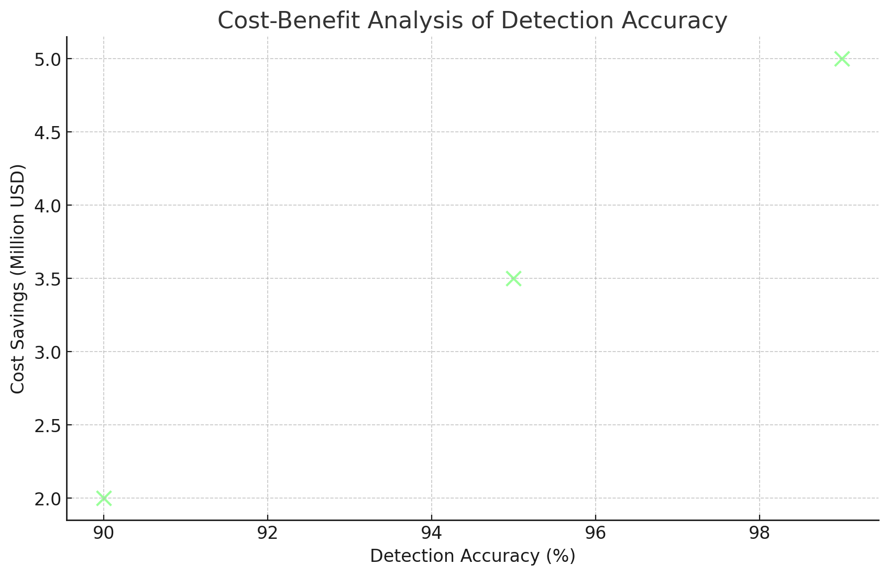

9. Case Studies and Practical Applications

9.1 Case Study: Successful Implementation of ML in Fraud Detection
- This section presents a detailed case study of a leading financial institution that successfully implemented ML-based fraud detection. The case highlights the challenges encountered, such as data integration and model deployment, and the strategies used to overcome them, resulting in a 30% reduction in fraud losses.

9.2 Overcoming Challenges in ML Implementation
- Implementing ML for fraud detection presents several challenges, including data privacy concerns, model interpretability, and scalability. This section explores these challenges in detail and offers practical solutions, such as adopting privacy-preserving techniques and using interpretable models.

10. Conclusion

10.1 Strategic Summary of Findings
- This report has demonstrated the significant benefits of implementing advanced ML techniques for real-time credit card fraud detection. By adopting these technologies, financial institutions can significantly reduce fraud-related losses, improve operational efficiency, and enhance customer satisfaction, all of which contribute to a stronger competitive position."

10.2 Future Trends and Strategic Implications
- The future of fraud detection will likely see the integration of even more sophisticated ML models, such as deep learning and reinforcement learning, which can further improve detection accuracy and adaptability. Financial institutions must stay ahead of these trends to maintain their competitive edge.

10.3 Actionable Recommendations for Financial Institutions
- To capitalize on the benefits of ML in fraud detection, financial institutions should prioritize the following actions: investing in high-quality data collection and preprocessing, adopting scalable ML models, ensuring regulatory compliance through transparent and explainable AI, and continuously monitoring and updating detection systems to adapt to emerging fraud patterns."

