**Assignment_1**

**Submitted by: Sehajleen kaur(102203342)**

**//mpiTrial**

#include <mpi.h>

#include <stdio.h>

int main(int argc, char** argv) {

// Initialize the MPI environment

MPI_Init(NULL, NULL);

// Get the number of processes

int world_size;

MPI_Comm_size(MPI_COMM_WORLD, &world_size);

// Get the rank of the process

int world_rank;

MPI_Comm_rank(MPI_COMM_WORLD, &world_rank);

// Get the name of the processor

char processor_name[MPI_MAX_PROCESSOR_NAME];

int name_len;

MPI_Get_processor_name(processor_name, &name_len);

// Print off a hello world message

printf("Hello world from processor %s, rank %d out of %d processors\n",

processor_name, world_rank, world_size);

// Finalize the MPI environment.

MPI_Finalize();

}

**//Outputs:**

MPI_TRIAL(HELLO WORLD)

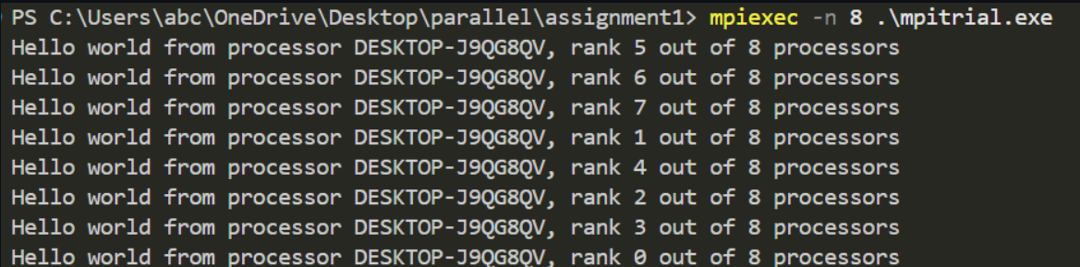

Send Receive



//SendReceiveCode

#include <mpi.h>

#include <stdio.h>

#include <stdlib.h>

//Basic Send functions in MPI

// MPI_Send(

// void* data,

// int count,

// MPI_Datatype datatype,

// int destination,

// int tag,

// MPI_Comm communicator

// )

//Basic Receive functions in MPI

// MPI_Recv(

// void* data,

// int count,

// MPI_Datatype datatype,

// int source,

// int tag,

// MPI_Comm communicator,

// MPI_Status* status

// )

int main(int argc, char** argv){

MPI_Init(NULL, NULL);

//rank

int world_rank;

MPI_Comm_rank(MPI_COMM_WORLD, &world_rank);

//size

int world_size;

MPI_Comm_size(MPI_COMM_WORLD, &world_size);

// assuming 2 processors for this task

if(world_size<5){

fprintf(stderr,"World size must be greater than 5 for %s.\n", argv[0]);

MPI_Abort(MPI_COMM_WORLD, 5);

}

int number;

if(world_rank==0){

number=-1;

MPI_Send(

&number,

1,

MPI_INT,

1,

0,

MPI_COMM_WORLD

);

}

else if(world_rank==1){

MPI_Recv(

&number,

1,

MPI_INT,

0,

0,

MPI_COMM_WORLD,

MPI_STATUS_IGNORE

);

printf("process 1 received number %d from process 0.\n", number);

}

MPI_Finalize();

}

//README_FILE_AS_PER_GITHUB:

