**Assignment_2**

**Submitted by: Sehajleen kaur(102203342)**

**//Dot_Product**

#include <stdio.h>

#include <stdlib.h>

#include <mpi.h>

#define N 8 //size of vector

int main(int argc, char *argv[]){

int rank, num_procs;

int local_N;

int A[N]={1,2,3,4,5,6,7,8};

int B[N]={8,7,6,5,4,3,2,1};

MPI_Init(&argc, &argv);

MPI_Comm_rank(MPI_COMM_WORLD, &rank);

MPI_Comm_size(MPI_COMM_WORLD, &num_procs);

local_N=N/num_procs; //workload divide

int local_A[local_N], local_B[local_N], local_dot_product=0, global_dot_product=0;

//scattering data

MPI_Scatter(

A,

local_N,

MPI_INT,

local_A,

local_N,

MPI_INT,

0,

MPI_COMM_WORLD

);

MPI_Scatter(

B,

local_N,

MPI_INT,

local_B,

local_N,

MPI_INT,

0,

MPI_COMM_WORLD

);

//compute dot product

for(int i=0; i<local_N; i++){

local_dot_product+=local_A[i]*local_B[i];

}

//reduce

MPI_Reduce(

&local_dot_product,

&global_dot_product,

1,

MPI_INT,

MPI_SUM,

0,

MPI_COMM_WORLD

);

if (rank == 0) {

printf("Dot Product: %d\n", global_dot_product);

}

MPI_Finalize();

return 0;

}

**//Output:**



**//heatDistributionSimulation**

#include <stdio.h>

#include <stdlib.h>

#include <mpi.h>

#include <math.h>

#define N 10 // grid size

#define MAX_ITER 1000

#define THRESHOLD 0.01

void initialize_grid(double grid[N][N])

{

for (int i = 0; i < N; i++)

{

for (int j = 0; j < N; j++)

{

if (i == 0 || i == N - 1 || j == 0 || j == N - 1)

grid[i][j] = 100.0; // boundary conditions

else

grid[i][j] = 0.0; // interior points

}

}

}

void print_grid(double grid[N][N])

{

for (int i = 0; i < N; i++)

{

for (int j = 0; j < N; j++)

{

printf("%.1f ", grid[i][j]);

}

printf("\n");

}

printf("\n");

}

int main(int argc, char *argv[])

{

int rank, num_procs, rows_per_proc;

MPI_Init(&argc, &argv);

MPI_Comm_rank(MPI_COMM_WORLD, &rank);

MPI_Comm_size(MPI_COMM_WORLD, &num_procs);

rows_per_proc = N / num_procs;

if (N % num_procs != 0)

{

if (rank == 0)

printf("Error: grid rows must be divisble by number of processes.\n");

MPI_Finalize();

return -1;

}

double grid[N][N], local_grid[rows_per_proc + 2][N], new_grid[rows_per_proc + 2][N];

if (rank == 0)

initialize_grid(grid);

// scatter the grid to processes

MPI_Scatter(

grid,

rows_per_proc * N,

MPI_DOUBLE,

&local_grid[1][0],

rows_per_proc * N,

MPI_DOUBLE,

0,

MPI_COMM_WORLD);

// Main computation loop

for (int iter = 0; iter < MAX_ITER; iter++)

{

if (rank > 0)

{

MPI_Send(

&local_grid[1][0],

N,

MPI_DOUBLE,

rank - 1,

0,

MPI_COMM_WORLD);

MPI_Recv(

&local_grid[0][0],

N,

MPI_DOUBLE,

rank - 1,

0,

MPI_COMM_WORLD,

MPI_STATUS_IGNORE);

}

if (rank < num_procs - 1)

{

MPI_Send(

&local_grid[rows_per_proc][0],

N,

MPI_DOUBLE,

rank + 1,

0,

MPI_COMM_WORLD);

MPI_Recv(

&local_grid[rows_per_proc + 1][0],

N,

MPI_DOUBLE,

rank + 1,

0,

MPI_COMM_WORLD,

MPI_STATUS_IGNORE

);

}

// computing new temp values

double max_diff = 0.0;

for (int i = 1; i <= rows_per_proc; i++)

{

for (int j = 1; j < N - 1; j++)

{

new_grid[i][j] = 0.25 * (local_grid[i - 1][j] + local_grid[i + 1][j] + local_grid[i][j - 1] + local_grid[i][j + 1]);

double diff = fabs(new_grid[i][j] - local_grid[i][j]);

if (diff > max_diff)

max_diff = diff;

}

}

//swap grids

for(int i=1; i<=rows_per_proc; i++){

for(int j=0; j<N; j++){

local_grid[i][j]=new_grid[i][j];

}

}

double global_max_diff;

MPI_Allreduce(

&max_diff,

&global_max_diff,

1,

MPI_DOUBLE,

MPI_MAX,

MPI_COMM_WORLD);

if (global_max_diff < THRESHOLD) break;

}

MPI_Gather(

&local_grid[1][0],

rows_per_proc*N,

MPI_DOUBLE,

grid,

rows_per_proc*N,

MPI_DOUBLE,

0,

MPI_COMM_WORLD

);

if(rank==0){

printf("Final Heat Distribution.\n");

print_grid(grid);

}

MPI_Finalize();

return 0;

}

**//Output:**

**//Matrix Multiplication**

#include <stdio.h>

#include <mpi.h>

#include <stdlib.h>

#define N 70

void multiply_matrices(double A[N][N], double B[N][N], double C[N][N], int start, int end){

for(int i=start; i<end; i++){

for (int j = 0; j < N; j++) {

C[i][j] = 0;

for (int k = 0; k < N; k++) {

C[i][j] += A[i][k] * B[k][j];

}

}

}

}

int main(int argc, char* argv[]){

int rank, size;

double A[N][N], B[N][N], C[N][N];

double local_A[N][N], local_C[N][N];

double start_time, run_time;

MPI_Init(&argc, &argv);

MPI_Comm_size(MPI_COMM_WORLD, &size);

MPI_Comm_rank(MPI_COMM_WORLD, &rank);

int rows_per_process=N/size;

int start=rank*rows_per_process;

int end=(rank == size - 1) ? N : start + rows_per_process;

if(rank==0){

for(int i=0; i<N; i++){

for(int j=0; j<N; j++){

A[i][j]=rand()%10;

B[i][j]=rand()%10;

}

}

start_time=MPI_Wtime();

}

MPI_Bcast(

B,

N*N,

MPI_DOUBLE,

0,

MPI_COMM_WORLD

);

MPI_Scatter(

A,

rows_per_process*N,

MPI_DOUBLE,

local_A,

rows_per_process*N,

MPI_DOUBLE,

0,

MPI_COMM_WORLD

);

multiply_matrices(local_A, B, local_C, start, end);

MPI_Gather(

local_C,

rows_per_process*N,

MPI_DOUBLE,

C,

rows_per_process*N,

MPI_DOUBLE,

0,

MPI_COMM_WORLD

);

if (rank == 0) {

run_time = MPI_Wtime() - start_time;

printf("MPI Matrix Multiplication Time: %f seconds\n", run_time);

}

MPI_Finalize();

return 0;

}

**//Output:**



**//Matrix Transpose**

#include <stdio.h>

#include <mpi.h>

#include <stdlib.h>

#define N 4

void print_matrix(int matrix[N][N], const char* label){

printf("%s:\n", label);

for(int i=0; i<N; i++){

for(int j=0; j<N; j++){

printf("%d ", matrix[i][j]);

}

printf("\n");

}

printf("\n");

}

int main(int argc, char* argv[]){

int rank, size;

int matrix[N][N], transpose[N][N];

int local_row[N];

MPI_Init(&argc, &argv);

MPI_Comm_size(MPI_COMM_WORLD, &size);

MPI_Comm_rank(MPI_COMM_WORLD, &rank);

if(size!=N){

if(rank==0){

printf("this program requires exactly %d no. of processes\n", N);

}

MPI_Finalize();

}

if(rank==0){

int count=1;

for (int i = 0; i < N; i++) {

for (int j = 0; j < N; j++) {

matrix[i][j] = count++;

}

}

print_matrix(matrix, "Original Matrix");

}

MPI_Scatter(

matrix,

N,

MPI_INT,

local_row,

N,

MPI_INT,

0,

MPI_COMM_WORLD

);

int local_col[N];

for(int i=0; i<N; i++){

local_col[i]=local_row[i];

}

MPI_Gather(

local_col,

N,

MPI_INT,

transpose,

N,

MPI_INT,

0,

MPI_COMM_WORLD

);

if(rank==0){

print_matrix(transpose, "Transposed Matrix");

}

MPI_Finalize();

return 0;

}

**//Output:**

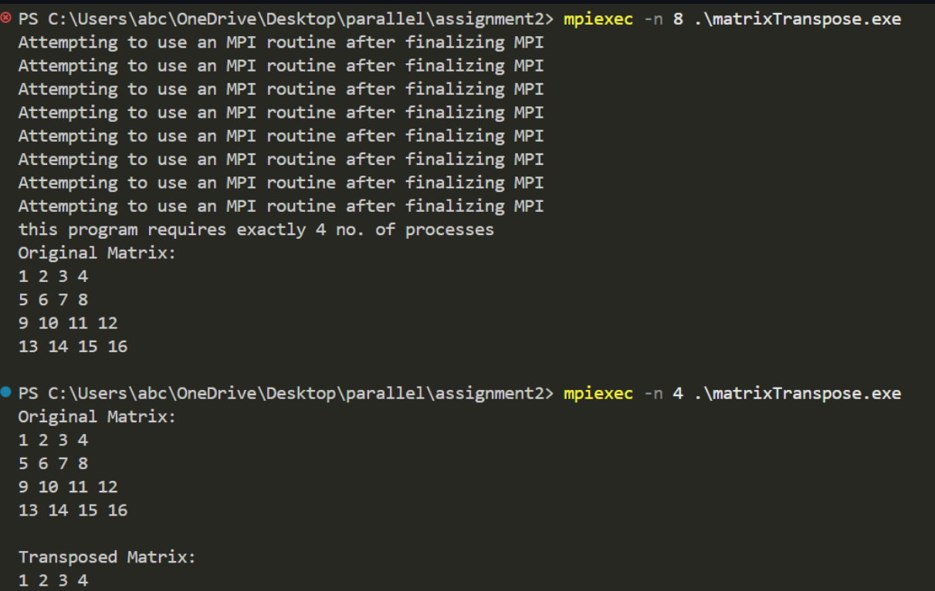

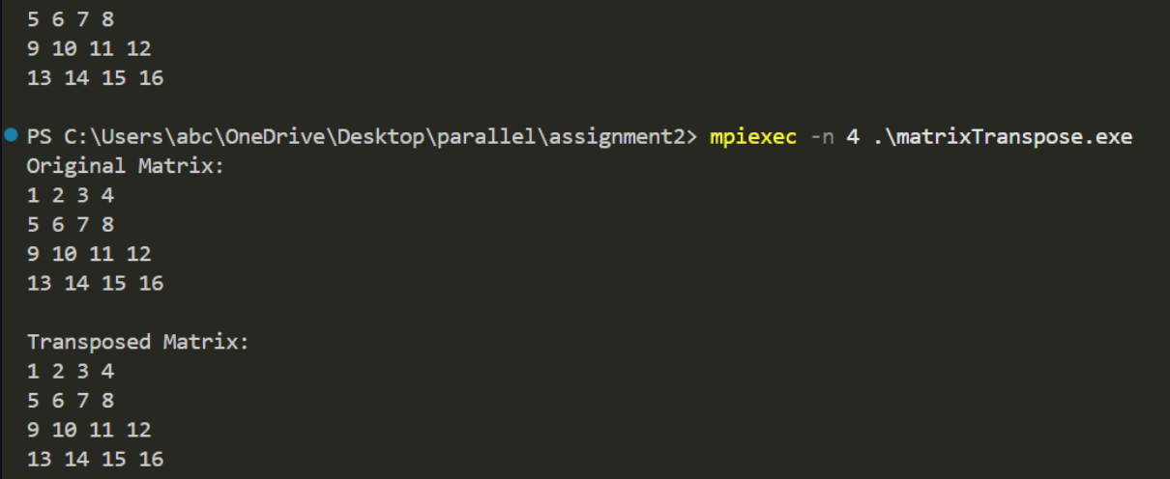

**//Odd_Even**

#include <stdio.h>

#include <mpi.h>

#include <stdlib.h>

void even_odd_sort(int *local_array, int local_size, int global_size, int rank, int num_procs){

int phase, partner, temp;

MPI_Status status;

for(phase=0; phase<global_size; phase++){

if(phase%2==0){ //even phase

if(rank%2==0)

partner=rank+1;

else

partner=rank-1;

}

else{ //odd phase

if(rank%2==0)

partner=rank-1;

else

partner=rank+1;

}

if(partner>=0 && partner<num_procs){

int received;

MPI_Sendrecv(

&local_array[0],

1,

MPI_INT,

partner,

0,

&received,

1,

MPI_INT,

partner,

0,

MPI_COMM_WORLD,

&status

);

if((rank<partner && local_array[0] > received) || (rank>partner && local_array[0]<received)){

temp=local_array[0];

local_array[0]=received;

received=temp;

}

MPI_Sendrecv(

&received,

1,

MPI_INT,

partner,

0,

&local_array[0],

1,

MPI_INT,

partner,

0,

MPI_COMM_WORLD,

&status

);

}

}

}

int main(int argc, char *argv[]){

int rank, num_procs;

int global_size=8;

int local_array[1];

MPI_Init(&argc, &argv);

MPI_Comm_rank(MPI_COMM_WORLD, &rank);

MPI_Comm_size(MPI_COMM_WORLD, &num_procs);

if(num_procs!=global_size){

if(rank==0){

printf("Error: the number of processes must be equal to the number of elemnts.\n");

}

MPI_Finalize();

return 1;

}

int global_array[]={9,7,3,5,1,8,6,2};

MPI_Scatter(

global_array,

1,

MPI_INT,

local_array,

1,

MPI_INT,

0,

MPI_COMM_WORLD

);

if(rank==1){

printf("Inital Array: ");

for(int i=0; i<global_size; i++){

printf("%d ", global_array[i]);

}

printf("\n");

}

even_odd_sort(

local_array,

1,

global_size,

rank,

num_procs

);

MPI_Gather(

local_array,

1,

MPI_INT,

global_array,

1,

MPI_INT,

0,

MPI_COMM_WORLD

);

if(rank==0){

printf("sorted array: ");

for(int i=0; i<global_size; i++){

printf("%d ", global_array[i]);

}

printf("\n");

}

MPI_Finalize();

return 0;

}

**//Output:**

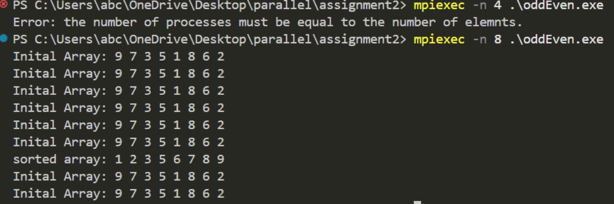

**//Parallel_Reduction**

#include <stdio.h>

#include <stdlib.h>

#include <mpi.h>

int main(int argc, char *argv[]){

int rank, num_procs;

int global_sum, local_value;

MPI_Init(&argc, &argv);

MPI_Comm_rank(MPI_COMM_WORLD, &rank);

MPI_Comm_size(MPI_COMM_WORLD, &num_procs);

local_value=rank+1;

MPI_Reduce(

&local_value,

&global_sum,

1,

MPI_INT,

MPI_SUM,

0,

MPI_COMM_WORLD

);

if(rank==0){

printf("total sum using MPI_Reduce: %d\n", global_sum);

}

MPI_Finalize();

return 0;

}

**//Value of Pi**

#include <stdio.h>

#include <stdlib.h>

#include <time.h>

#include <mpi.h>

#define NO_OF_ITERATIONS 1000000

int main(int argc, char **argv)

{

int rank, size;

long long int circle_points = 0, square_points = 0, interval = 0;

double x, y, d;

double pi;

MPI_Init(&argc, &argv);

MPI_Comm_rank(MPI_COMM_WORLD, &rank);

MPI_Comm_size(MPI_COMM_WORLD, &size);

srand(time(NULL) + rank);

while (interval < NO_OF_ITERATIONS / size)

{

x = (double)rand() / RAND_MAX;

y = (double)rand() / RAND_MAX;

d = x * x + y * y;

if (d <= 1)

{

circle_points++;

}

square_points++;

interval++;

}

long long int global_circle_points, global_square_points;

MPI_Reduce(&circle_points, &global_circle_points, 1, MPI_LONG_LONG_INT, MPI_SUM, 0, MPI_COMM_WORLD);

MPI_Reduce(&square_points, &global_square_points, 1, MPI_LONG_LONG_INT, MPI_SUM, 0, MPI_COMM_WORLD);

if (rank == 0)

{

pi = 4.0 * (double)global_circle_points / (double)global_square_points;

printf("%f", pi);

}

return 0;

}

**//PrefixSum**

#include <stdio.h>

#include <mpi.h>

int main(int argc, char* argv[]){

int rank, size;

int local_value, prefix_sum;

MPI_Init(&argc, &argv);

MPI_Comm_size(MPI_COMM_WORLD, &size);

MPI_Comm_rank(MPI_COMM_WORLD, &rank);

local_value=rank+1;

MPI_Scan(

&local_value,

&prefix_sum,

1,

MPI_INT,

MPI_SUM,

MPI_COMM_WORLD

);

printf("Process %d: Local value = %d, Prefix sum = %d\n", rank, local_value, prefix_sum);

MPI_Finalize();

return 0;

}