 website traffic analysis

Phase 5 submission document

Project title: website traffic analysis

Phase 5:

Project documentation &submission

Topic:

In this session we will document the complete project and prepare it for submission.

Introduction:

* Website traffic analysis using IBM Cognos is a powerful approach to gain insights into the performance of your website, providing data-driven information to make informed decisions and optimize your online presence. IBM Cognos is a business intelligence and performance management tool that can be used to collect, process, and visualize web traffic data.
* Website traffic analysis using IBM Cognos enables businesses to leverage data to drive their online strategies, enhance user experiences, and ultimately achieve their digital objectives. By providing a comprehensive view of website performance, it empowers organizations to make informed decisions and stay competitive in the digital landscape.

1. Data Collection:

* Website traffic data can be collected using various web analytics tools such as Google Analytics, Adobe Analytics, or custom data sources. These tools track metrics like page views, sessions, bounce rates, and more. IBM Cognos can integrate with these sources to extract data.

2. Data Integration:

* Once data is collected, it needs to be integrated into the IBM Cognos environment. Data from different sources may need to be transformed and standardized to create a unified dataset for analysis.

3. Data Modeling:

* IBM Cognos allows you to create a data model that reflects your website's structure and the key performance indicators (KPIs) you want to track. This includes defining dimensions (e.g., pages, visitors, traffic sources) and measures (e.g., page views, conversion rates).

4. Traffic Sources:

* Analyze where your website traffic is coming from (e.g., search engines, social media, referrals).
* Visitor Demographics: Understand your audience's characteristics (e.g., age, location, device).
* Page Performance: Measure the effectiveness of individual web pages.
* Conversion Rates: Track the percentage of visitors who complete desired actions (e.g., form submissions, purchases).

5. Data Exploration:

* Users can explore the data, apply filters, and drill down into specific details to uncover insights and answers to specific questions.

Data set:

Link:(<https://www.kaggle.com/datasets/bobnau/daily-website-visitors>)

Given dataset:

|  |  |  |  |  |  |  |  |
| --- | --- | --- | --- | --- | --- | --- | --- |
| Row | Day | Day.Of.Week | Date | Page.Loads | Unique.Visits | First.Time.Visits | Returning.Visits |
| 1 | Sunday | 1 | 9/14/2014 | 2,146 | 1,582 | 1,430 | 152 |
| 2 | Monday | 2 | 9/15/2014 | 3,621 | 2,528 | 2,297 | 231 |
| 3 | Tuesday | 3 | 9/16/2014 | 3,698 | 2,630 | 2,352 | 278 |
| 4 | Wednesday | 4 | 9/17/2014 | 3,667 | 2,614 | 2,327 | 287 |
| 5 | Thursday | 5 | 9/18/2014 | 3,316 | 2,366 | 2,130 | 236 |
| 6 | Friday | 6 | 9/19/2014 | 2,815 | 1,863 | 1,622 | 241 |
| 7 | Saturday | 7 | 9/20/2014 | 1,658 | 1,118 | 985 | 133 |
| 8 | Sunday | 1 | 9/21/2014 | 2,288 | 1,656 | 1,481 | 175 |
| 9 | Monday | 2 | 9/22/2014 | 3,638 | 2,586 | 2,312 | 274 |
| 10 | Tuesday | 3 | 9/23/2014 | 4,462 | 3,257 | 2,989 | 268 |
| 11 | Wednesday | 4 | 9/24/2014 | 4,414 | 3,175 | 2,891 | 284 |
| 12 | Thursday | 5 | 9/25/2014 | 4,315 | 3,029 | 2,743 | 286 |
| 13 | Friday | 6 | 9/26/2014 | 3,323 | 2,249 | 2,033 | 216 |
| 14 | Saturday | 7 | 9/27/2014 | 1,656 | 1,180 | 1,040 | 140 |
| 15 | Sunday | 1 | 9/28/2014 | 2,465 | 1,806 | 1,613 | 193 |

Necessary steps:

Import the libraries:

import pandas as pd

import matplotlib.pyplot as plt

import numpy as np

Python programs:

import re

log_file_path = "access.log"

def parse_log(log_file):

with open(log_file, "r") as file:

log_data = file.readlines()

log_entries = []

for line in log_data:

match = re.match(r'(\S+) (\S+) (\S+) \[([\w:/]+\s[+\-]\d{4})\] "(\S+) (\S+) (\S+)" (\d{3}) (\d+)', line)

if match:

entry = {

"ip": match.group(1),

"user": match.group(2),

"timestamp": match.group(4),

"method": match.group(5),

"url": match.group(6),

"status_code": match.group(8),

"bytes_sent": match.group(9)

}

log_entries.append(entry)

return log_entries

log_entries = parse_log(log_file_path)

def analyze_traffic(log_entries):

page_views = len(log_entries)

unique_ips = len(set(entry["ip"] for entry in log_entries))

return page_views, unique_ips

page_views, unique_ips = analyze_traffic(log_entries)

print(f"Page Views: {page_views}")

print(f"Unique Visitors: {unique_ips}")

IN:

import math

from scipy.stats import norm

import numpy as np

import pandas as pd

import matplotlib.pyplot as plt

from IPython.core.display import HTML

import os

for dirname, _, filenames in os.walk('/kaggle/input'):

for filename in filenames:

print(os.path.join(dirname, filename))

df = pd.read_csv("/kaggle/input/daily-website-visitors/daily-website-visitors.csv", \

index_col = 'Date', thousands = ',', parse_dates=True)

df.head()

OUT :

|  |  |  |  |  |  |  |
| --- | --- | --- | --- | --- | --- | --- |
| Row | Day | Day.Of.Week | Date | Page.Loads | Unique.Visits | First.Time.Visits |
| 1 | Sunday | 1 | 9/14/2014 | 2,146 | 1,582 | 1,430 |
| 2 | Monday | 2 | 9/15/2014 | 3,621 | 2,528 | 2,297 |
| 3 | Tuesday | 3 | 9/16/2014 | 3,698 | 2,630 | 2,352 |
| 4 | Wednesday | 4 | 9/17/2014 | 3,667 | 2,614 | 2,327 |

IN:

df.plot(figsize=(14,7))

OUT:

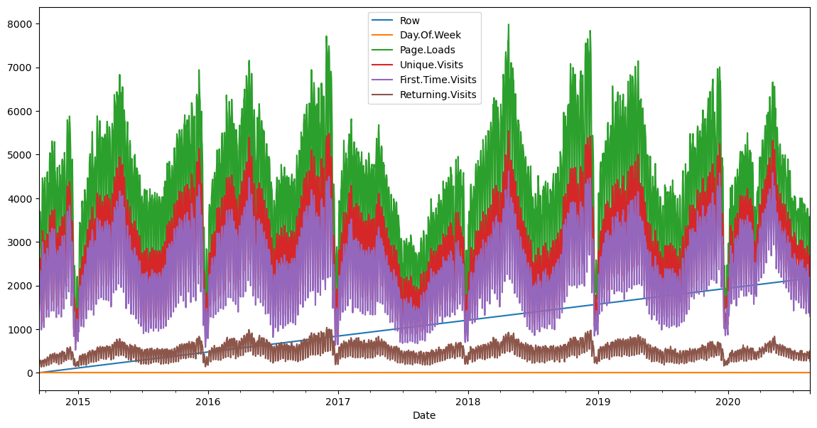

IN:

def prob(t, n, lmbda):

return math.pow(lmbda * t, n)/math.factorial(n)*math.exp(-lmbda*t)

mean = df['Page.Loads'].mean()

print( "mean loads per day:", mean)

std = df['Page.Loads'].std()

print( "std deviation of loads per day:", std)

n = 1

px = np.linspace(1, 8000, 50)

py = np.zeros(50)

for i in range(0, 50):

x = (px[i]-mean)/std

p = norm.pdf(x)

py[i] = 1000*p

OUT:

mean loads per day: 4116.9893862482695

std deviation of loads per day: 1350.9778426999621

IN:

fig, ax1 = plt.subplots()

df['Page.Loads'].plot.hist(ax = ax1, label='Page.Loads')

plt.plot([mean, mean], [0, 480], label='mean')

plt.plot(px, py, label='normal', color='red')

plt.legend()

plt.show()

OUT:

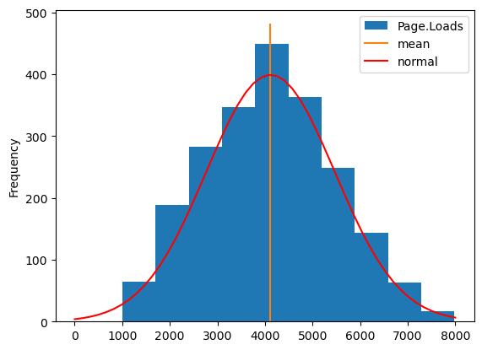

IN:

fig, ax1 = plt.subplots()

df['Page.Loads'].plot(ax = ax1, label='Page.Loads')

plt.plot([df.index[0], df.index[-1]], [mean, mean], color='red')

upper = mean + 1.96*std

lower = mean - 1.96*std

plt.plot([df.index[0], df.index[-1]], [upper, upper], color='green')

plt.plot([df.index[0], df.index[-1]], [lower, lower], color='green')

plt.show()

OUT:

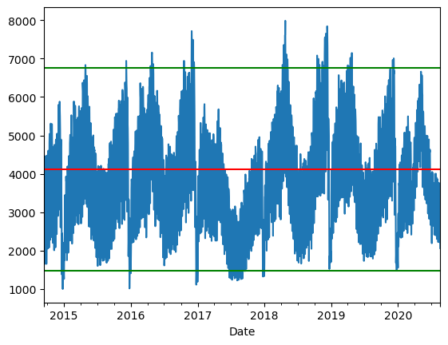

IN:

**import pandas as pd**

**FILE_LOCATION = ('/kaggle/input/daily-website-visitors/daily-website-visitors.csv')**

**whole_dataset=pd.read_csv(FILE_LOCATION,index_col='Date',thousands=',')**

**whole_dataset.index = pd.to_datetime(whole_dataset.index)**

**whole_dataset**

OUT:

|  |  |  |  |  |  |  |  |
| --- | --- | --- | --- | --- | --- | --- | --- |
| Row | Day | Day.Of.week | Date | Page.Loads | Unique.Visits | First.Time.Visits | Returning.Visits |
| 1 | Sunday | 1 | 9/14/2014 | 2,146 | 1,582 | 1,430 | 152 |
| 2 | Monday | 2 | 9/15/2014 | 3,621 | 2,528 | 2,297 | 231 |
| 3 | Tuesday | 3 | 9/16/2014 | 3,698 | 2,630 | 2,352 | 278 |
| 4 | Wednesday | 4 | 9/17/2014 | 3,667 | 2,614 | 2,327 | 287 |
| 5 | Thursday | 5 | 9/18/2014 | 3,316 | 2,366 | 2,130 | 236 |
| 6 | Friday | 6 | 9/19/2014 | 2,815 | 1,863 | 1,622 | 241 |
| 7 | Saturday | 7 | 9/20/2014 | 1,658 | 1,118 | 985 | 133 |
| 8 | Sunday | 1 | 9/21/2014 | 2,288 | 1,656 | 1,481 | 175 |
| 9 | Monday | 2 | 9/22/2014 | 3,638 | 2,586 | 2,312 | 274 |

IN:

**import matplotlib.pyplot as** **plt**

**fig, axs = plt.subplots(3, figsize=(12, 5))**

**axs[0].plot(whole_dataset['First.Time.Visits'])**

**axs[1].plot(whole_dataset['Unique.Visits'])**

**axs[2].plot(whole_dataset['Returning.Visits'])**

**plt.show()**

**OUT:**

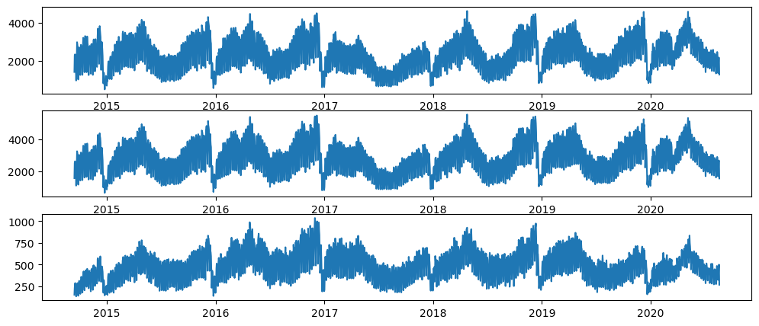  
IN:

**target_column = whole_dataset['Returning.Visits']**

**target_column**

**OUT:**

**Date**

**2014-09-14 152**

**2014-09-15 231**

**2014-09-16 278**

**2014-09-17 287**

**2014-09-18 236**

**...**

**2020-08-15 323**

**2020-08-16 351**

**2020-08-17 457**

**2020-08-18 499**

**2020-08-19 267**

**Name: Returning.Visits, Length: 2167, dtype: int64**

**In:**

**target_column.plot(figsize=(15, 3))**

**plt.show()**

out:

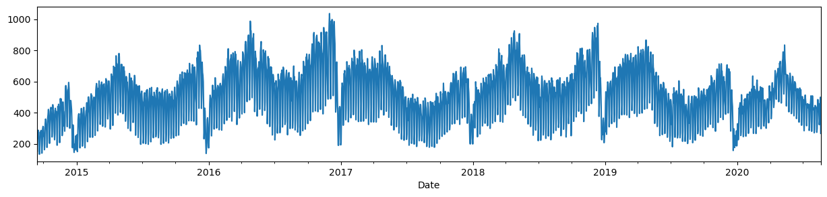

In:

**TEST_DATA_PERCENTAGE = 0.1**

**TEST_DATA_BOUNDARY_INDEX = int((1 - TEST_DATA_PERCENTAGE) * len(target_column))**

**print(f"Train data:\tReturning Visits [:{TEST_DATA_BOUNDARY_INDEX}] ({TEST_DATA_BOUNDARY_INDEX + 1})")**

**print(f"Test data:\tReturning Visits [{TEST_DATA_BOUNDARY_INDEX}:] ({len(target_column) - TEST_DATA_BOUNDARY_INDEX})")**

**print(f"\nLast target on train data: {target_column[TEST_DATA_BOUNDARY_INDEX]}")**

**out:**

**Train data: Returning Visits [:1950] (1951)**

**Test data: Returning Visits [1950:] (217)**

**In:**

**target_column[TEST_DATA_BOUNDARY_INDEX10:TEST_DATA_BOUNDARY_INDEX+10].**

**values, (list(train_dataset)[-1][0][-1].numpy(), list(train_dataset)[-1][1][-1].numpy())**

out:

(array([429, 423, 442, 464, 372, 253, 277, 515, 434, 394, 441, 413, 246, 314, 443, 484, 473, 490, 353, 249]),

(array([277, 515, 434]), 394))

Plot the train and test datasets

**In:**

**import numpy as np**

**import matplotlib.dates as** **mdates**

**def** **plot_time_series(predictions = None, start_index=1500):**

**timesteps = pd.to_datetime(target_column.index)**

**fig,ax = plt.subplots(1,figsize=(15,5))** **ax.xaxis.set_major_locator(mdates.MonthLocator(bymonth=(1, 7)))**

**ax.xaxis.set_minor_locator(mdates.MonthLocator())** **ax.xaxis.set_major_formatter(mdates.DateFormatter('%Y-%b'))**

***# Plot train dataset*** **plt.plot(timesteps[start_index:TEST_DATA_BOUNDARY_INDEX], target_column[start_index:TEST_DATA_BOUNDARY_INDEX],**

**color='blue')**

***# Plot test dataset***

**plt.plot(timesteps[TEST_DATA_BOUNDARY_INDEX:], target_column[TEST_DATA_BOUNDARY_INDEX:],**

**color='green', linewidth=0.4)**

**if** **predictions is not None:**

**pred_timesteps = timesteps[TEST_DATA_BOUNDARY_INDEX:]**

**plt.plot(pred_timesteps, predictions, linewidth=0.4, color='red')**

**plt.scatter(pred_timesteps, predictions, s=0.4, color='red')**

**plot_time_series()**

out:

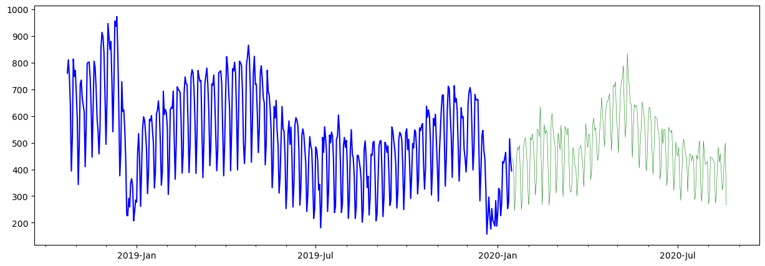

**In:**

import tensorflow as tf

from tensorflow.keras.layers import Layer

from tensorflow.keras import Model

class **NaiveForecastLayer**(Model):

def __init__(self):

super().__init__()

def call(self, inputs):

result = inputs[:, -1]

return result[:, tf.newaxis]

baseline_model = NaiveForecastLayer()

baseline_model._name = 'model_0'

baseline_model.compile(metrics=[tf.keras.metrics.MeanAbsoluteError()])

baseline_predictions = baseline_model.predict(test_dataset)

plot_time_series(baseline_predictions.ravel(), start_index=1900)

out:

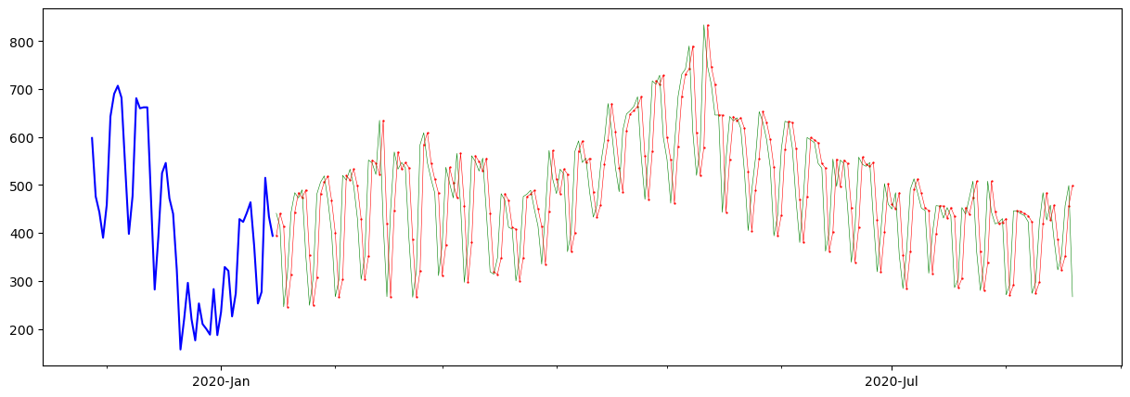

In:

**y_true = target_column[TEST_DATA_BOUNDARY_INDEX : ]**

**len(y_true), y_true**

out:

(217,

**Date**

**2020-01-16 441**

**2020-01-17 413**

**2020-01-18 246**

**2020-01-19 314**

**2020-01-20 443**

**...**

**2020-08-15 323**

**2020-08-16 351**

**2020-08-17 457**

**2020-08-18 499**

**2020-08-19 267**

**Name: Returning.Visits, Length: 217, dtype: int64)**

**In:**

**DAYS_OF_WEEK = ['Monday', 'Tuesday', 'Wednesday', 'Thursday', 'Friday', 'Saturday', 'Sunday']**

**pd.DataFrame(dataset_by_day['Returning.Visits'].mean()).loc[DAYS_OF_WEEK].plot(kind='bar')**

**out:**

<Axes: xlabel='Day'>

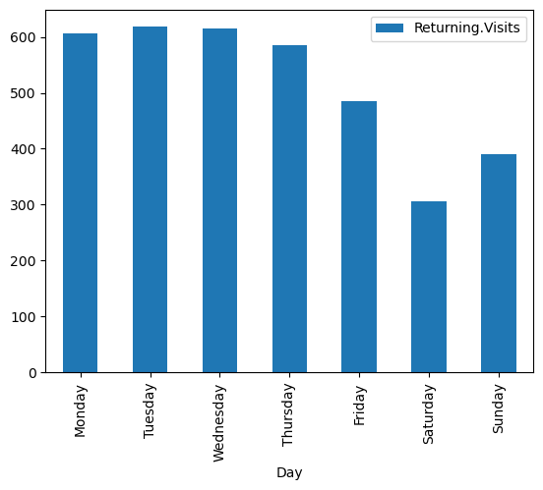

**In:**

**dataset_by_day['Returning.Visits'].hist(legend=True, alpha=0.5)**

**plt.show()**

**out:**

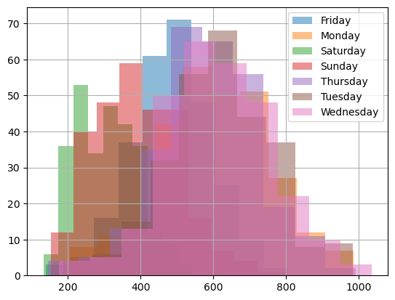

**In:**

**pd.DataFrame(dataset_group_by_month['Returning.Visits'].mean()).loc[MONTH_NAMES].plot(kind='bar')**

**plt.show()**

**out:**

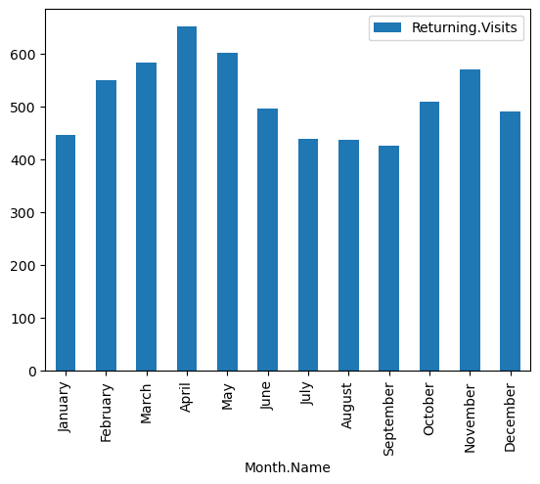

**In:**

**from tensorflow.data import** **Dataset**

**model3_history = model_3.fit(x=[dataset2_rv_history_features, X_cat_encoded], y=train_dataset2, epochs=5)**

**pd.DataFrame(model3_history.history).plot()**

**out:**

**Epoch 1/5**

**61/61 [==============================] - 3s 7ms/step - loss: 232.3113**

**Epoch 2/5**

**61/61 [==============================] - 0s 7ms/step - loss: 105.8665**

**Epoch 3/5**

**61/61 [==============================] - 0s 7ms/step - loss: 90.6746**

**Epoch 4/5**

**61/61 [==============================] - 0s 7ms/step - loss: 82.1568**

**Epoch 5/561/61 [==============================]- 0s 7ms/step - loss: 80.3541**

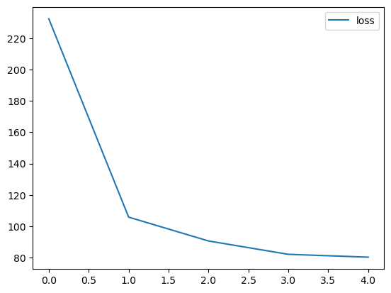

<Axes: >

**In:**

**y_dataset = test_dataset2['Returning.Visits']**

**y_dataset**

out:

**Date**

**2020-01-16 441**

**2020-01-17 413**

**2020-01-18 246**

**2020-01-19 314**

**2020-01-20 443**

**...**

**2020-08-15 323**

**2020-08-16 351**

**2020-08-17 457**

**2020-08-18 499**

**2020-08-19 267**

**Name: Returning.Visits, Length: 217, dtype: int64**

**In:**

**def** **evaluate_model_predictions(y_true, predictions, model_name):**

**metrics = evaluate_predictions(y_true, predictions)**

**MODEL_METRICS.loc[model_name] = metrics**

**plot_time_series(predictions.ravel(), start_index=1900)**

**return** **metrics**

**evaluate_model_predictions(y_dataset, model_3_preds, 'model_3 (multi-input)')**

**out:**

**{'mae': 72.46600053497174,**

**'mse': 8797.218902262757,**

**'rmse': 93.79349072437147,**

**'mape': 0.15300125677432075}**

**In:**

**import numpy as np**

**import pandas as pd**

**import pandas_profiling**

**import warnings**

**warnings.filterwarnings('ignore')**

**import datetime**

**from datetime import date**

**import seaborn as sns**

**import matplotlib.pyplot as plt**

**%matplotlib inline**

**sns.set_style("whitegrid")**

**# import chart_studio.plotly as py**

**import cufflinks as cf**

**import plotly.express as px**

**from plotly.offline import download_plotlyjs, init_notebook_mode, plot, iplot**

**init_notebook_mode(connected=True)**

**cf.go_offline()**

**import pandas_profiling**

**import plotly.graph_objects as go**

**from sklearn.model_selection import train_test_split, cross_val_score, GridSearchCV**

**from sklearn.metrics import accuracy_score**

**from sklearn.svm import SVR**

**from sklearn.linear_model import LinearRegression**

**from sklearn.tree import DecisionTreeRegressor**

**import xgboost as xg**

**df=pd.read_csv('../input/daily-website-visitors/daily-website-visitors.csv')**

**df.rename(columns = {'Day.Of.Week':'day_of_week'**

**,'Page.Loads':'page_loads'**

**,'Unique.Visits':'unique_visits'**

**,'First.Time.Visits':'first_visits'**

**,'Returning.Visits':'returning_visits'}, inplace = True)**

**df=df.replace(',','',regex=True)**

**df['page_loads']=df['page_loads'].astype(int)**

**df['unique_visits']=df['unique_visits'].astype(int)**

**df['first_visits']=df['first_visits'].astype(int)**

**df['returning_visits']=df['returning_visits'].astype(int)**

**df**

**out:**

**Row Day day_of_week Date page_loads unique_visit first_visits**

**0 1 Sunday 1 9/14/2014 2146 1582 1430 152**

**1 2 Monday 2 9/15/2014 3621 2528 2297 231**

**2 3 Tuesday 3 9/16/2014 3698 2630 2352 278**

**3 4 Wednesday 4 9/17/2014 3667 2614 2327 287**

**4 5 Thursday 5 9/18/2014 3316 2366 2130 236**

**... ... ... ... ... ... ... ... ...**

**2162 2163 Saturday 7 8/15/2020 2221 1696 1373 323**

**2163 2164 Sunday 1 8/16/2020 2724 2037 1686 351**

In:

df.isna().sum()

out:

Row 0

Day 0

day_of_week 0

Date 0

page_loads 0

unique_visits 0

first_visits 0

returning_visits 0

dtype: int64

In:

df.duplicated().sum()

out:

0

In:

df.info()

out:

<class 'pandas.core.frame.DataFrame'>

RangeIndex: 2167 entries, 0 to 2166

Data columns (total 8 columns):

# Column Non-Null Count Dtype

--- ------ -------------- -----

0 Row 2167 non-null int64

1 Day 2167 non-null object

2 day_of_week 2167 non-null int64

3 Date 2167 non-null object

4 page_loads 2167 non-null int64

5 unique_visits 2167 non-null int64

6 first_visits 2167 non-null int64

7 returning_visits 2167 non-null int64

dtypes: int64(6), object(2)

memory usage: 135.6+ KB

In:

px.line(df,x='Date',y=['page_loads' ,'unique_visits' ,'first_visits' ,'returning_visits'],

labels={'value':'Visits'}

,title='Page Loads & visitors over Time')

Out:

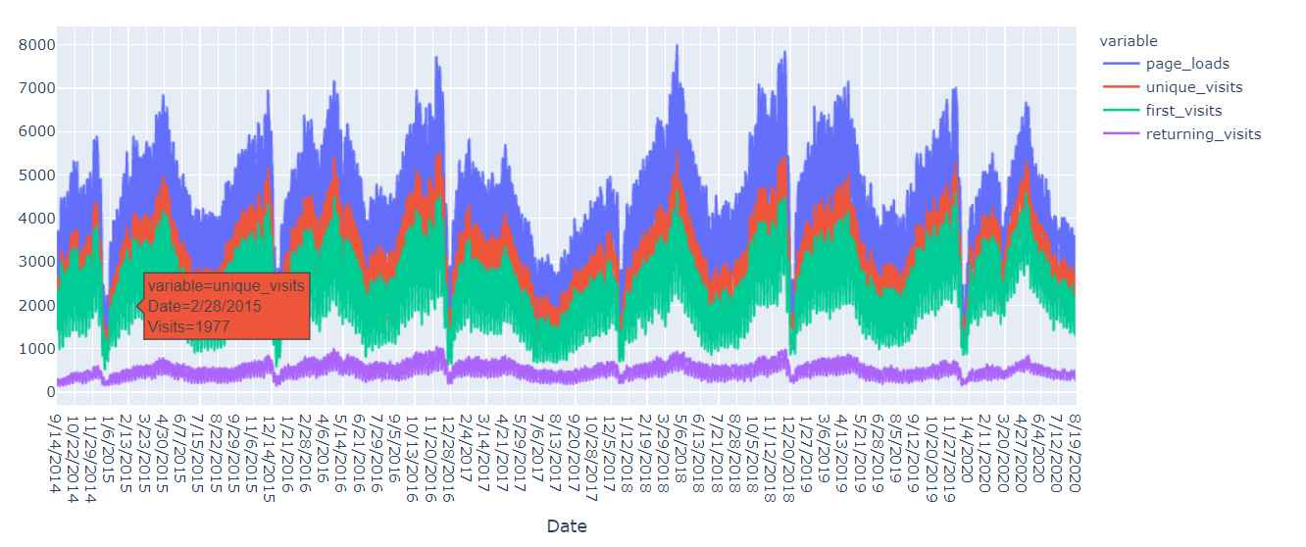

In:

px.histogram(df,x='unique_visits',color='Day',title='unique visits for each day')

out:

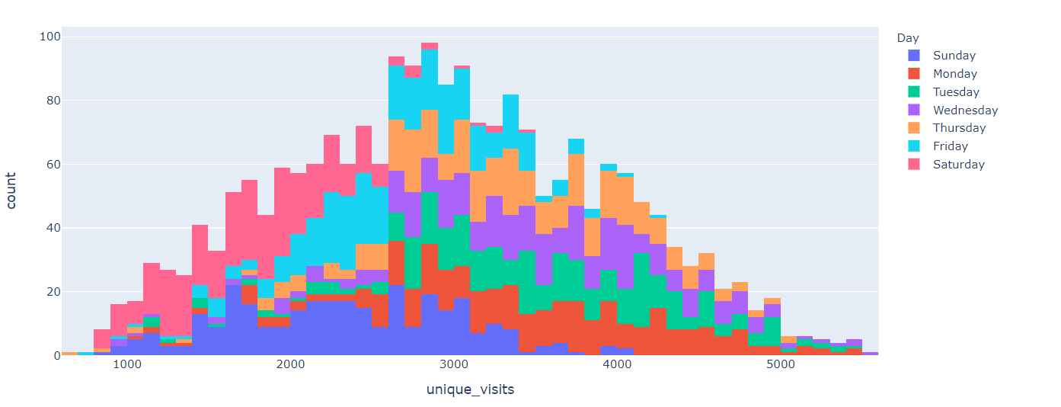

In:

day_imp=df.groupby(['Day'])['unique_visits'].agg(['sum']).sort_values(by='sum',ascending=False)

px.bar(day_imp,labels={'value':'sum of unique visits'},title='Sum of Unique visits for each day')

out:

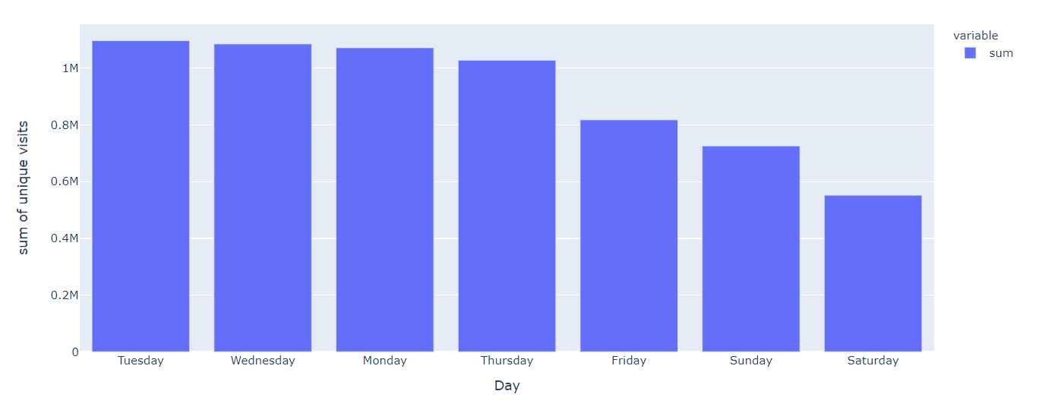

In:

px.histogram(df,x='Date',y='unique_visits',color='Day',title='Sum of unique visits for each day over Time')

out: 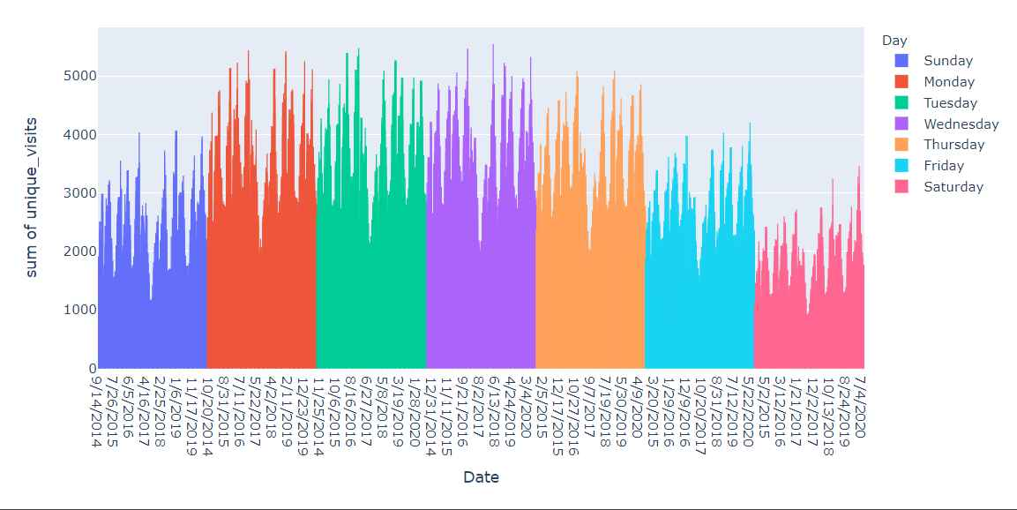

In:

sums=df.groupby(['Day'])[['page_loads' ,'unique_visits' ,'first_visits' ,'returning_visits']].sum().sort_values(

by='unique_visits',ascending=False)

sums

out:

| page_loads | unique_visits | first_visits | returning_visits |
| --- | --- | --- | --- |
| Day |  |  |  |
| Tuesday | 1536154 | 1097181 | 907752 |
| Wednesday | 1517114 | 1085624 | 897602 |

In:

px.bar(sums,barmode='group',title='Sum of page loads and visits for each of their days')

out:

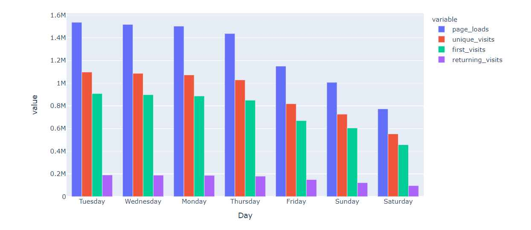

In:

px.density_heatmap(df, x='Date',y=['page_loads' ,'unique_visits' ,'first_visits' ,'returning_visits']

*color_continuous_scale="Viridis"*

,marginal_x="histogram", marginal_y="histogram",title='Correlation for each data point')

Out: 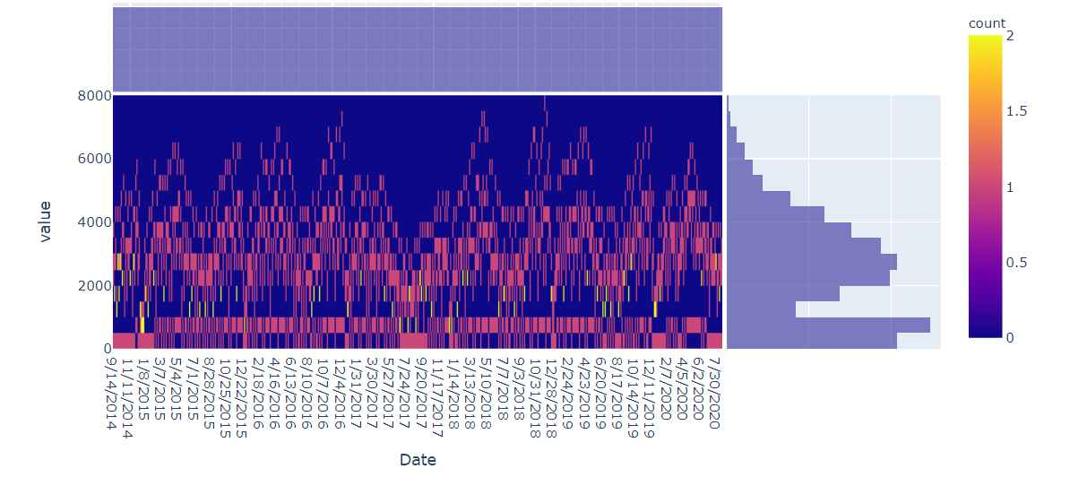

In:

fig, ax = plt.subplots()

fig.set_size_inches(8, 6)

sns.heatmap(df[['page_loads' ,'unique_visits' ,'first_visits' ,'returning_visits']].corr(),

annot=True,

cmap='viridis_r',

fmt='g')

out:

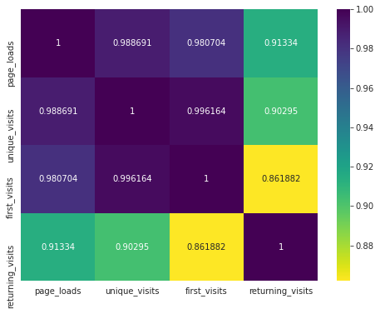

In:

px.scatter_matrix(df[['page_loads' ,'unique_visits' ,'first_visits' ,'returning_visits']])

out:

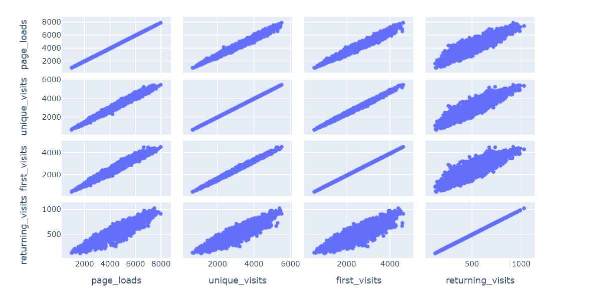

In:

px.scatter(

df, x='first_visits', y='unique_visits',opacity=0.4,

trendline='ols', trendline_color_override='purple',title="Regression line for unique visits and first visits"

)

Out:

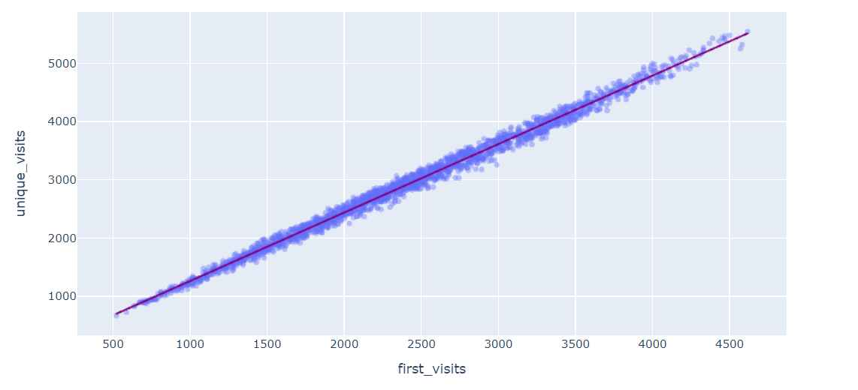

In:

px.violin(df,y=['page_loads' ,'unique_visits' ,'first_visits' ,'returning_visits'],box=True,points='all')

out:

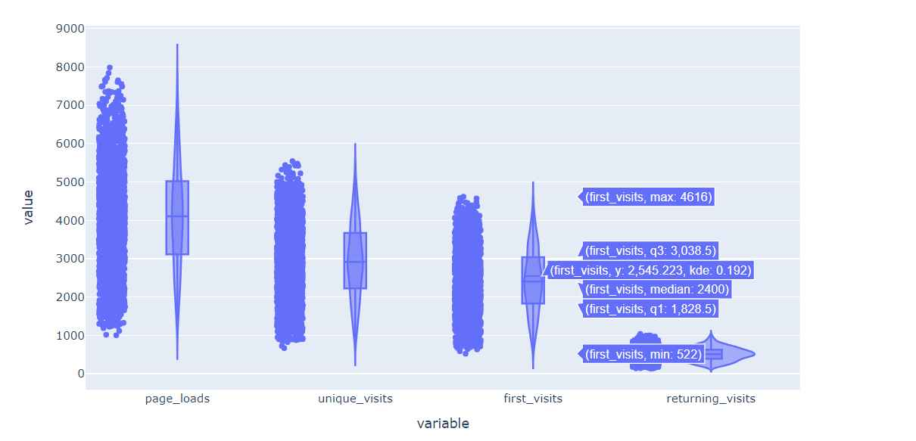

In:

regressor2=LinearRegression(fit_intercept=False,normalize=True)

regressor2.fit(X_train, y_train)

out:

LinearRegression(fit_intercept=False, normalize=True)

In:

plt.figure(figsize=(16,8))

sns.lineplot(data=lr2)

out:

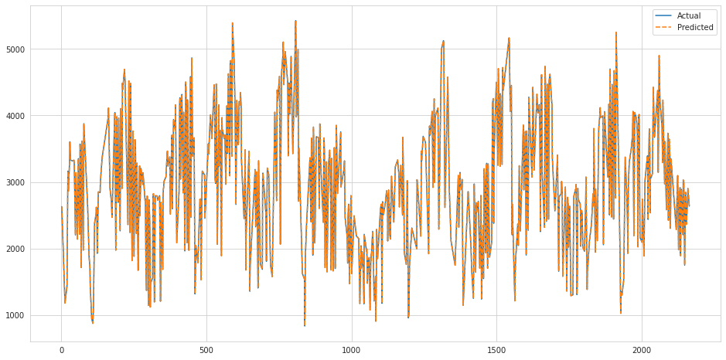

In:

regressor2.score(X_test,y_test)*100

out:

100.0

In:

svr_rbf = SVR(kernel='rbf', C=1e3, gamma=0.00001)

svr_rbf.fit(X_train, y_train)

out 19:

SVR(C=1000.0, gamma=1e-05)

In:

plt.figure(figsize=(16,8))

sns.lineplot(data=svr)

out:

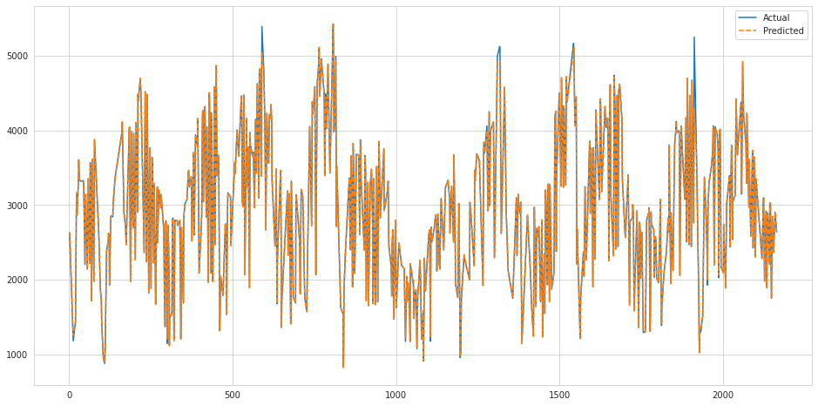

In:

svr_rbf.score(X_test,y_test)*100

out:

99.80054455767926

In:

xgb_r = xg.XGBRegressor(objective ='reg:squarederror',n_estimators = 10, seed = 123)

xgb_r.fit(X_train, y_train)

out:

XGBRegressor(base_score=0.5, booster='gbtree', colsample_bylevel=1,

colsample_bynode=1, colsample_bytree=1, gamma=0, gpu_id=-1,

importance_type='gain', interaction_constraints='',

learning_rate=0.300000012, max_delta_step=0, max_depth=6,

min_child_weight=1, missing=nan, monotone_constraints='()',

n_estimators=10, n_jobs=4, num_parallel_tree=1, random_state=123,

reg_alpha=0, reg_lambda=1, scale_pos_weight=1, seed=123,

subsample=1, tree_method='exact', validate_parameters=1,

verbosity=None)

In:

plt.figure(figsize=(16,8))

sns.lineplot(data=xgb_df)

out:

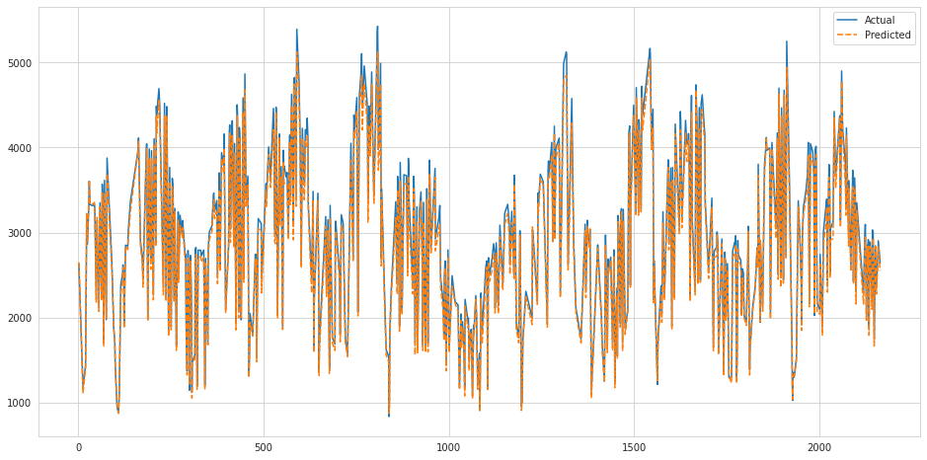

In:

xgb_r.score(X_test,y_test)*100

out:

98.7655882096893

Benefits:

Website traffic analysis is a crucial activity for businesses and website owners because it provides valuable insights into how a website is performing and how visitors are interacting with it. Here are some of the key benefits of website traffic analysis:

* Performance Evaluation:

Website traffic analysis allows you to assess the overall performance of your website. You can track metrics like the number of visitors, page views, and bounce rate to see how well your website is attracting and retaining visitors.

* Visitor Behavior:

Understanding how visitors interact with your website can help you identify what content is most popular, which pages are driving conversions, and where visitors tend to drop off. This information can guide content and design improvements.

* Content Optimization:

By analyzing which content is most engaging and which isn't, you can tailor your content strategy to meet the preferences of your audience. This can lead to higher engagement, longer time spent on your site, and increased conversions.

* Conversion Rate Improvement:

Website traffic analysis helps you track conversion goals, such as form submissions, product purchases, or other desired actions. By identifying where users drop off in the conversion funnel, you can make targeted improvements to increase your conversion rates.

* User Experience Enhancement:

Through metrics like page load times and device usage, you can optimize your website's user experience. A faster, responsive, and user-friendly site can result in higher user satisfaction and more return visits.

* Marketing ROI:

Analyzing website traffic can help you measure the effectiveness of your marketing efforts. You can determine which marketing channels are driving the most traffic and conversions, enabling you to allocate resources more effectively.

* SEO Optimization:

Analyzing search traffic can help you refine your SEO strategy. You can identify keywords that drive traffic, monitor your search engine rankings, and discover opportunities to improve your website's search engine visibility.

* Data-Driven Decision Making:

Website traffic analysis provides data to support decision-making. Instead of relying on guesswork, you can make informed choices about website improvements, marketing strategies, and resource allocation.

* Security Monitoring:

Monitoring your website's traffic can also help you detect unusual or potentially harmful activities, such as malicious bot traffic or security breaches.

* Cost Efficiency:

By understanding the behavior of your website visitors, you can allocate resources more efficiently, reducing costs and increasing the return on investment.

To perform website traffic analysis, web analytics tools like Google Analytics, Adobe Analytics, or other specialized platforms are commonly used. These tools provide detailed insights into website performance, user behavior, and more, making it easier to harness the benefits mentioned above.

Advantages:

Website traffic analysis offers several advantages for website owners and businesses, helping them make informed decisions, improve their online presence, and achieve their goals. Some of the key advantages of website traffic analysis include:

* Performance Monitoring:

You can track the performance of your website in real-time or over a specified period. This allows you to assess the health and stability of your site and make necessary adjustments.

* Visitor Insights:

Website traffic analysis provides valuable data about your website's visitors, including their demographics, geographic location, and browsing behavior. This information helps you understand your audience better.

* Content Optimization:

By analyzing which pages and content are most popular, you can tailor your content strategy to meet the preferences of your audience, leading to higher engagement and user satisfaction.

* Conversion Rate Improvement:

Traffic analysis tools help you identify where users drop off in the conversion funnel, enabling you to make targeted improvements to increase conversion rates and achieve your business goals.

* User Experience Enhancement:

You can identify issues that affect user experience, such as slow page load times, mobile responsiveness problems, or broken links, and take steps to address them, resulting in a more user-friendly website.

* Marketing ROI:

Website traffic analysis allows you to track the effectiveness of your marketing efforts, helping you allocate resources more effectively and optimize your marketing strategies.

* Search Engine Optimization (SEO):

You can analyze search traffic to determine which keywords drive traffic, monitor search engine rankings, and identify opportunities to improve your website's visibility on search engines.

* Competitor Analysis:

You can compare your website's performance metrics to those of your competitors, helping you identify areas for improvement and gain a competitive advantage.

* Data-Driven Decision Making:

Website traffic analysis provides data-driven insights that support decision-making. This reduces the reliance on guesswork and helps you make informed choices about your website and marketing strategies.

* Cost Efficiency:

By understanding visitor behavior and preferences, you can allocate resources more efficiently, reduce costs, and increase the return on investment.

* Security Monitoring:

You can use traffic analysis to detect and mitigate security threats, such as malicious bot traffic or unauthorized access attempts.

* Trend Identification:

Tracking website traffic over time can help you identify trends in visitor behavior and adapt your strategies accordingly.

* Feedback and Improvement:

The data generated from traffic analysis can be used as feedback to make continuous improvements to your website, ensuring it remains current and relevant.

* Performance Benchmarks:

Website traffic analysis allows you to set performance benchmarks and goals, which can be useful in measuring your progress and setting targets for improvement.

* Adaptation to Changes:

As the digital landscape evolves, website traffic analysis helps you adapt to changes in user behavior, technology, and marketing trends.

In summary, website traffic analysis is a powerful tool that provides insights into your website's performance, user behavior, and the effectiveness of your online strategies. These insights can be used to make data-informed decisions, improve your website, and achieve your business objectives.

Dis-advantage:

While website traffic analysis offers numerous advantages, it also has some potential disadvantages and limitations that should be considered:

* Privacy Concerns:

Collecting and analyzing website traffic data may raise privacy concerns, especially when personally identifiable information is inadvertently or intentionally collected. Compliance with data protection regulations, such as GDPR or CCPA, is essential.

* Resource Intensive:

Implementing and maintaining web analytics tools can be resource-intensive in terms of time, money, and personnel. Smaller websites may find it challenging to allocate these resources.

* Inaccurate Data:

Traffic analysis tools may not always provide perfectly accurate data. Bots, ad blockers, and other factors can skew metrics. It's important to be aware of potential inaccuracies in the data.

* Overemphasis on Metrics:

Overreliance on web analytics metrics can lead to a narrow focus on numbers at the expense of qualitative insights and a deeper understanding of user behavior and motivations.

* Data Overload:

With an abundance of data available, it's easy to become overwhelmed by the sheer volume of information. It's important to focus on the most relevant metrics and avoid analysis paralysis.

To overcome these potential disadvantages, website owners and businesses should approach web traffic analysis thoughtfully, prioritize data privacy and security, use data as a supplement to qualitative insights, and continually seek to improve their data interpretation skills. analysis paralysis.

Conclusion:

In conclusion, website traffic analysis is a valuable practice for website owners and businesses seeking to understand and optimize their online presence. It provides a wealth of insights into website performance, user behavior, and the effectiveness of digital strategies. These insights can inform data-driven decision-making, content optimization, and marketing efforts, leading to improved user experiences and higher conversion rates.

However, it's important to approach website traffic analysis with awareness of its potential disadvantages, including privacy concerns, data accuracy issues, and the risk of focusing too heavily on numbers over qualitative insights. To maximize the benefits and minimize the drawbacks, website owners should prioritize user privacy and data security, strike a balance between quantitative and qualitative analysis, and ensure they have the expertise to interpret and act upon the data effectively.

In an ever-evolving digital landscape, website traffic analysis is an indispensable tool for adapting to changes, identifying trends, and making continuous improvements to ensure a website remains relevant, competitive, and aligned with its goals. When used wisely, website traffic analysis can be a cornerstone of success in the online world.