**Website traffic analysis**

**Phase 4**: Development part 2

**Topic:** Use IBM Cognos to create interactive dashboards and reports that display insights such as popular pages, traffic sources, and user engagement metrics.

* Use Python libraries like Pandas and Matplotlib to perform more complex analyses on the data, such as time series analysis, user segmentation, or machine learning-based predictions.



**Introduction:**

* Website traffic refers to the volume of visitors or users who access a particular website during a given period. It is a fundamental metric in web analytics, providing valuable insights into a website's performance and the behavior of its audience. Understanding website traffic is essential for businesses, organizations, and individuals seeking to optimize their online presence and achieve various goals, such as increasing brand visibility, driving conversions, or improving user experience.

**Program:**

import numpy as np

import pandas as pd

import pandas_profiling

import warnings

warnings.filterwarnings('ignore')

import datetime

from datetime import date

import seaborn as sns

import matplotlib.pyplot as plt

%matplotlib inline

sns.set_style("whitegrid")

# import chart_studio.plotly as py

import cufflinks as cf

import plotly.express as px

from plotly.offline import download_plotlyjs, init_notebook_mode, plot, iplot

init_notebook_mode(connected=True)

cf.go_offline()

import pandas_profiling

import plotly.graph_objects as go

from sklearn.model_selection import train_test_split, cross_val_score, GridSearchCV

from sklearn.metrics import accuracy_score

from sklearn.svm import SVR

from sklearn.linear_model import LinearRegression

from sklearn.tree import DecisionTreeRegressor

import xgboost as xg

df=pd.read_csv('../input/daily-website-visitors/daily-website-visitors.csv')

df.rename(columns = {'Day.Of.Week':'day_of_week'

,'Page.Loads':'page_loads'

,'Unique.Visits':'unique_visits'

,'First.Time.Visits':'first_visits'

,'Returning.Visits':'returning_visits'}, inplace = True)

df=df.replace(',','',regex=True)

df['page_loads']=df['page_loads'].astype(int)

df['unique_visits']=df['unique_visits'].astype(int)

df['first_visits']=df['first_visits'].astype(int)

df['returning_visits']=df['returning_visits'].astype(int)

df

**out 1:**

**Row Day day_of_week Date page_loads unique_visit first_visits**

**0 1 Sunday 1 9/14/2014 2146 1582 1430 152**

**1 2 Monday 2 9/15/2014 3621 2528 2297 231**

**2 3 Tuesday 3 9/16/2014 3698 2630 2352 278**

**3 4 Wednesday 4 9/17/2014 3667 2614 2327 287**

**4 5 Thursday 5 9/18/2014 3316 2366 2130 236**

**... ... ... ... ... ... ... ... ...**

**2162 2163 Saturday 7 8/15/2020 2221 1696 1373 323**

**2163 2164 Sunday 1 8/16/2020 2724 2037 1686 351**

**In 2:**

df.isna().sum()

**out 2:**

Row 0

Day 0

day_of_week 0

Date 0

page_loads 0

unique_visits 0

first_visits 0

returning_visits 0

dtype: int64

**In 3:**

df.duplicated().sum()

**out 3:**

0

**In 4:**

df.info()

**out 4:**

<class 'pandas.core.frame.DataFrame'>

RangeIndex: 2167 entries, 0 to 2166

Data columns (total 8 columns):

# Column Non-Null Count Dtype

--- ------ -------------- -----

0 Row 2167 non-null int64

1 Day 2167 non-null object

2 day_of_week 2167 non-null int64

3 Date 2167 non-null object

4 page_loads 2167 non-null int64

5 unique_visits 2167 non-null int64

6 first_visits 2167 non-null int64

7 returning_visits 2167 non-null int64

dtypes: int64(6), object(2)

memory usage: 135.6+ KB

**In 5:**

px.line(df,x='Date',y=['page_loads' ,'unique_visits' ,'first_visits' ,'returning_visits'],

labels={'value':'Visits'}

,title='Page Loads & visitors over Time')

**Out 5:**

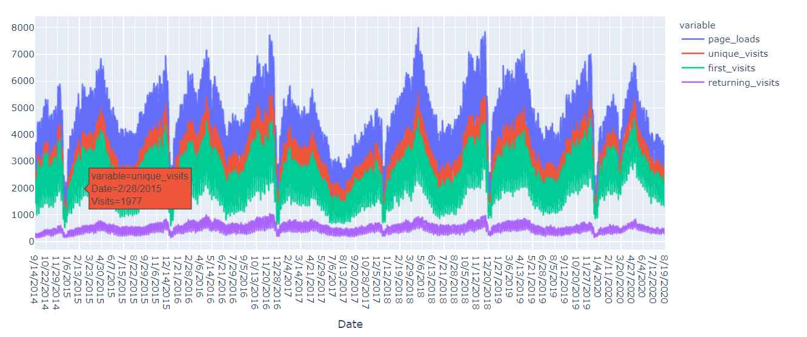

**In 6:**

px.histogram(df,x='unique_visits',color='Day',title='unique visits for each day')

**out 6:**

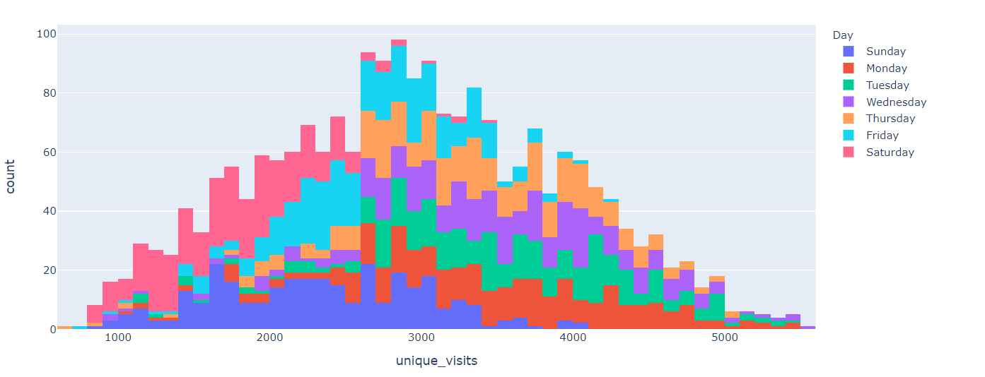

**In 7:**

day_imp=df.groupby(['Day'])['unique_visits'].agg(['sum']).sort_values(by='sum',ascending=False)

px.bar(day_imp,labels={'value':'sum of unique visits'},title='Sum of Unique visits for each day')

**out 7:**

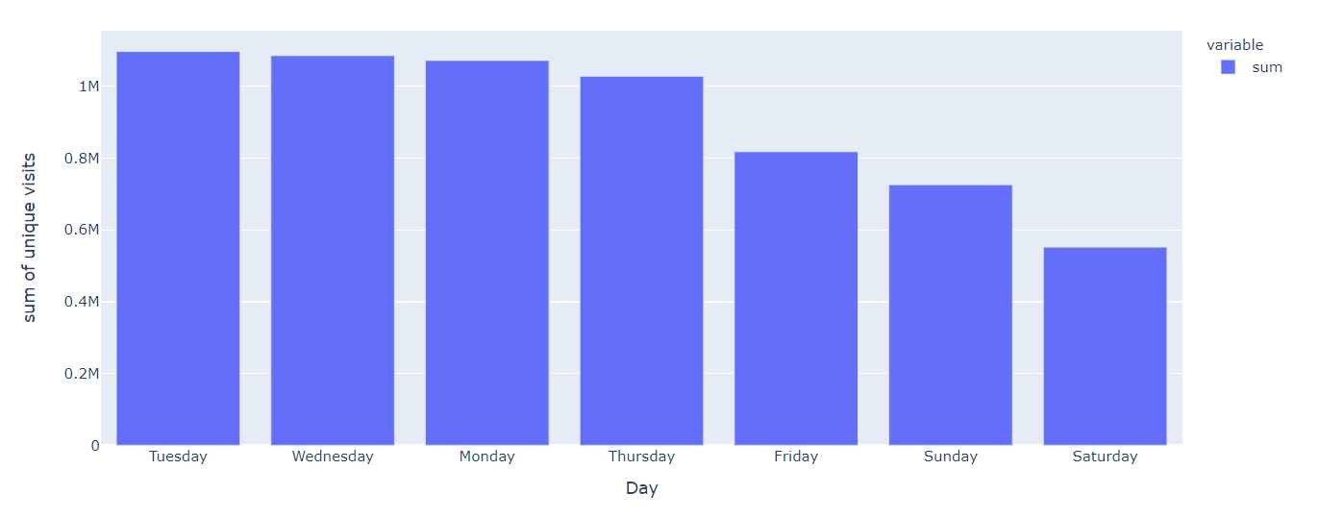

**In 8:**

px.histogram(df,x='Date',y='unique_visits',color='Day',title='Sum of unique visits for each day over Time')

**out 8:**

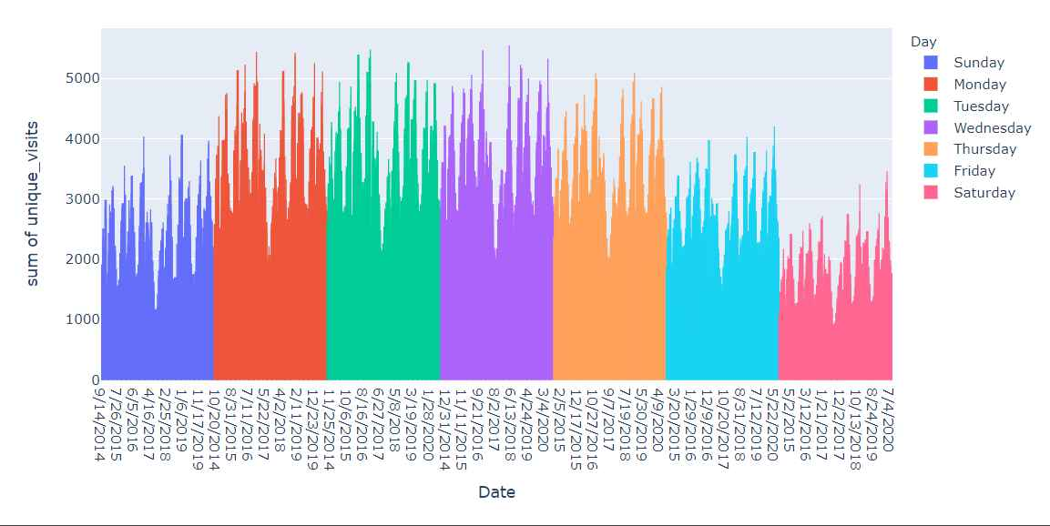

**In 9:**

sums=df.groupby(['Day'])[['page_loads' ,'unique_visits' ,'first_visits' ,'returning_visits']].sum().sort_values(

by='unique_visits',ascending=False)

sums

**out 9:**

| page_loads | unique_visits | first_visits | returning_visits |
| --- | --- | --- | --- |
| Day |  |  |  |
| Tuesday | 1536154 | 1097181 | 907752 |
| Wednesday | 1517114 | 1085624 | 897602 |

**In 10:**

px.bar(sums,barmode='group',title='Sum of page loads and visits for each of their days')

**out 10:**

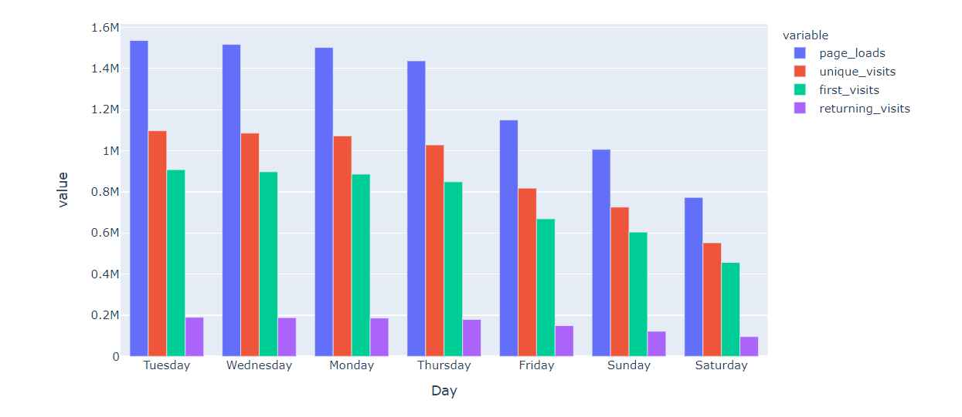

**In 11:**

px.density_heatmap(df, x='Date',y=['page_loads' ,'unique_visits' ,'first_visits' ,'returning_visits']

*color_continuous_scale="Viridis"*

,marginal_x="histogram", marginal_y="histogram",title='Correlation for each data point')

**Out 11:** 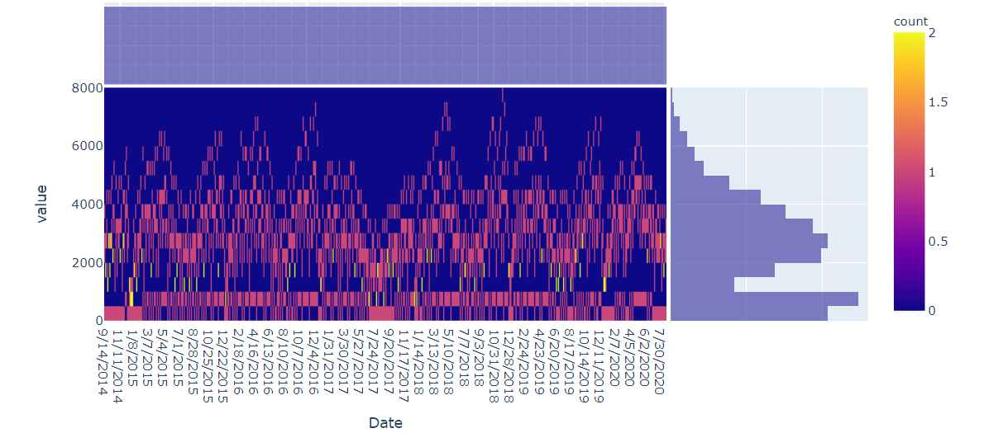

**In 12:**

fig, ax = plt.subplots()

fig.set_size_inches(8, 6)

sns.heatmap(df[['page_loads' ,'unique_visits' ,'first_visits' ,'returning_visits']].corr(),

annot=True,

cmap='viridis_r',

fmt='g')

**out 12:**

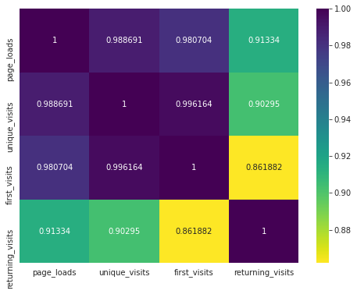

**In 13:**

px.scatter_matrix(df[['page_loads' ,'unique_visits' ,'first_visits' ,'returning_visits']])

**out 13:**

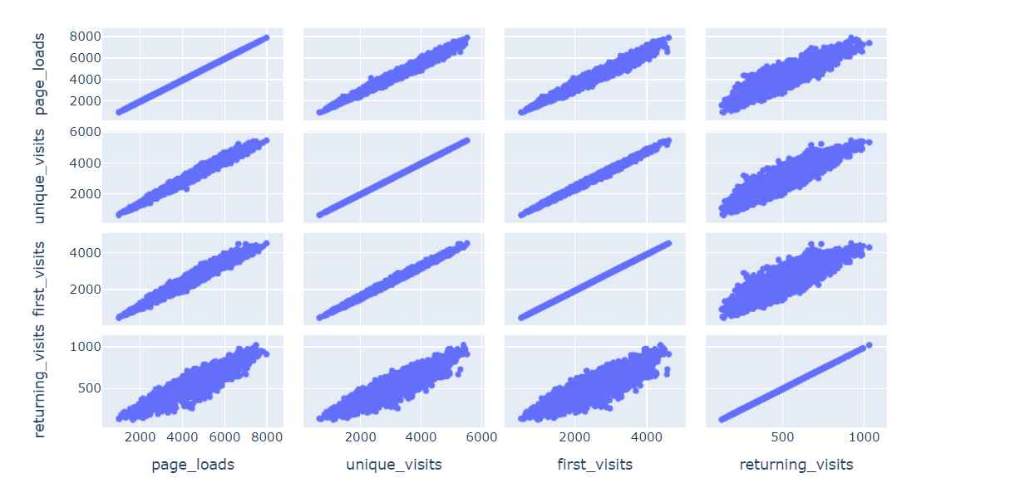

**In 14:**

px.scatter(

df, x='first_visits', y='unique_visits',opacity=0.4,

trendline='ols', trendline_color_override='purple',title="Regression line for unique visits and first visits"

)

**Out 14:**

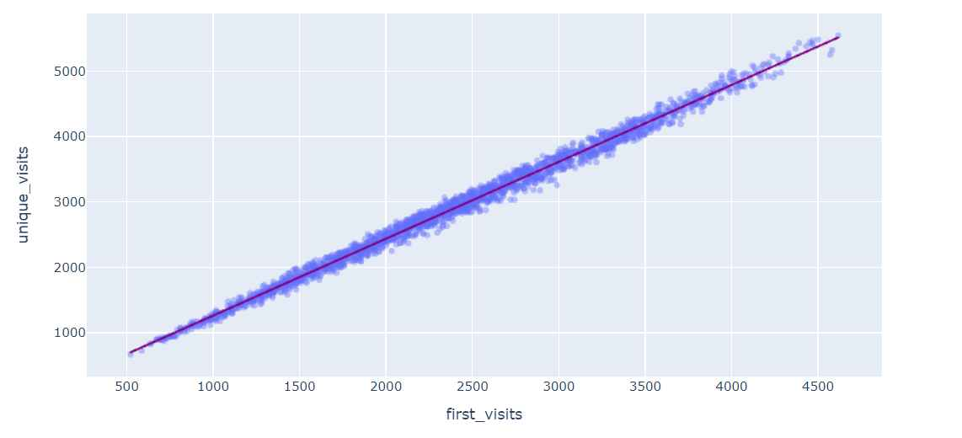

**In 15:**

px.violin(df,y=['page_loads' ,'unique_visits' ,'first_visits' ,'returning_visits'],box=True,points='all')

**out 15:**

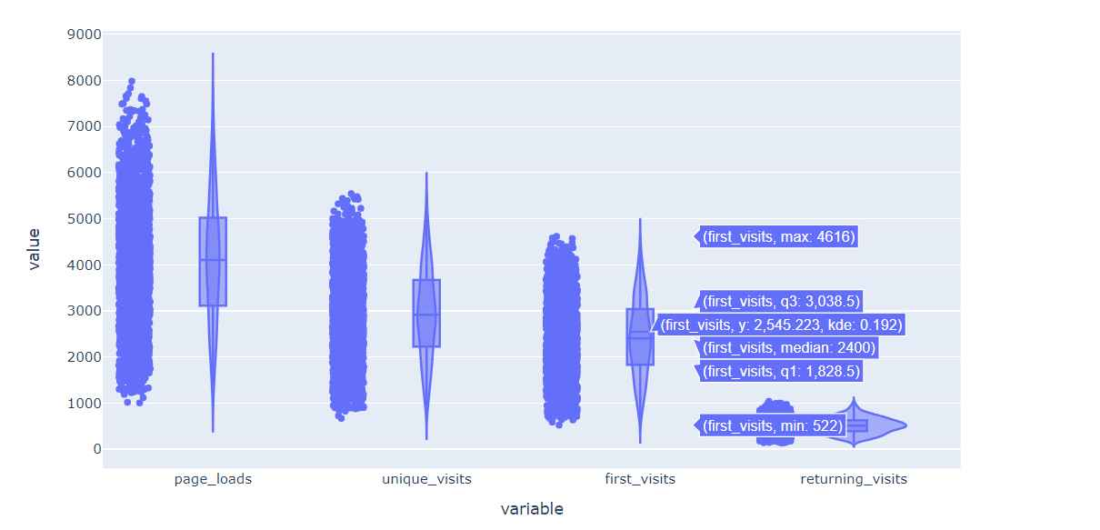

**In 16:**

regressor2=LinearRegression(fit_intercept=False,normalize=True)

regressor2.fit(X_train, y_train)

**out 16:**

LinearRegression(fit_intercept=False, normalize=True)

**In 17:**

plt.figure(figsize=(16,8))

sns.lineplot(data=lr2)

**out 17:**

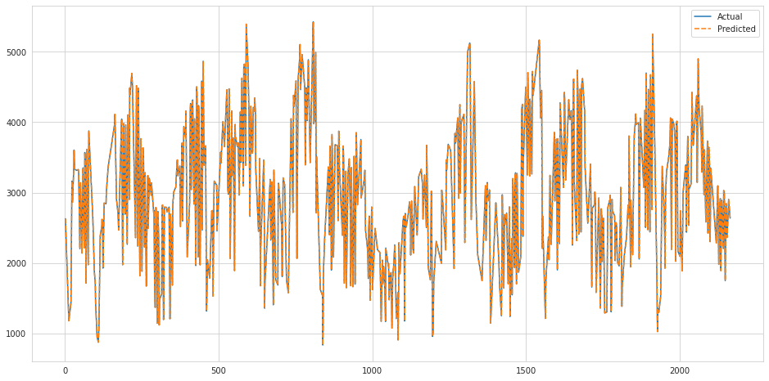

**In 18:**

regressor2.score(X_test,y_test)*100

**out 18:**

100.0

**In 19:**

svr_rbf = SVR(kernel='rbf', C=1e3, gamma=0.00001)

svr_rbf.fit(X_train, y_train)

**out 19:**

SVR(C=1000.0, gamma=1e-05)

**In 20:**

plt.figure(figsize=(16,8))

sns.lineplot(data=svr)

**out 20:**

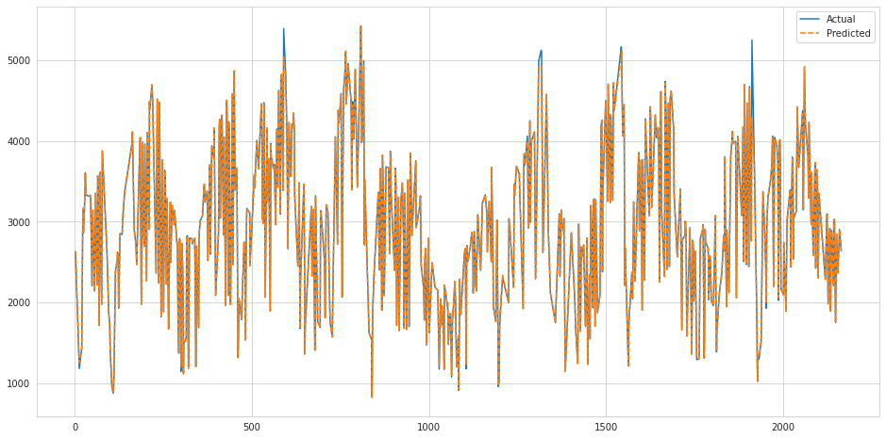

**In 21:**

svr_rbf.score(X_test,y_test)*100

**out 21:**

99.80054455767926

**In 22:**

xgb_r = xg.XGBRegressor(objective ='reg:squarederror',n_estimators = 10, seed = 123)

xgb_r.fit(X_train, y_train)

**out 22:**

XGBRegressor(base_score=0.5, booster='gbtree', colsample_bylevel=1,

colsample_bynode=1, colsample_bytree=1, gamma=0, gpu_id=-1,

importance_type='gain', interaction_constraints='',

learning_rate=0.300000012, max_delta_step=0, max_depth=6,

min_child_weight=1, missing=nan, monotone_constraints='()',

n_estimators=10, n_jobs=4, num_parallel_tree=1, random_state=123,

reg_alpha=0, reg_lambda=1, scale_pos_weight=1, seed=123,

subsample=1, tree_method='exact', validate_parameters=1,

verbosity=None)

**In 23:**

plt.figure(figsize=(16,8))

sns.lineplot(data=xgb_df)

**out 23:**

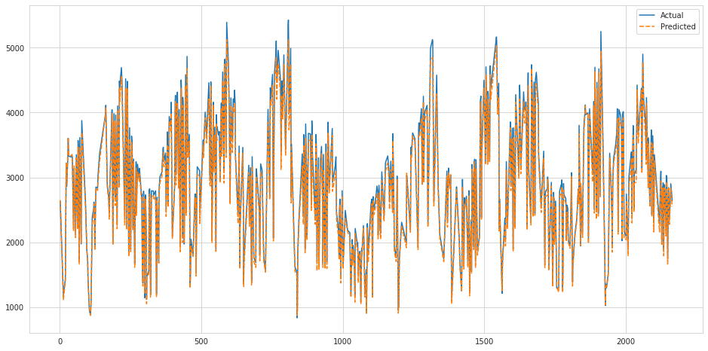

**In 24:**

xgb_r.score(X_test,y_test)*100

**out 24:**

98.7655882096893

**Conclusion:**

* In today's Web development, a good page design is essential. A bad design will lead to the loss of visitors and that can lead to a loss of business. In general, a good page layout has to satisfy the basic elements of a good page design. This includes color contrast, text organization, font selection, style of a page, page size, graphics used, and consistency. In order to create a well-designed page for a specific audience. The developer needs to organized and analyze the users' statistics and the background of the users. Although it can be hard to come up with a design that is well suited to all of the users, there will be a design that is appropriate for most of the audience. The better the page design, the more hits a page will get. That implies an increase in accessibility and a possible increase in business**.**