Assignment 3: Understanding Algorithm Efficiency and Scalability

Soundarya Kavimani
Student ID: 005059619
MSCS-532-B01 Algorithms and Data Structures
Dr. Michael Solomon
November 8, 2026

Assignment 3: Understanding Algorithm Efficiency and Scalability
This report analyzes two randomized algorithms that are widely used in practice: Quicksort with a random pivot, and a hash table that resolves collisions by chaining and uses a universal hash function. For each one, it gives a Python implementation, derives the expected running time, and tests that analysis with experiments. All code, data and screenshots are in the GitHub repository at https://github.com/skavimani/algorithm-efficiency-assignment3, whose README explains how to run each program.

Part 1: Randomized Quicksort

Implementation
Quicksort (Hoare, 1962) picks a pivot, partitions the array into elements smaller than, equal to and larger than the pivot, and then sorts the two outer parts recursively. In quicksort.py, the function randomized_quicksort chooses the pivot uniformly at random from the current subarray with random.randint(lo, hi). The function deterministic_quicksort always uses the first element. Both share the same partition and recursion code, so pivot choice is the only difference between them, which keeps the comparison fair.
The implementation handles the required edge cases as follows:
- Empty and one-element arrays are returned immediately, because they are already sorted.
- Repeated elements are handled by a three-way partition (Bentley & McIlroy, 1993). One left-to-right scan splits the subarray into the regions < pivot, = pivot and > pivot. All copies of the pivot are then in their final positions and are never examined again. A plain two-way partition, by contrast, degrades to quadratic time when all keys are equal.
- Already-sorted and reverse-sorted arrays are no problem for the randomized version, because its behavior does not depend on the input order. To keep the deterministic version from crashing when it hits its worst case, the code recurses only into the smaller side of each partition and loops over the larger side. This bounds the recursion depth by O(log n) for both versions, even when the running time is quadratic.
The partition moves only elements that are smaller than or equal to the pivot, so elements larger than the pivot keep their order, as in the textbook Lomuto scheme. This detail matters for the experiment. An earlier version used Dijkstra's swap-from-both-ends three-way partition, which happens to scramble sorted input. That partially hid the first-element worst case and would have made the comparison misleading. The repository includes 11 unit tests covering all of these cases, plus randomized stress tests against Python's built-in sorted. Figures 1 and 2 show the programs running in the macOS Terminal. Figure 1 is a small mixed array, with repeated values and a negative number, sorted identically by both versions. Figure 2 runs both versions on every required edge case, and every row ends in OK.
Figure 1
Output of quicksort.py: Both Versions Sorting the Same Array
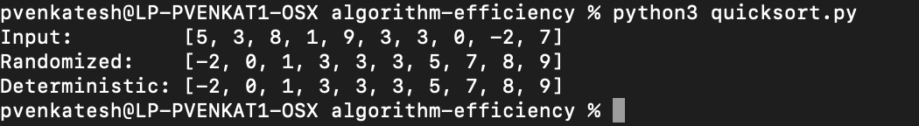
Figure 2
Output of demo_quicksort.py (Edge Cases) and compare_quicksort.py
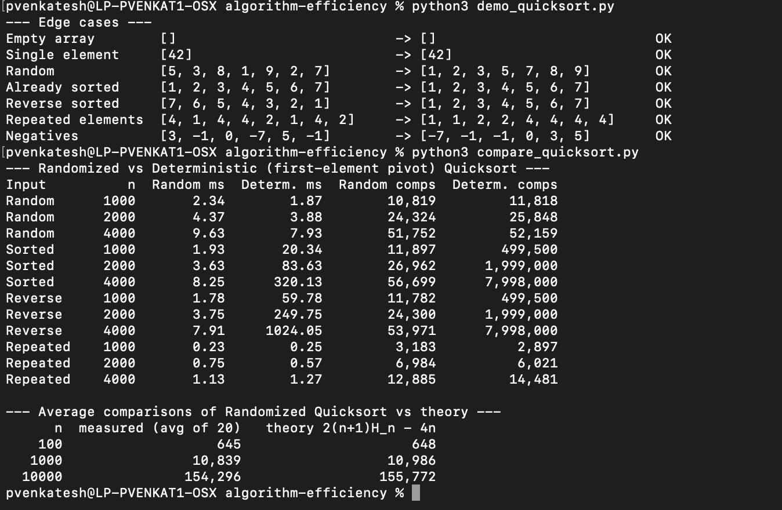

Average-Case Analysis
The running time of Quicksort is proportional to the number of comparisons between an element and a pivot, since every other step of a partition does a constant amount of work per comparison. Let X be the total number of comparisons made by randomized Quicksort on n distinct keys. Rename the keys in sorted order as z₁ < z₂ < … < zₙ, and for i < j define the indicator random variable
Xᵢⱼ = I{ zᵢ is compared with zⱼ at some point during the sort }.
Two keys are compared only when one of them is the pivot, and after that partition the pivot is never compared again. So every pair is compared at most once, and X = Σᵢ<ⱼ Xᵢⱼ. By linearity of expectation, E[X] = Σᵢ<ⱼ Pr{zᵢ is compared with zⱼ}.
Consider the set Zᵢⱼ = {zᵢ, zᵢ₊₁, …, zⱼ}, which contains j − i + 1 keys. While no pivot has been chosen from Zᵢⱼ, all of its keys stay together in the same subarray. The first time a pivot is chosen from Zᵢⱼ, there are two possibilities. If that pivot is zᵢ or zⱼ, the two keys are compared. If it is any key strictly between them, zᵢ and zⱼ are sent to different sides and are never compared. Because every pivot is chosen uniformly at random, each of the j − i + 1 keys in Zᵢⱼ is equally likely to be chosen first. Therefore
Pr{zᵢ is compared with zⱼ} = 2 / (j − i + 1).
Substituting k = j − i and summing gives
E[X] = Σᵢ₌₁ⁿ⁻¹ Σₖ₌₁ⁿ⁻ⁱ 2/(k + 1) < Σᵢ₌₁ⁿ 2Hₙ = 2nHₙ = O(n log n),
where Hₙ = 1 + 1/2 + … + 1/n ≤ ln n + 1 is the n-th harmonic number. Evaluating the double sum exactly gives
E[X] = 2(n + 1)Hₙ − 4n ≈ 2n ln n ≈ 1.39 n log₂ n.
The same result follows from a recurrence (Sedgewick, 1977). The first pivot is equally likely to have rank 1, 2, …, n, it is compared with the other n − 1 keys, and it leaves subproblems of sizes q − 1 and n − q. So C(n) = (n − 1) + (2/n) Σₖ₌₀ⁿ⁻¹ C(k), with C(0) = C(1) = 0. Multiplying by n and subtracting the same equation for n − 1 gives nC(n) = (n + 1)C(n − 1) + 2(n − 1). Dividing by n(n + 1) turns this into a telescoping sum, which again produces C(n) = 2(n + 1)Hₙ − 4n = Θ(n log n).
The analysis explains why the average case is O(n log n). A random pivot is unlikely to be extreme: with probability 1/2 it falls in the middle half of the keys and leaves no side larger than 3n/4. So the subproblem sizes shrink geometrically and there are O(log n) levels of recursion on average, each doing O(n) work. The worst case is still Θ(n²), but it now requires the random generator to keep picking extreme pivots, and that event has negligible probability. Crucially, the expectation holds for every input, including sorted, reverse-sorted and adversarial arrays, because the randomness comes from the algorithm and not from the data. With repeated keys, the three-way partition only improves on this bound: with k distinct values the expected cost is O(n log k).
The deterministic version gives no such guarantee. On sorted input the first element is the minimum of every subarray, so each partition removes just one key. The algorithm then makes (n − 1) + (n − 2) + … + 1 = n(n − 1)/2 = Θ(n²) comparisons. The same happens on reverse-sorted input, where the first element is the maximum.

Empirical Comparison
Both versions were run on arrays of n = 1,000, 2,000, 4,000, 8,000 and 16,000 elements, drawn from four distributions: uniformly random integers, already-sorted, reverse-sorted, and arrays containing only 10 distinct values (repeated elements). Each timing is the median of five runs, measured with time.perf_counter in CPython 3, and every result was checked against Python's sorted. A separate instrumented run counted the exact number of comparisons. Table 1 shows a subset of the results, and Figure 3 plots all of them.
Table 1
Running Time and Comparison Counts of Randomized and Deterministic Quicksort
Distribution | n | Rand. (ms) | Det. (ms) | Rand. comparisons | Det. comparisons
Random | 1,000 | 0.91 | 0.78 | 10,720 | 11,818
Random | 4,000 | 4.33 | 3.70 | 59,741 | 56,211
Random | 16,000 | 25.01 | 35.11 | 261,781 | 269,044
Already sorted | 1,000 | 1.08 | 12.72 | 11,030 | 499,500
Already sorted | 4,000 | 5.23 | 193.51 | 52,159 | 7,998,000
Already sorted | 16,000 | 39.91 | 3,151.43 | 255,613 | 127,992,000
Reverse sorted | 1,000 | 0.86 | 32.89 | 11,002 | 499,500
Reverse sorted | 4,000 | 4.38 | 689.18 | 52,954 | 7,998,000
Reverse sorted | 16,000 | 17.35 | 11,344.74 | 287,705 | 127,992,000
Repeated (10 values) | 1,000 | 0.26 | 0.17 | 4,131 | 2,953
Repeated (10 values) | 4,000 | 0.86 | 0.91 | 14,045 | 12,849
Repeated (10 values) | 16,000 | 3.37 | 2.60 | 68,516 | 52,927
Note. Rand. = randomized pivot; Det. = first-element pivot. Times are medians of five runs. Full results for all sizes are in results/quicksort_times.csv.

Figure 3
Running Time of Randomized and Deterministic Quicksort on Four Input Distributions
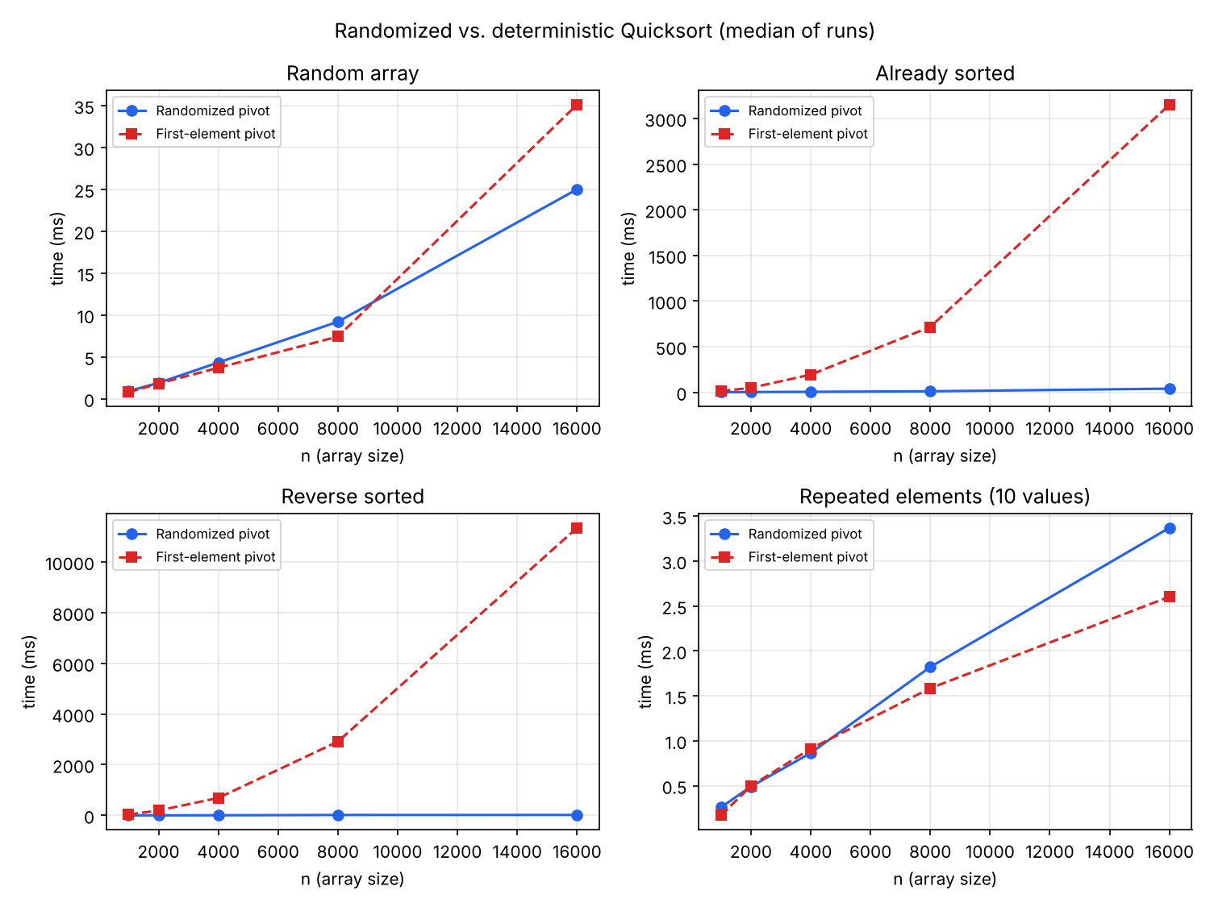
The results match the theory closely. The randomized version stayed in the O(n log n) regime on every distribution, sorting 16,000 sorted or reverse-sorted keys in 39.9 ms and 17.3 ms. The deterministic version hit its quadratic worst case on both ordered inputs. At n = 16,000 it made exactly 127,992,000 = n(n − 1)/2 comparisons and needed 3.15 s on sorted input and 11.34 s on reverse-sorted input. Its time roughly quadrupled each time n doubled, which is the signature of Θ(n²) growth, while the randomized times roughly doubled.
Table 2 tests the analysis more directly. For each size, randomized Quicksort was run 30 times on arrays of distinct keys. The mean number of comparisons was within about 1% of the exact expectation 2(n + 1)Hₙ − 4n at every size, from n = 100 to n = 100,000. The standard deviation as a fraction of the mean also fell as n grew (from 9% at n = 100 to 2% at n = 100,000), so for large inputs the running time is not only good on average but reliably close to the average. The shorter terminal run in Figure 2, made separately on a MacBook, shows the same pattern. On 4,000 reverse-sorted keys the deterministic version took 1,024 ms and made exactly 7,998,000 comparisons, while the randomized version took 7.91 ms. In the same run, the average comparison counts (645, 10,839 and 154,296) were close to the expected 648, 10,986 and 155,772.
Table 2
Mean Comparisons of Randomized Quicksort Over 30 Trials Versus the Exact Expectation
n | Mean comparisons | Std. deviation | 2(n+1)Hₙ − 4n | Difference
100 | 643.8 | 60.8 | 647.9 | -0.63%
1,000 | 11,004.0 | 793.1 | 10,985.9 | 0.16%
10,000 | 155,866.7 | 6,450.3 | 155,771.7 | 0.06%
100,000 | 1,998,123.5 | 47,121.1 | 2,018,053.4 | -0.99%

Discrepancies Between Theory and Measurement
Some measurements differ from what the asymptotic analysis alone would predict, and each difference has a clear cause:
- On random input, the deterministic version was about as fast or slightly faster. When the input is already in random order, the first element is itself a random pivot, so both versions do the same expected work (their comparison counts in Table 1 are nearly identical). The randomized version also pays for a call to the random-number generator at every partition, which adds a constant cost that Big-O notation hides. Randomization protects against bad inputs; it does not make the algorithm faster on good ones.
- Reverse-sorted input was about 3.6 times slower than sorted input for the deterministic version, even though both made exactly the same number of comparisons. In this partition scheme, elements larger than the pivot are skipped, while elements smaller than the pivot are moved with three writes. On sorted input every element is larger than the pivot (the minimum), so almost nothing moves. On reverse-sorted input every element is smaller than the pivot (the maximum), so every comparison also triggers data movement. Comparison counting treats both cases as identical, but real running time also depends on memory writes.
- Repeated elements were the fastest case for both versions, which is the opposite of what happens with a basic two-way partition. With only 10 distinct values, the three-way partition removes every copy of the pivot at once, so the recursion runs out of distinct values after about log₂ 10 levels and the cost is close to linear. This is consistent with the O(n log k) bound.
- Timing noise. A few individual points are irregular, for example the deterministic time on random input at n = 16,000. Wall-clock timings in Python are affected by memory allocation, garbage collection and other processes. That is why each timing is a median of five runs and why the comparison counts, which are exact, are reported alongside them.

Part 2: Hashing With Chaining

Implementation
The HashTable class in hash_table.py keeps an array of m slots, and each slot holds a Python list (the chain) of key–value pairs. It supports three operations:
- insert(key, value) hashes the key, scans its chain and updates the value if the key is already there, and otherwise appends a new pair.
- search(key) hashes the key and scans its chain, returning the stored value or a default.
- delete(key) finds the pair in its chain, overwrites it with the chain's last pair and pops the end. This removes it in O(1) once found, without shifting the rest of the list.
The hash function is drawn from the universal family of Carter and Wegman (1979):
h₍ₐ,ᵦ₎(k) = ((a·k + b) mod p) mod m,
where p = 2⁶¹ − 1 is a Mersenne prime, a is chosen at random from {1, …, p − 1}, and b from {0, …, p − 1}. For any two distinct keys, the probability over the random choice of a and b that they collide is at most about 1/m. The guarantee holds for every set of keys, so no particular data set can reliably cause many collisions. Strings and other non-integer keys are first converted to an integer with a polynomial pre-hash. A new pair (a, b) is drawn whenever the table is resized.
Figures 4 and 5 show the hash table running in the macOS Terminal. In Figure 4, the built-in example inserts five words, finds one, deletes another, and then reports a load factor of 0.5. Figure 5 is a fuller demonstration. The table starts with 4 slots and doubles to 8 when the fifth key would push the load factor above 1. Searching for a missing key returns None, and inserting an existing key replaces its value. Deleting a key that is already gone returns False. The last line lists the length of every chain.
Figure 4
Output of hash_table.py: Insert, Search and Delete
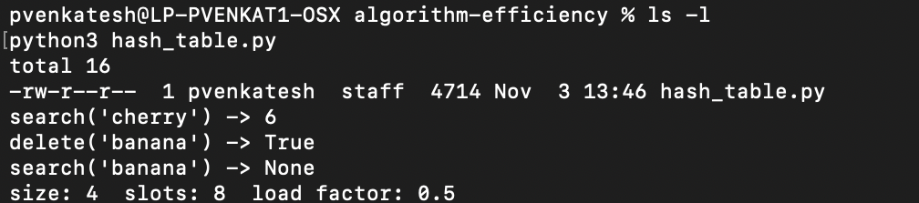
Figure 5
Output of demo_hash.py: Insert, Search, Update, Delete and Resizing
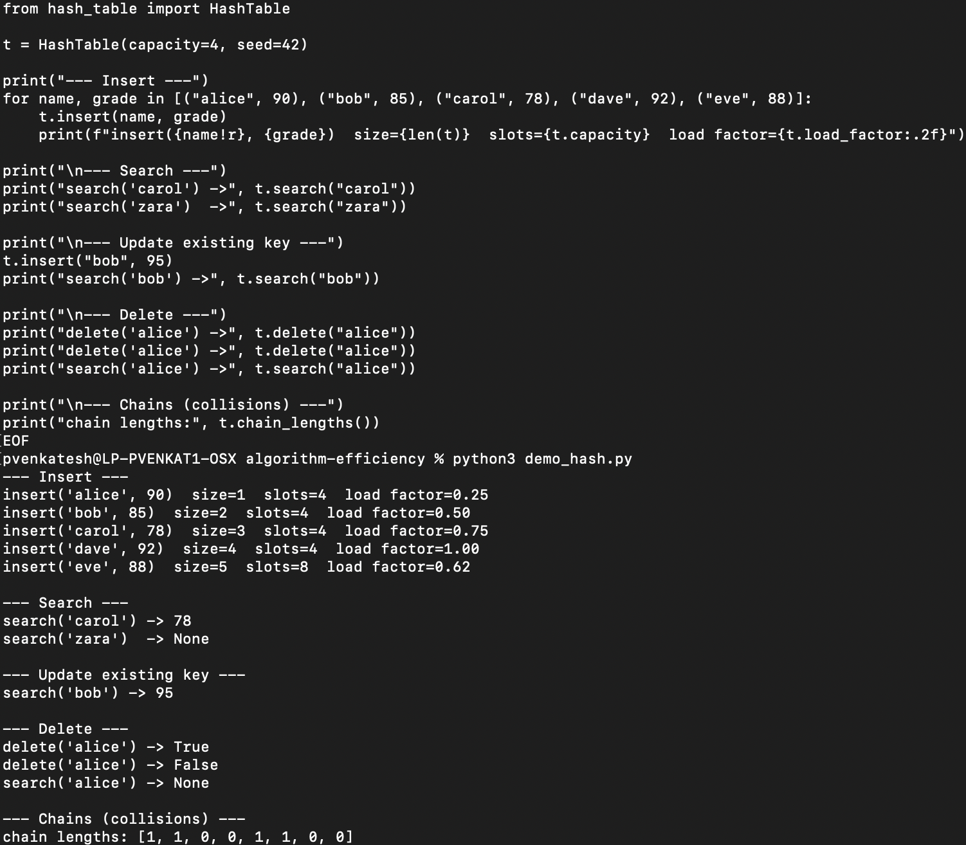

Expected Running Times Under Simple Uniform Hashing
Under the assumption of simple uniform hashing, each key is equally likely to land in any of the m slots, independently of the other keys. With n keys stored, the load factor is α = n/m, and the expected length of every chain is exactly α. Computing the hash takes O(1) time, so the cost of each operation is O(1) plus the number of keys examined in one chain.
- Unsuccessful search (the key is absent) must scan the entire chain it hashes to. The expected chain length is α, so the expected time is Θ(1 + α).
- Successful search for a key x scans only the keys in x's chain that were inserted before x, plus x itself. Averaging over which key is searched for, the expected number of keys examined is 1 + α/2 − α/(2n), so the expected time is also Θ(1 + α), with about half the scanning cost of an unsuccessful search.
- Insert without a duplicate check is O(1), because it just adds to the chain. This implementation checks whether the key is already present so that it can update the value instead of storing a duplicate. That check costs the same as an unsuccessful search, so insert takes Θ(1 + α) expected time.
- Delete costs a successful search to find the pair, Θ(1 + α), plus O(1) for the swap-and-pop removal. With a doubly linked list and a pointer to the node, the removal alone would be O(1).
If the number of slots grows in proportion to the number of keys, so that n = O(m), then α = O(1) and all three operations take O(1) expected time. Universal hashing provides the same expected bounds without assuming that the keys themselves are random: for any fixed key set, the expected chain length containing a given key is at most 1 + α over the random choice of hash function (Carter & Wegman, 1979).

Effect of the Load Factor
To isolate the effect of the load factor, resizing was turned off, the table was fixed at m = 4,096 slots, and it was filled to α = 0.25 to 16. Besides timing each operation, the experiment counted how many keys each search examined. That count is independent of the machine and can be compared directly with the formulas above. The results are shown in Table 3 and Figure 6. The match is almost exact. At α = 16, a successful search examined 9.02 keys on average against a predicted 9.0, and an unsuccessful search examined 16.028 against a predicted 16. At every load factor, the mean chain length equaled α.
Table 3
Keys Examined and Time per Operation at Different Load Factors (m = 4,096 Slots, No Resizing)
α | n | Hit keys | 1 + α/2 | Miss keys | α | Longest chain | Hit (µs) | Miss (µs) | Delete (µs)
0.25 | 1,024 | 1.14 | 1.125 | 0.249 | 0.250 | 3 | 0.36 | 0.31 | 0.41
0.5 | 2,048 | 1.246 | 1.250 | 0.503 | 0.500 | 4 | 0.32 | 0.30 | 0.47
1 | 4,096 | 1.493 | 1.500 | 0.998 | 1.000 | 6 | 0.34 | 0.34 | 0.48
2 | 8,192 | 2.021 | 2.000 | 2.005 | 2.000 | 9 | 0.64 | 0.55 | 0.49
4 | 16,384 | 3.007 | 3.000 | 4.007 | 4.000 | 13 | 1.09 | 1.20 | 0.56
8 | 32,768 | 4.968 | 5.000 | 8.017 | 8.000 | 22 | 1.01 | 1.41 | 0.56
16 | 65,536 | 9.02 | 9.000 | 16.028 | 16.000 | 36 | 1.61 | 2.58 | 0.66
Note. "Hit" = successful search; "Miss" = unsuccessful search. Keys examined are averages over 20,000 searches.

Figure 6
Keys Examined per Search Versus Theory (Left) and Time per Operation (Right)
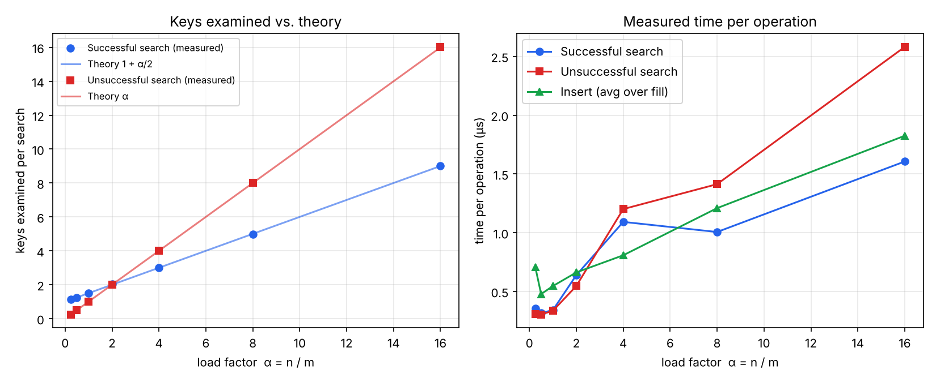
Measured times grow roughly linearly with α, as predicted. The unsuccessful-search line rises fastest because it scans whole chains. The time curves are noisier and flatter than the key counts for two reasons. First, at α ≤ 1 the fixed cost of computing the universal hash, a large-integer multiply and two modulo operations in Python, outweighs the cost of scanning a chain of about one key. Second, a microsecond-scale operation is easily disturbed by caching and interpreter overhead. The longest chain also grew more slowly than the average. At α = 1 the longest of the 4,096 chains held only 6 keys, consistent with the known Θ(log n / log log n) expected maximum chain length for a table with α = 1 (Gonnet, 1981). So even the worst-case lookup in a well-loaded table stays short.

Keeping the Load Factor Low and Minimizing Collisions
Because every operation costs Θ(1 + α), the most important design decision is to keep α bounded by a constant. This implementation combines several strategies:
- Dynamic resizing by doubling. When an insert pushes α above 1, the table allocates 2m slots, draws a new hash function and reinserts every key. A single resize costs Θ(n), but because the size doubles each time, the total cost of all resizes during n insertions is at most n + n/2 + n/4 + … < 2n. The amortized cost per insert therefore stays O(1).
- Shrinking with a gap. When deletions push α below 1/4, the table halves its size. Leaving a gap between the grow threshold (1) and the shrink threshold (1/4) prevents thrashing, where alternating inserts and deletes near one boundary would trigger a full rehash every time. After any resize, α is about 1/2, so Θ(m) operations must happen before the next one.
- Universal hashing and rehashing with a fresh function. Choosing the hash function at random means no fixed set of keys can systematically collide (Carter & Wegman, 1979). Drawing a new function on each resize also means that an unlucky choice is not carried forward.
- A good pre-hash for non-integer keys. Strings are mapped to integers with a polynomial hash modulo a large prime, so that similar strings such as "key1" and "key2" do not map to nearby or identical integers before the universal function is applied.
- Further options. Larson (1988) showed how linear hashing can be used for in-memory hash tables: the table grows one slot at a time, so the cost of resizing is spread over many inserts instead of causing one long pause for a full rehash. Dynamic perfect hashing guarantees worst-case O(1) lookups at the cost of a more complex structure (Dietzfelbinger et al., 1994).
Figure 7 shows the practical impact of resizing. Both tables started with only 8 slots and were filled with up to 50,000 keys. With resizing, α stayed between 0.5 and 1, and the average search took 0.813 µs at n = 50,000. Without resizing, α reached 6,250, and each search took 233 µs, nearly 300 times slower and growing linearly with n. The small upward drift of the resizing line, from about 0.3 µs to 0.8 µs, is not predicted by the RAM model. It reflects the hardware: as the table outgrows the CPU caches, each lookup is more likely to wait for main memory.
Figure 7
Average Search Time With and Without Dynamic Resizing (Table Starts With 8 Slots)
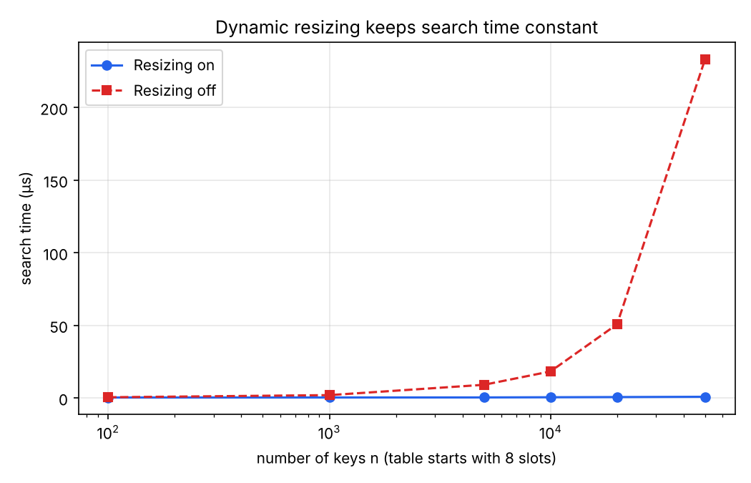

Conclusion
Both experiments confirm that randomization turns a bad worst case into a strong expected-case guarantee. Randomized Quicksort performed within 1% of its predicted 2(n + 1)Hₙ − 4n comparisons and stayed O(n log n) on every input, while the first-element version collapsed to Θ(n²) on ordered data, the kind of data that is common in practice. Likewise, a hash table using universal hashing matched the simple-uniform-hashing predictions almost exactly, and dynamic resizing kept the load factor, and with it the cost of every operation, constant. When choosing an algorithm, the lesson is that average-case bounds are only useful if the assumptions behind them hold. Randomizing inside the algorithm makes those assumptions true for every input, at the price of a small constant overhead, as the random-input timings show.
References
Bentley, J. L., & McIlroy, M. D. (1993). Engineering a sort function. Software: Practice and Experience, 23(11), 1249–1265. https://doi.org/10.1002/spe.4380231105
Carter, J. L., & Wegman, M. N. (1979). Universal classes of hash functions. Journal of Computer and System Sciences, 18(2), 143–154. https://doi.org/10.1016/0022-0000(79)90044-8
Dietzfelbinger, M., Karlin, A., Mehlhorn, K., Meyer auf der Heide, F., Rohnert, H., & Tarjan, R. E. (1994). Dynamic perfect hashing: Upper and lower bounds. SIAM Journal on Computing, 23(4), 738–761. https://doi.org/10.1137/S0097539791194094
Gonnet, G. H. (1981). Expected length of the longest probe sequence in hash code searching. Journal of the ACM, 28(2), 289–304. https://doi.org/10.1145/322248.322254
Hoare, C. A. R. (1962). Quicksort. The Computer Journal, 5(1), 10–16. https://doi.org/10.1093/comjnl/5.1.10
Larson, P.-Å. (1988). Dynamic hash tables. Communications of the ACM, 31(4), 446–457. https://doi.org/10.1145/42404.42410
Sedgewick, R. (1977). The analysis of Quicksort programs. Acta Informatica, 7(4), 327–355. https://doi.org/10.1007/BF00289467

