Heap Data Structures: Implementation, Analysis, and Applications

Soundarya Kavimani
Student ID: 005059619
MSCS-532-B01 Algorithms and Data Structures
Dr. Michael Solomon
November 5, 2026

Heap Data Structures: Implementation, Analysis, and Applications
A binary heap is a complete binary tree stored in an array in which every parent is at least as large as its children (a max-heap) or at most as large (a min-heap). The structure was introduced by Williams (1964) as the basis of Heapsort, and Floyd (1964) showed how to build a heap from an unsorted array in linear time. This report presents a Python implementation of Heapsort, analyzes its time and space complexity, compares it experimentally with Quicksort and Merge Sort, and then uses the same heap idea to build a priority queue that drives a task-scheduler simulation. All code, data, and charts are available in the GitHub repository at https://github.com/skavimani/heap-data-structures.

Heapsort Implementation
The implementation in src/heapsort.py stores the heap in the Python list being sorted, using 0-based indexing: the children of index i are at 2i + 1 and 2i + 2, and its parent is at (i − 1) // 2. Because a complete tree has no gaps, these formulas reach every node without pointers. The algorithm has two phases. First, build_max_heap calls a sift-down routine on every internal node from index n//2 − 1 back to the root, which turns the list into a max-heap (Floyd, 1964). Second, the largest element, which is always at index 0, is swapped with the last element of the heap region; the region shrinks by one, and a single sift-down from the root restores the heap property. After n − 1 such steps the list is sorted in ascending order. The core of the code is shown below.
def _sift_down(arr, start, end):
root = start
while True:
left = 2 * root + 1
if left >= end: # root is a leaf
return
largest, right = root, left + 1
if arr[left] > arr[largest]:
largest = left
if right < end and arr[right] > arr[largest]:
largest = right
if largest == root: # heap property holds
return
arr[root], arr[largest] = arr[largest], arr[root]
root = largest

def heapsort(arr):
n = len(arr)
for i in range(n // 2 - 1, -1, -1): # build max-heap, O(n)
_sift_down(arr, i, n)
for end in range(n - 1, 0, -1): # n-1 extractions
arr[0], arr[end] = arr[end], arr[0]
_sift_down(arr, 0, end)
return arr
Sift-down is written as a loop rather than a recursive function so that it needs only a constant amount of extra memory and cannot hit Python's recursion limit. The full file also accepts an optional counter used by the experiments to count key comparisons; it does not change the algorithm. Seven unit tests in tests/test_heaps.py check the empty list, single elements, duplicates, negative numbers, 200 random lists, and that build_max_heap produces a valid heap. Figure 1 shows the file being created in the macOS Terminal, Figure 2 shows the demonstration run, and Figure 3 shows all seven tests passing.
Figure 1
Creating and Running heapsort.py in the Terminal
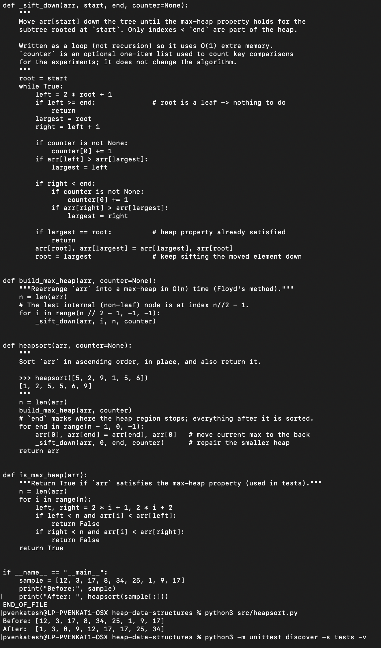
Note. The code was entered with a here-document (cat > src/heapsort.py) and then run with python3 src/heapsort.py; the last lines show the sorted output. The file's opening comment block is above the visible area.
Figure 2
Python Version and Heapsort Demonstration Output
Note. The nine-element sample, including the duplicate 17, is returned in ascending order.
Figure 3
Unit Test Results
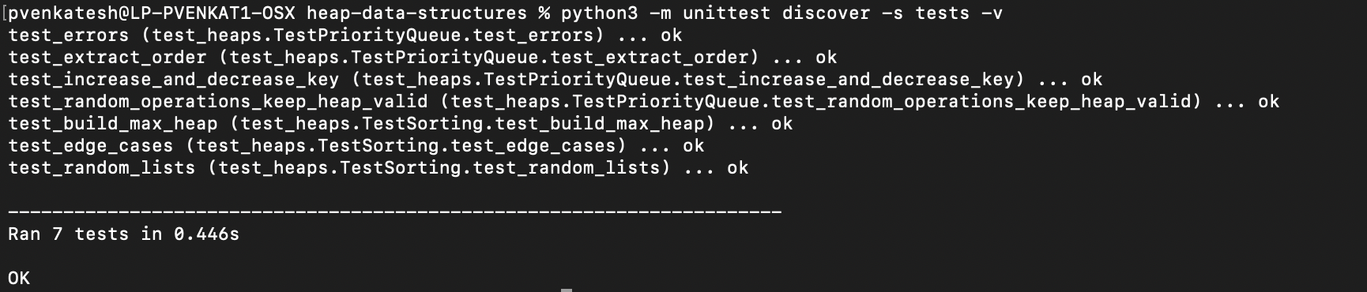
Note. Four tests cover the priority queue and three cover the sorting algorithms; all pass.

Analysis of Heapsort

Building the Heap Takes O(n) Time
A sift-down that starts at a node of height h performs at most h swaps and at most 2h comparisons. A heap with n nodes has at most ⌈n / 2^(h+1)⌉ nodes of height h, so the total work of build_max_heap is bounded by the sum over h of (n / 2^(h+1)) · O(h) = O(n · Σ h / 2^h). The series Σ h / 2^h converges to 2, so the whole build phase costs O(n). This is the reason Floyd's bottom-up construction is preferred to inserting the elements one by one, which would cost O(n log n).

The Extraction Phase Takes O(n log n) Time
The second phase runs n − 1 iterations. In the iteration whose heap holds i elements, the swap costs O(1) and the sift-down travels at most ⌊log₂ i⌋ levels, doing at most two comparisons per level. The total is therefore at most Σ 2 log₂ i for i = 2 to n, which equals 2 log₂((n − 1)!) and, by Stirling's approximation, is about 2n log₂ n − O(n). Adding the O(n) build phase gives an upper bound of O(n log n).

Worst, Average, and Best Cases
Worst case. The bound above holds for every input, so the worst case is O(n log n). Unlike Quicksort, Heapsort has no input that makes it quadratic, because its structure is fixed by the shape of the complete tree rather than by data-dependent choices such as a pivot.
Average case. Schaffer and Sedgewick (1993) proved that for a random permutation of distinct keys, standard Heapsort uses about 2n log₂ n comparisons on average, so the average case is Θ(n log n). The reason is that the element moved to the root in each step was taken from the bottom of the heap and is usually small, so it tends to sink almost all the way back down.
Best case. Schaffer and Sedgewick (1993) also showed that even the best possible input of distinct keys forces about ½ n log₂ n sift-down steps, so the best case is also Θ(n log n). This agrees with the general lower bound: any sort that only compares keys must make at least log₂(n!) ≈ n log₂ n comparisons in the worst case. The only exception is a degenerate input where many keys are equal; if all keys are identical, each sift-down stops after one level and the run takes O(n).

Why Heapsort Is O(n log n) in All Cases
Heapsort is O(n log n) in every case for two reasons. First, its upper bound does not depend on the data: the heap is always a complete tree of height ⌊log₂ n⌋, so no single sift-down can cost more than O(log n), and exactly n − 1 of them are performed. Second, the lower bound is also unavoidable for distinct keys, because each extraction moves a leaf element to the root, and that element must be compared its way back down. Sorted or reverse-sorted input does not help: a sorted array is turned into a heap by the build phase anyway, and the extraction phase then behaves almost exactly as it does on random data. The experiments below confirm this, with comparison counts within about 6% of each other across all three input orders.

Space Complexity and Other Overheads
Heapsort sorts in place. Apart from the input list it uses only a few index variables, so its auxiliary space is O(1); the iterative sift-down avoids even the O(log n) call stack a recursive version would need. By contrast, Merge Sort needs an O(n) temporary array, and Quicksort needs O(log n) expected stack space. Heapsort does have practical overheads. It is not stable, meaning equal keys may change their relative order. Its comparison count, about 2n log₂ n, is roughly double that of Merge Sort. Finally, it has poor locality of reference: moving from index i to 2i + 1 jumps further through memory at every level, so for large arrays most steps touch a different cache line. LaMarca and Ladner (1999) measured that this cache behavior makes Heapsort slower than Quicksort and Merge Sort on modern hardware even when the instruction counts are similar. In Python, each list slot holds a reference to an integer object, so swaps move references rather than values, but every comparison is an interpreted operation, which makes the extra comparisons especially visible.

Empirical Comparison With Quicksort and Merge Sort

Experimental Setup
The program src/benchmark_sorts.py compared three algorithms written in the same plain-Python style: the Heapsort above, Quicksort with a uniformly random pivot and Lomuto partitioning (Hoare, 1962), and top-down Merge Sort. Each was run on lists of 1,000, 5,000, 10,000, 25,000, 50,000, and 100,000 distinct integers in three orders: random, already sorted, and reverse-sorted. Each configuration was timed five times with time.perf_counter on a fresh copy of the input, the median is reported, and every output was checked against Python's built-in sorted. One extra counted run recorded the number of key comparisons. A second experiment ran a Quicksort that always uses the first element as its pivot on sorted lists of 500 to 8,000 elements to show Quicksort's worst case. The runs were made with Python 3.12.3 on a Mac running macOS; absolute times will differ on other computers, but the relative results should not. Figure 4 shows the program's full output.
Table 1
Median Running Time in Milliseconds at n = 100,000
Algorithm | Random | Sorted | Reverse-sorted
Heapsort | 295.1 | 293.5 | 262.3
Quicksort (random pivot) | 207.2 | 199.5 | 197.9
Merge Sort | 253.1 | 212.4 | 215.6
Note. Median of five runs. Times for all six input sizes are in results/sort_times.csv.
Figure 4
Output of the Sorting Benchmark (python3 src/benchmark_sorts.py)
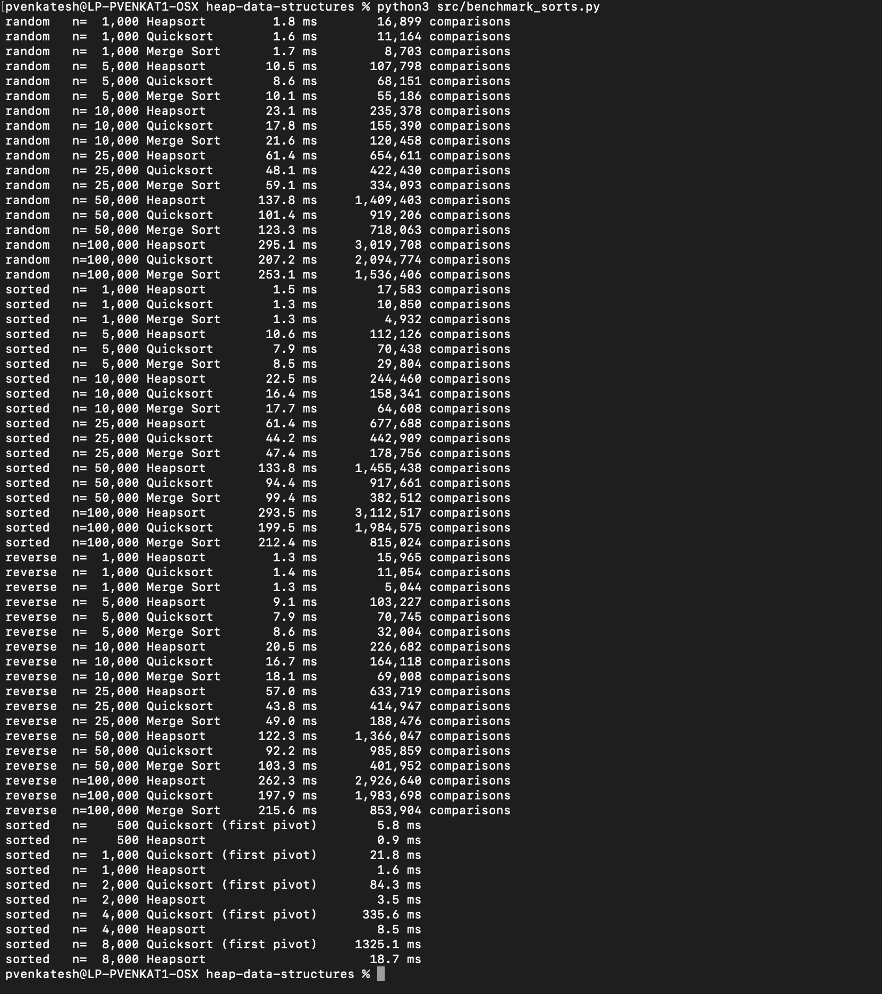
Note. Each line gives the median time and the comparison count for one algorithm, distribution, and input size. The last ten lines are the first-element-pivot Quicksort experiment.
Figure 5
Running Time Versus Input Size for Each Input Distribution
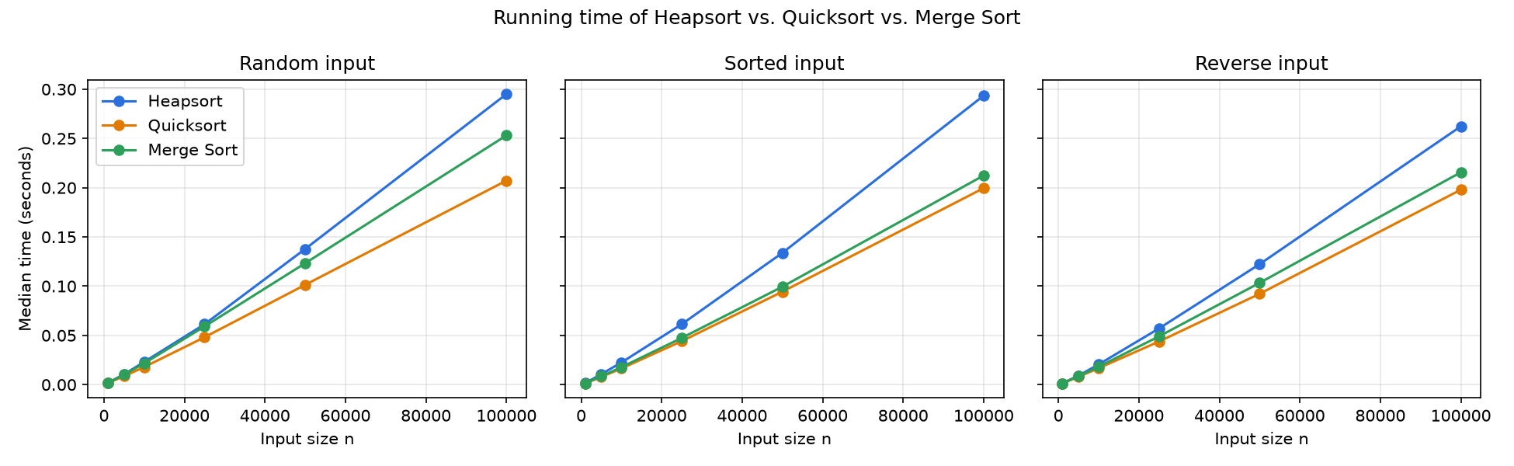
Note. Each point is the median of five runs. All three algorithms grow at the same slightly-faster-than-linear rate expected of O(n log n).
Table 2
Key Comparisons Divided by n log₂ n at n = 100,000
Algorithm | Random | Sorted | Reverse-sorted
Heapsort | 1.82 | 1.87 | 1.76
Quicksort (random pivot) | 1.26 | 1.19 | 1.19
Merge Sort | 0.93 | 0.49 | 0.51
Note. A constant ratio across sizes and distributions indicates Θ(n log n) behavior. Heapsort made about 3.0 million comparisons on random input.
Figure 6
Already-Sorted Input: First-Element-Pivot Quicksort Versus Heapsort
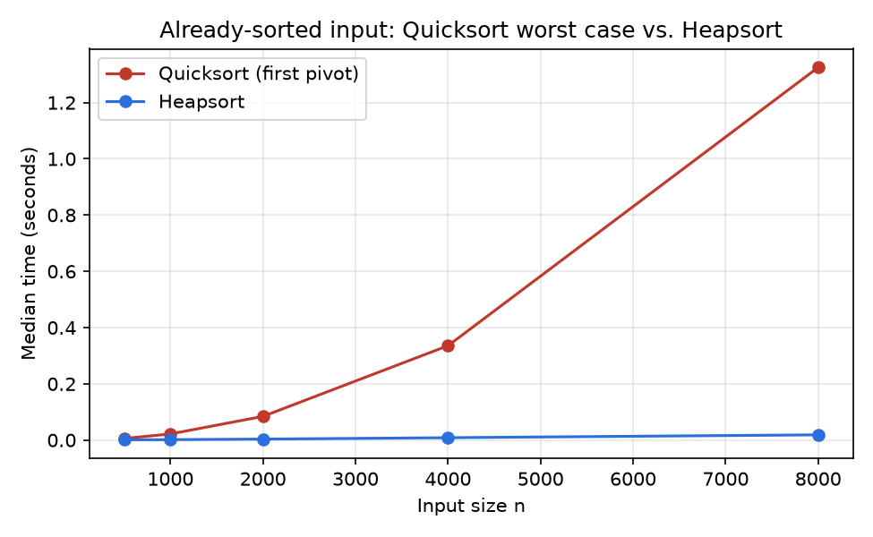
Note. Each time the input size doubles, the naive Quicksort's time roughly quadruples (5.8, 21.8, 84.3, 335.6, 1,325.1 ms), while Heapsort's roughly doubles (0.9 to 18.7 ms).

Discussion of the Results
The measurements (Figures 4 to 6) agree with the theory in four ways. First, Heapsort's behavior did not depend on the input order. Its time at n = 100,000 varied by only about 13% across the three distributions (Table 1), and its comparison count stayed between 1.76 and 1.87 times n log₂ n (Table 2), close to the 2n log₂ n average predicted by Schaffer and Sedgewick (1993). The slightly lower value on reverse-sorted input is expected, because a descending list is already a max-heap, so the build phase does almost no swaps.
Second, all three algorithms showed n log n growth. Going from 50,000 to 100,000 elements, a 2× increase, raised Heapsort's time on random data by 2.14×, Quicksort's by 2.04×, and Merge Sort's by 2.05×. A purely linear algorithm would show 2.00× and a quadratic one 4.00×; the small amount above 2.00 is the log n factor, which is larger for Heapsort because of a cache effect as the array outgrows the processor's fastest caches.
Third, sharing the same O(n log n) class did not make the algorithms equally fast. Heapsort was the slowest on every distribution, about 1.4× slower than randomized Quicksort and 1.2× slower than Merge Sort on random data. Two causes explain this. Heapsort performs the most comparisons (Table 2), and in Python every comparison is costly, and its parent-to-child jumps have poorer memory locality than the sequential scans of the other two algorithms (LaMarca & Ladner, 1999). Merge Sort benefited most from ordered data: when the two halves are already in order, its merge loop ends as soon as one half is used up, so it needed only about half as many comparisons on sorted or reverse-sorted input. Randomized Quicksort was largely unaffected by input order, as expected, because the random pivot makes every input behave like a random one (Sedgewick, 1977).
Fourth, the naive-pivot experiment (Figure 6) shows the value of Heapsort's guarantee. When Quicksort always chose the first element on sorted input, every partition split off only one element, and its time grew quadratically, reaching 1,325 ms for only 8,000 elements, about 71 times slower than Heapsort on the same input. For this reason, production libraries that use Quicksort often switch to Heapsort when the recursion becomes too deep, a design called introsort that keeps Quicksort's average speed while guaranteeing O(n log n) in the worst case (Musser, 1997). In summary, Heapsort is the best choice when a worst-case guarantee and O(1) extra memory matter more than average speed, while randomized Quicksort or Merge Sort are usually faster in practice.

Priority Queue Implementation

Choice of Data Structure
The priority queue in src/priority_queue.py stores a binary heap in a Python list. A list was chosen over a linked tree of node objects for three reasons. It is easy to implement, because parent and child positions are computed with simple arithmetic and no pointers have to be maintained. It is efficient, because adding or removing the last element of a Python list is O(1) amortized, which is exactly what insert and extract_max need, and the elements sit next to each other in memory. Finally, a complete binary tree has no gaps, so an array wastes no space. A linked representation would need to locate the next free position at the bottom of the tree, which is awkward without the array index.
One addition was needed for increase_key and decrease_key. These operations name a task, but a heap is not ordered by task ID, so finding the task would take O(n) by scanning the list. The queue therefore keeps a dictionary, _pos, that maps each task ID to its current index in the list. Every swap updates both entries, which adds only O(1) work per swap, and gives O(1) lookup. This is the standard way to support key changes in a heap-based priority queue.

The Task Class
Each job is a Task dataclass with the fields task_id, priority (a larger number means more important), arrival_time, duration (time steps of CPU needed), and deadline, plus start_time and finish_time, which the simulation fills in. A key method returns the tuple (priority, −arrival_time, −task_id), and the heap compares these tuples. As a result, the highest priority wins, ties are broken in favor of the task that arrived first, and any remaining tie goes to the smaller ID. This makes the scheduling order deterministic and fair among equal-priority tasks.

Max-Heap or Min-Heap
The scheduler runs the most important waiting task next, and importance is expressed as a larger priority number, so a max-heap was used; the next task to run is always at the root. A min-heap would be the natural choice for a policy such as earliest-deadline-first, where the smallest deadline should come out first (Liu & Layland, 1973). The same code could support either by changing only the key method.

Core Operations and Their Time Complexity
insert(task). The new task is appended at the end of the list, which is the next free leaf, and recorded in the index map. It is then sifted up: while it has a larger key than its parent, the two are swapped. The tree has height ⌊log₂ n⌋, so at most that many swaps occur, and insert is O(log n) in the worst case. For tasks with random priorities, the expected number of levels climbed is a small constant (Porter & Simon, 1975), which is why the measured insert time in Figure 8 stays flat.
extract_max(). The root holds the highest-priority task. It is swapped with the last element, removed with pop() in O(1), and deleted from the index map. The element now at the root is sifted down, being swapped with its larger child until both children are smaller. This travels at most the height of the tree, so extract_max is O(log n). Calling it on an empty queue raises an IndexError.
increase_key(task_id, new_priority). The task's index is found in O(1) through the index map, its priority is raised, and it is sifted up, because a larger key can only violate the heap property with its parent. This is O(log n).
decrease_key(task_id, new_priority). The task is found in O(1), its priority is lowered, and it is sifted down, because a smaller key can only violate the property with its children. This is also O(log n). Both key-change methods reject a change in the wrong direction with a ValueError, which keeps the sift direction correct.
is_empty(). This returns whether the list has length zero, which is O(1). A peek method that returns the root without removing it is also O(1).
Table 3
Time Complexity of the Priority Queue Operations
Operation | Worst case | How the heap property is restored
insert(task) | O(log n) | Append, then sift up
extract_max() | O(log n) | Move last to root, then sift down
increase_key(id, p) | O(log n) | O(1) lookup, then sift up
decrease_key(id, p) | O(log n) | O(1) lookup, then sift down
peek() / is_empty() | O(1) | No change to the heap
Note. n is the number of tasks in the queue. The extra index map uses O(n) space.
Figure 7 shows the demonstration in priority_queue.py. Four tasks with priorities 3, 9, 5 and 1 are inserted, and increase_key then raises task 4 from priority 1 to 10. Repeated calls to extract_max return the tasks in the order 4, 2, 3, 1, which confirms that insert, increase_key, and extract_max all keep the heap property.
Figure 7
Priority Queue Demonstration (python3 src/priority_queue.py)
Note. Task 4 is extracted first because increase_key moved it to the root.
Figure 8 shows measured times per operation as the heap grew from 1,000 to 1,000,000 tasks. A 1,000-fold increase in n raised the cost of extract_max from about 6.9 to 31.6 microseconds and the cost of increase_key (with a large increase that moves the task all the way to the root) from about 1.7 to 11.5 microseconds. This slow growth is consistent with O(log n); part of the increase at the largest sizes comes from cache misses rather than extra steps. Insertion of random priorities stayed between 1.3 and 1.5 microseconds at every size, matching the constant expected cost noted above. A randomized unit test performs 2,000 mixed operations and checks after each one that the heap property and the index map are both still correct.
Figure 8
Average Time per Priority Queue Operation Versus Heap Size
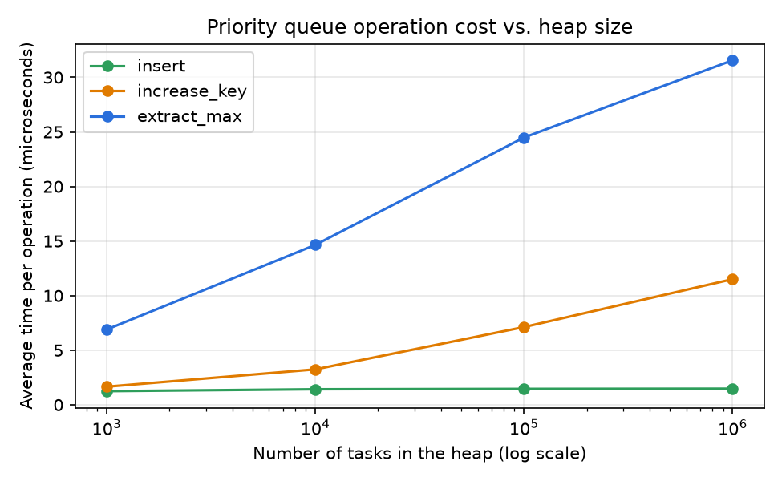
Note. The horizontal axis is logarithmic. A straight, gently rising line on this scale is the signature of O(log n) cost.

Scheduler Simulation

Design of the Simulation
The program src/scheduler_simulation.py models one CPU that runs tasks without preemption: once a task starts, it runs to completion. A fixed random seed generates 1,000 tasks. Arrival gaps follow an exponential distribution with a mean of about 5.6 time steps, durations are 1 to 9 steps, and priorities are 1 to 10. Each task's deadline is its arrival time plus its duration plus some slack, with less slack for higher priorities, so urgent tasks are also time-critical. The CPU is busy about 87% of the time (4,852 steps of work over 5,562 steps), which is high enough for a queue to build up so that the scheduling policy matters. At each step, newly arrived tasks are inserted into the waiting structure, and when the CPU is free the next task is removed and run.
Three policies were compared on the identical workload. FIFO runs tasks in arrival order using a plain queue and serves as the baseline. Priority uses the max-heap and always runs the waiting task with the highest priority via extract_max. Priority + Aging also uses the max-heap but, every 30 time steps, raises the priority of every waiting task by one with increase_key, up to the maximum of 10. Aging is a standard remedy for starvation, the situation in which low-priority work waits indefinitely because higher-priority work keeps arriving.
Table 4
Scheduling Results for 1,000 Tasks
Metric | FIFO | Priority | Priority + Aging
Average wait, all tasks | 24.9 | 25.5 | 25.4
Average wait, priority 8–10 | 21.6 | 2.7 | 2.8
Average wait, priority 1–3 | 24.4 | 66.4 | 54.0
Longest wait | 95 | 567 | 204
Missed deadlines (all) | 288 | 123 | 202
Missed deadlines (priority 8–10) | 127 | 2 | 4
Note. Waits are in time steps from arrival to start. All three policies finish the last task at step 5,562.
Figure 9
Output of the Scheduler Simulation (python3 src/scheduler_simulation.py)
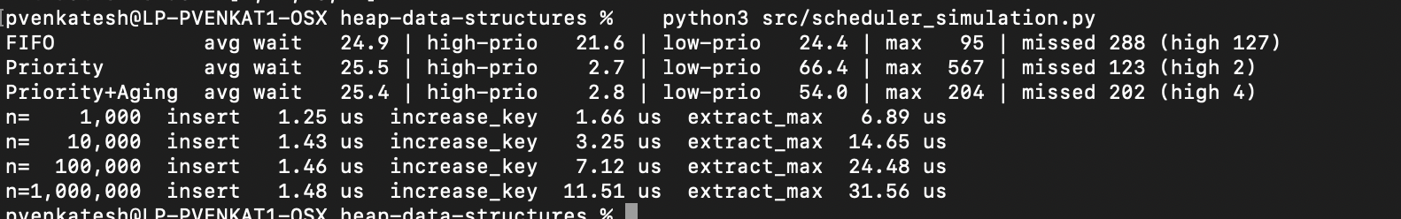
Note. The first three lines give the results in Table 4; the last four lines give the operation timings plotted in Figure 8.
Figure 10
Comparison of the Three Scheduling Policies
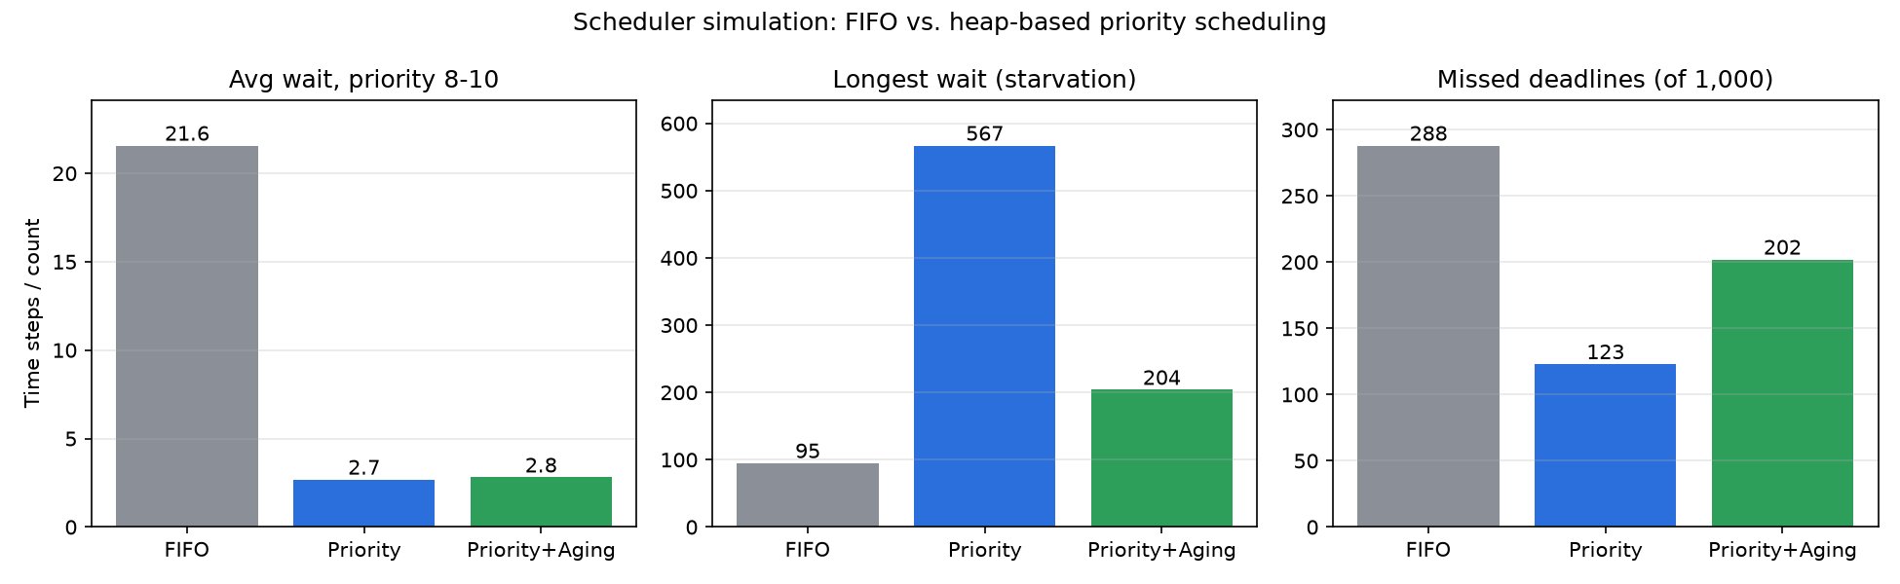
Note. Lower is better in every panel.

Analysis of the Scheduling Results
Heap-based priority scheduling did what it was designed to do (Table 4 and Figure 10). Urgent tasks (priority 8–10) waited an average of 2.7 time steps instead of 21.6 under FIFO, about eight times less, and only 2 of them missed their deadlines instead of 127. Because urgent tasks also had the tightest deadlines, total missed deadlines fell from 288 to 123. The average wait over all tasks was almost unchanged (about 25 steps for every policy), which is expected: with a non-preemptive single CPU, the same total amount of work must be done, and the policy only decides who waits, not how much waiting there is in total.
The cost of strict priority was paid by low-priority tasks. Their average wait rose from 24.4 to 66.4 steps, and the longest wait grew from 95 to 567 steps, which is starvation in practice. Aging reduced this: the longest wait fell to 204 and the low-priority average to 54.0, while urgent tasks were barely affected (2.8 steps, 4 missed). The trade-off is that more deadlines were missed overall (202) because some aged, low-priority tasks were run ahead of mid-priority tasks with tighter deadlines. A system designer would tune the aging interval to balance fairness against deadline misses, or use a deadline-based policy such as earliest-deadline-first, which Liu and Layland (1973) showed to be optimal for meeting deadlines on a single processor under preemptive scheduling.
From a complexity point of view, each task is inserted once and extracted once, so FIFO and Priority each do O(n log n) heap work in total for n tasks, which took a few milliseconds here. Aging adds an increase_key call for each waiting task every 30 steps, costing O(q log q) per aging round when q tasks are waiting. Being able to change a task's priority in O(log n) without rebuilding the heap is what makes aging practical, and it depends on the index map described earlier.
Both experiments save their raw results as CSV files and their charts as PNG images in the results folder of the repository, shown in Figure 11, so the tables and figures in this report can be checked or regenerated.
Figure 11
Files Produced in the results Folder
Note. Four CSV data files and the four charts used as Figures 5, 6, 8 and 10.

Conclusion
This assignment implemented the binary heap twice: as the engine of an in-place sorting algorithm and as a priority queue for scheduling. The analysis showed that Heapsort is Θ(n log n) in the worst, average, and best cases with O(1) extra memory, and the experiments confirmed that its running time and comparison count barely change with input order. In practice, however, Heapsort was 1.2 to 1.4 times slower than Merge Sort and randomized Quicksort because it makes more comparisons and has poorer cache behavior; its strength is its guarantee, which the quadratic slowdown of a naive Quicksort made clear. The heap-based priority queue supported insert, extract_max, increase_key, and decrease_key in O(log n), and in the scheduling simulation it cut urgent tasks' waiting time by about eight times compared with FIFO. Adding aging through increase_key reduced starvation, showing how the efficient key-change operation turns a simple heap into a practical scheduling tool.

References
Floyd, R. W. (1964). Algorithm 245: Treesort 3. Communications of the ACM, 7(12), 701. https://doi.org/10.1145/355588.365103
Hoare, C. A. R. (1962). Quicksort. The Computer Journal, 5(1), 10–16. https://doi.org/10.1093/comjnl/5.1.10
LaMarca, A., & Ladner, R. E. (1999). The influence of caches on the performance of sorting. Journal of Algorithms, 31(1), 66–104. https://doi.org/10.1006/jagm.1998.0985
Liu, C. L., & Layland, J. W. (1973). Scheduling algorithms for multiprogramming in a hard-real-time environment. Journal of the ACM, 20(1), 46–61. https://doi.org/10.1145/321738.321743
Musser, D. R. (1997). Introspective sorting and selection algorithms. Software: Practice and Experience, 27(8), 983–993. https://doi.org/10.1002/(SICI)1097-024X(199708)27:8<983::AID-SPE117>3.0.CO;2-#
Porter, T., & Simon, I. (1975). Random insertion into a priority queue structure. IEEE Transactions on Software Engineering, SE-1(3), 292–298. https://doi.org/10.1109/TSE.1975.6312854
Schaffer, R., & Sedgewick, R. (1993). The analysis of heapsort. Journal of Algorithms, 15(1), 76–100. https://doi.org/10.1006/jagm.1993.1031
Sedgewick, R. (1977). The analysis of Quicksort programs. Acta Informatica, 7(4), 327–355. https://doi.org/10.1007/BF00289467
Williams, J. W. J. (1964). Algorithm 232: Heapsort. Communications of the ACM, 7(6), 347–348. https://doi.org/10.1145/512274.512284

