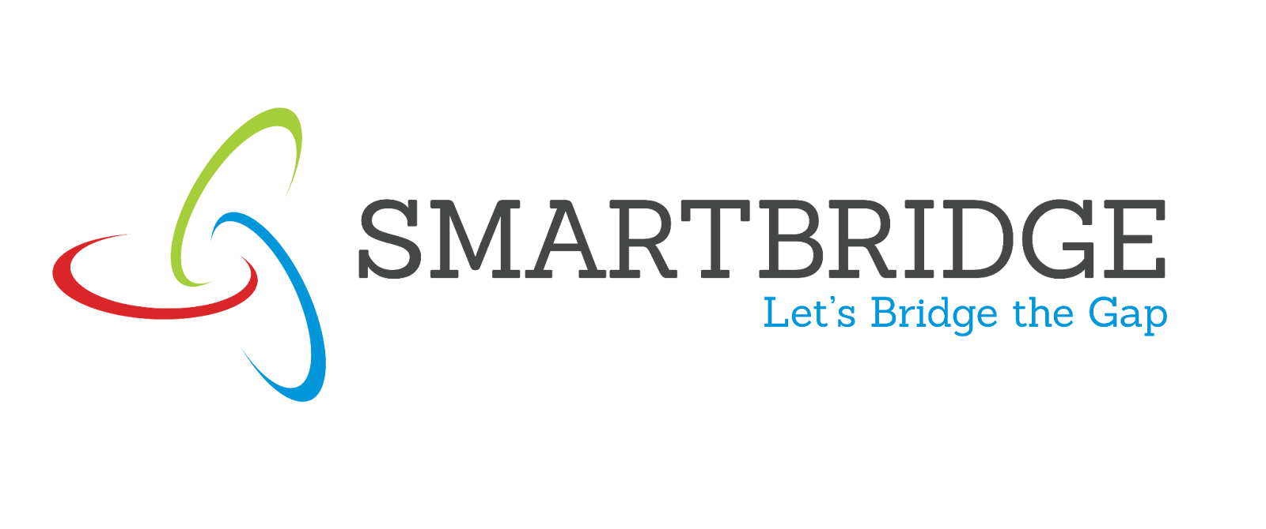
Story

Date | 17 August 2026
Team ID
Project Name | Global AI Adoption in Education: A Comprehensive Global Performance Analysis
Maximum Marks

Activity 1:
Description
The data story for this global AI adoption in education project is structured into multiple scenes, each focusing on a distinct aspect of AI in educational technology:
Scene 1 - Introduction: Global AI in Education Challenge
Establishes the significance of understanding global AI adoption in education and the urgency of bridging educational technology gaps
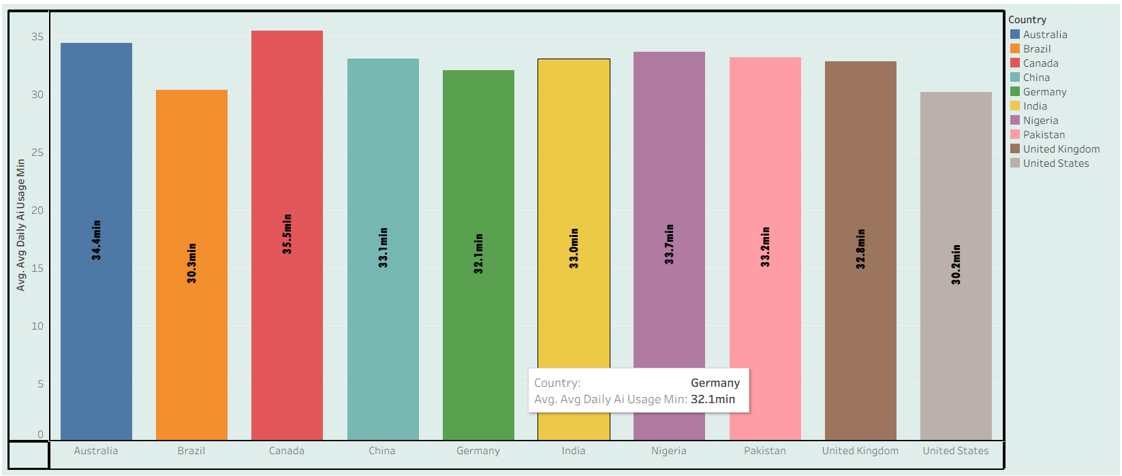
Scene 2 - Geographic Disparity: Regional AI Adoption Variations
Reveals significant geographic disparities in AI adoption across regions, with Oceania leading at 34.6% school adoption
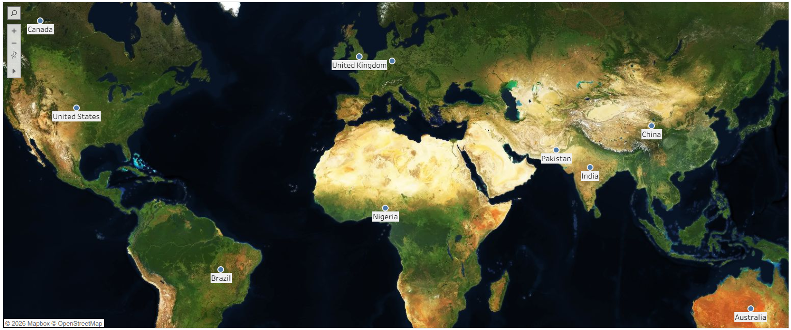
Scene 3 - Temporal Trends: AI Adoption Journey (2015-2026)
Demonstrates how AI adoption has grown from minimal levels in 2015 (5%) to substantial levels by 2026 (60%), showing accelerating adoption trajectory
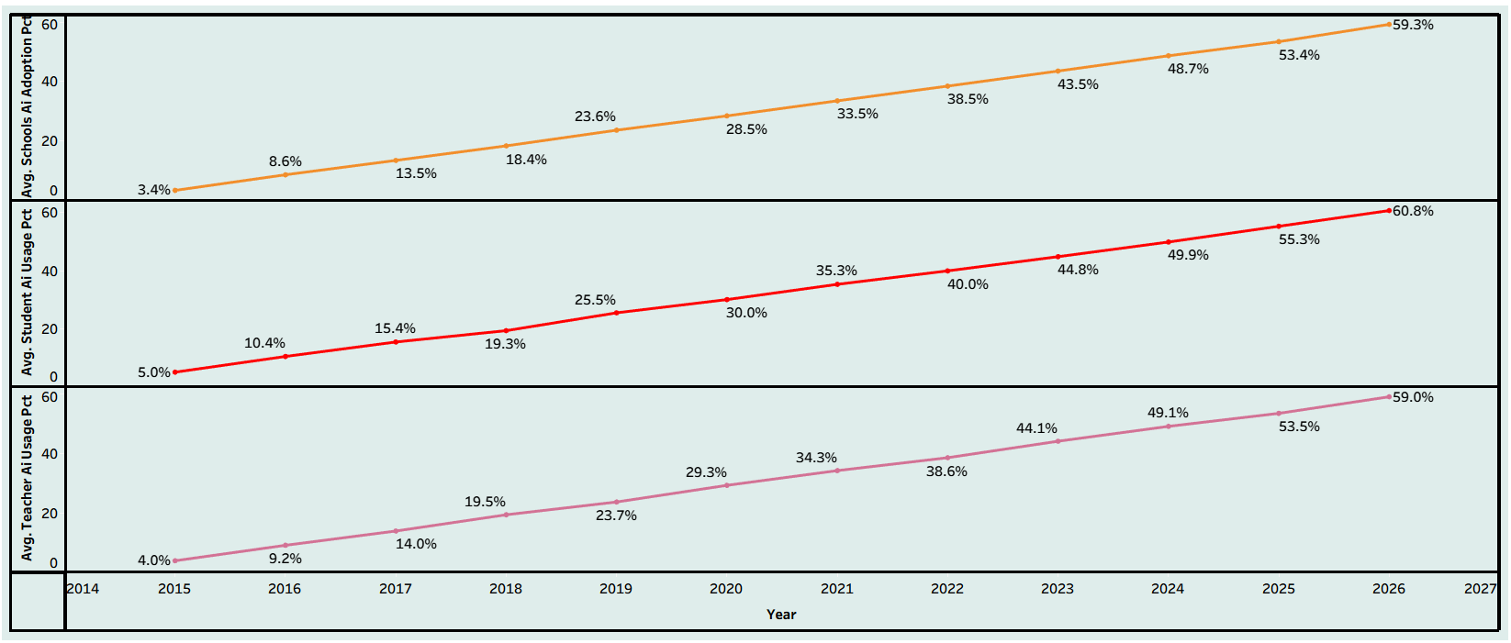
Scene 4 - Tool Competition: Leading AI Platforms Market Share
Analyzes the competitive landscape of AI tools in education, showing nearly equal market distribution among ChatGPT (26.7%), Copilot (25.1%), Gemini (24.3%), and Khanmigo (24.0%)
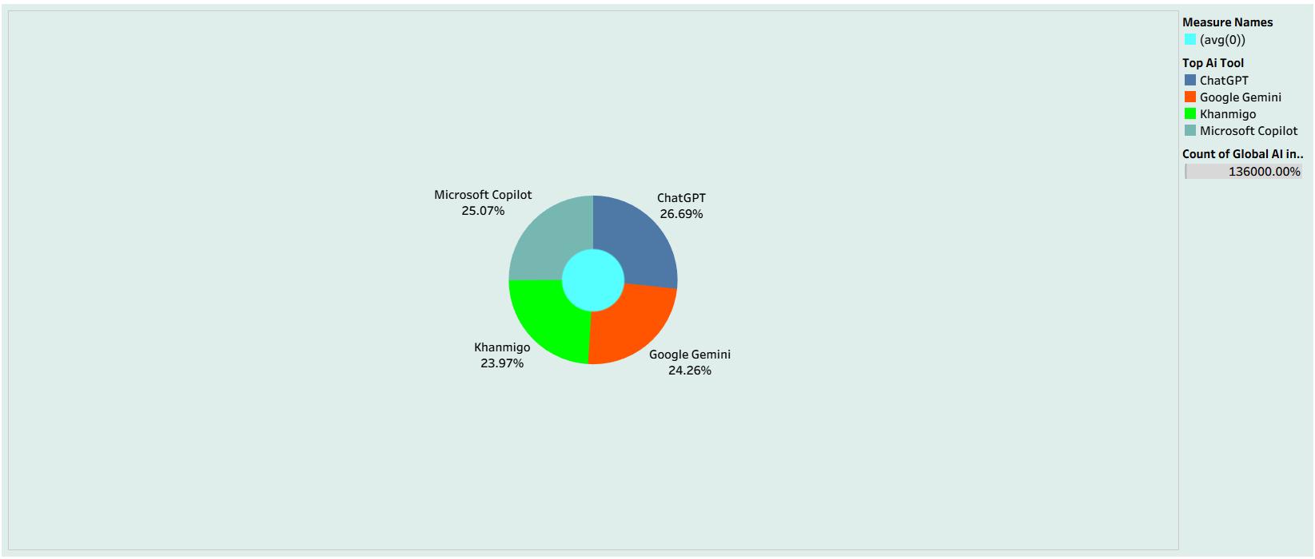
Scene 5 - Digital Equity: Urban-Rural Adoption Divide
Examines the persistent gap between urban (33.56%) and rural (21.60%) AI adoption, highlighting digital equity challenges
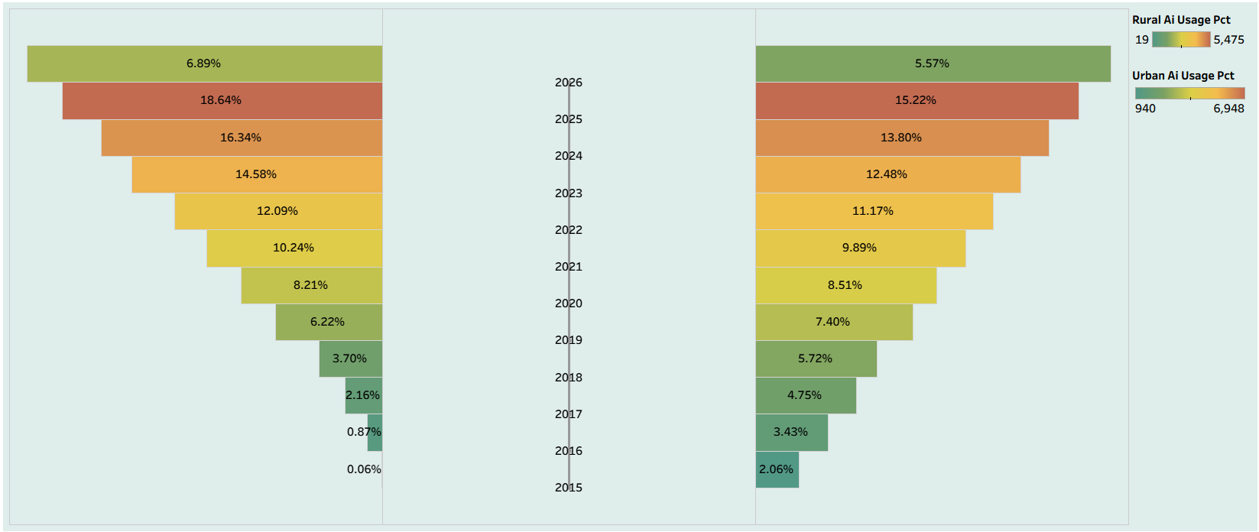
Scene 6 - Stakeholder Engagement: Student vs Teacher Adoption Parity
Explores similar adoption rates between students (30.99%) and teachers (29.91%), indicating balanced implementation strategies
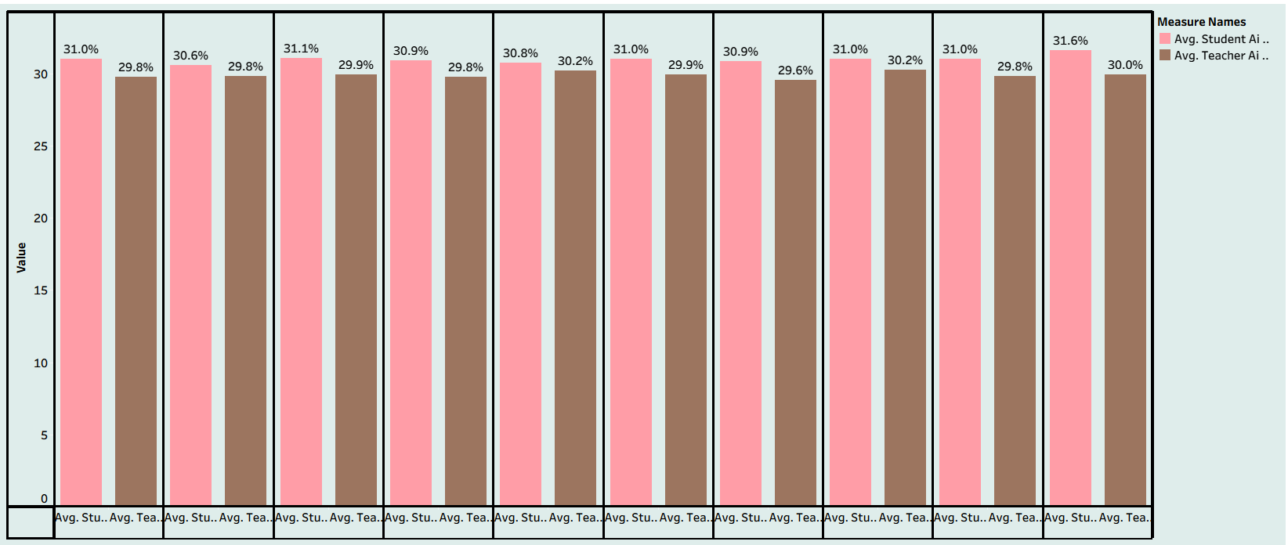
Scene 7 - Conclusions and Recommendations: Strategic Pathways Forward
Synthesizes findings into evidence-based recommendations for educational policymakers, institutional leaders, and technology vendors
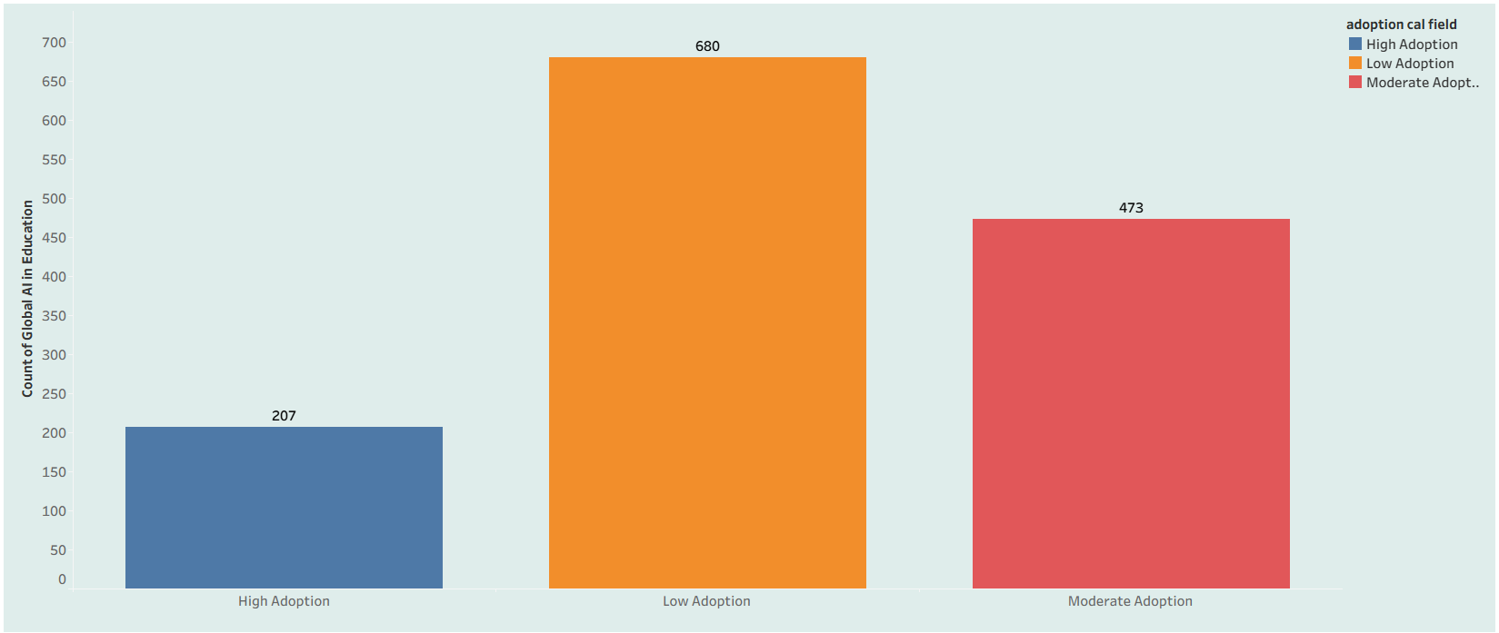

OUTCOME:
Scene 1 Outcome: Confirms that global AI adoption in education is an urgent, unevenly understood phenomenon, justifying the need for structured, data-driven monitoring across countries and demographics.
Scene 2 Outcome: Oceania leads at 34.6% school adoption, but other regions trail closely behind (around 29%), showing geographic disparity exists without being extreme — supporting a near-uniform, low-friction regional rollout strategy.
Scene 3 Outcome: AI adoption has grown roughly 12x, from 5% in 2015 to 60% in 2026, confirming a durable, accelerating trend rather than a short-lived spike.
Scene 4 Outcome: No single AI tool dominates the market (ChatGPT 26.7%, Copilot 25.1%, Gemini 24.3%, Khanmigo 24.0%), signaling that institutions should plan for multi-tool integration rather than single-platform lock-in.
Scene 5 Outcome: A clear digital equity gap of about 12 percentage points separates urban (33.56%) and rural (21.60%) adoption, making rural infrastructure and access investment the top equity priority.
Scene 6 Outcome: Adoption parity between students (30.99%) and teachers (29.91%) indicates adoption is being driven by coordinated institutional strategy rather than a single stakeholder group.
Scene 7 – Outcomes: Key Takeaways from the Data Story. This concluding scene consolidates the outcomes derived from Scenes 1–6, translating the visual narrative into actionable insights for educational technology leaders and policymakers.
Overall Project Outcome: Global AI adoption in education is a rapidly accelerating, globally distributed trend, adopted in a coordinated way by both students and teachers across a diversified toolset — but its benefits are not yet reaching rural communities equally, making digital equity the single largest challenge for the next phase of adoption.

Activity 2:
Publish Story on Tableau Public and Paste Public link below:
https://public.tableau.com/views/GlobalAIAdoptioninEducationStory/Story1?:language=en-US&publish=yes&:sid=&:redirect=auth&:display_count=n&:origin=viz_share_link

