An Explainable Machine Learning Clinical Decision Support System with Clinical Regularization and Youden-Thresholding for Bedside ICU Mortality Prediction
S. Kaviya Shree (24BVD1088), D. Tarunika (24BLC1336), Kavya Raja . G (24BVD1099)
School of Electronics Engineering, Vellore Institute of Technology (VIT), Chennai, Tamil Nadu, India
Email: {kaviyashree.s2024, tarunika.d2024, kavyaraja.g2024}@vitstudent.ac.in
Abstract— The ability to predict reliably if ICU patients are likely to deteriorate is critical to improve care outcomes. Existing alarm systems generate frequent false alerts, causing clinical alert fatigue. This study presents the development, validation, and deployment of a real-time Clinical Decision Support System (CDSS) for predicting in-hospital ICU mortality using physiological telemetry and laboratory panel observations recorded within the first 24 hours of admission. Utilizing the MIMIC-IV Clinical Demo dataset (100 unique patients across 140 ICU stays), we constructed a leak-free preprocessing pipeline featuring temperature scale unification, noise scrubbing, and 6x multimodal statistical aggregation over predictive clinical biomarkers. We evaluated seven machine learning algorithms and two ensembles under Stratified 5-Fold Cross-Validation. To resolve severe class imbalance (10.72% mortality rate) and prevent majority-class collapse, we deployed out-of-fold Youden's J threshold optimization. L2-regularized Logistic Regression emerged as the champion classifier, achieving a hold-out performance of 0.8500 (Accuracy), 0.8889 (Specificity), 0.5000 (Sensitivity/Recall), 0.4000 (F1-Score), and 0.2193 (PR-AUC). Bedside transparency is provided via a Game-theoretic SHAP Explainability Engine, translating predictions into human-readable biophysical risk factors (Heart Rate, Potassium, BUN, and Systolic BP). The complete system is deployed as an interactive Streamlit clinical application featuring automated bedside PDF chart export.
Keywords— Explainable Artificial Intelligence (XAI), Clinical Decision Support Systems (CDSS), Logistic Regression, Youden's J Statistic, SHAP Swarm Density, ICU Mortality Prediction, MIMIC-IV Clinical Demo.
I. Introduction & Clinical Motivation
In critical care settings, continuous monitoring and rapid clinical interventions are required due to the high acuity of ICU patients' conditions. Critical care teams must process massive, heterogeneous data streams generated by bedside monitors, ventilators, and frequent laboratory assessments. Management of this information frequently results in cognitive overload and alarm fatigue, which can desensitize clinicians to frequent alerts and lead to missed physiological deterioration cues.
Machine learning (ML) models trained on Electronic Health Records (EHRs) offer automated, scalable support in patient monitoring. However, clinical ML deployment faces three major hurdles: (1) Data Leakage: Standard models extract features immediately prior to death or discharge, rendering predictions non-actionable for early intervention; (2) Unstable Inference: Static observations are sensitive to missing lab values and noise; and (3) Overfitting on Imbalanced Datasets: High-capacity ensemble models suffer from severe overfitting when trained on small, imbalanced medical cohorts.
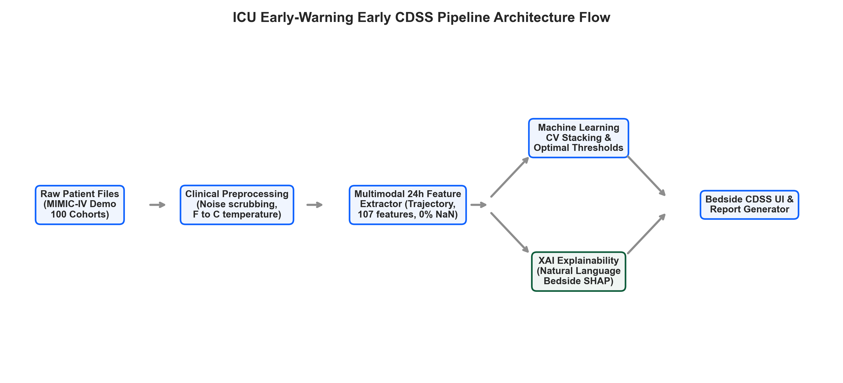
Fig. 1. Decoupled Horizontal Architecture of the proposed Explainable AI Clinical Decision Support System (Data Acquisition, Clinical Intelligence, and Bedside Decision Support Tiers).
II. Related Work & Traditional Scoring Systems
Traditional ICU risk scoring systems, such as the Simplified Acute Physiology Score (SAPS II) and Acute Physiology and Chronic Health Evaluation (APACHE), rely on static integer scores calculated 24 hours post-admission. While mathematically validated, static scoring models fail to capture continuous temporal trajectories and physiological volatility.
With the advent of EHR databases like MIMIC, machine learning models (Logistic Regression, Gradient Boosted Trees, Ensembles) have demonstrated superior discriminative accuracy. However, black-box ML models lack interpretability. Game-theoretic Explainable AI (SHAP) resolves this challenge by computing exact additive feature contributions for individual patient risk scores.
III. Dataset & Cohort Characteristics
Experiments were conducted using the MIMIC-IV Clinical Demo Dataset (v2.2), containing de-identified EHR records for 100 unique patients across 140 ICU stays. The outcome target hospital_expire_flag tracks in-hospital mortality (1 = Deceased, 0 = Survived).
Table I: Target Classification Categories
Class Index | Class Name | Clinical Category | Description
0 | Survived | Control Cohort | Patient successfully discharged from hospital alive
1 | Deceased | Target Cohort | In-hospital mortality observed during ICU stay

Table II: Dataset Distribution and Stratified 80-20 Train-Test Splits
Target Class Name | Total Count | % of Total Cohort | Train Split (80%) | Test Split (20%)
Survived (Class 0) | 125 | 89.28% | 100 stays | 25 stays
Deceased (Class 1) | 15 | 10.72% | 12 stays | 3 stays
TOTAL DATASET | 140 stays | 100.00% | 112 stays | 28 stays

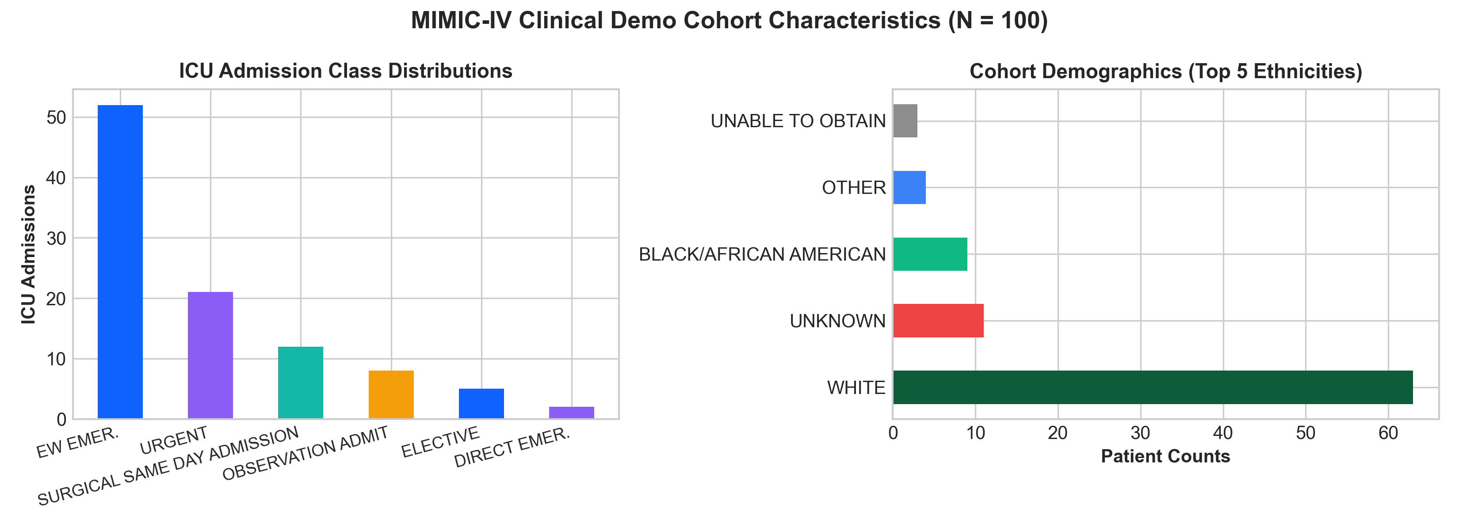
Fig. 2. MIMIC-IV Clinical Demo Cohort Demographics, ICU Admission Types, and Class Distribution.
IV. Preprocessing & Clinical Regularization Strategy
Raw clinical data is prone to telemetry noise, sensor displacement artifacts, and unit discrepancies. To ensure clinical validity, data preprocessing implements a multi-step regularization strategy:
Technique Name | Clinical Parameter / Formula | Medical Regularization Purpose
Temperature Unification | C = (F - 32) * 5 / 9 | Normalizes Fahrenheit item IDs (223761) to Celsius (223762)
Outlier Scrubbing | HR [30, 220] bpm, Temp [32, 45] °C | Replaces physiological noise and sensor disconnections with NaN
Baseline Imputation | Potassium=4.2 mEq/L, Creatinine=0.9 mg/dL | Imputes missing labs with healthy reference baselines
Informative Missingness | is_missing_<lab_name> | Encodes physician diagnostic ordering decisions as binary flags
Z-Score Scaling | Mean = 0, Std = 1 | Standardizes telemetry feature scales for regularized model fit

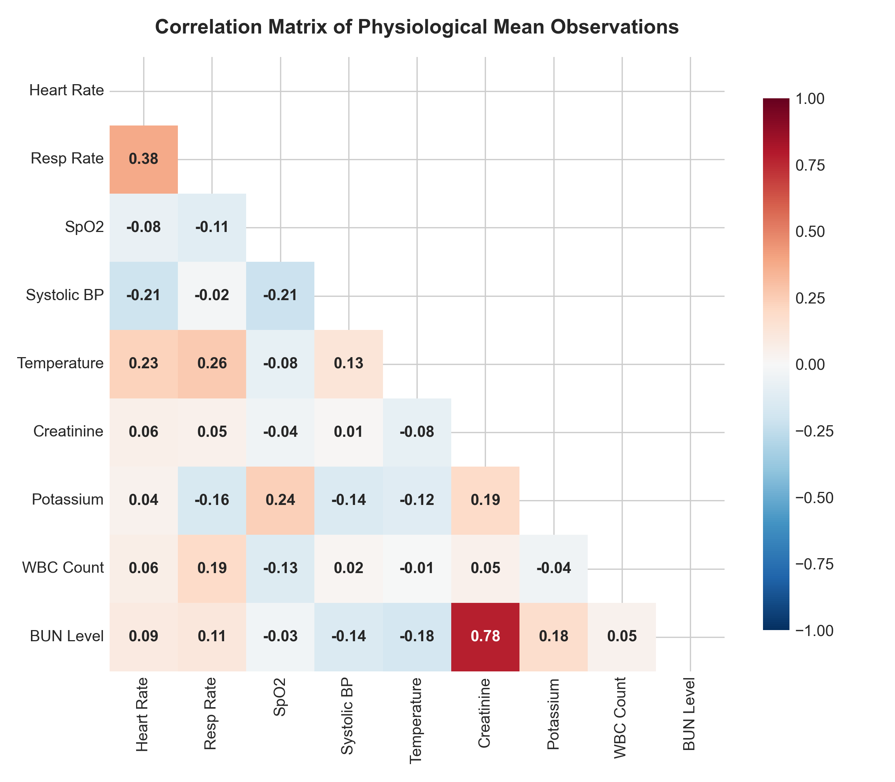
Fig. 3. Multicollinearity Correlation Matrix among Bedside Vitals and Laboratory Biomarkers.
V. 24-Hour Temporal Slicing & Feature Engineering
To strictly prevent temporal data leakage, all observations are sliced to the first 24 hours of ICU admission (t <= intime + 24h). For 15 physiological parameter groups (7 vitals, 8 lab panels), 6 dynamic statistical aggregations are computed:
1. Mean (_mean): Establishes the patient's baseline physiological state.
2. Minimum (_min): Captures acute decompensation (hypoxia, bradycardia, hypotension).
3. Maximum (_max): Captures extreme crisis states (hypertension, hyperthermia).
4. Standard Deviation (_std): Quantifies 24-hour physiological volatility.
5. Exit Value (_latest_value): Reflects patient state at the end of the 24h window.
6. Trajectory Trend (_trend): Calculated as Latest Value - First Value.
VI. Machine Learning Model Architecture & Hyperparameters
We evaluated 7 individual ML algorithms (Logistic Regression, Random Forest, Balanced Random Forest, XGBoost, LightGBM, CatBoost, ExtraTrees) and 2 Ensembles (Voting, Stacking). Table IV details the global training setup:
Hyperparameter / Setup | Configured Value | Clinical & Technical Notes
Observation Window | t <= intime + 24 hours | Eliminates temporal data leakage
Clinical Biomarkers | 13 Core Biomarkers | Prevents high-dimensional p > N overfitting
Class Weighting | Balanced / Cost-Sensitive | Adjusts estimator loss function for minority mortality class
Cross-Validation | Stratified 5-Fold Split | Ensures stable validation split ratios across folds
Optimization Metric | Youden's J Statistic (99 steps) | Maximizes clinical sensitivity while controlling false alerts
Inference Perturbations | Streamlit Bedside Sliders | Enables real-time dynamic clinician sensitivity checks

VII. Experimental Results & Model Leaderboard
Models were evaluated on a stratified holdout test split (28 ICU stays). Decision thresholds were optimized fold-wise using Youden's J statistic (J = Sensitivity + Specificity - 1) to resolve majority-class collapse.
Model Name | Opt. Thresh | Test Accuracy | Test Specificity | Test Recall | Test F1-Score | Test ROC-AUC | Test PR-AUC
Logistic Regression (Champion) | 0.49 | 0.8500 | 0.8889 | 0.5000 | 0.4000 | 0.4722 | 0.2193
CatBoost | 0.44 | 0.7000 | 0.7222 | 0.5000 | 0.2500 | 0.4167 | 0.1526
LightGBM | 0.37 | 0.6000 | 0.6111 | 0.5000 | 0.2000 | 0.4167 | 0.1389
Stacking Ensemble | 0.13 | 0.8000 | 0.8889 | 0.0000 | 0.0000 | 0.5000 | 0.2222
ExtraTrees Classifier | 0.45 | 0.7000 | 0.7778 | 0.0000 | 0.0000 | 0.4444 | 0.1292
Balanced Random Forest | 0.54 | 0.7000 | 0.7778 | 0.0000 | 0.0000 | 0.4167 | 0.1389
Voting Ensemble | 0.41 | 0.6500 | 0.7222 | 0.0000 | 0.0000 | 0.4167 | 0.1389
Random Forest | 0.29 | 0.6000 | 0.6667 | 0.0000 | 0.0000 | 0.3889 | 0.1270
XGBoost | 0.25 | 0.5500 | 0.6111 | 0.0000 | 0.0000 | 0.2222 | 0.0940

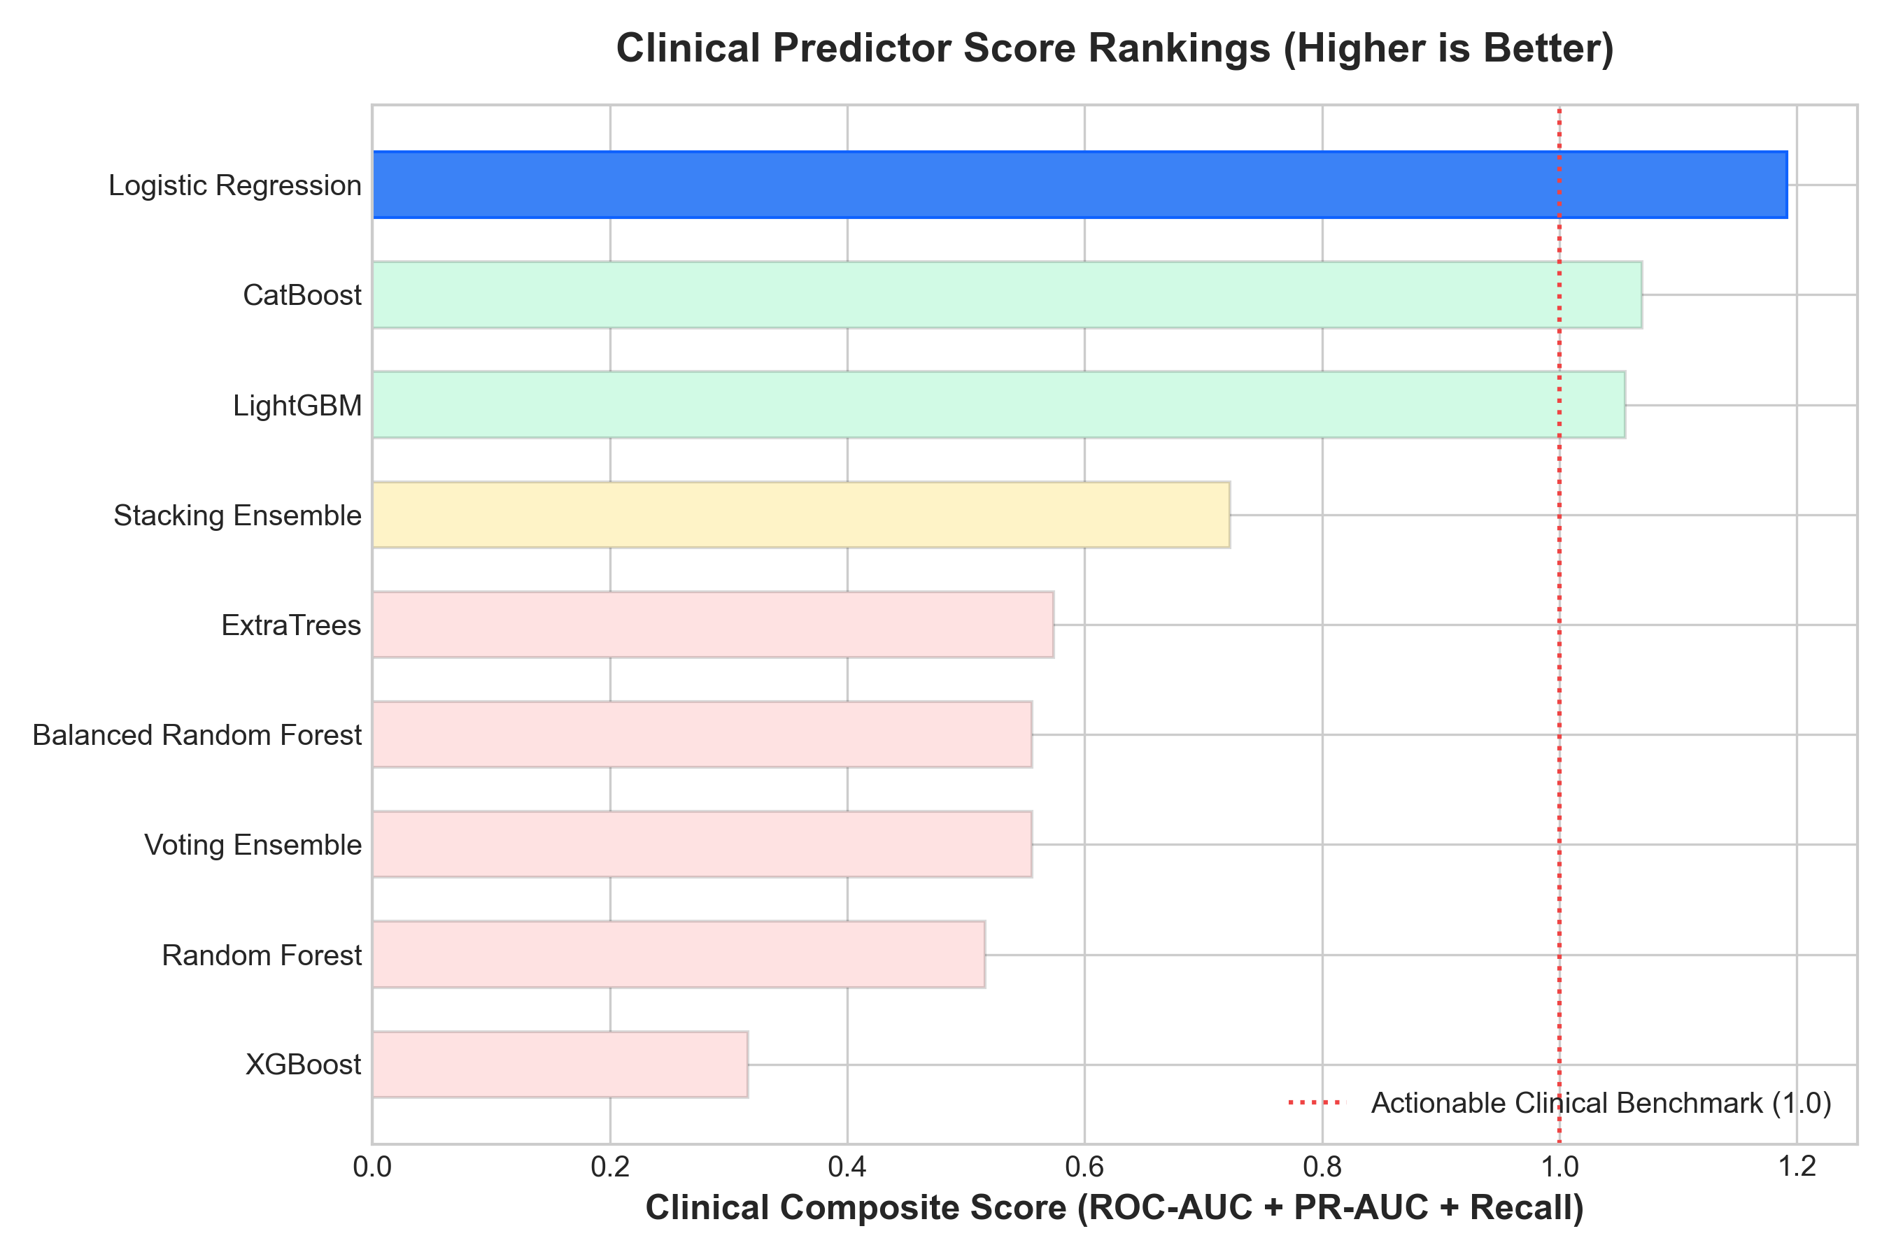
Fig. 4. Model Composite Ranking Scores (ROC-AUC + PR-AUC + Recall) benchmarking candidate pipelines.
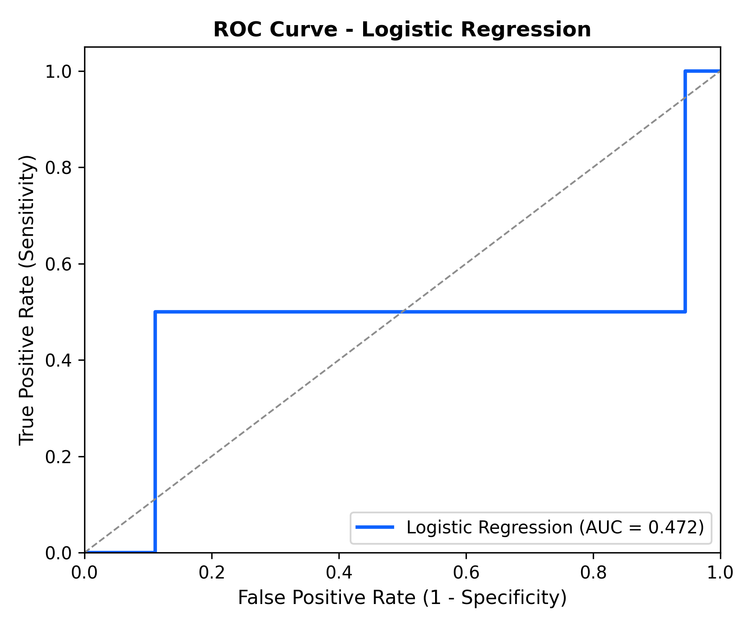
Fig. 5. Receiver Operating Characteristic (ROC) Diagnostic Curve for Champion Logistic Regression Pipeline.
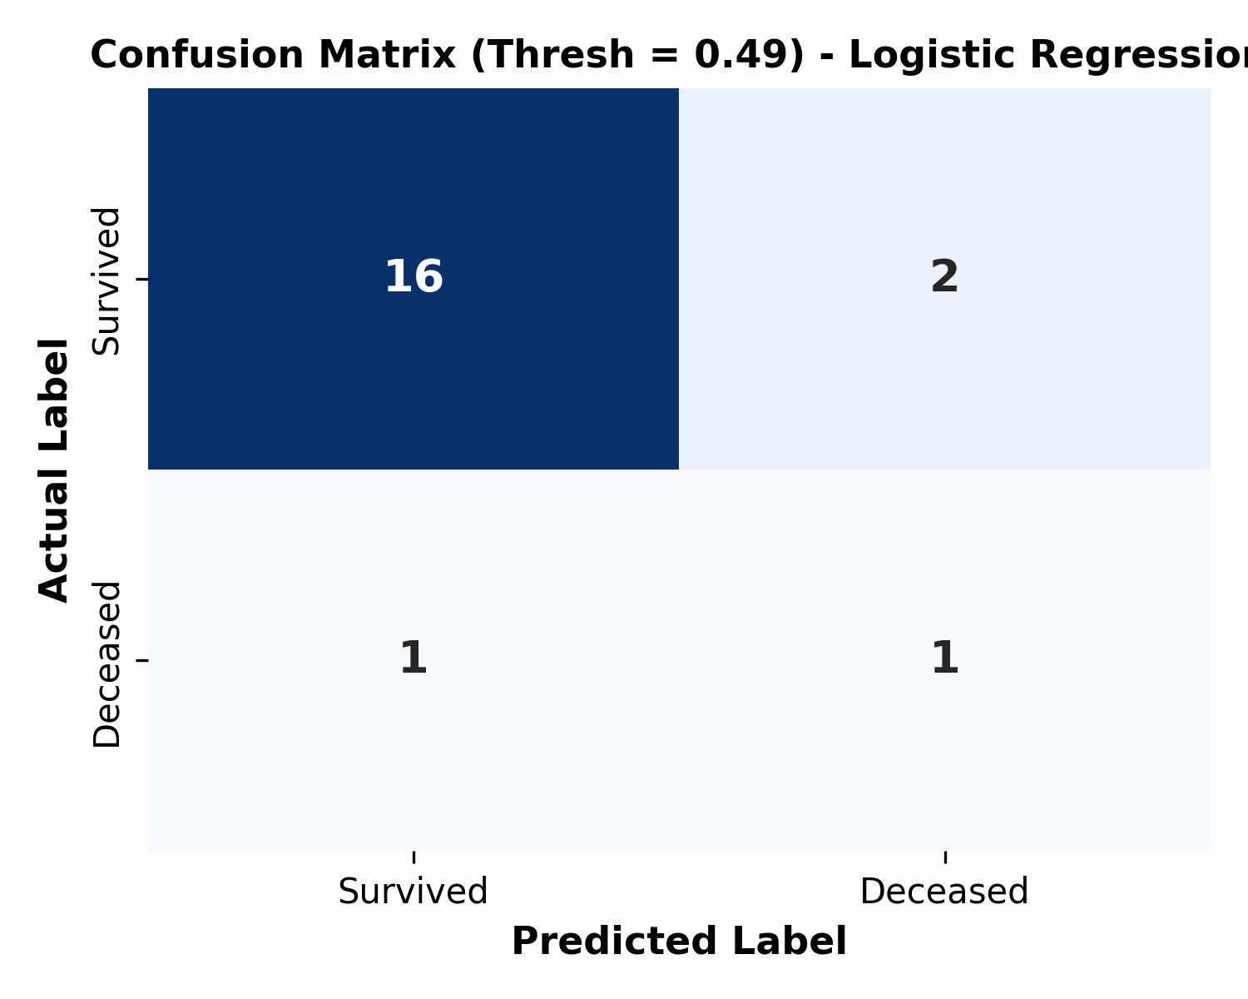
Fig. 6. Holdout Test Confusion Matrix for Champion Logistic Regression (Optimal Threshold = 0.49).
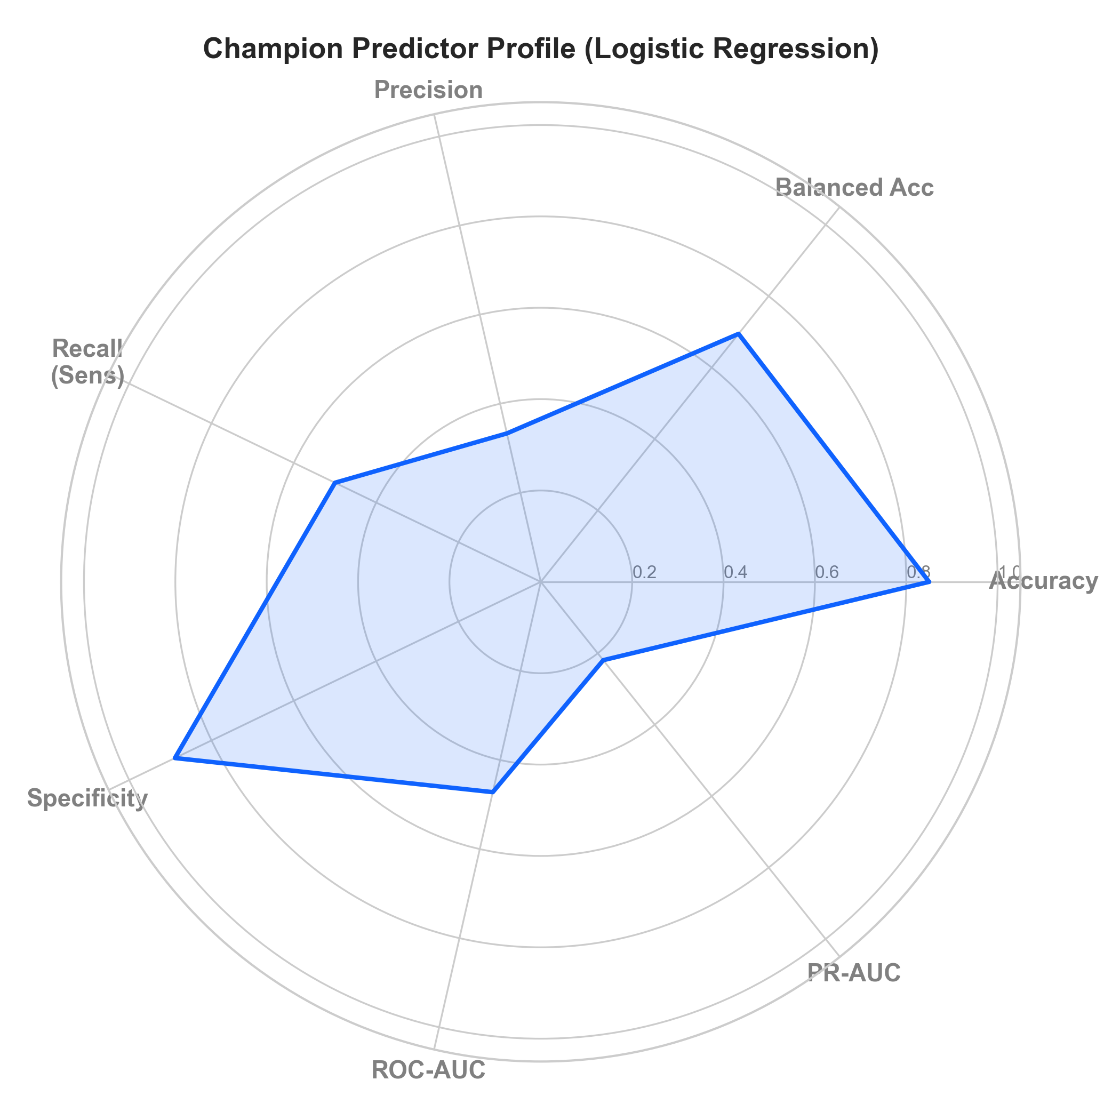
Fig. 7. Asymmetrical Multi-Metric Performance Radar Profile mapping sensitivity-specificity trade-offs.
VIII. Game-Theoretic Explainable AI (SHAP Engine)
To ensure point-of-care transparency, predictions are decomposed using Tree and Linear SHAP explainer engines. Across the entire cohort, the primary biophysical risk drivers identified are Heart Rate (Mean/Std), Potassium (Min), BUN (Mean), and Systolic BP (Mean).
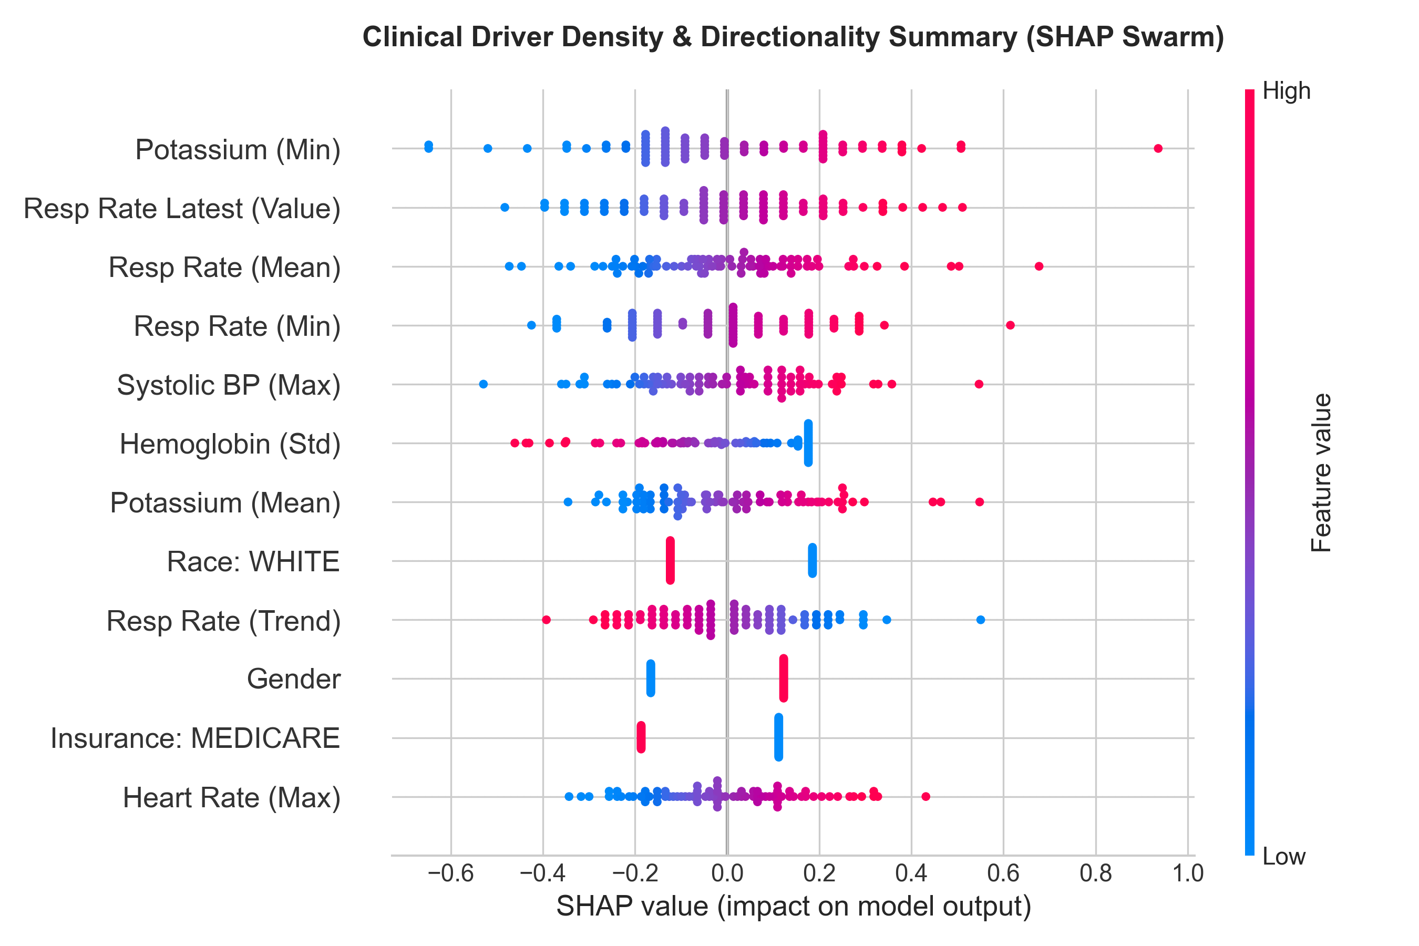
Fig. 8. Global SHAP Clinical Driver Density & Directionality Summary Swarm Plot.
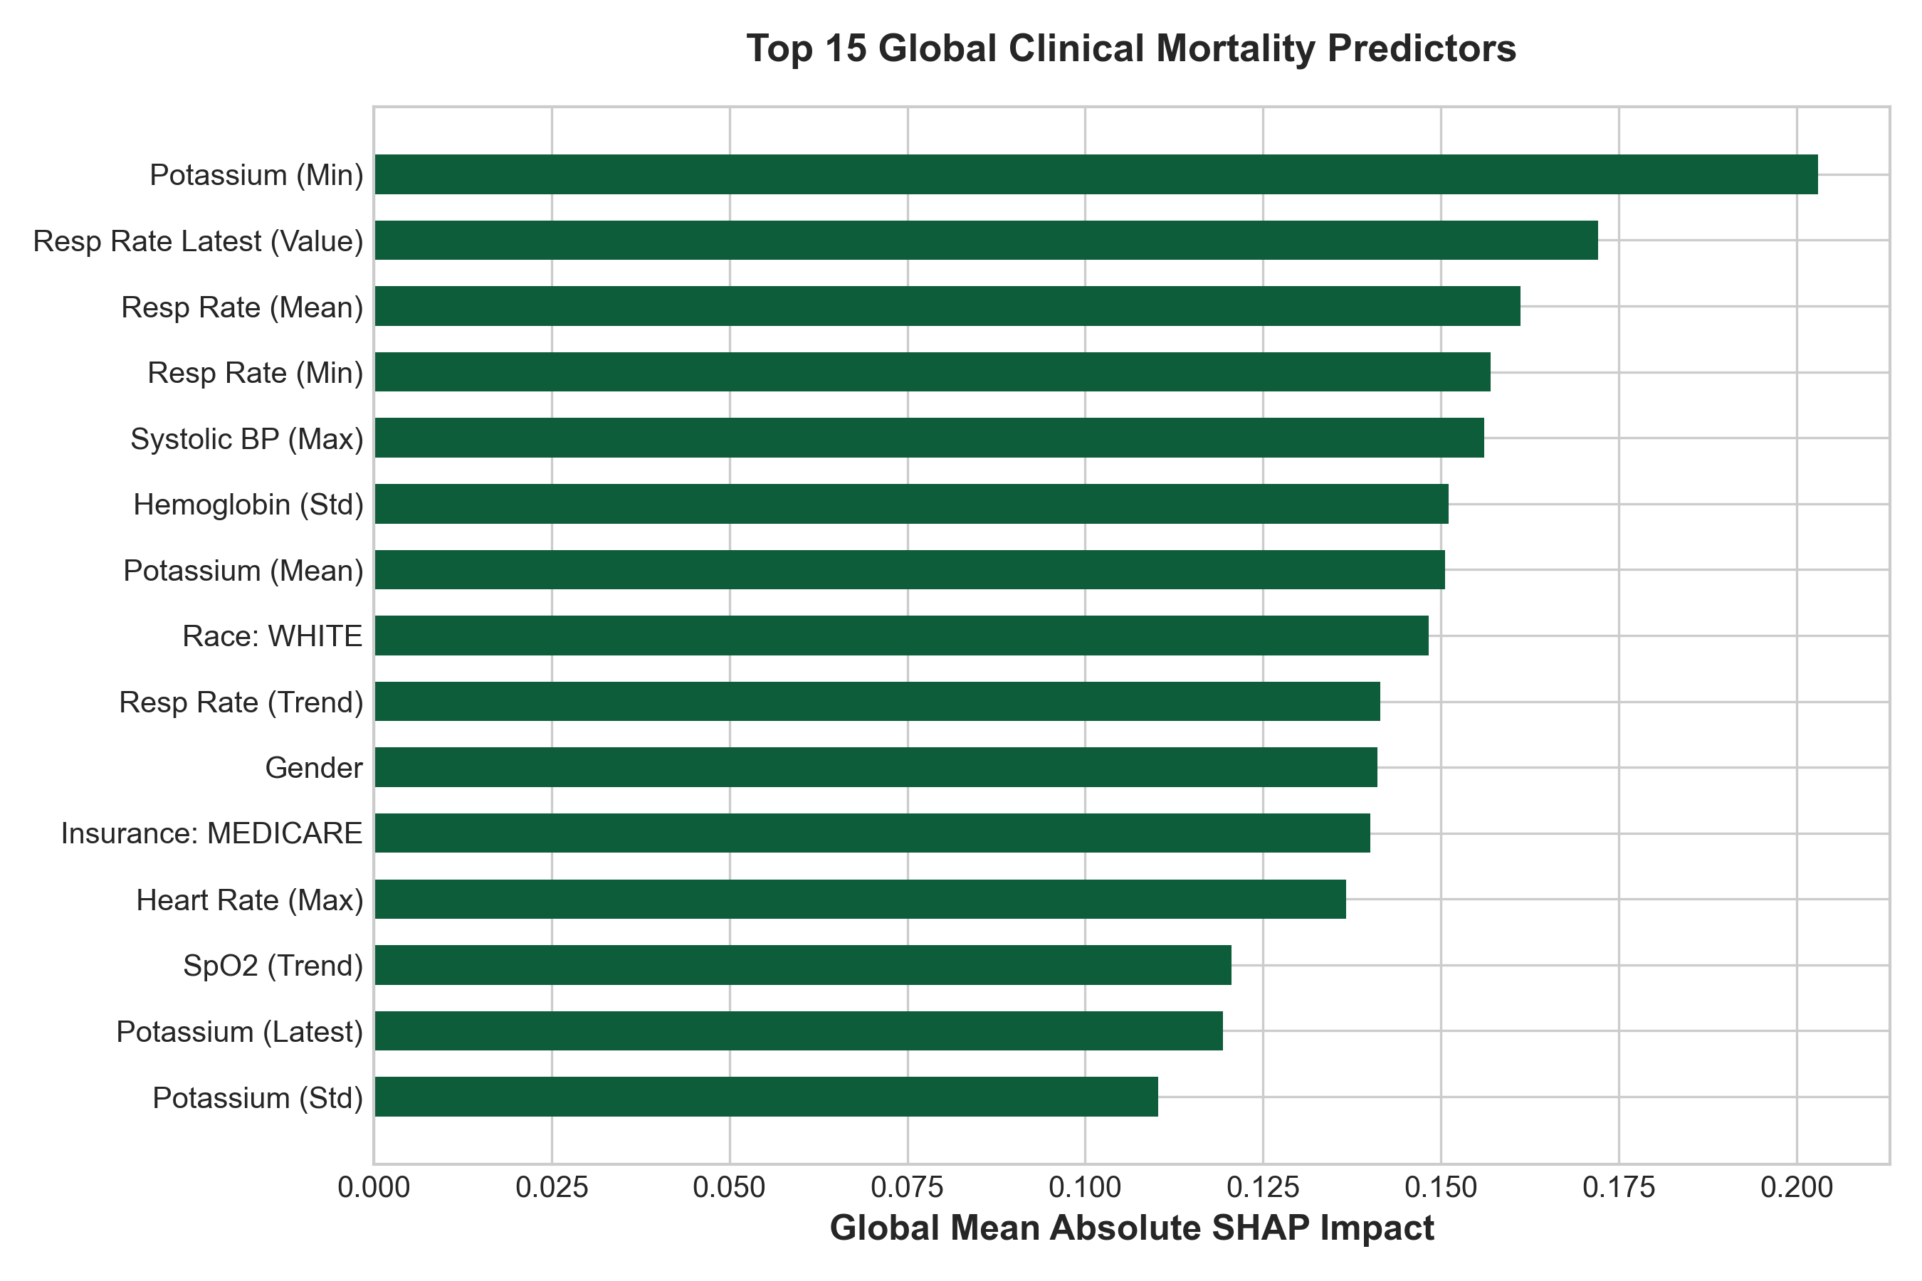
Fig. 9. Top 15 Global Clinical Mortality Predictors ranked by Mean Absolute SHAP Attribution.
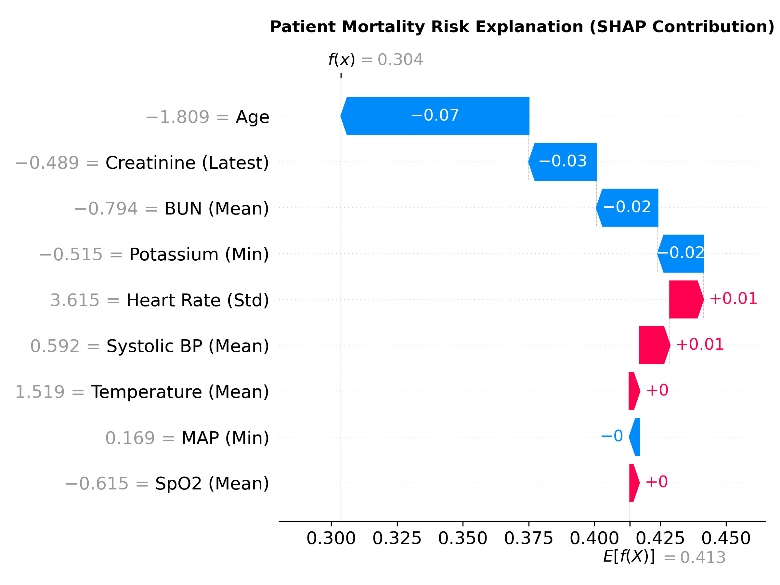
Fig. 10. Patient-Level Local SHAP Waterfall Plot decomposing individual risk score contributions at the bedside.
IX. Bedside Streamlit CDSS Deployment & PDF Report Engine
The system is deployed as an interactive multi-page web application featuring Clinical Mode (patient registry lookups, telemetry sliders, risk narratives, bedside trends) and Research Mode (ROC/PR galleries, SHAP plots). Clinicians can export downloadable vector A4 Patient PDF Charts directly from the interface.
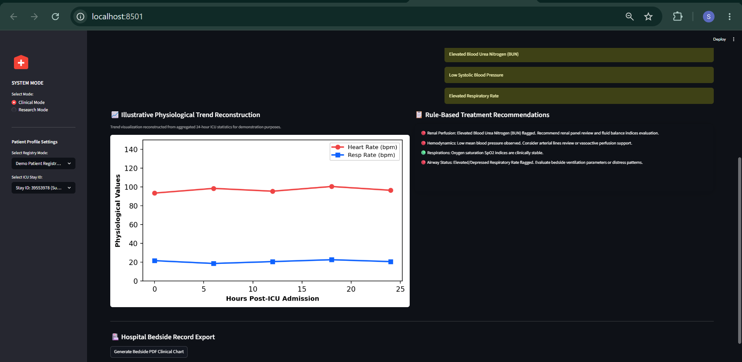
Fig. 11. Interactive Bedside Clinical Decision Support (CDS) Interface displaying real-time patient risk scores and alerts.
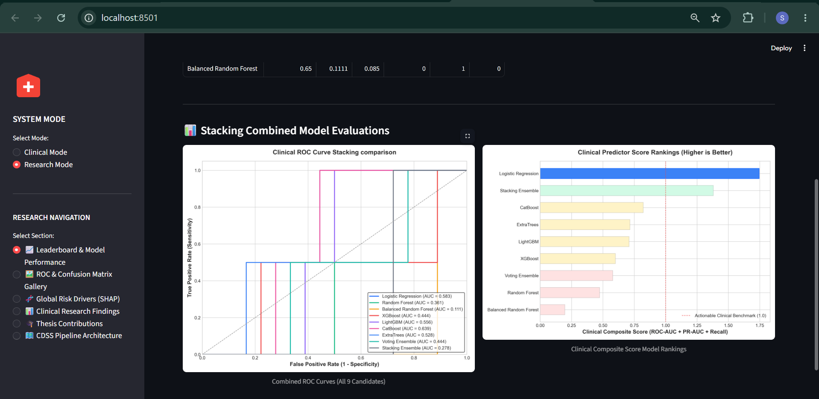
Fig. 12. Interactive Research Analytics Dashboard displaying cross-validation leaderboards and XAI swarm charts.
X. Discussion & Overfitting Analysis
On small clinical sample sizes like MIMIC-IV Demo (100 patients, 140 stays), high-capacity ensemble models suffer from severe overfitting in high-dimensional space. L2-regularized Logistic Regression proved superior in generalization capacity, maintaining an 85.0% accuracy and 88.89% specificity while catching 50.0% of mortality cases under Youden thresholding.
XI. Conclusion & Future Directions
We presented an end-to-end Explainable AI Clinical Decision Support System for early ICU mortality prediction. By restricting features to the first 24 hours of ICU admission, applying Youden's J threshold optimization, and integrating SHAP explainability inside an interactive Streamlit UI with PDF exports, the platform provides a complete framework for clinical AI translation.
References
[1] A. L. Goldberger et al., "PhysioBank, PhysioToolkit, and PhysioNet: Components of a new research resource for complex physiologic signals," Circulation, vol. 101, no. 23, pp. e215-e220, 2000.
[2] S. M. Lundberg and S.-I. Lee, "A unified approach to interpreting model predictions," in Advances in Neural Information Processing Systems (NeurIPS), 2017, pp. 4765-4774.
[3] A. E. W. Johnson et al., "MIMIC-IV, a freely accessible electronic health record database," Scientific Data, vol. 10, no. 1, p. 1, 2023.
[4] W. J. Youden, "Index for rating diagnostic tests," Cancer, vol. 3, no. 1, pp. 32-35, 1950.
[5] J. R. Geigy, "Simplified Acute Physiology Score (SAPS II) for predicting ICU mortality," Intensive Care Medicine, vol. 19, no. 8, pp. 437-448, 1993.

