****DATA/TREND ANALYSIS OF KICSTARTER CAMPAIGNS****

****KAVYA SHABNAVEEs****

****HOME ASSIGNMENT – 1****

****DATA ANALYSIS OF CAMPAIGNS FuNDED ON KICSTARTER****

Based on the data provided that contained details of past Campaigns that attempted to get funds on Kickstarter, some observations have been made to analyze pull some trends that led to successful outcomes. These observations might serve a purpose of reference for upcoming Campaigns to design and plan their way to success.

Below questions are answered further in this document:

1. What are three conclusions we can make about Kickstarter campaigns given the provided data? (Refer to pages 3 – 5)
2. What are some of the limitations of this dataset? (Refer to page 6)
3. What are some other possible tables/graphs that we could create? (Refer to pages 7-9)

NOTE: Refer to Page 10 for Bonus Data Graph and findings.

**CONCLUSIONS DRAWN FROM THE DATA PROVIDED:**

1. **Observations from Chart 1.1**

Chart (Figure-1.1) below shows the count of each state (marked with different colors) for every category.

* Firstly, by observing the Chart below, we could clearly see “Theater” category secured highest number of success campaigns with reference to the provided data.
* Another interesting detail that can be drawn from the same Chart is that “Music” category holds highest percent of success (77 %). So, new campaigns that focus on “Music” might see more of successes than failures compared to other categories.

Figure - 1.1

* 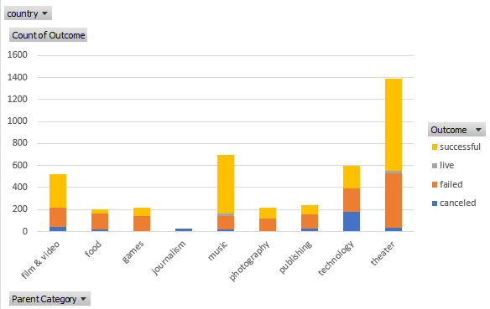

1. **Observations from Chart 2.1**

Chart below shows the number of outcomes(success/failed/cancelled/live) for each sub-category.

* From the Chart, we could see that “Plays” sub-category with considerably highest number of Campaigns (1066), produced a good number of successes (~700) with a rate of 65%.

Figure - 2.1

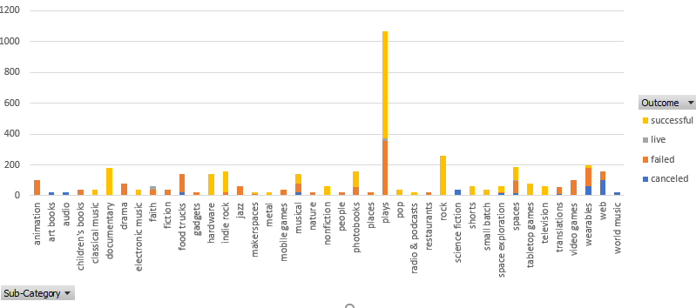

1. **Observations from Chart 3.1**

The Chart in figure 3.1 shows the monthly trend of different outcomes(cancelled/failed/successful) for years 2009 to 2017. Observations are as below:

* The trend in the Chart infers that majority of successful Campaigns are observed to be active for the month of May and dropped from there.

**Figure – 3.1**

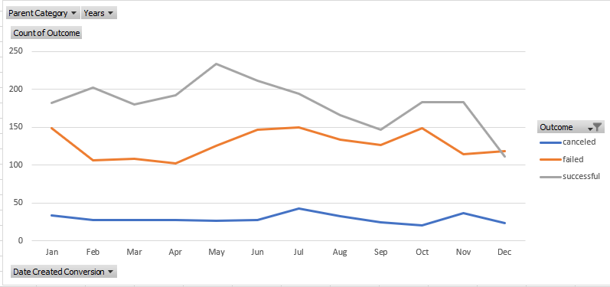

****LIMITATIONS OF THE DATASET****

1. **The data set provided includes data related to only 4115 projects out of 300000 projects that were launched. So, our conclusions are based only on a minimal set of data (1.37%) of the entire campaigns.**

**2. Considering the data, we are provided with 33% of the data is related to one**

**campaign, Theatre and the rest is unevenly spread among other categories.**

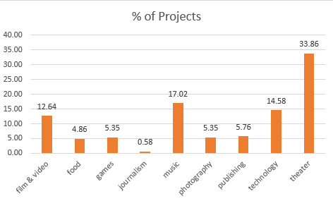

****OTHER possible tables/graphs****

1. **We could create a graph to observe count of projects and their outcomes for each country. The below graphs show that 74% of projects are based out of one country, “US”.**

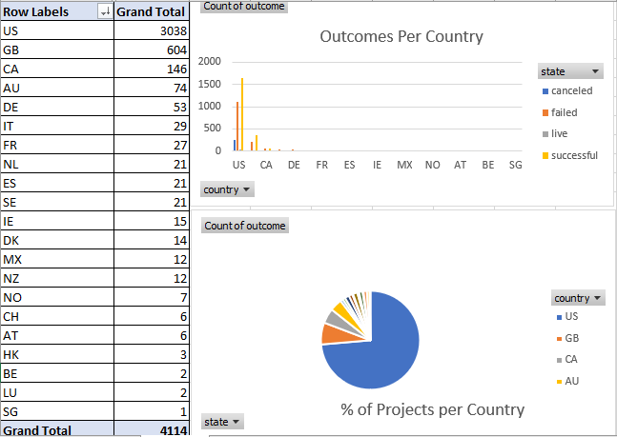

****2.** With a chart as below with backers count per project, the trend of most people showing interest in “Hardware” under “Technology” could be noticed.**

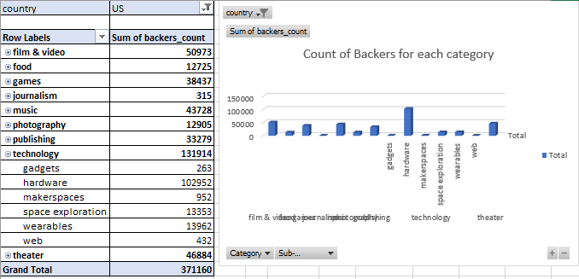

**3. Below graph interprets a stabilized increase and decrease patterns of successful projects every year in Publishing category.**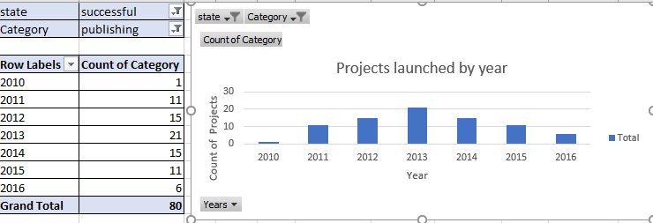

**4. Below graph could help us notice that, in past 6 years, a continual drop of participation in Music campaigns.**

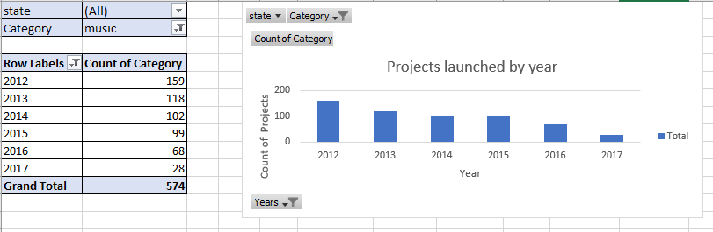

**5. Below graph captures 2015 as the year that has recorded highest number of successful campaigns and an increasing pattern from 2013-2015 followed by a decreasing pattern from 2015-2017.**

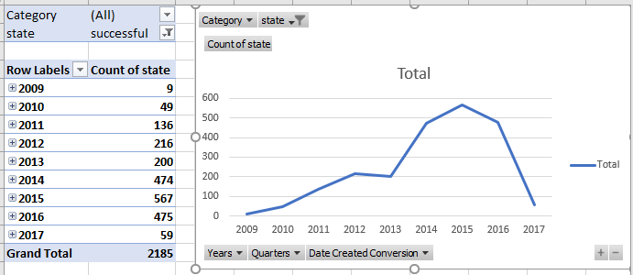

****BONUS****

**Below graph represents campaign outcomes for various ranges of initial goals.**

* **Highest success rate of projects is noticed at lowest range of initial goal.**
* **As the goal range increased, number of cancelled projects increased.**

